A3
Input Information
Input file(s): | A_3.assembled.fastq
Input format(s): | FASTQ
# Sequences: | 19,411,452
Total bases: | 2,985,988,048

Length Distribution
Mean sequence length: | 153.83 ± 49.22 bp
Minimum length: | 50 bp
Maximum length: | 240 bp
Length range: | 191 bp
Mode length: | 152 bp with 126,884 sequences
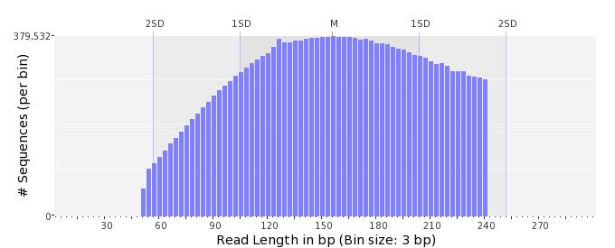

GC Content Distribution
Mean GC content: | 51.08 ± 11.13 %
Minimum GC content: | 0 %
Maximum GC content: | 100 %
GC content range: | 101 %
Mode GC content: | 50 % with 752,990 sequences
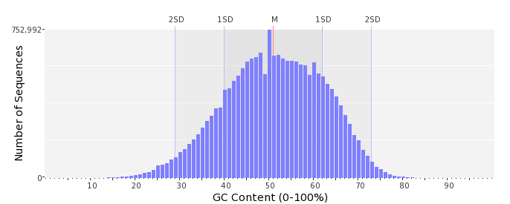

Base Quality Distribution
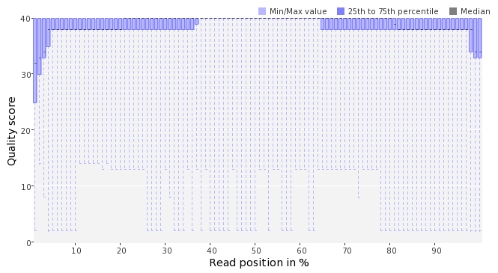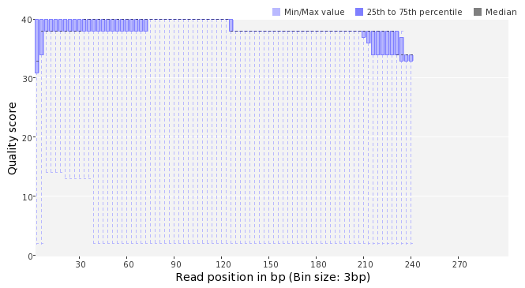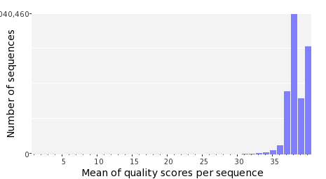

Occurence of N
Sequences with N: | 139,781 (0.72 %)
Max percentage of Ns per sequence: | 6 %
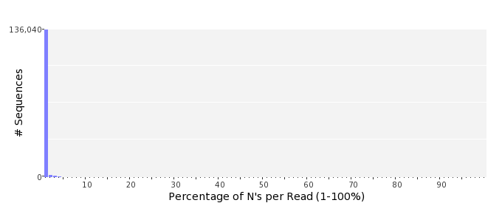

Poly-A/T Tails
 | 5'-end | 3'-end
Sequences with tail: | 74,555 (0.38 %) | 77,327 (0.40 %)
Maximum tail length: | 28 | 120
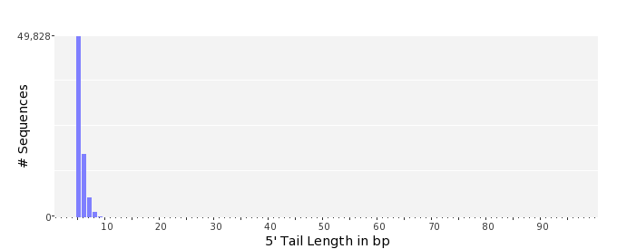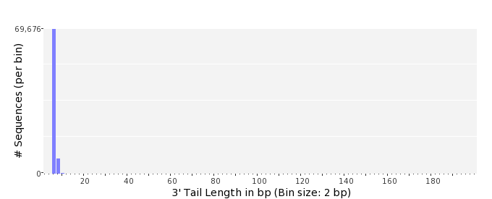

Tag Sequence Check
 | 5'-end | 3'-end
Probability of tag sequence: | 0 % | 0 %
GSMIDs or RLMIDs: | none

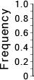 |  |  |  |  |  |  |  |  |  |  |  |  |  |  |  |  |  |  |  |  | ...
 | 1 |  |  |  | 5 |  |  |  |  | 10 |  |  |  |  | 15 |  |  |  |  | 20 |  | 20 |  |  |  |  | 15 |  |  |  |  | 10 |  |  |  |  | 5 |  |  |  | 1
 | Position from Sequence Ends

Sequence Duplication
 | # Sequences | Max duplicates
Exact duplicates: | 1,006,089 (5.18 %) | 224
Exact duplicates with reverse complements: | 926 (0.00 %) | 2
5' duplicates | 103,634 (0.53 %) | 18
3' duplicates | 77,196 (0.40 %) | 34
5'/3' duplicates with reverse complements | 118,273 (0.61 %) | 3
Total: | 1,306,118 (6.73 %) | -
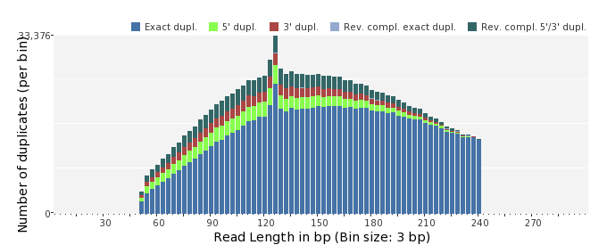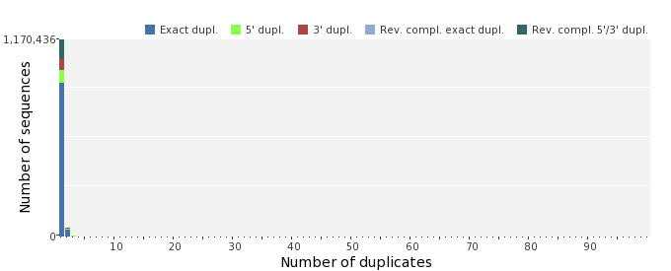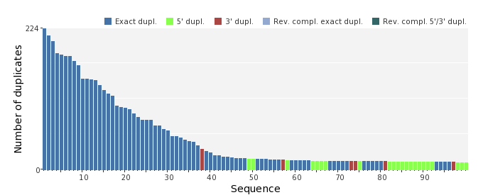

Sequence Complexity
 | Value | Sequence
Minimum DUST score: | 0 | TTCTTCTCGACATGTTCCGCCAAAGCAATAGGCACAACTTTGGGATATCCAGCCGGAGTA  AAGCCT
Maximum DUST score: | 89 | CAATCAGGTCTTGTTTTTTTTTTTTTTTTTTTTTTTTTTTTTTTTTTTTTTTTTTTTTTT  TTTTTTTTTTTTTTTTTTTTTTTTTTTTTTTTTTTTTTTTTTTTTTTTTTTTTTTTTTTT  TTTTTTTTTTTTT
Minimum Entropy value: | 5 | TTTTGTTTTTTTGTTTTTTTTGTTTTTTTTTTTTTTTTTTTTTTTTTTTTTTTTTTTTTT  TTTTTTTTTTTTTTTTTTTTTTTTTTTTTTTTTTTTTTTTTTTTTTTTTTTTTTTTTTTT  TTG
Maximum Entropy value: | 98 | TCCCTTTGGCAGGGGACGCGTAGAGTTCACCAAGATGAACTGCTCGGTCT
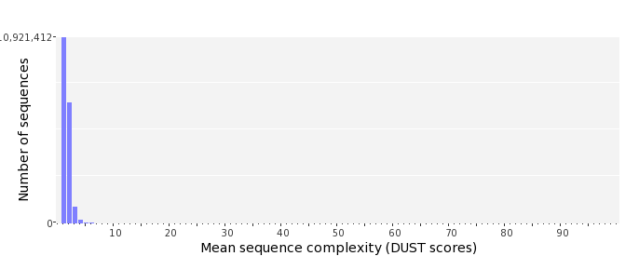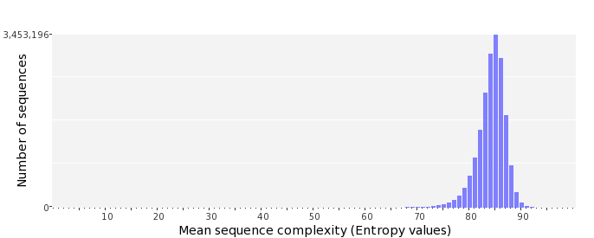

Dinucleotide Odds Ratios
 | AA/TT | AC/GT | AG/CT | AT | CA/TG | CC/GG | CG | GA/TC | GC | TA
Odds ratio | 1.1754 | 0.8447 | 0.9124 | 1.1014 | 1.0826 | 0.9967 | 1.0073 | 1.0584 | 1.1201 | 0.6365
