C4
Input Information
Input file(s): | C_4.assembled.fastq
Input format(s): | FASTQ
# Sequences: | 18,128,296
Total bases: | 2,610,778,442

Length Distribution
Mean sequence length: | 144.02 ± 48.72 bp
Minimum length: | 50 bp
Maximum length: | 240 bp
Length range: | 191 bp
Mode length: | 125 bp with 142,661 sequences
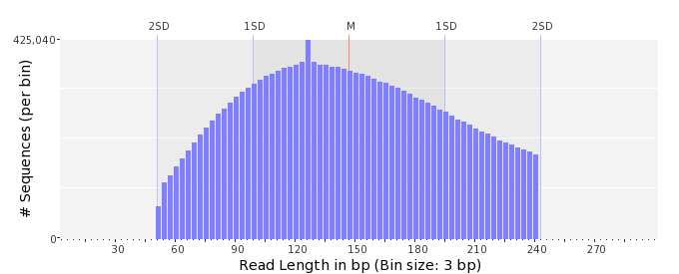

GC Content Distribution
Mean GC content: | 50.42 ± 12.37 %
Minimum GC content: | 0 %
Maximum GC content: | 100 %
GC content range: | 101 %
Mode GC content: | 50 % with 663,717 sequences
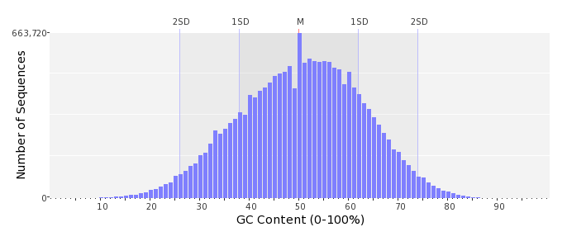

Base Quality Distribution
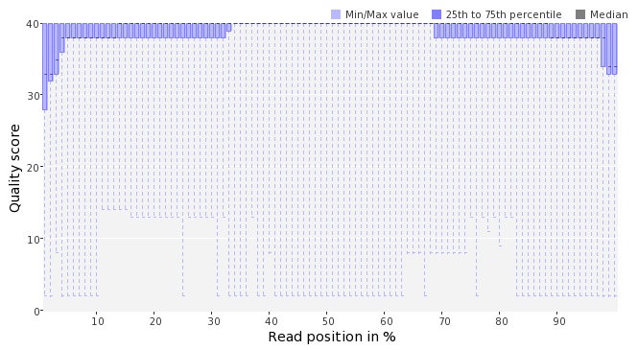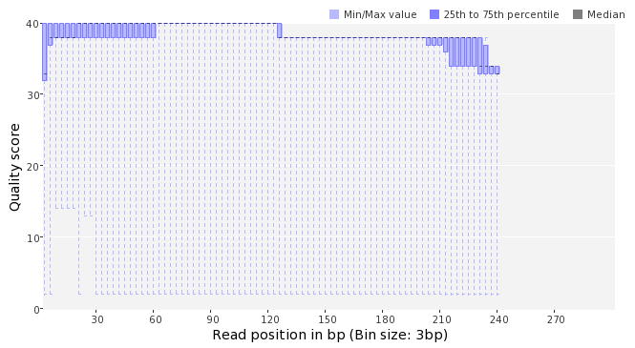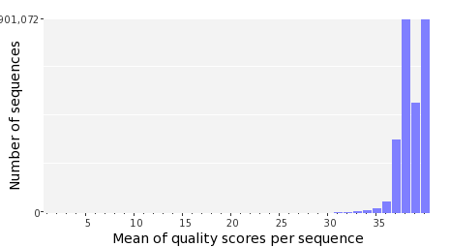

Occurence of N
Sequences with N: | 284,304 (1.57 %)
Max percentage of Ns per sequence: | 10 %
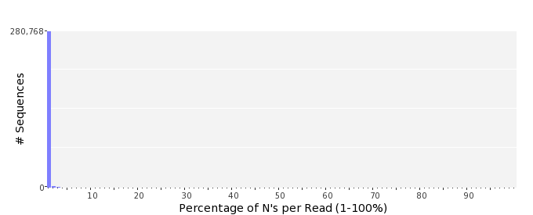

Poly-A/T Tails
 | 5'-end | 3'-end
Sequences with tail: | 70,760 (0.39 %) | 73,200 (0.40 %)
Maximum tail length: | 78 | 118
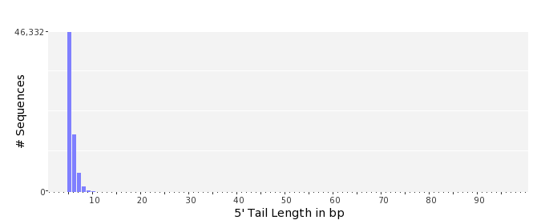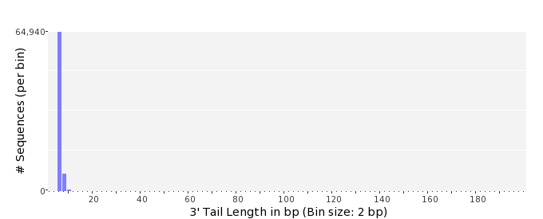

Tag Sequence Check
 | 5'-end | 3'-end
Probability of tag sequence: | 0 % | 0 %
GSMIDs or RLMIDs: | none

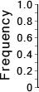 |  |  |  |  |  |  |  |  |  |  |  |  |  |  |  |  |  |  |  |  | ...
 | 1 |  |  |  | 5 |  |  |  |  | 10 |  |  |  |  | 15 |  |  |  |  | 20 |  | 20 |  |  |  |  | 15 |  |  |  |  | 10 |  |  |  |  | 5 |  |  |  | 1
 | Position from Sequence Ends

Sequence Duplication
 | # Sequences | Max duplicates
Exact duplicates: | 337,460 (1.86 %) | 2570
Exact duplicates with reverse complements: | 881 (0.00 %) | 2
5' duplicates | 140,184 (0.77 %) | 16
3' duplicates | 103,276 (0.57 %) | 10
5'/3' duplicates with reverse complements | 170,130 (0.94 %) | 4
Total: | 751,931 (4.15 %) | -
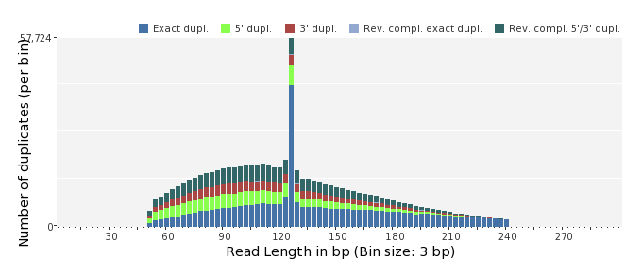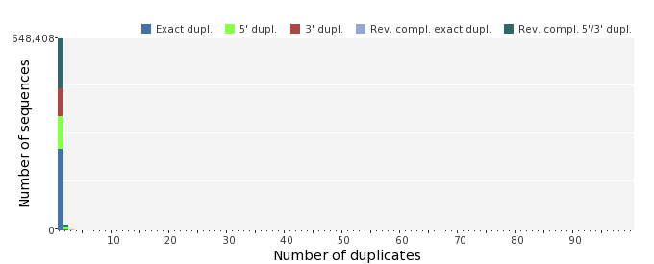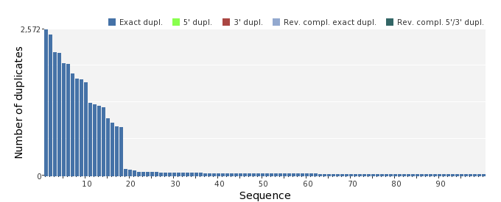

Sequence Complexity
 | Value | Sequence
Minimum DUST score: | 0 | TCGTCCTCTCCCAACAGGGCTGTGCCCGCATCGCAGTTGGTGTTCTACGGAG
Maximum DUST score: | 100 | TTTTTTTTTTTTTTTTTTTTTTTTTTTTTTTTTTTTTTTTTTTTTTTTTTTTTTTTTT
Minimum Entropy value: | 0 | TTTTTTTTTTTTTTTTTTTTTTTTTTTTTTTTTTTTTTTTTTTTTTTTTTTTTTTTTT
Maximum Entropy value: | 97 | GCTTCTCGCAAGCCTTAACACTGTGCCATCAGGAGATAGTAAATTTGGGTTA
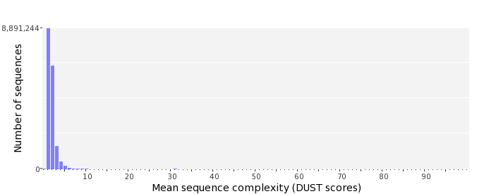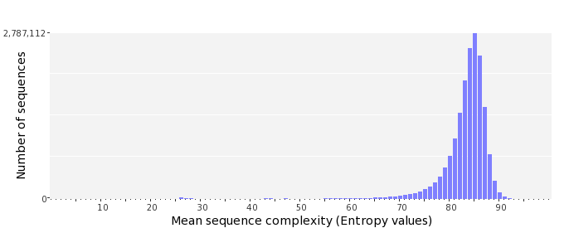

Dinucleotide Odds Ratios
 | AA/TT | AC/GT | AG/CT | AT | CA/TG | CC/GG | CG | GA/TC | GC | TA
Odds ratio | 1.1589 | 0.8657 | 0.9562 | 1.0433 | 1.0805 | 0.9891 | 0.9694 | 1.0533 | 1.1109 | 0.6662
