I1
Input Information
Input file(s): | I_1.assembled.fastq
Input format(s): | FASTQ
# Sequences: | 16,025,902
Total bases: | 2,455,584,792

Length Distribution
Mean sequence length: | 153.23 ± 49.06 bp
Minimum length: | 50 bp
Maximum length: | 240 bp
Length range: | 191 bp
Mode length: | 154 bp with 105,487 sequences
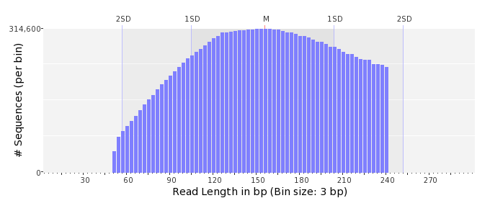

GC Content Distribution
Mean GC content: | 47.08 ± 12.35 %
Minimum GC content: | 0 %
Maximum GC content: | 98 %
GC content range: | 99 %
Mode GC content: | 50 % with 530,723 sequences
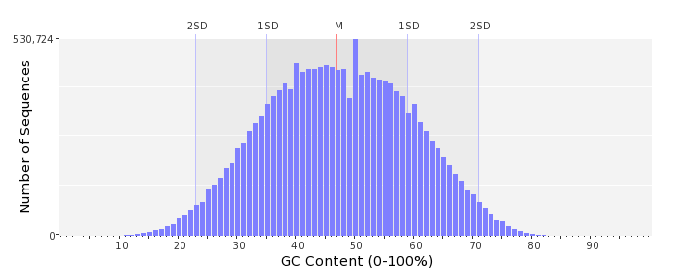

Base Quality Distribution
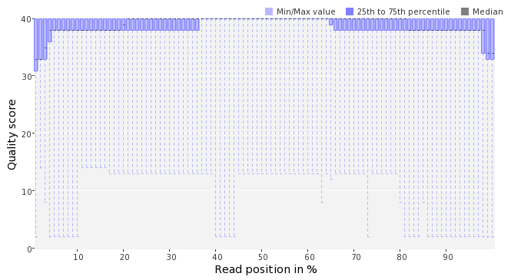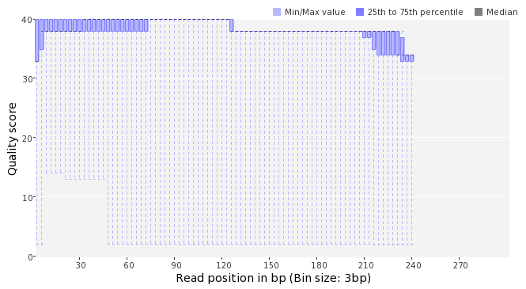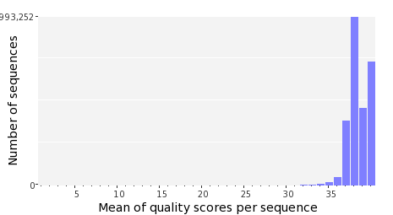

Occurence of N
Sequences with N: | 110,673 (0.69 %)
Max percentage of Ns per sequence: | 6 %
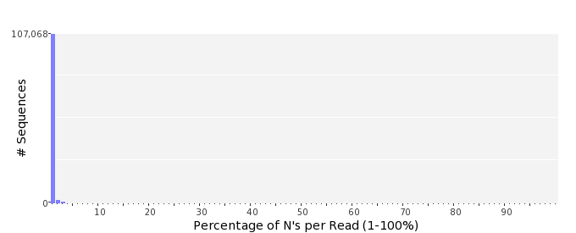

Poly-A/T Tails
 | 5'-end | 3'-end
Sequences with tail: | 80,801 (0.50 %) | 80,480 (0.50 %)
Maximum tail length: | 125 | 125
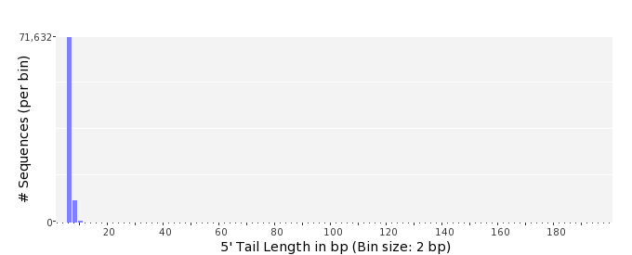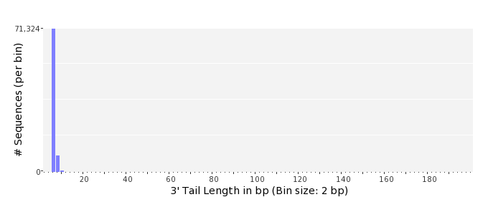

Tag Sequence Check
 | 5'-end | 3'-end
Probability of tag sequence: | 0 % | 0 %
GSMIDs or RLMIDs: | none

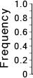 |  |  |  |  |  |  |  |  |  |  |  |  |  |  |  |  |  |  |  |  | ...
 | 1 |  |  |  | 5 |  |  |  |  | 10 |  |  |  |  | 15 |  |  |  |  | 20 |  | 20 |  |  |  |  | 15 |  |  |  |  | 10 |  |  |  |  | 5 |  |  |  | 1
 | Position from Sequence Ends

Sequence Duplication
 | # Sequences | Max duplicates
Exact duplicates: | 425,375 (2.65 %) | 56
Exact duplicates with reverse complements: | 661 (0.00 %) | 1
5' duplicates | 145,625 (0.91 %) | 19
3' duplicates | 91,986 (0.57 %) | 11
5'/3' duplicates with reverse complements | 136,397 (0.85 %) | 4
Total: | 800,044 (4.99 %) | -
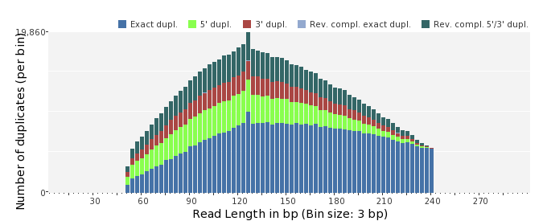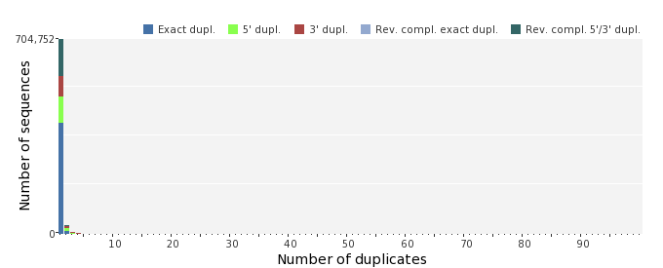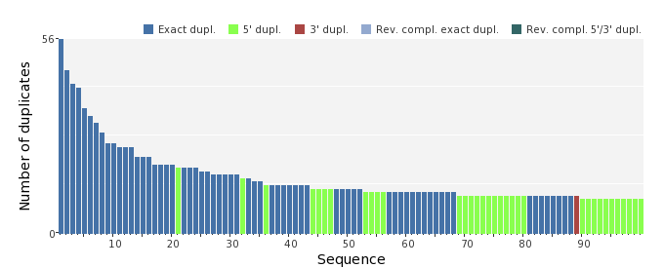

Sequence Complexity
 | Value | Sequence
Minimum DUST score: | 0 | ATACATCGGGTATCCATAATACCCGTAGTAGCTTTCCTCAAACTGTTGCGAGACGGGCTT  ATCACTGCCCA
Maximum DUST score: | 100 | TTTTTTTTTTTTTTTTTTTTTTTTTTTTTTTTTTTTTTTTTTTTTTTTTTTTTT
Minimum Entropy value: | 0 | TTTTTTTTTTTTTTTTTTTTTTTTTTTTTTTTTTTTTTTTTTTTTTTTTTTTTT
Maximum Entropy value: | 96 | ATCCGCCTGTAGCTGAACGAGACCATGGCGACTTCAGAATTACCTAACACGTTGCTGGTC  TCGGCCGGG
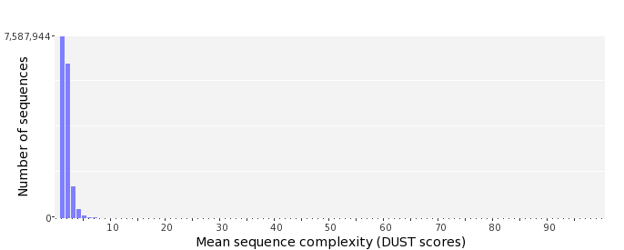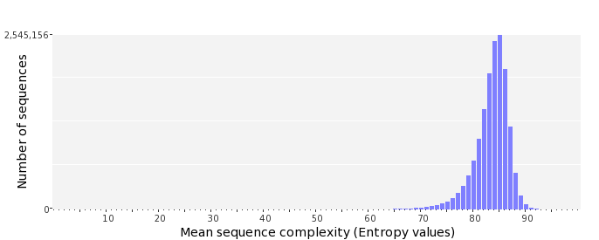

Dinucleotide Odds Ratios
 | AA/TT | AC/GT | AG/CT | AT | CA/TG | CC/GG | CG | GA/TC | GC | TA
Odds ratio | 1.1787 | 0.8590 | 0.9154 | 1.0429 | 1.0990 | 1.0199 | 0.9583 | 1.0440 | 1.1136 | 0.6546
