I2
Input Information
Input file(s): | I_2.assembled.fastq
Input format(s): | FASTQ
# Sequences: | 17,625,331
Total bases: | 2,581,064,017

Length Distribution
Mean sequence length: | 146.44 ± 48.99 bp
Minimum length: | 50 bp
Maximum length: | 240 bp
Length range: | 191 bp
Mode length: | 124 bp with 125,358 sequences
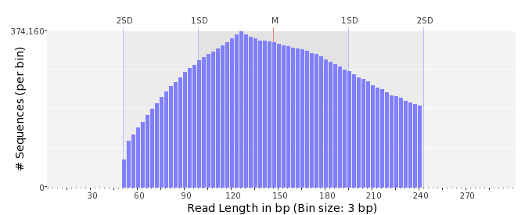

GC Content Distribution
Mean GC content: | 52.59 ± 13.01 %
Minimum GC content: | 0 %
Maximum GC content: | 96 %
GC content range: | 97 %
Mode GC content: | 50 % with 541,472 sequences
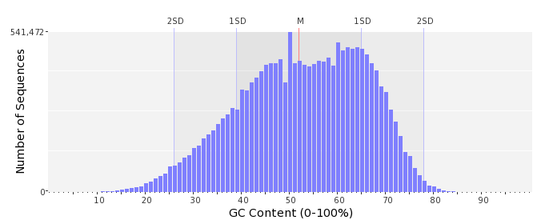

Base Quality Distribution
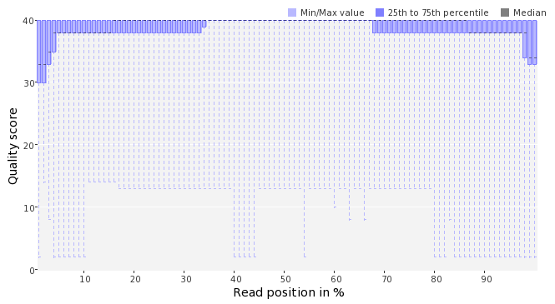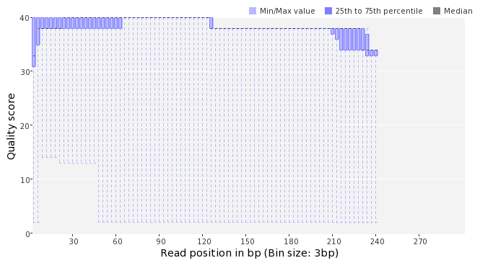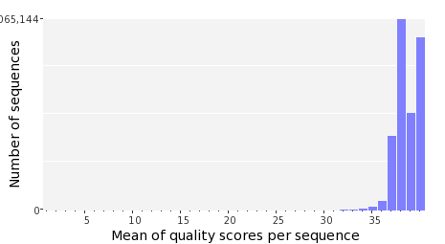

Occurence of N
Sequences with N: | 113,586 (0.64 %)
Max percentage of Ns per sequence: | 8 %
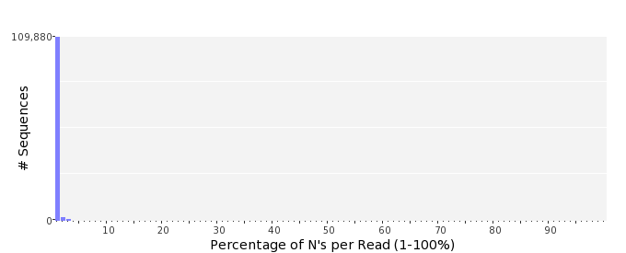

Poly-A/T Tails
 | 5'-end | 3'-end
Sequences with tail: | 71,609 (0.41 %) | 73,253 (0.42 %)
Maximum tail length: | 125 | 125
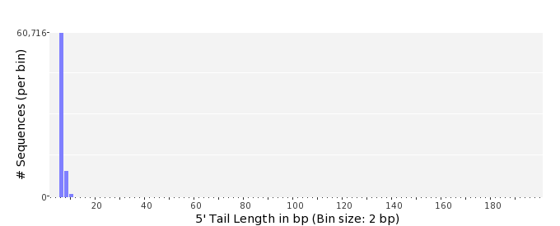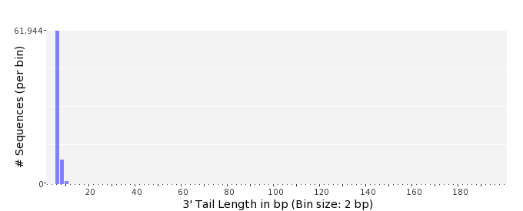

Tag Sequence Check
 | 5'-end | 3'-end
Probability of tag sequence: | 0 % | 0 %
GSMIDs or RLMIDs: | none

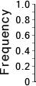 |  |  |  |  |  |  |  |  |  |  |  |  |  |  |  |  |  |  |  |  | ...
 | 1 |  |  |  | 5 |  |  |  |  | 10 |  |  |  |  | 15 |  |  |  |  | 20 |  | 20 |  |  |  |  | 15 |  |  |  |  | 10 |  |  |  |  | 5 |  |  |  | 1
 | Position from Sequence Ends

Sequence Duplication
 | # Sequences | Max duplicates
Exact duplicates: | 468,117 (2.66 %) | 160
Exact duplicates with reverse complements: | 3,678 (0.02 %) | 2
5' duplicates | 1,164,998 (6.61 %) | 28
3' duplicates | 613,376 (3.48 %) | 10
5'/3' duplicates with reverse complements | 785,045 (4.45 %) | 5
Total: | 3,035,214 (17.22 %) | -
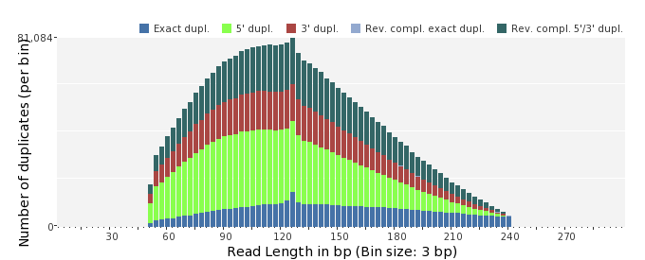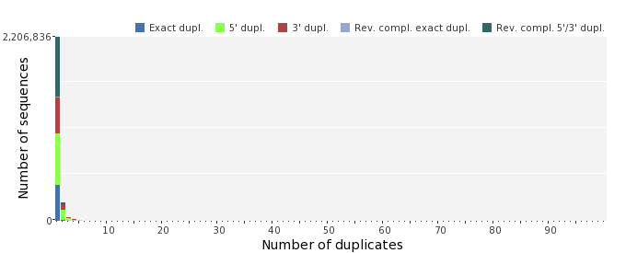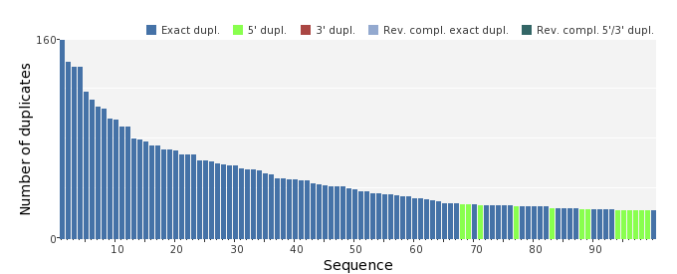

Sequence Complexity
 | Value | Sequence
Minimum DUST score: | 0 | CGCGCGTGTTAGCGCGGTAATCTTTGCAAAACGCTATCGATACTTTTATTGAAGCCCTGG  CCACCGCAACCGATGTCTGGGAAGGTGCCATCGCGCAGTTG
Maximum DUST score: | 98 | TTTTTTTTTTTTTTTTTTTTTTTTTTTTTTTTTTTTTTTTTTTTTTTTTTTTTTTTTTTT  TTTTTTTTTTTTTTTTTTTTTTTTTTTTTTTTTTTTTTTTTTTTTTTTTTTTTTTTTTTT  TTTTT
Minimum Entropy value: | 0 | TTTTTTTTTTTTTTTTTTTTTTTTTTTTTTTTTTTTTTTTTTTTTTTTTTTTTTTTTTTT  TTTTTTTTTTTTTTTTTTTTTTTTTTTTTTTTTTTTTTTTTTTTTTTTTTTTTTTTTTTT  TTTTT
Maximum Entropy value: | 96 | ACCTGTCCATCTCTATTCACAAGTATGGATTGAATACCGCCTTTAAACGGCGTTT
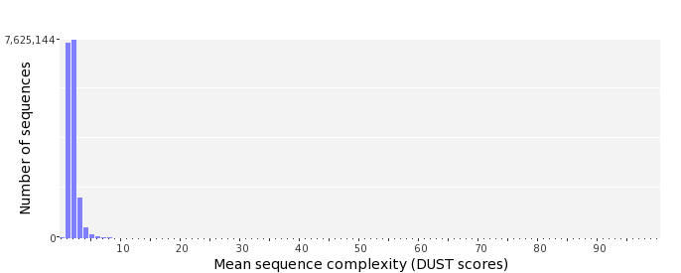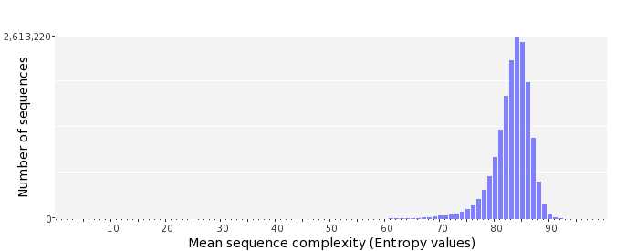

Dinucleotide Odds Ratios
 | AA/TT | AC/GT | AG/CT | AT | CA/TG | CC/GG | CG | GA/TC | GC | TA
Odds ratio | 1.1394 | 0.8813 | 0.9358 | 1.0915 | 1.1568 | 1.0068 | 0.9001 | 1.0531 | 1.0752 | 0.5818
