C5
Input Information
Input file(s): | C_5.assembled.fastq
Input format(s): | FASTQ
# Sequences: | 16,574,453
Total bases: | 2,436,531,445

Length Distribution
Mean sequence length: | 147.01 ± 49.52 bp
Minimum length: | 50 bp
Maximum length: | 240 bp
Length range: | 191 bp
Mode length: | 125 bp with 110,842 sequences
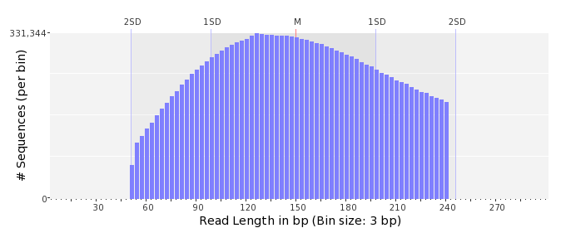

GC Content Distribution
Mean GC content: | 49.38 ± 12.30 %
Minimum GC content: | 0 %
Maximum GC content: | 100 %
GC content range: | 101 %
Mode GC content: | 50 % with 555,208 sequences
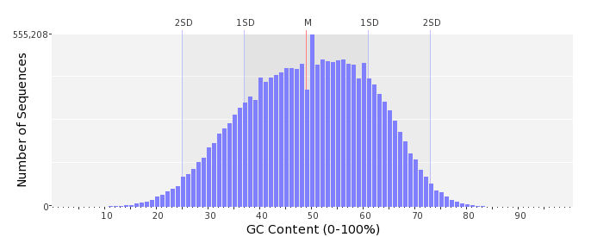

Base Quality Distribution
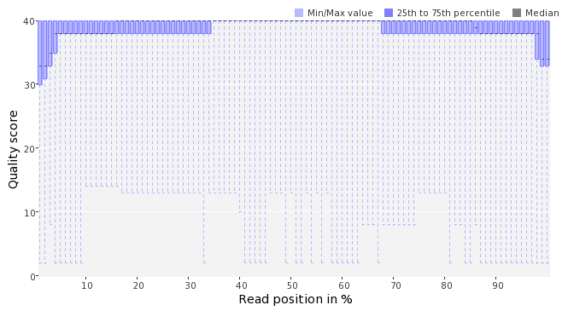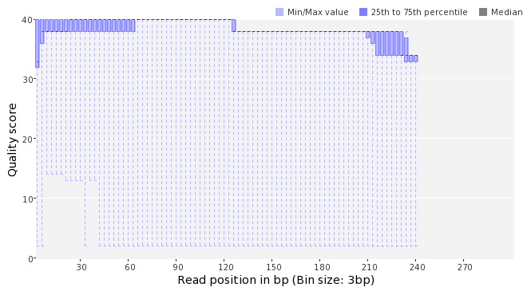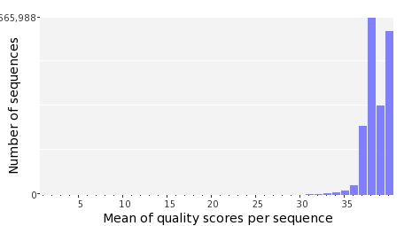

Occurence of N
Sequences with N: | 265,042 (1.60 %)
Max percentage of Ns per sequence: | 6 %
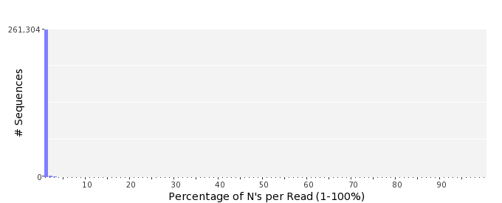

Poly-A/T Tails
 | 5'-end | 3'-end
Sequences with tail: | 59,642 (0.36 %) | 60,981 (0.37 %)
Maximum tail length: | 125 | 125
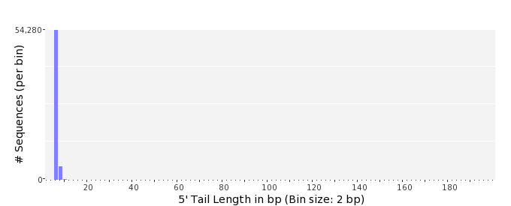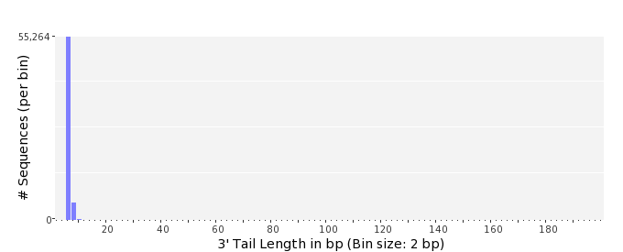

Tag Sequence Check
 | 5'-end | 3'-end
Probability of tag sequence: | 0 % | 0 %
GSMIDs or RLMIDs: | none

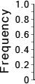 |  |  |  |  |  |  |  |  |  |  |  |  |  |  |  |  |  |  |  |  | ...
 | 1 |  |  |  | 5 |  |  |  |  | 10 |  |  |  |  | 15 |  |  |  |  | 20 |  | 20 |  |  |  |  | 15 |  |  |  |  | 10 |  |  |  |  | 5 |  |  |  | 1
 | Position from Sequence Ends

Sequence Duplication
 | # Sequences | Max duplicates
Exact duplicates: | 745,918 (4.50 %) | 44
Exact duplicates with reverse complements: | 318 (0.00 %) | 1
5' duplicates | 57,474 (0.35 %) | 14
3' duplicates | 47,894 (0.29 %) | 21
5'/3' duplicates with reverse complements | 81,416 (0.49 %) | 3
Total: | 933,020 (5.63 %) | -
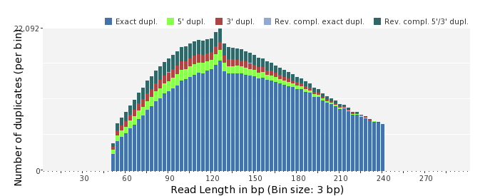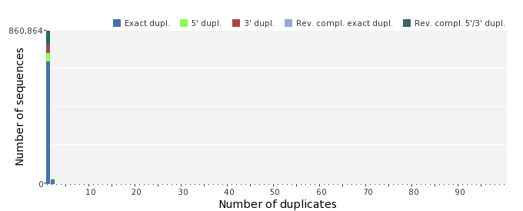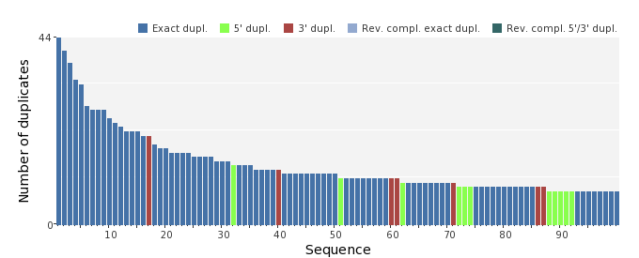

Sequence Complexity
 | Value | Sequence
Minimum DUST score: | 0 | TTTGTTGAGCCATGCGAAGGCAATCATCCCGTCACTGCTCCTTGTCTACAAATTCAACTA  TAGTTGATGAGAAAGCAGTTAAGCTATGGCCCCATTCACTGCACCA
Maximum DUST score: | 98 | TTTTTTTTTTTTTTTTTTTTTTTTTTTTTTTTTTTTTTTTTTTTTTTTTTTTTTTTTTTT  TTTTTTTTTTTTTTTTTTTTTTTTTTTTTTTTTTTTTTTTTTTTTTTTTTTTTTTTTTTT  TTTTT
Minimum Entropy value: | 0 | TTTTTTTTTTTTTTTTTTTTTTTTTTTTTTTTTTTTTTTTTTTTTTTTTTTTTTTTTTTT  TTTTTTTTTTTTTTTTTTTTTTTTTTTTTTTTTTTTTTTTTTTTTTTTTTTTTTTTTTTT  TTTTT
Maximum Entropy value: | 99 | GATGCAGACCTACTTCTGAATATCGCCAAGTCATTTAACGAGGTTGCGGA
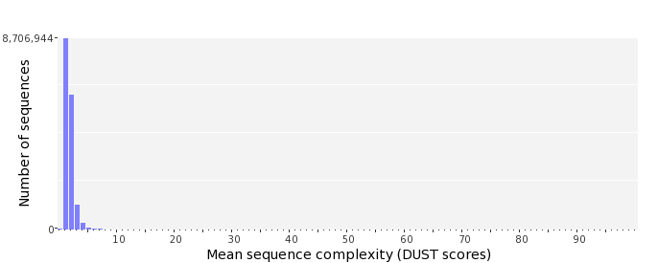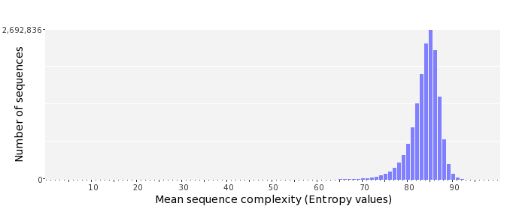

Dinucleotide Odds Ratios
 | AA/TT | AC/GT | AG/CT | AT | CA/TG | CC/GG | CG | GA/TC | GC | TA
Odds ratio | 1.1346 | 0.8808 | 0.9336 | 1.0706 | 1.0893 | 0.9898 | 0.9748 | 1.0590 | 1.0990 | 0.6802
