D4
Input Information
Input file(s): | D_4.assembled.fastq
Input format(s): | FASTQ
# Sequences: | 17,767,092
Total bases: | 2,611,840,076

Length Distribution
Mean sequence length: | 147.00 ± 49.24 bp
Minimum length: | 50 bp
Maximum length: | 240 bp
Length range: | 191 bp
Mode length: | 134 bp with 119,018 sequences
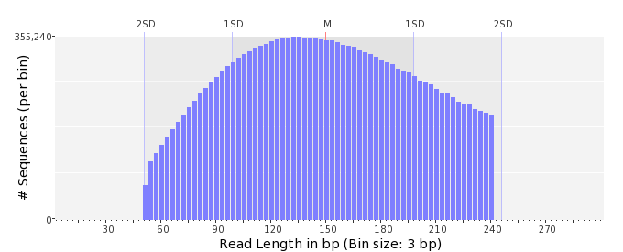

GC Content Distribution
Mean GC content: | 49.32 ± 10.36 %
Minimum GC content: | 0 %
Maximum GC content: | 96 %
GC content range: | 97 %
Mode GC content: | 50 % with 844,731 sequences
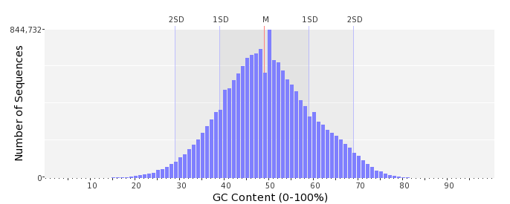

Base Quality Distribution
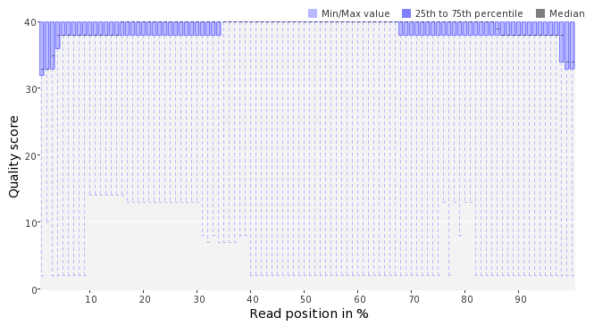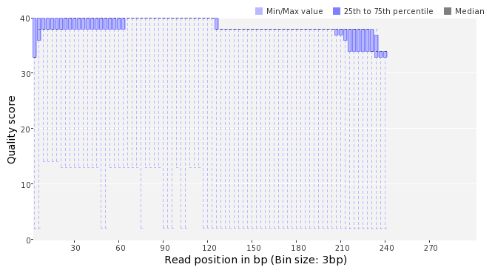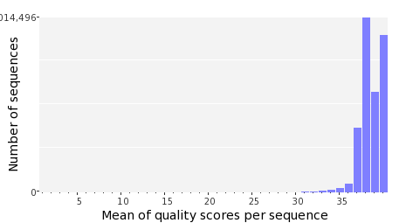

Occurence of N
Sequences with N: | 89,449 (0.50 %)
Max percentage of Ns per sequence: | 4 %
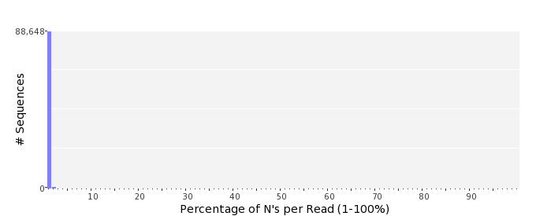

Poly-A/T Tails
 | 5'-end | 3'-end
Sequences with tail: | 71,687 (0.40 %) | 74,769 (0.42 %)
Maximum tail length: | 48 | 97
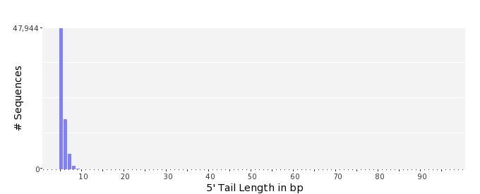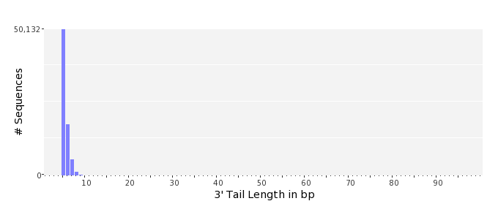

Tag Sequence Check
 | 5'-end | 3'-end
Probability of tag sequence: | 0 % | 0 %
GSMIDs or RLMIDs: | none

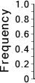 |  |  |  |  |  |  |  |  |  |  |  |  |  |  |  |  |  |  |  |  | ...
 | 1 |  |  |  | 5 |  |  |  |  | 10 |  |  |  |  | 15 |  |  |  |  | 20 |  | 20 |  |  |  |  | 15 |  |  |  |  | 10 |  |  |  |  | 5 |  |  |  | 1
 | Position from Sequence Ends

Sequence Duplication
 | # Sequences | Max duplicates
Exact duplicates: | 464,339 (2.61 %) | 13
Exact duplicates with reverse complements: | 2,180 (0.01 %) | 1
5' duplicates | 687,659 (3.87 %) | 20
3' duplicates | 363,590 (2.05 %) | 41
5'/3' duplicates with reverse complements | 401,851 (2.26 %) | 6
Total: | 1,919,619 (10.80 %) | -
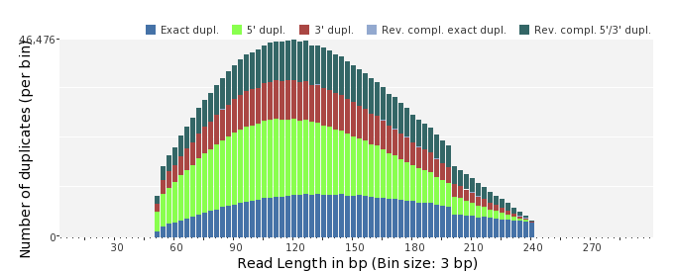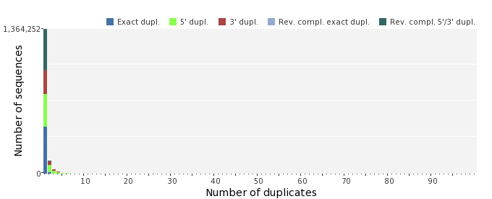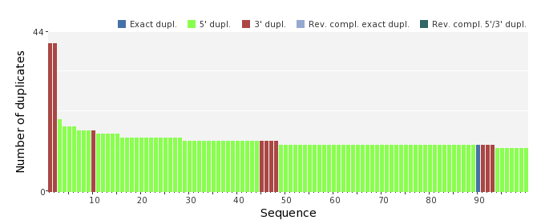

Sequence Complexity
 | Value | Sequence
Minimum DUST score: | 0 | GACCCTCACTGGACAGTTTGAGAACTTTATCGGCAGTAGCTTCAACGACGTAATTTATGT  GCA
Maximum DUST score: | 96 | CGTTTTTTTTTTTTTTTTTTTTTTTTTTTTTTTTTTTTTTTTTTTTTTTTTTTTTTTTTT  TTTTTTTTTTTTTTTTTTTTTTTTTTTTTTTTTTTTTTT
Minimum Entropy value: | 1 | CGTTTTTTTTTTTTTTTTTTTTTTTTTTTTTTTTTTTTTTTTTTTTTTTTTTTTTTTTTT  TTTTTTTTTTTTTTTTTTTTTTTTTTTTTTTTTTTTTTT
Maximum Entropy value: | 97 | CCTCGCTCTGACGTCAATTGGTGAGCACATCGATATGCCCGGAAACCAGA
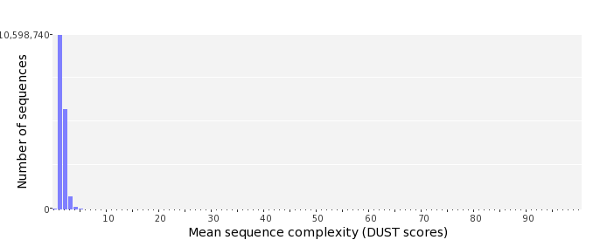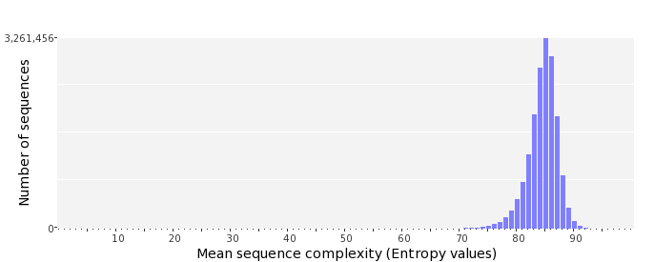

Dinucleotide Odds Ratios
 | AA/TT | AC/GT | AG/CT | AT | CA/TG | CC/GG | CG | GA/TC | GC | TA
Odds ratio | 1.1858 | 0.8092 | 0.9262 | 1.0948 | 1.0454 | 1.0151 | 1.0114 | 1.0700 | 1.1333 | 0.6702
