E1
Input Information
Input file(s): | E_1.assembled.fastq
Input format(s): | FASTQ
# Sequences: | 12,912,260
Total bases: | 1,965,369,629

Length Distribution
Mean sequence length: | 152.21 ± 49.56 bp
Minimum length: | 50 bp
Maximum length: | 240 bp
Length range: | 191 bp
Mode length: | 146 bp with 83,350 sequences
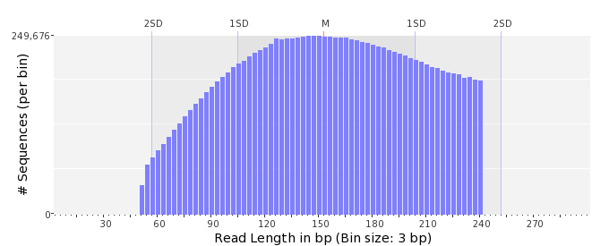

GC Content Distribution
Mean GC content: | 49.32 ± 11.80 %
Minimum GC content: | 0 %
Maximum GC content: | 100 %
GC content range: | 101 %
Mode GC content: | 50 % with 482,066 sequences
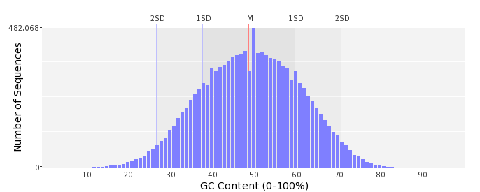

Base Quality Distribution
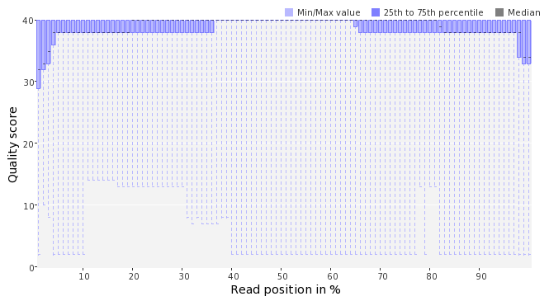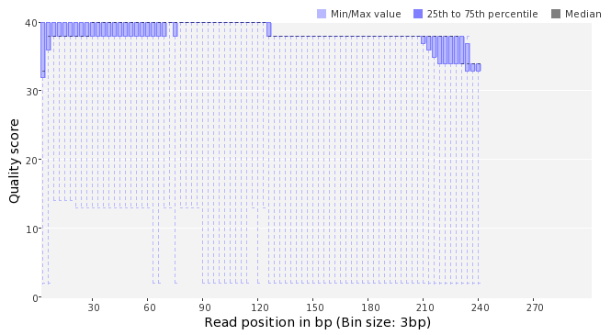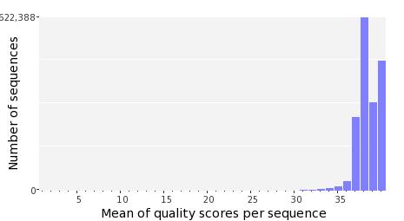

Occurence of N
Sequences with N: | 76,581 (0.59 %)
Max percentage of Ns per sequence: | 4 %
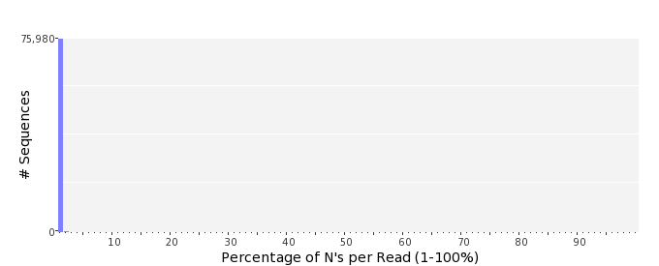

Poly-A/T Tails
 | 5'-end | 3'-end
Sequences with tail: | 44,730 (0.35 %) | 46,120 (0.36 %)
Maximum tail length: | 74 | 125
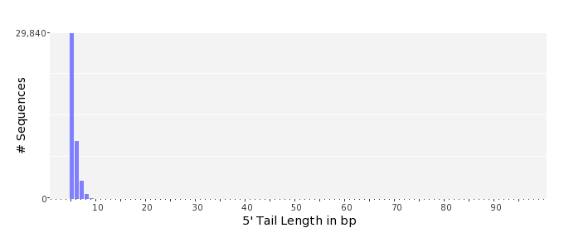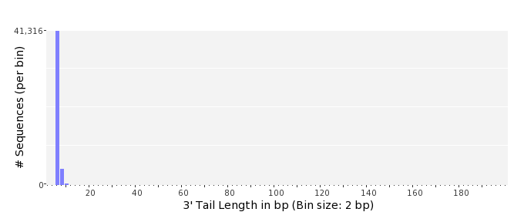

Tag Sequence Check
 | 5'-end | 3'-end
Probability of tag sequence: | 0 % | 0 %
GSMIDs or RLMIDs: | none

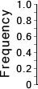 |  |  |  |  |  |  |  |  |  |  |  |  |  |  |  |  |  |  |  |  | ...
 | 1 |  |  |  | 5 |  |  |  |  | 10 |  |  |  |  | 15 |  |  |  |  | 20 |  | 20 |  |  |  |  | 15 |  |  |  |  | 10 |  |  |  |  | 5 |  |  |  | 1
 | Position from Sequence Ends

Sequence Duplication
 | # Sequences | Max duplicates
Exact duplicates: | 232,234 (1.80 %) | 27
Exact duplicates with reverse complements: | 626 (0.00 %) | 1
5' duplicates | 94,183 (0.73 %) | 16
3' duplicates | 85,153 (0.66 %) | 24
5'/3' duplicates with reverse complements | 145,025 (1.12 %) | 4
Total: | 557,221 (4.32 %) | -
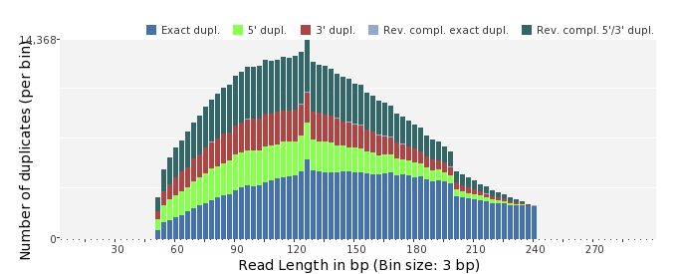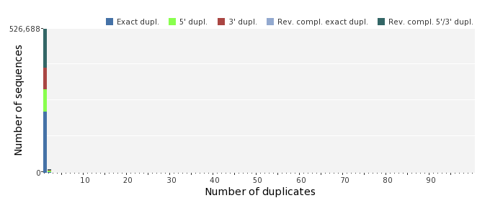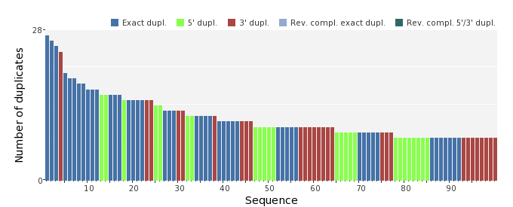

Sequence Complexity
 | Value | Sequence
Minimum DUST score: | 0 | GATTCGCCGAGTGCAGGCATGCTTACTGAAAAGGTCATCGCGATTTCTCCTATTACCCGT  GGGC
Maximum DUST score: | 100 | TTTTTTTTTTTTTTTTTTTTTTTTTTTTTTTTTTTTTTTTTTTTTTTTTT
Minimum Entropy value: | 0 | TTTTTTTTTTTTTTTTTTTTTTTTTTTTTTTTTTTTTTTTTTTTTTTTTTTTTTTTTTTT  TTTTTTTTTTTTT
Maximum Entropy value: | 97 | GTGATTTCTCCTTGGGGTAATATGTACAAGCCAGGAGACGAACTGGCATGC
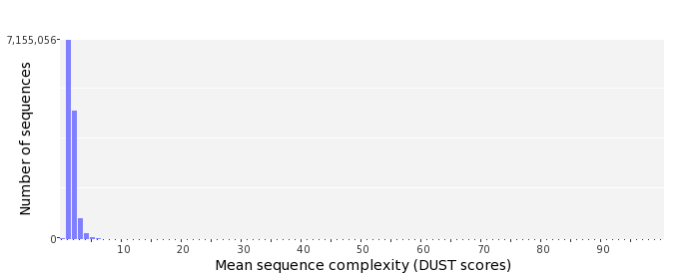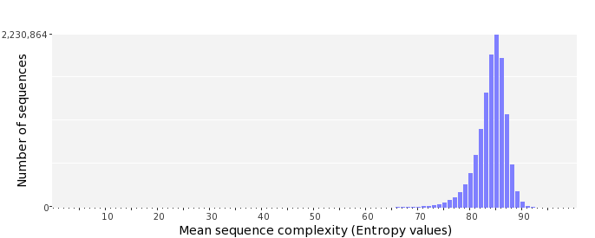

Dinucleotide Odds Ratios
 | AA/TT | AC/GT | AG/CT | AT | CA/TG | CC/GG | CG | GA/TC | GC | TA
Odds ratio | 1.1348 | 0.8990 | 0.9510 | 1.0390 | 1.1286 | 0.9513 | 0.9457 | 1.0475 | 1.1330 | 0.6453
