E2
Input Information
Input file(s): | E_2.assembled.fastq
Input format(s): | FASTQ
# Sequences: | 16,798,779
Total bases: | 2,554,265,747

Length Distribution
Mean sequence length: | 152.05 ± 49.48 bp
Minimum length: | 50 bp
Maximum length: | 240 bp
Length range: | 191 bp
Mode length: | 152 bp with 108,860 sequences
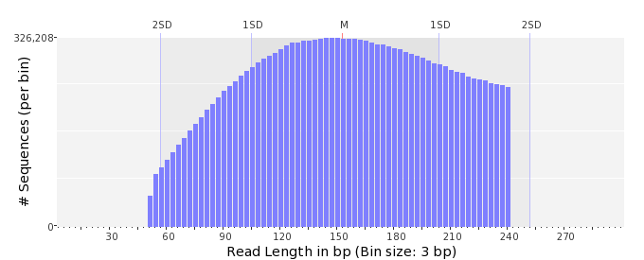

GC Content Distribution
Mean GC content: | 47.37 ± 11.64 %
Minimum GC content: | 0 %
Maximum GC content: | 96 %
GC content range: | 97 %
Mode GC content: | 50 % with 608,238 sequences
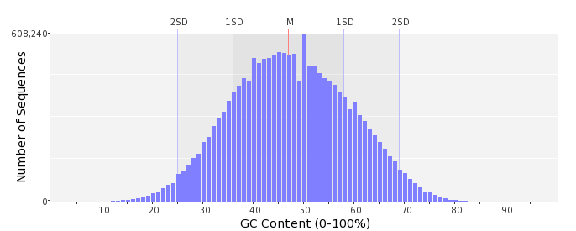

Base Quality Distribution
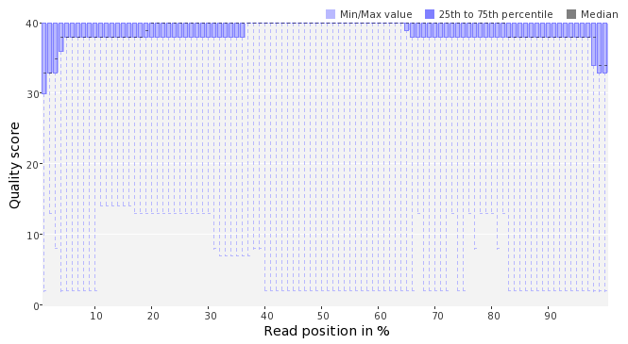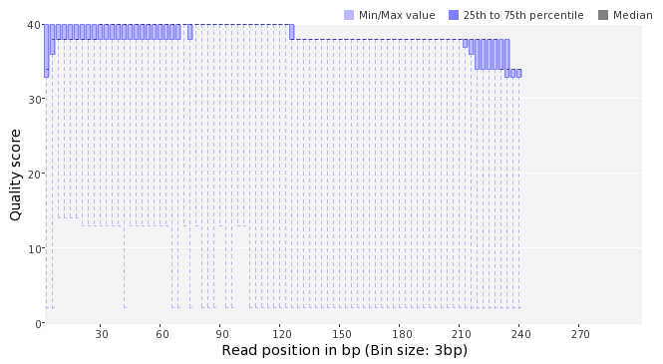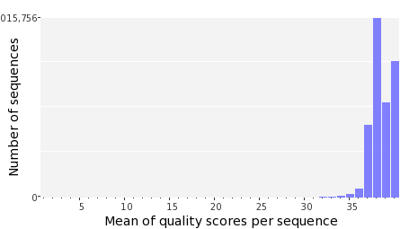

Occurence of N
Sequences with N: | 99,124 (0.59 %)
Max percentage of Ns per sequence: | 5 %
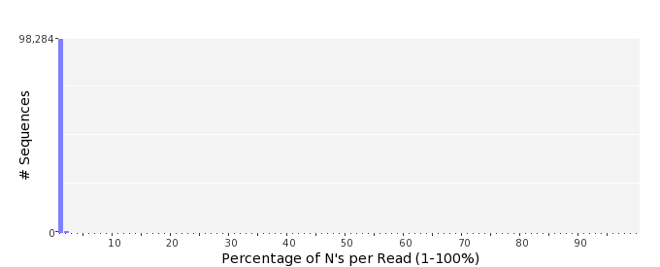

Poly-A/T Tails
 | 5'-end | 3'-end
Sequences with tail: | 68,653 (0.41 %) | 70,634 (0.42 %)
Maximum tail length: | 71 | 116
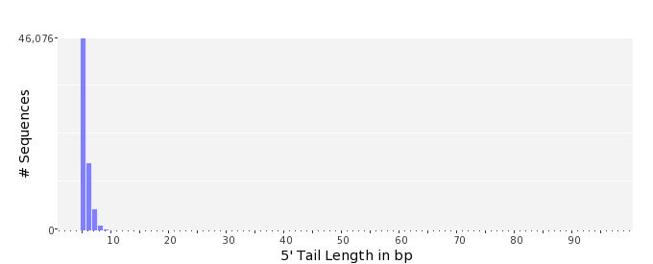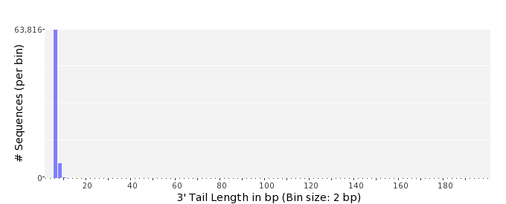

Tag Sequence Check
 | 5'-end | 3'-end
Probability of tag sequence: | 0 % | 0 %
GSMIDs or RLMIDs: | none

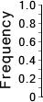 |  |  |  |  |  |  |  |  |  |  |  |  |  |  |  |  |  |  |  |  | ...
 | 1 |  |  |  | 5 |  |  |  |  | 10 |  |  |  |  | 15 |  |  |  |  | 20 |  | 20 |  |  |  |  | 15 |  |  |  |  | 10 |  |  |  |  | 5 |  |  |  | 1
 | Position from Sequence Ends

Sequence Duplication
 | # Sequences | Max duplicates
Exact duplicates: | 316,024 (1.88 %) | 30
Exact duplicates with reverse complements: | 694 (0.00 %) | 1
5' duplicates | 123,418 (0.73 %) | 25
3' duplicates | 103,003 (0.61 %) | 18
5'/3' duplicates with reverse complements | 173,186 (1.03 %) | 3
Total: | 716,325 (4.26 %) | -
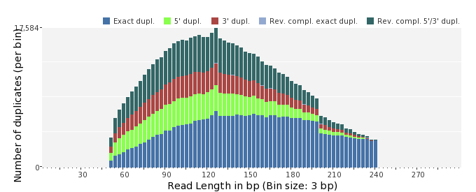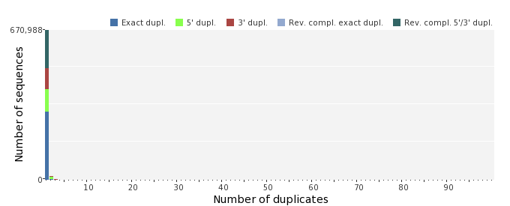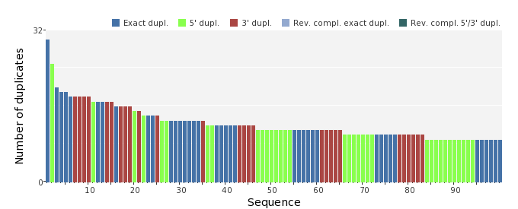

Sequence Complexity
 | Value | Sequence
Minimum DUST score: | 0 | GTCCATGCTTTACTACCTTGGAAATGAGATGTATTCGTTGCAGCTCACCGCATATAATCC  AA
Maximum DUST score: | 95 | TTTTTTTTTTTTTTTTTTTTTTTTCTTTTTTTTTTTTTTTTTTTTTTTTTTTTTTTTTTT  TTTTTTTTTTTTTTTTTTTTTTTTTTTTTTTTTTTTTTTTTTTTTTTTTTTTTTTTTTTT  TTTTT
Minimum Entropy value: | 1 | TTTTTTTTTTTTTTTTTTTTTTTTCTTTTTTTTTTTTTTTTTTTTTTTTTTTTTTTTTTT  TTTTTTTTTTTTTTTTTTTTTTTTTTTTTTTTTTTTTTTTTTTTTTTTTTTTTTTTTTTT  TTTTT
Maximum Entropy value: | 96 | CCACCTGAAACCCGTCGATACGGACATTGCTTTCATGTATCCTGGCAAGTTC
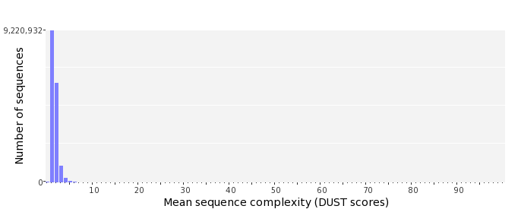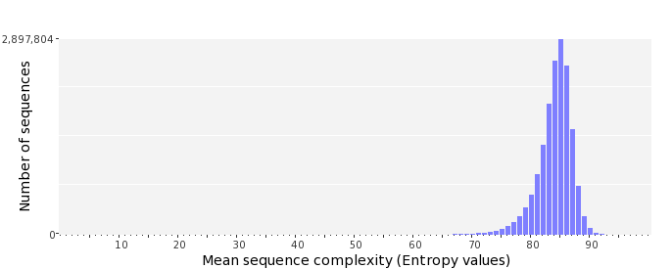

Dinucleotide Odds Ratios
 | AA/TT | AC/GT | AG/CT | AT | CA/TG | CC/GG | CG | GA/TC | GC | TA
Odds ratio | 1.1469 | 0.8786 | 0.9431 | 1.0405 | 1.1094 | 0.9903 | 0.9318 | 1.0328 | 1.1402 | 0.6847
