A2
Input Information
Input file(s): | A_2.assembled.fastq
Input format(s): | FASTQ
# Sequences: | 18,658,330
Total bases: | 2,812,094,754

Length Distribution
Mean sequence length: | 150.72 ± 49.72 bp
Minimum length: | 50 bp
Maximum length: | 240 bp
Length range: | 191 bp
Mode length: | 126 bp with 150,269 sequences
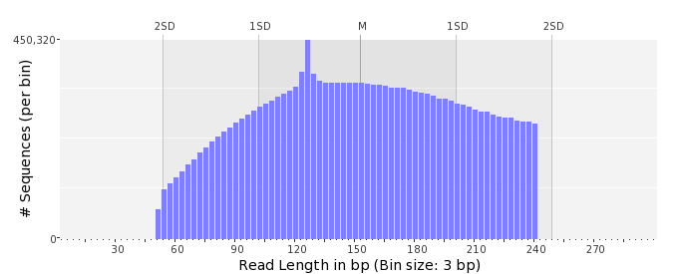

GC Content Distribution
Mean GC content: | 47.73 ± 11.77 %
Minimum GC content: | 0 %
Maximum GC content: | 98 %
GC content range: | 99 %
Mode GC content: | 50 % with 700,139 sequences
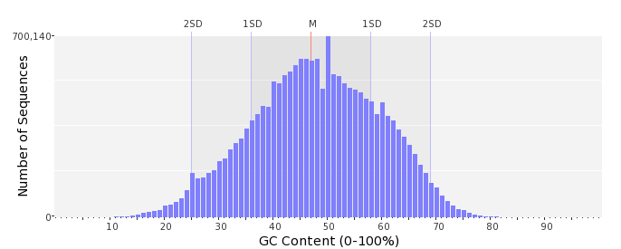

Base Quality Distribution
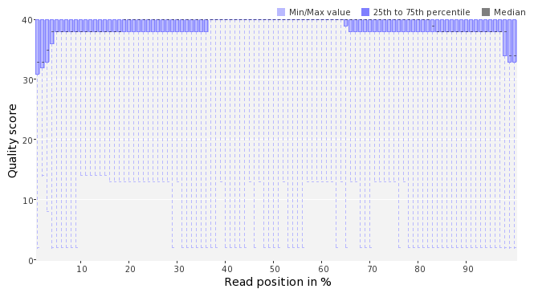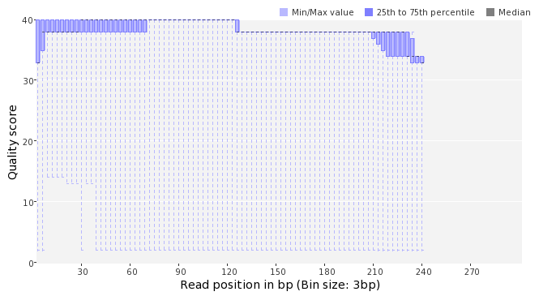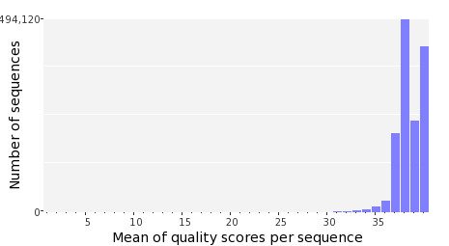

Occurence of N
Sequences with N: | 126,535 (0.68 %)
Max percentage of Ns per sequence: | 7 %
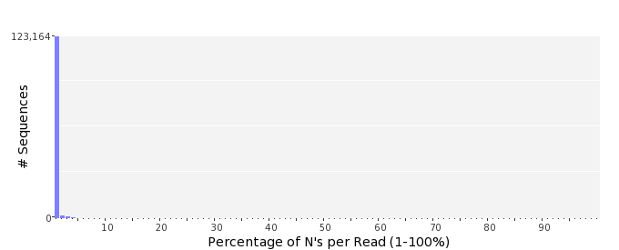

Poly-A/T Tails
 | 5'-end | 3'-end
Sequences with tail: | 101,771 (0.55 %) | 101,478 (0.54 %)
Maximum tail length: | 125 | 125
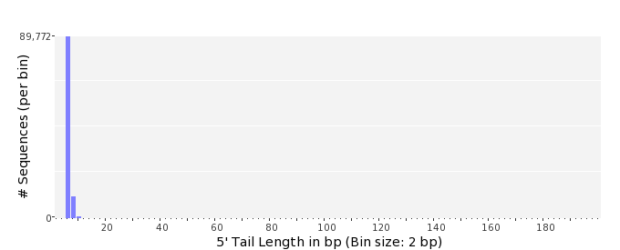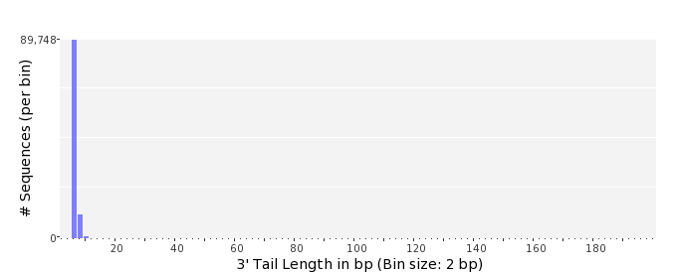

Tag Sequence Check
 | 5'-end | 3'-end
Probability of tag sequence: | 0 % | 0 %
GSMIDs or RLMIDs: | none

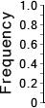 |  |  |  |  |  |  |  |  |  |  |  |  |  |  |  |  |  |  |  |  | ...
 | 1 |  |  |  | 5 |  |  |  |  | 10 |  |  |  |  | 15 |  |  |  |  | 20 |  | 20 |  |  |  |  | 15 |  |  |  |  | 10 |  |  |  |  | 5 |  |  |  | 1
 | Position from Sequence Ends

Sequence Duplication
 | # Sequences | Max duplicates
Exact duplicates: | 495,594 (2.66 %) | 1939
Exact duplicates with reverse complements: | 831 (0.00 %) | 2
5' duplicates | 115,695 (0.62 %) | 26
3' duplicates | 64,903 (0.35 %) | 33
5'/3' duplicates with reverse complements | 109,450 (0.59 %) | 3
Total: | 786,473 (4.22 %) | -
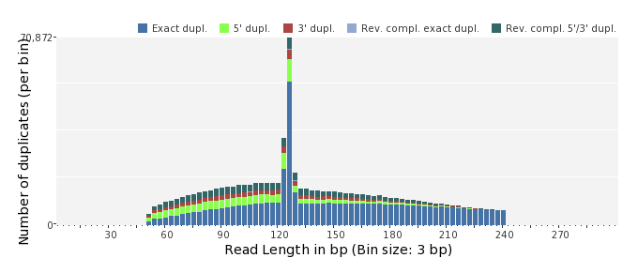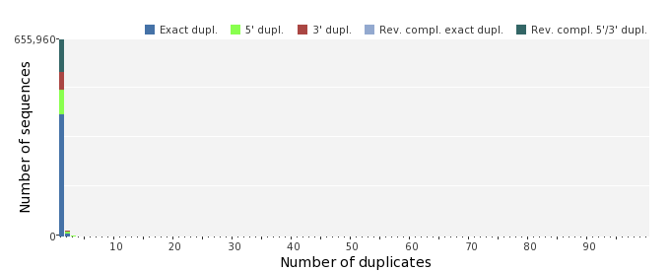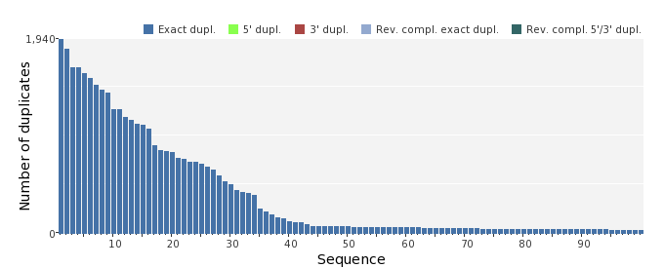

Sequence Complexity
 | Value | Sequence
Minimum DUST score: | 0 | TGGCTTACTACAACTCTTTCAGCTCCGTTGATAATGAAAGTAGCGTTCTCGGTCATGAGA  GGAACATCGCCG
Maximum DUST score: | 98 | TTTTTTTTTTTTTTTTTTTTTTTTTTTTTTTTTTTTTTTTTTTTTTTTTTTTTTTTTTTT  TTTTTTTTTTTTTTTTTTTTTTTTTTTTTTTTTTTTTTTTTTTTTTTTTTTTTTTTTTTT  TTTTT
Minimum Entropy value: | 0 | TTTTTTTTTTTTTTTTTTTTTTTTTTTTTTTTTTTTTTTTTTTTTTTTTTTTTTTTTTTT  TTTTTTTTTTTTTTTTTTTTTTTTTTTTTTTTTTTTTTTTTTTTTTTTTTTTTTTTTTTT  TTTTT
Maximum Entropy value: | 96 | TTTAGTGTAGGATCAGTCTCCGAAGACGTTCGCTTAAATATCATGGCGGG
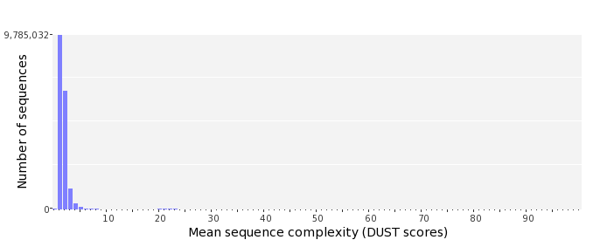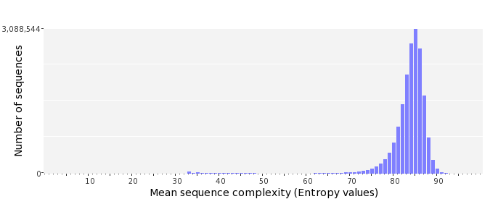

Dinucleotide Odds Ratios
 | AA/TT | AC/GT | AG/CT | AT | CA/TG | CC/GG | CG | GA/TC | GC | TA
Odds ratio | 1.1550 | 0.8768 | 0.9132 | 1.0697 | 1.1168 | 1.0077 | 0.9377 | 1.0228 | 1.1164 | 0.6847
