I3
Input Information
Input file(s): | I_3.assembled.fastq
Input format(s): | FASTQ
# Sequences: | 13,881,351
Total bases: | 2,124,457,817

Length Distribution
Mean sequence length: | 153.04 ± 48.95 bp
Minimum length: | 50 bp
Maximum length: | 240 bp
Length range: | 191 bp
Mode length: | 161 bp with 91,578 sequences
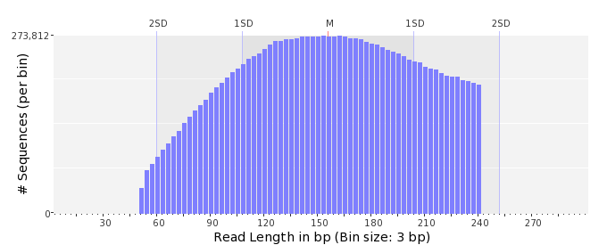

GC Content Distribution
Mean GC content: | 53.14 ± 12.80 %
Minimum GC content: | 0 %
Maximum GC content: | 96 %
GC content range: | 97 %
Mode GC content: | 60 % with 459,528 sequences
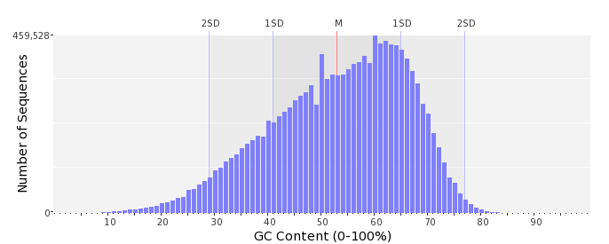

Base Quality Distribution
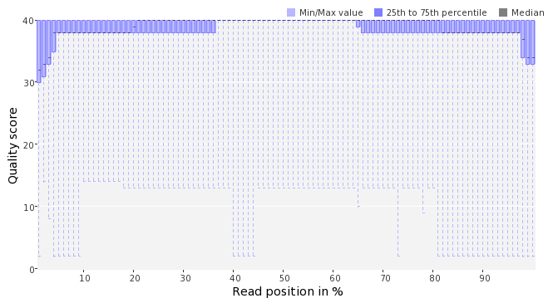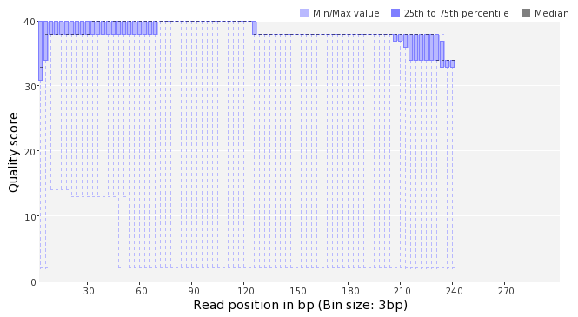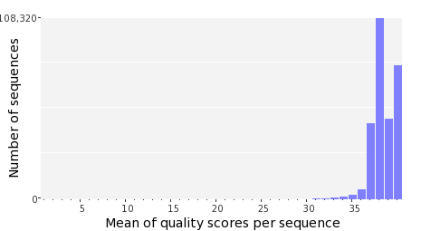

Occurence of N
Sequences with N: | 96,447 (0.69 %)
Max percentage of Ns per sequence: | 5 %
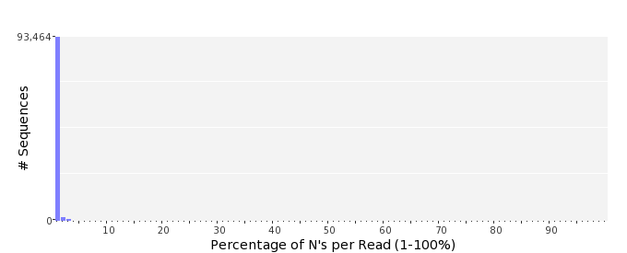

Poly-A/T Tails
 | 5'-end | 3'-end
Sequences with tail: | 48,641 (0.35 %) | 50,542 (0.36 %)
Maximum tail length: | 125 | 125
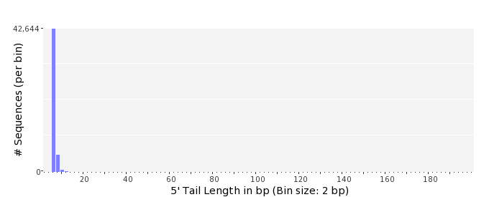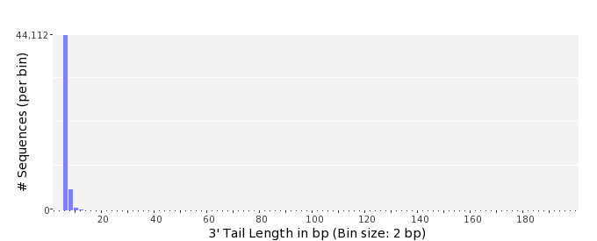

Tag Sequence Check
 | 5'-end | 3'-end
Probability of tag sequence: | 0 % | 0 %
GSMIDs or RLMIDs: | none

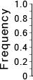 |  |  |  |  |  |  |  |  |  |  |  |  |  |  |  |  |  |  |  |  | ...
 | 1 |  |  |  | 5 |  |  |  |  | 10 |  |  |  |  | 15 |  |  |  |  | 20 |  | 20 |  |  |  |  | 15 |  |  |  |  | 10 |  |  |  |  | 5 |  |  |  | 1
 | Position from Sequence Ends

Sequence Duplication
 | # Sequences | Max duplicates
Exact duplicates: | 261,628 (1.88 %) | 37
Exact duplicates with reverse complements: | 990 (0.01 %) | 1
5' duplicates | 178,655 (1.29 %) | 22
3' duplicates | 143,479 (1.03 %) | 63
5'/3' duplicates with reverse complements | 245,429 (1.77 %) | 4
Total: | 830,181 (5.98 %) | -
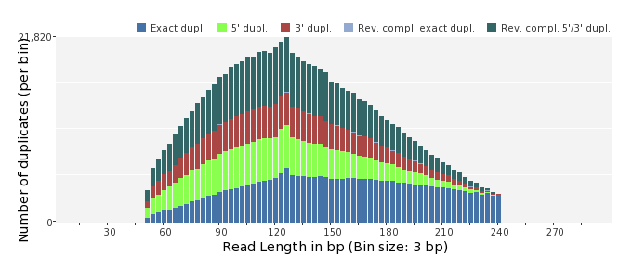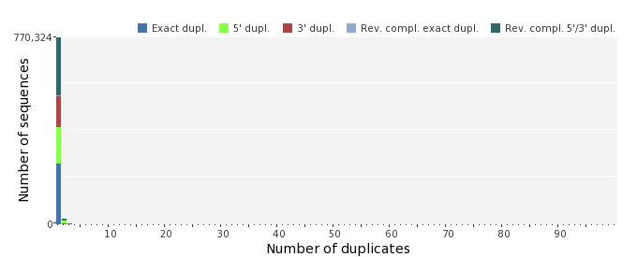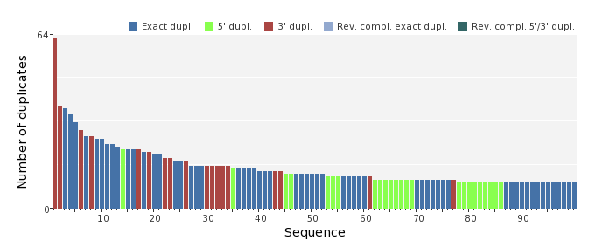

Sequence Complexity
 | Value | Sequence
Minimum DUST score: | 0 | CCATCTCGGTGCGCGTCCAGTCAAACACCGGCATGAAGTTGTAGCAAATGACCTTTACA
Maximum DUST score: | 98 | TTTTTTTTTTTTTTTTTTTTTTTTTTTTTTTTTTTTTTTTTTTTTTTTTTTTTTTTTTTT  TTTTTTTTTTTTTTTTTTTTTTTTTTTTTTTTTTTTTTTTTTTTTTTTTTTTTTTTTTTT  TTTTT
Minimum Entropy value: | 0 | TTTTTTTTTTTTTTTTTTTTTTTTTTTTTTTTTTTTTTTTTTTTTTTTTTTTTTTTTTTT  TTTTTTTTTTTTTTTTTTTTTTTTTTTTTTTTTTTTTTTTTTTTTTTTTTTTTTTTTTTT  TTTTT
Maximum Entropy value: | 97 | TATCCTTAGTTCAGATTGTAGGCTGCAACTCGCCTACATGAAGGTGGAAT
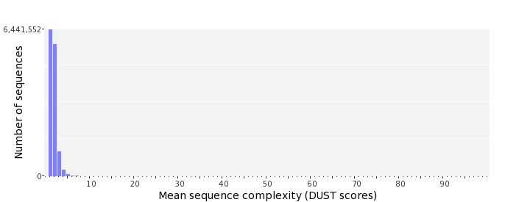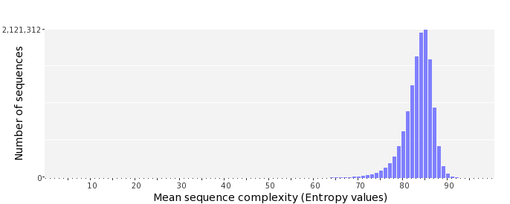

Dinucleotide Odds Ratios
 | AA/TT | AC/GT | AG/CT | AT | CA/TG | CC/GG | CG | GA/TC | GC | TA
Odds ratio | 1.1684 | 0.8567 | 0.9068 | 1.1457 | 1.0958 | 0.9586 | 1.0188 | 1.0668 | 1.1436 | 0.5969
