D1
Input Information
Input file(s): | D_1.assembled.fastq
Input format(s): | FASTQ
# Sequences: | 14,945,863
Total bases: | 2,263,527,131

Length Distribution
Mean sequence length: | 151.45 ± 48.80 bp
Minimum length: | 50 bp
Maximum length: | 240 bp
Length range: | 191 bp
Mode length: | 145 bp with 99,803 sequences
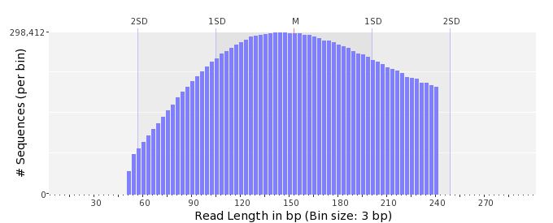

GC Content Distribution
Mean GC content: | 48.66 ± 11.52 %
Minimum GC content: | 0 %
Maximum GC content: | 93 %
GC content range: | 94 %
Mode GC content: | 50 % with 549,318 sequences
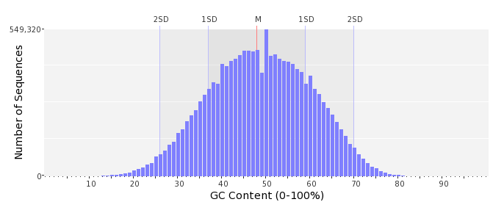

Base Quality Distribution
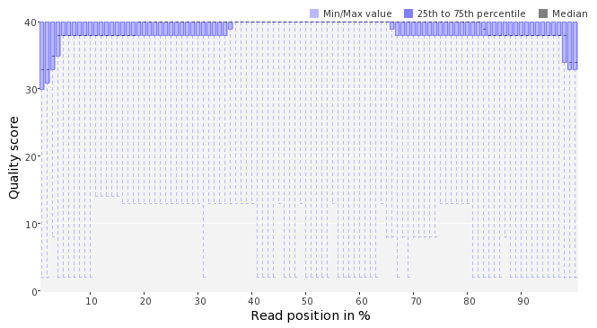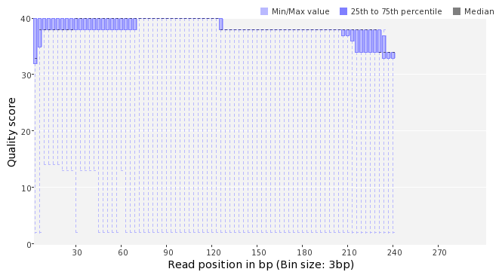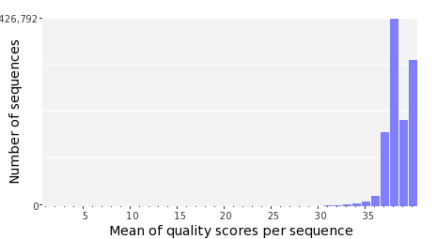

Occurence of N
Sequences with N: | 253,147 (1.69 %)
Max percentage of Ns per sequence: | 7 %
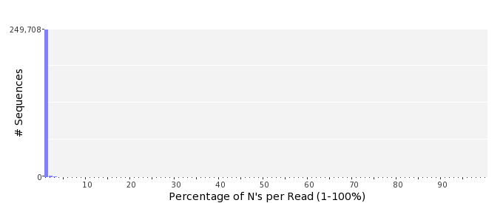

Poly-A/T Tails
 | 5'-end | 3'-end
Sequences with tail: | 63,182 (0.42 %) | 67,336 (0.45 %)
Maximum tail length: | 57 | 125
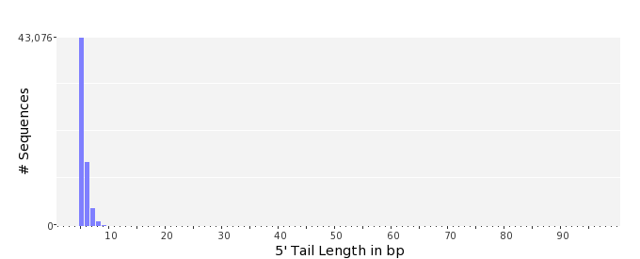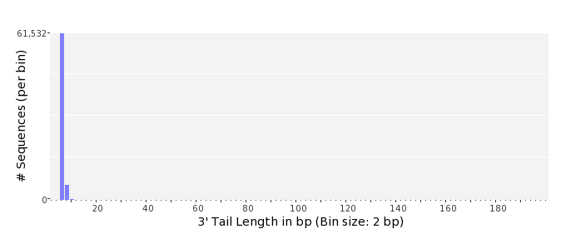

Tag Sequence Check
 | 5'-end | 3'-end
Probability of tag sequence: | 0 % | 0 %
GSMIDs or RLMIDs: | none

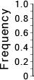 |  |  |  |  |  |  |  |  |  |  |  |  |  |  |  |  |  |  |  |  | ...
 | 1 |  |  |  | 5 |  |  |  |  | 10 |  |  |  |  | 15 |  |  |  |  | 20 |  | 20 |  |  |  |  | 15 |  |  |  |  | 10 |  |  |  |  | 5 |  |  |  | 1
 | Position from Sequence Ends

Sequence Duplication
 | # Sequences | Max duplicates
Exact duplicates: | 428,401 (2.87 %) | 80
Exact duplicates with reverse complements: | 135 (0.00 %) | 1
5' duplicates | 18,619 (0.12 %) | 16
3' duplicates | 15,887 (0.11 %) | 13
5'/3' duplicates with reverse complements | 29,141 (0.19 %) | 2
Total: | 492,183 (3.29 %) | -
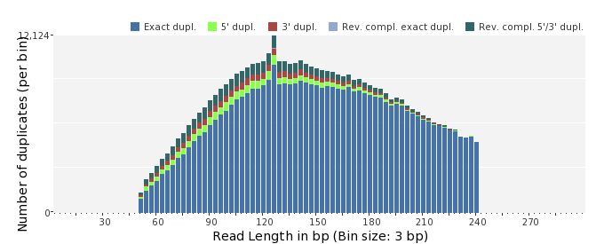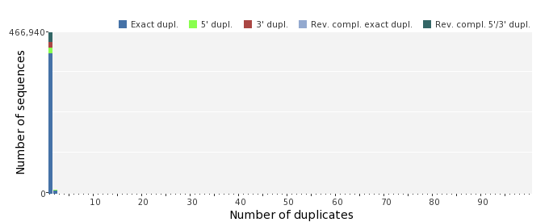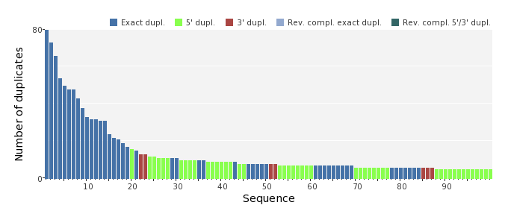

Sequence Complexity
 | Value | Sequence
Minimum DUST score: | 0 | GGATATAGCGTCCGTCCTGTTACTCATCTTGAAGAGGCAAAGAGCACTGCTAC
Maximum DUST score: | 97 | NTTTTTTTTTTTTTTTTTTTTTTTTTTTTTTTTTTTTTTTTTTTTTTTTTTTTTTTTTTT  TTTTTT
Minimum Entropy value: | 1 | GAAATTTTTTTTTTTTTTTTTTTTTTTTTTTTTTTTTTTTTTTTTTTTTTTTTTTTTTTT  TTTTTTTTTTTTTTTTTTTTTTTTTTTTTTTTTTTTTTTTTTTTTTTTTTTTTTTTTTTT  TTTTTTTTT
Maximum Entropy value: | 96 | GTTGGACATTAAATAGTGCAACAGCCTGAATTCCGTCGGGCCCAGATCTAT
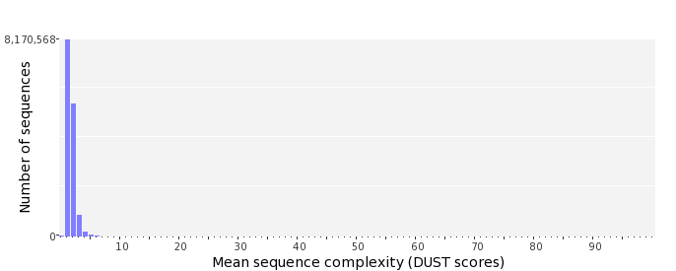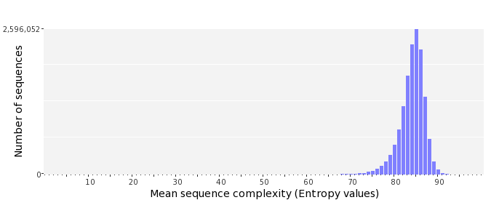

Dinucleotide Odds Ratios
 | AA/TT | AC/GT | AG/CT | AT | CA/TG | CC/GG | CG | GA/TC | GC | TA
Odds ratio | 1.1705 | 0.8419 | 0.9270 | 1.0720 | 1.0645 | 1.0052 | 0.9943 | 1.0586 | 1.1336 | 0.6741
