D2
Input Information
Input file(s): | D_2.assembled.fastq
Input format(s): | FASTQ
# Sequences: | 14,521,903
Total bases: | 2,148,945,145

Length Distribution
Mean sequence length: | 147.98 ± 49.32 bp
Minimum length: | 50 bp
Maximum length: | 240 bp
Length range: | 191 bp
Mode length: | 133 bp with 96,721 sequences
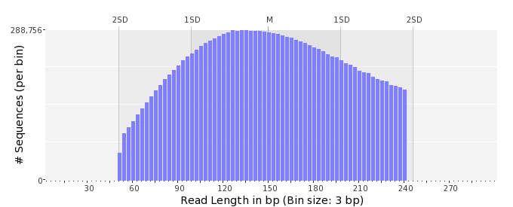

GC Content Distribution
Mean GC content: | 48.57 ± 11.78 %
Minimum GC content: | 0 %
Maximum GC content: | 98 %
GC content range: | 99 %
Mode GC content: | 50 % with 531,763 sequences
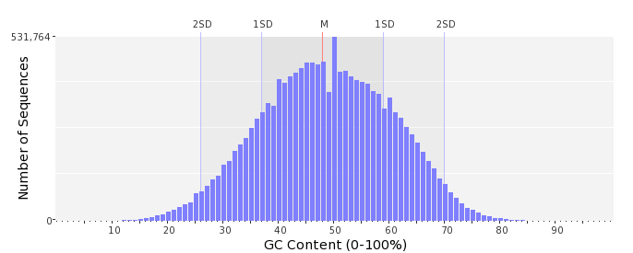

Base Quality Distribution
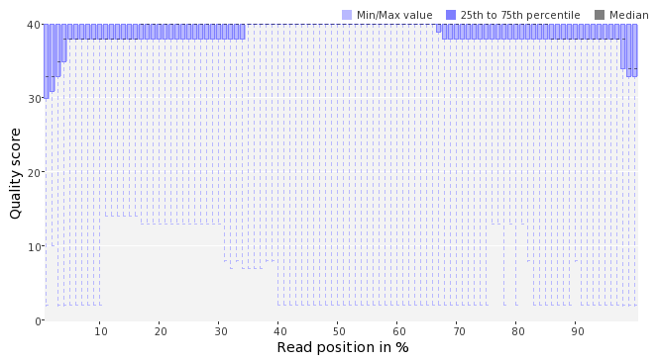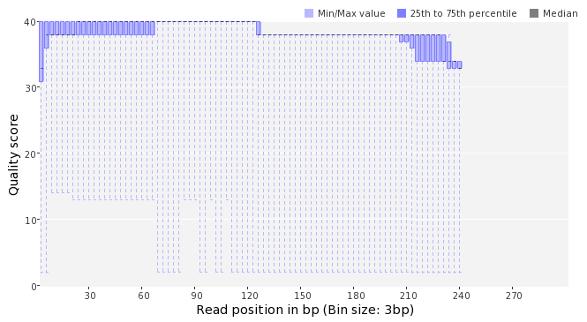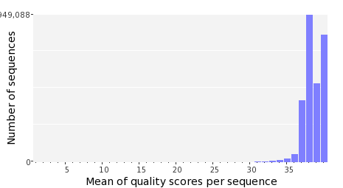

Occurence of N
Sequences with N: | 75,536 (0.52 %)
Max percentage of Ns per sequence: | 5 %
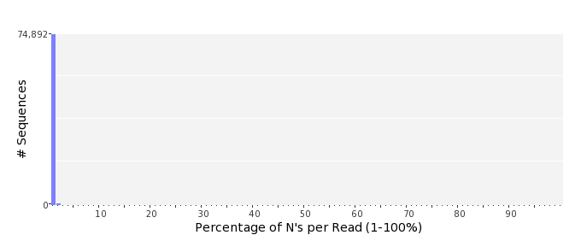

Poly-A/T Tails
 | 5'-end | 3'-end
Sequences with tail: | 71,217 (0.49 %) | 72,361 (0.50 %)
Maximum tail length: | 31 | 125
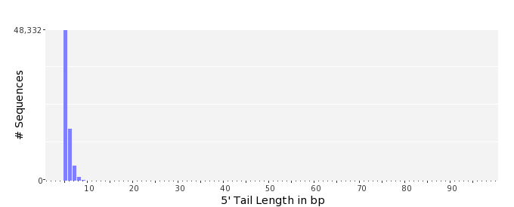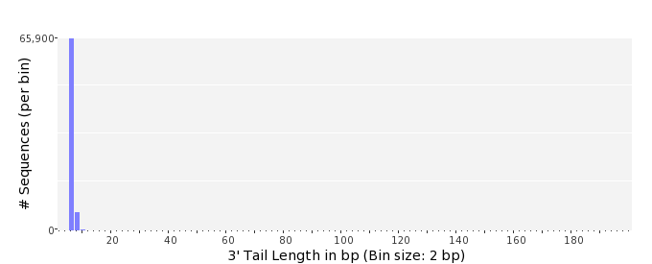

Tag Sequence Check
 | 5'-end | 3'-end
Probability of tag sequence: | 0 % | 0 %
GSMIDs or RLMIDs: | none

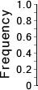 |  |  |  |  |  |  |  |  |  |  |  |  |  |  |  |  |  |  |  |  | ...
 | 1 |  |  |  | 5 |  |  |  |  | 10 |  |  |  |  | 15 |  |  |  |  | 20 |  | 20 |  |  |  |  | 15 |  |  |  |  | 10 |  |  |  |  | 5 |  |  |  | 1
 | Position from Sequence Ends

Sequence Duplication
 | # Sequences | Max duplicates
Exact duplicates: | 347,219 (2.39 %) | 28
Exact duplicates with reverse complements: | 164 (0.00 %) | 1
5' duplicates | 31,721 (0.22 %) | 18
3' duplicates | 25,226 (0.17 %) | 16
5'/3' duplicates with reverse complements | 42,760 (0.29 %) | 3
Total: | 447,090 (3.08 %) | -
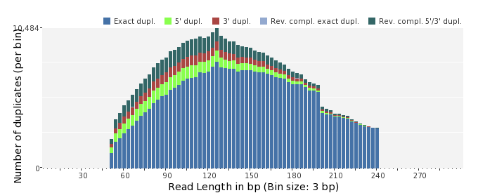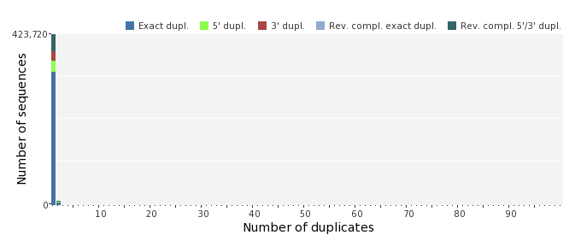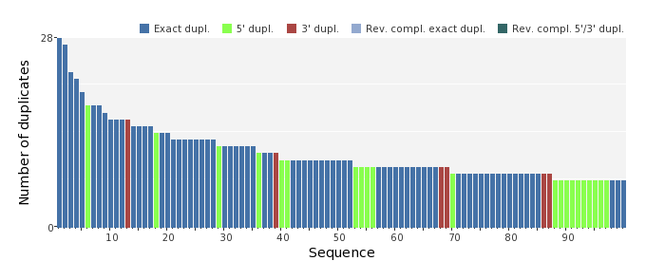

Sequence Complexity
 | Value | Sequence
Minimum DUST score: | 0 | GCGCAGGAAAGCATCAGCCCGTCGACAATGCTGGCATGATTAAGTTTATCG
Maximum DUST score: | 97 | CAAAAAAAAAAAAAAAAAAAAAAAAAAAAAAAAAAAAAAAAAAAAAAAAAAAAAAAAAAA  AAAAAAAAAAAAAAAAAAAAAAAAAAAAAAAAAAAAAAAAAAAAAAAAAAAAAAAAAAAA  AAAAAA
Minimum Entropy value: | 0 | CAAAAAAAAAAAAAAAAAAAAAAAAAAAAAAAAAAAAAAAAAAAAAAAAAAAAAAAAAAA  AAAAAAAAAAAAAAAAAAAAAAAAAAAAAAAAAAAAAAAAAAAAAAAAAAAAAAAAAAAA  AAAAAA
Maximum Entropy value: | 97 | CTATCAGCGCCCGTTTAGCAAGGAAATGTCTCCTAACTGGTATAGATTCG
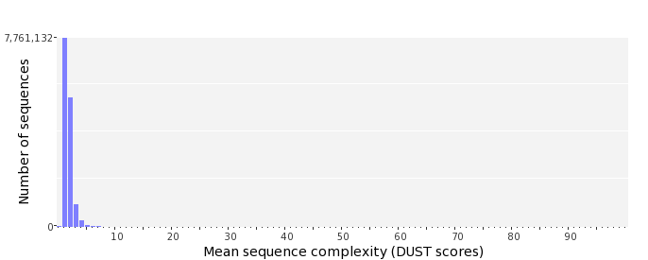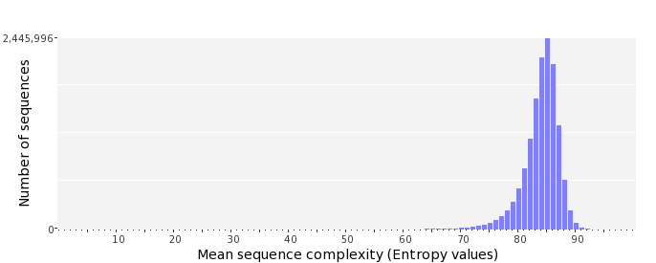

Dinucleotide Odds Ratios
 | AA/TT | AC/GT | AG/CT | AT | CA/TG | CC/GG | CG | GA/TC | GC | TA
Odds ratio | 1.1578 | 0.8419 | 0.9337 | 1.0726 | 1.0662 | 1.0122 | 0.9828 | 1.0623 | 1.1234 | 0.6796
