E4
Input Information
Input file(s): | E_4.assembled.fastq
Input format(s): | FASTQ
# Sequences: | 15,946,341
Total bases: | 2,378,875,662

Length Distribution
Mean sequence length: | 149.18 ± 49.08 bp
Minimum length: | 50 bp
Maximum length: | 240 bp
Length range: | 191 bp
Mode length: | 145 bp with 106,171 sequences
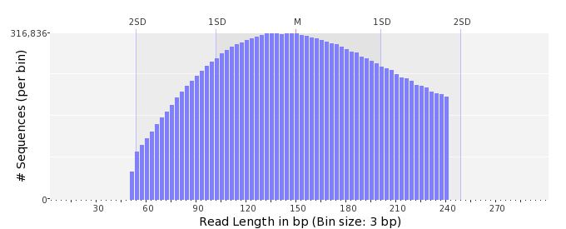

GC Content Distribution
Mean GC content: | 49.37 ± 10.45 %
Minimum GC content: | 0 %
Maximum GC content: | 94 %
GC content range: | 95 %
Mode GC content: | 50 % with 724,556 sequences
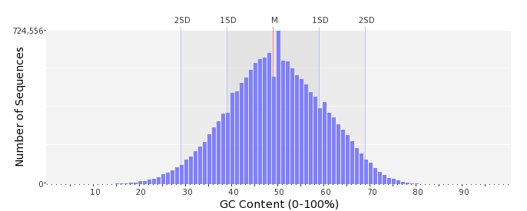

Base Quality Distribution
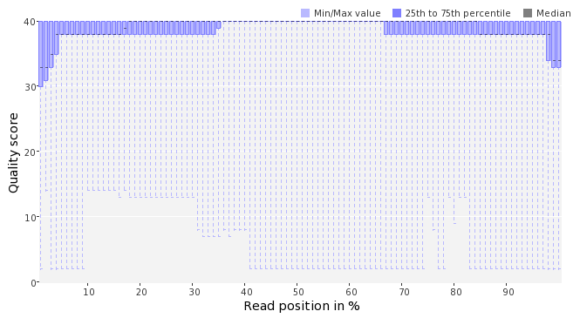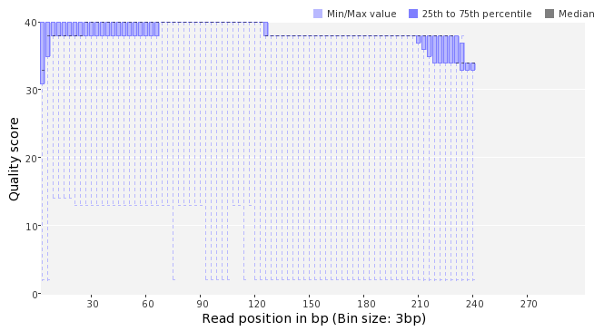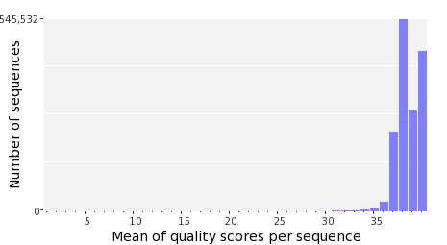

Occurence of N
Sequences with N: | 84,204 (0.53 %)
Max percentage of Ns per sequence: | 4 %
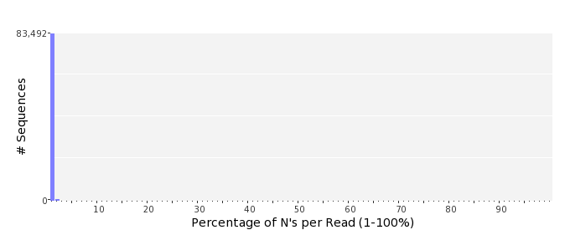

Poly-A/T Tails
 | 5'-end | 3'-end
Sequences with tail: | 63,035 (0.40 %) | 65,287 (0.41 %)
Maximum tail length: | 125 | 125
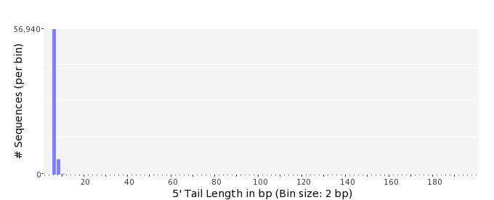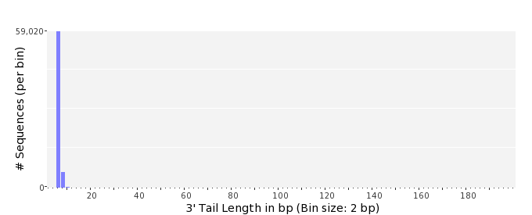

Tag Sequence Check
 | 5'-end | 3'-end
Probability of tag sequence: | 0 % | 0 %
GSMIDs or RLMIDs: | none

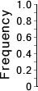 |  |  |  |  |  |  |  |  |  |  |  |  |  |  |  |  |  |  |  |  | ...
 | 1 |  |  |  | 5 |  |  |  |  | 10 |  |  |  |  | 15 |  |  |  |  | 20 |  | 20 |  |  |  |  | 15 |  |  |  |  | 10 |  |  |  |  | 5 |  |  |  | 1
 | Position from Sequence Ends

Sequence Duplication
 | # Sequences | Max duplicates
Exact duplicates: | 260,397 (1.63 %) | 11
Exact duplicates with reverse complements: | 2,021 (0.01 %) | 2
5' duplicates | 350,151 (2.20 %) | 23
3' duplicates | 225,730 (1.42 %) | 19
5'/3' duplicates with reverse complements | 218,491 (1.37 %) | 4
Total: | 1,056,790 (6.63 %) | -
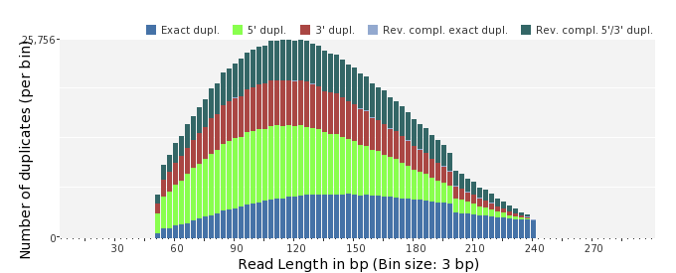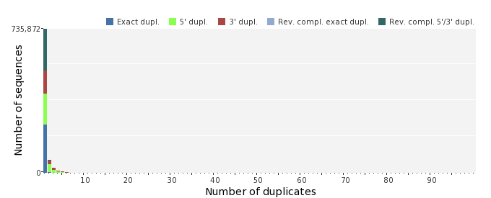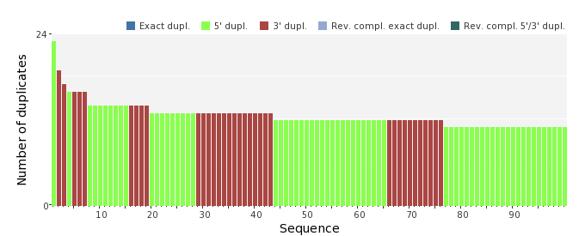

Sequence Complexity
 | Value | Sequence
Minimum DUST score: | 0 | GCCGGCAGACGGCAATTTGATGCTTCGCGGCCTGTAAGTCATTGCCCAGGGATGCAACCT  GGTTCGGAT
Maximum DUST score: | 96 | ACTTTTTTTTTTTTTTTTTTTTTTTTTTTTTTTTTTTTTTTTTTTTTTTTTTTTTTTTTT  TTTTTTTTTTTTTTTTTTTTTTTTTTTTTTTTTTTTTTTTTTTTTTTTTTTTTTTTTTTT  TTTTTTT
Minimum Entropy value: | 1 | ACTTTTTTTTTTTTTTTTTTTTTTTTTTTTTTTTTTTTTTTTTTTTTTTTTTTTTTTTTT  TTTTTTTTTTTTTTTTTTTTTTTTTTTTTTTTTTTTTTTTTTTTTTTTTTTTTTTTTTTT  TTTTTTT
Maximum Entropy value: | 97 | GGGAAGATAACTACGCACGGCGACAATTCCTCAGGCTTTATCGCCCAGTC
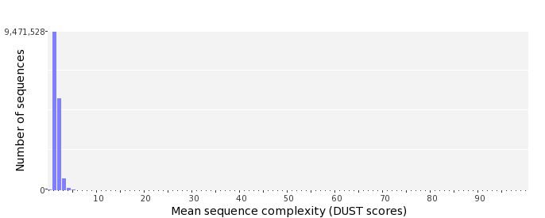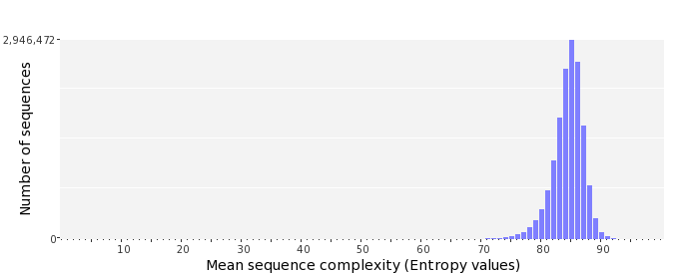

Dinucleotide Odds Ratios
 | AA/TT | AC/GT | AG/CT | AT | CA/TG | CC/GG | CG | GA/TC | GC | TA
Odds ratio | 1.1929 | 0.8190 | 0.9145 | 1.0936 | 1.0572 | 1.0210 | 1.0028 | 1.0653 | 1.1223 | 0.6568
