F4
Input Information
Input file(s): | F_4.assembled.fastq
Input format(s): | FASTQ
# Sequences: | 18,115,244
Total bases: | 2,648,771,016

Length Distribution
Mean sequence length: | 146.22 ± 49.47 bp
Minimum length: | 50 bp
Maximum length: | 240 bp
Length range: | 191 bp
Mode length: | 125 bp with 120,997 sequences
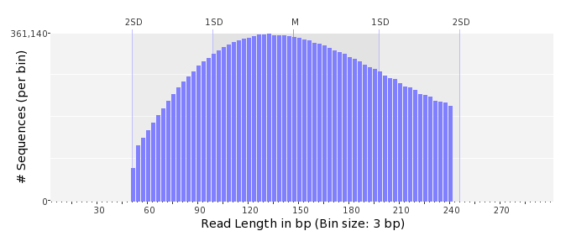

GC Content Distribution
Mean GC content: | 49.03 ± 9.89 %
Minimum GC content: | 1 %
Maximum GC content: | 96 %
GC content range: | 96 %
Mode GC content: | 50 % with 932,513 sequences
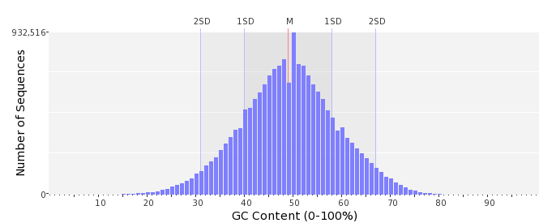

Base Quality Distribution
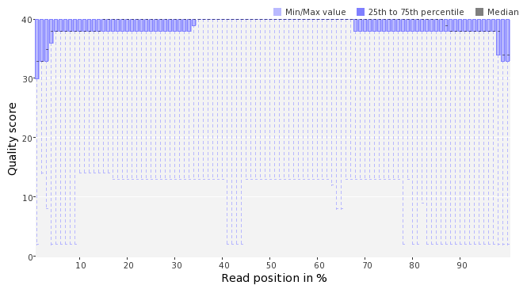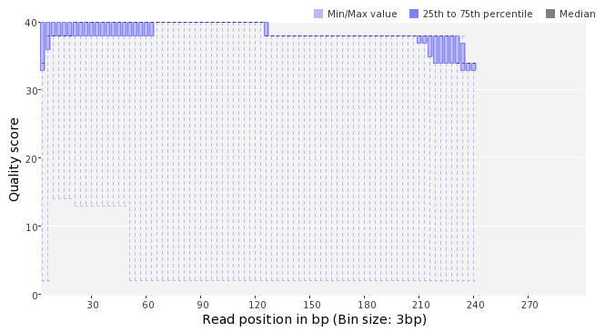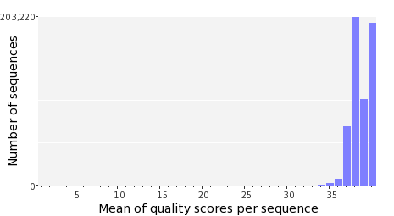

Occurence of N
Sequences with N: | 115,774 (0.64 %)
Max percentage of Ns per sequence: | 7 %
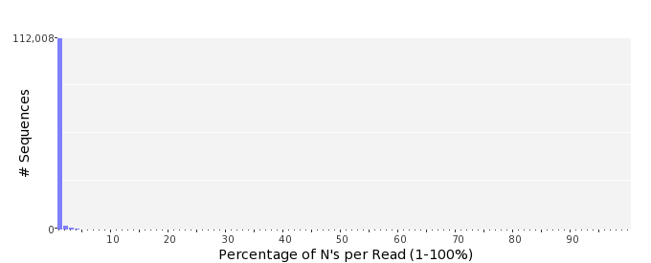

Poly-A/T Tails
 | 5'-end | 3'-end
Sequences with tail: | 69,673 (0.38 %) | 69,519 (0.38 %)
Maximum tail length: | 110 | 52
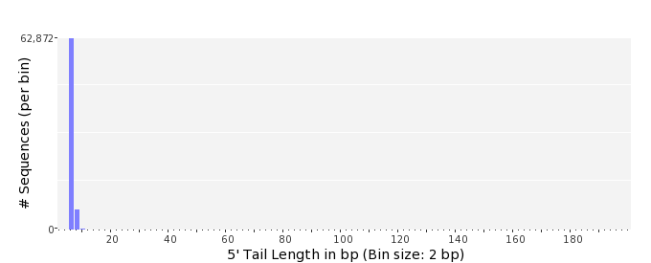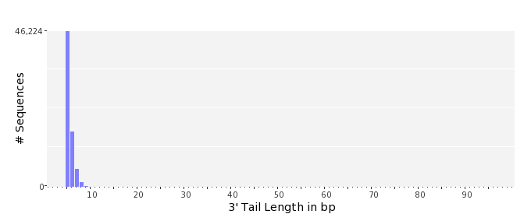

Tag Sequence Check
 | 5'-end | 3'-end
Probability of tag sequence: | 0 % | 0 %
GSMIDs or RLMIDs: | none

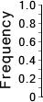 |  |  |  |  |  |  |  |  |  |  |  |  |  |  |  |  |  |  |  |  | ...
 | 1 |  |  |  | 5 |  |  |  |  | 10 |  |  |  |  | 15 |  |  |  |  | 20 |  | 20 |  |  |  |  | 15 |  |  |  |  | 10 |  |  |  |  | 5 |  |  |  | 1
 | Position from Sequence Ends

Sequence Duplication
 | # Sequences | Max duplicates
Exact duplicates: | 572,017 (3.16 %) | 16
Exact duplicates with reverse complements: | 4,503 (0.02 %) | 2
5' duplicates | 1,663,619 (9.18 %) | 23
3' duplicates | 723,262 (3.99 %) | 25
5'/3' duplicates with reverse complements | 524,990 (2.90 %) | 4
Total: | 3,488,391 (19.26 %) | -
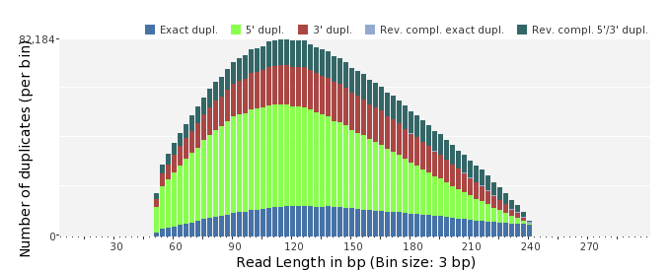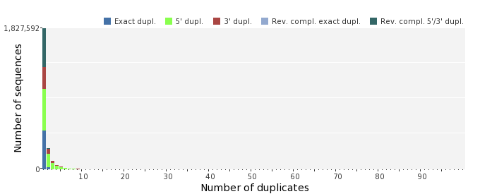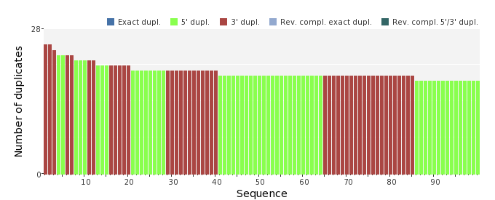

Sequence Complexity
 | Value | Sequence
Minimum DUST score: | 0 | ACCATGCTGCAATGAGCCTGACCCATGTGGGAGACGTCCTGGAAGAGGCAATGTCGAACT  ATCTC
Maximum DUST score: | 91 | AAAAAAAAAAAAAAAAAAAAAAAAAAAAAAAAAAAAAAAAAAAAAAAAAAAAAAAAAAAA  AAAAAAAAAAAAAAAAAAAAAAAAAAAAAAAAAAAAAAAAAAAAAAAAAACACGCAAAAA  AAAAA
Minimum Entropy value: | 4 | AAAAAAAAAAAAAAAAAAAAAAAAAAAAAAAAAAAAAAAAAAAAAAAAAAAAAAAAAAAA  AAAAAAAAAAAAAAAAAAAAAAAAAAAAAAAAAAAAAAAAAAAAAAAAAACACGCAAAAA  AAAAA
Maximum Entropy value: | 97 | AGGCTTTGTTATGACACCCTGCTCAAGTACGGTGCAAACGCCAGAATAGC
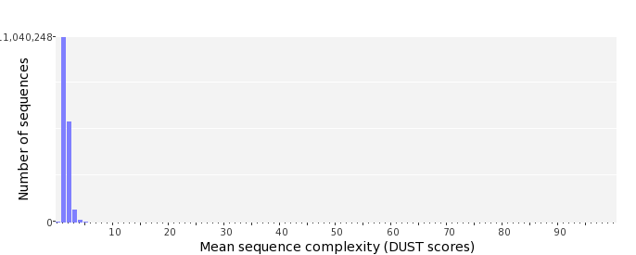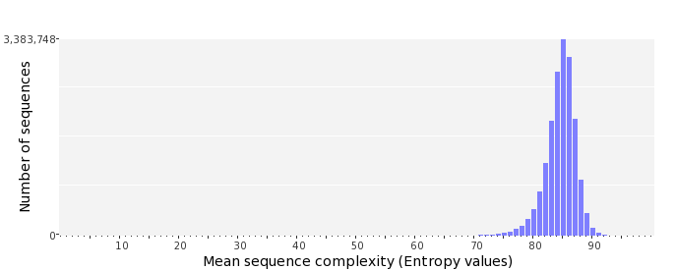

Dinucleotide Odds Ratios
 | AA/TT | AC/GT | AG/CT | AT | CA/TG | CC/GG | CG | GA/TC | GC | TA
Odds ratio | 1.1973 | 0.8072 | 0.9194 | 1.0907 | 1.0517 | 1.0215 | 1.0045 | 1.0652 | 1.1324 | 0.6631
