Application Package Request Form


Package Request Form

For
LUMILEDS
Google Chrome 147.0.7727.56 x64 EN

Document Information
Details
Prepared By: | Jimmy Antony
Project Name: | Packaging Request Form
Project Lead:
Reviewed By:
Review Date:
Approvers List
Approvers | Action* | Status | Comments
Action Types: Approve, Review, Inform, File, Action Required, Attend Meeting, Other (please specify)
Revision History
Issue. No. | Status | Issue Date | Revised By | Description
0.1 | Draft | 16-June,2022 | Deva | Initial Draft
0.2 | Draft

Contents
1 Application Request 5
2 Application Information 6
3 Application Owner 7
4 Application Requirements 7
5 Install Instructions 8
6 Install Instructions 9
7 Application Configuration 10
8 Security Permissions 11
File Permissions 11
Registry Permissions 11
9 Shortcuts 12
10 ODBC Settings 12
11 Office Add-ins 12
12 Excel Add-ins 13
13 File Type Associations 13
14 Environment Variables 13
15 Run Keys 14
16 Hosts/Services File Changes 14
17 Control Panel Applets 14
18 Additional Information 15
19 Test Instructions 16

- Application Request
This section outlines information about the application request to be processed.

Application Request
1.1* | Request Type | Application Update
 |  | Google Chrome 145.0.7632.76
1.2 | External Tracking ID | SCTASK0085732/RITM0087270
1.3 | ARM ID / DEVTRACK ID | Click here to enter text. | LUM0190
1.4 | Build Version | 1.0
1.5* | Priority Type | Normal/Scheduled Request
1.6 | Date Submitted | Apr 13,2026
1.7* | Platform Support | Windows 7 x32 | ☐
 |  | Windows 7 x64 | ☐
 |  | Windows 8.1 | ☐
 |  | Windows Server 2008 R2 | ☐
 |  | Windows Server 2012 | ☐
 |  | Windows 11 x64 | ☒
1.8* | Application Delivery Method | Windows Installer | ☐
 |  | Virtualized Application | ☐
1.9* | Source Files and PRF | FXS
1.10* | Estimated Total of Machines | NA

N.B. Click into any text followed by an information point,, and press F1 for further information.

- Application Information
This section outlines information about the application to be packaged.

Application Information
2.1* | Vendor Name | Google LLC
2.2* | Application Name | Google Chrome
2.3* | Application Version/Service Pack | 147.0.7727.56
2.4 | Environment Code | NA
2.5* | Application Architecture | x64
2.6* | Language | English (ENU) |  | ☒
 |  | Click here to enter text.
2.7 | Vendor Contact Details | Name: | Click here to enter text.
 |  | Email: | Click here to enter text.
 |  | Telephone No: | Click here to enter text.
2.8 | License Details | Redistributable
2.9 | Application Description | Web Browser

- Application Owner
This section outlines information about the application owners.

Application Owner
3.1 | Business Unit | Lumileds
3.2 | Application Manager | Name: | Subodh Uniyal
 |  | Email: | Subodh.uniyal@lumileds.com
 |  | Telephone No.: | 0103838749
 |  | Location: | Penang, Malaysia
3.3* | Application Expert | Name:
 |  | Email:
 |  | Telephone No.:
 |  | Location:
- Application Requirements
This section outlines additional requirements for packaging the application.

Application Requirements
4.1 | Hardware Requirements | NA
4.2 | Network Requirements | NA
4.3 | Firewall Requirements | NA
4.4 | Software Pre-requisites | NA
4.5 | Software Dependencies | NA
4.6 | Browser Configuration | NA
4.7 | Database or Application Server Type and Login Information | NA
4.8 | Application Test Login | NA

- Install Instructions
Please list any program settings/files that need to be saved in the event a user has to rebuild their workstation (e.g. "C:\Users\<user name>\Favorites" directory for Internet Explorer).
This will be used to perform an automated backup of user configurable files for Windows 7 x64 and Windows 10x64.

Please list registry entries (keys, values, and data), filenames, and directory locations.
If any special procedure should be followed to ensure functionality, please describe it in detail.

No. | Directory / Filenames / Registry Keys | Comments

- Install Instructions

This section outlines the steps required to install the application.

Installer | googlechromestandaloneenterprise64.msi

Right click on “googlechromestandaloneenterprise64.msi” and click on “Install”.
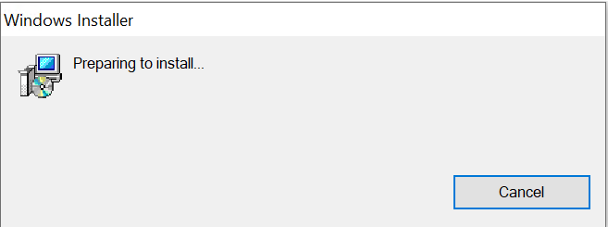

Click “Yes”

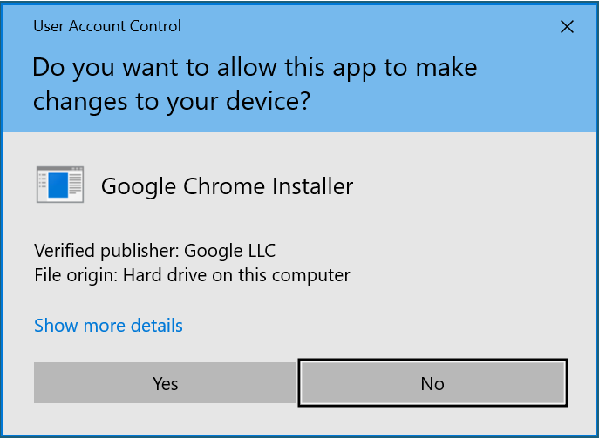

Installation will progress and closes after installed.

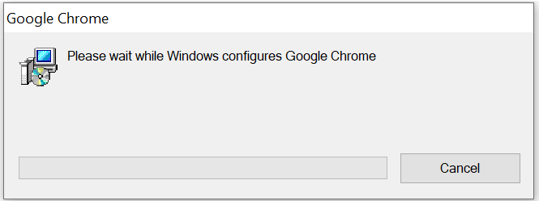

ARP Entry:

- Application Configuration
Any specific configuration required by the application. Use screenshots of the GUI as required.

Disable Auto Updates

Welcome screens need to be suppressed.

Click on “Don’t sign in“

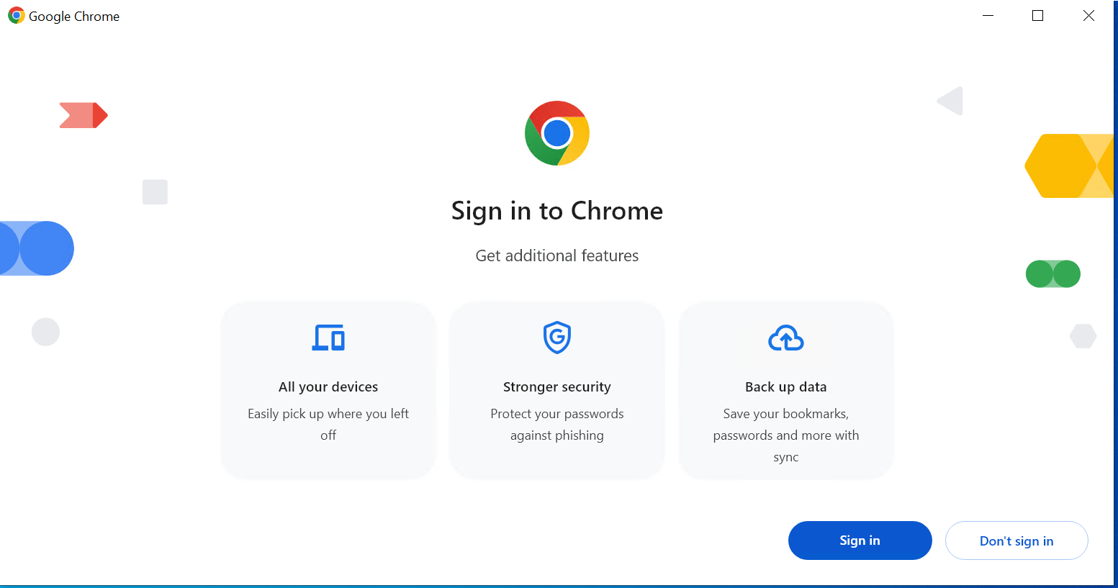

Click on “Skip”

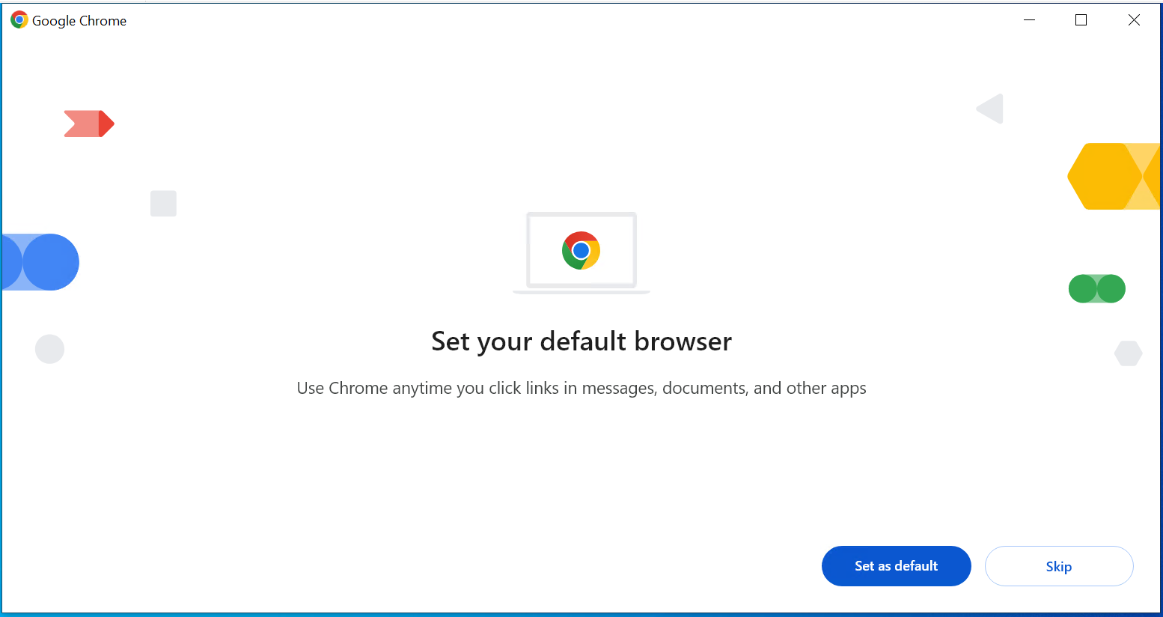

Click on “Got it”

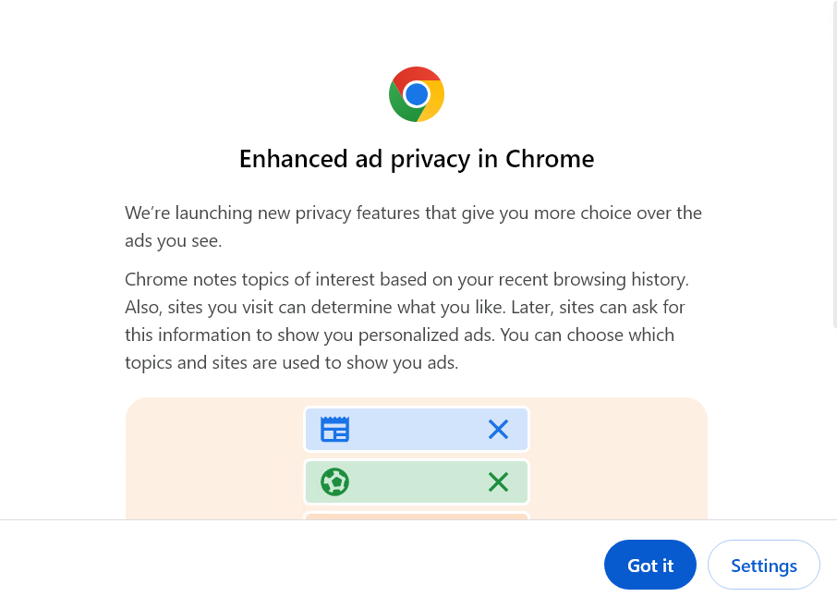
- Security Permissions
State all permissions required for the application to function correctly.

File Permissions
NTFS permissions on the application folders and files should be set as shown in the table below. By default application directories will have Read & Execute permissions.

File or Folder name (provide full path) | Permissions | User Group | Comments
 |  |  | <Including subfolders and files in subfolders>
Legend NTFS permissions:
F = Full Control
M = Modify
W = Write

Registry Permissions
Set registry permissions as in the table below.

Registry Hive (provide full path) | Permissions | User Group | Comments
 |  |  | <Including subfolders and files in subfolders>
Legend Registry Permissions
F = Full Control
R = Read

- Shortcuts
Specify any shortcuts to be included in the application. Note, unless explicitly required any shortcut in the ‘Start up’ folder is usually removed to ensure the logon process is optimized.

As per best practice we will remove desktop shortcut.

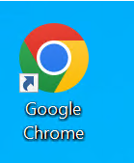

Start menu shortcut

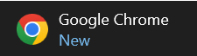

- ODBC Settings
Specify any ODBC requirements

Data | Comment

- Office Add-ins
List any Office add-ins required

Path | Comment

- Excel Add-ins
List any Excel Add-ins required

Path | Comment

- File Type Associations
Specify any File Type Associations to be included in the application. Note, that any files with these extensions will be set to open in the executable assigned to it by this application.

FTA’s required | Click here to enter text.

- Environment Variables
Please list all environment variables that are required and whether they should be user or system
- Run Keys
Specify any Run keys to be included in the application. Note, unless explicitly required any item added to the ‘Run’ folder is usually removed to ensure the logon process is optimized.
- Hosts/Services File Changes
Specify any modifications to be included in the Hosts/Services file. Note, it is recommended that all relevant entries are managed through DNS and not through the application and the Hosts/Services file.
Hosts/Services File Changes | Comment

- Control Panel Applets
Specify any control panel applets to be included in the application.

<Install Guide>
- Additional Information
Include any additional information that is required to install/package the application. This should include any custom logic, files to be backed up pre-upgrade, etc.

<Additional Information>

- Auto-Updates needs to be disabled.
- Desktop shortcut needs to be removed.
- Current Package should retain existing Passwords & Bookmarks if any.
- Below mentioned Welcome screens should be suppressed.
Click on “Don’t sign in”



Click on Skip


Click on “Got it”


- Test Instructions
This section outlines all of the steps necessary to test the application. The description should not leave any room for assumptions and therefore all relevant actions and screenshots should be included.

ARP Entry
On Launching “Google Chrome” shortcut from start menu.

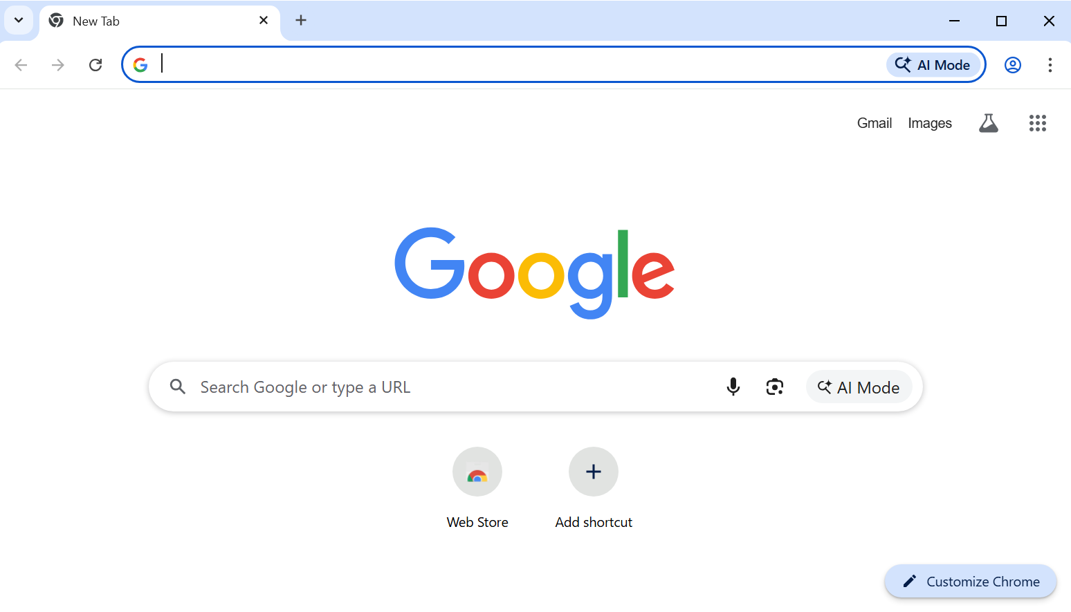

Click on Help and go to “About Google Chrome” to check version as shown below.

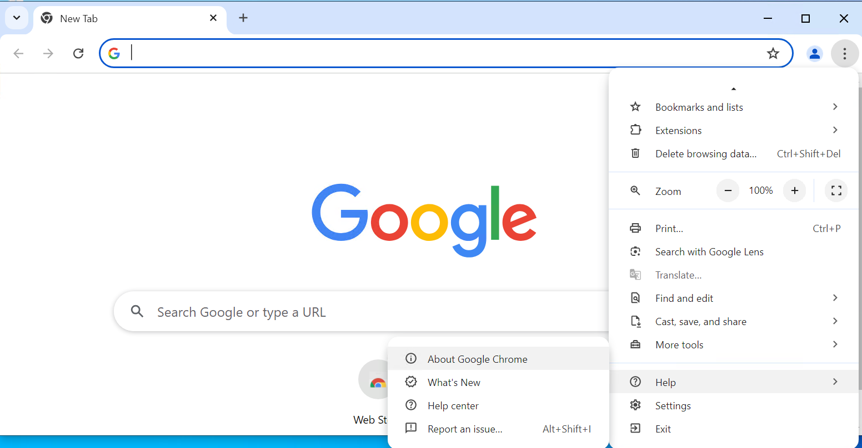

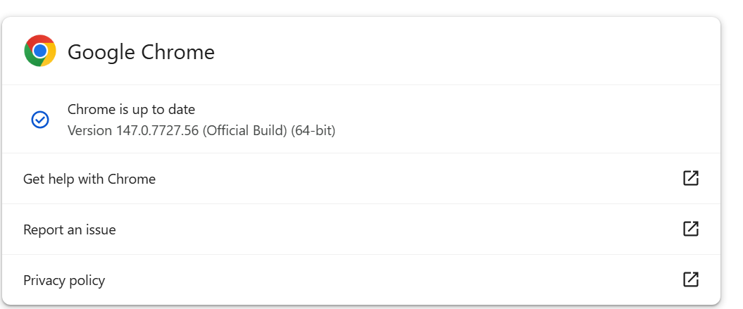

Full Functionality can be tested during UAT phase.

Appendix
These are the default configurations for any application submitted for packaging. These defaults can be overwritten by any specification made in this document.

Configuration | Configuration Description
Silent Install | The package will install silently and will not require any manual intervention in order to complete the installation on the target platform.
Silent Uninstall | The package will uninstall silently and will remove all components of the install, except for application-specific user data.
Uninstall shortcuts | The Uninstall shortcuts will not be made available.
Online Registration shortcuts | Online Registration shortcuts will not be made available.
Desktop shortcuts | Desktop shortcuts will not be made available.
Application Shortcut | Application shortcuts will be available to the user under Start à All Programs
Registration Popup Screens | Registration/activation screens, where possible, will not appear when launching the shortcuts.
Splash Screens & Advertisements | Splash screens and application advertisements, where possible, shall be disabled and will not appear.
Product Registration | Product registration dialogs and notifications, where possible, shall be disabled and will not appear.
User Privileges | The application will function under standard user account.

Proprietary Notice
The content of this document is subject to change without prior notice. All rights with respect to this document, especially the right to copy, to reproduce, to disclose to third parties and to translate the document, remain with DXC.Technologies.

