

MSc Data Science Project
7PAM2002
Department of Physics, Astronomy and Mathematics

Data Science FINAL PROJECT REPORT

Project Title:
Heart Disease Risk Prediction Using
Machine Learning

Student Name and SRN:
Renusree Kakarla and 24087145

Supervisor: Klaas Wiersema
Date Submitted: 21/06/2026
Word Count: 5522
GitHub Link: https://github.com/kakarlarenusree/renu_project_Heart-Disease-Risk-Prediction

DECLARATION STATEMENT

This report is submitted in partial fulfilment of the requirement for the degree of Master of Science in Data Science at the University of Hertfordshire.
I have read the detailed guidance to students on academic integrity, misconduct and plagiarism information at Assessment Offences and Academic Misconduct and understand the University process of dealing with suspected cases of academic misconduct and the possible penalties, which could include failing the project or course.
I certify that the work submitted is my own and that any material derived or quoted from published or unpublished work of other persons has been duly acknowledged. (Ref. UPR AS/C/6.1, section 7 and UPR AS/C/5, section 3.6)
I did not use human participants in my MSc Project.

I hereby give permission for the report to be made available on module websites provided the source is acknowledged.

Student Name printed: Renusree Kakarla

Student Name signature : Renusree Kakarla

Student SRN number: 24087145

UNIVERSITY OF HERTFORDSHIRE
SCHOOL OF PHYSICS, ENGINEERING AND COMPUTER SCIENCE

Table of contents:

 | Title | Page No.
 | ABSTRACT | 5
1 | INTRODUCTION | 6
1.1 | Background | 6
1.2 | Motivation | 6
1.3 | Research Question | 7
1.4 | Objectives | 7
2. | LITERATURE REVIEW | 8
2.1 | Overview of Existing Studies | 8
2.2 | Comparison of Literature | 9
3. | DATASET | 10
3.1 | Dataset Overview | 10
3.2 | Feature Description | 10
3.3 | Missing Values | 11
4. | ETHICAL CONSIDERATIONS | 13
5. | METHODOLOGY | 14
5.1 | Data Preprocessing | 14
 | 5.1.1 Target Variable Binarisation | 14
 | 5.1.2 Handling Missing Values | 15
 | 5.1.3 Train-Test Split | 15
 | 5.1.4 SMOTE -Class Imbalance Handling | 15
 | 5.1.5 Feature Scaling | 15
5.2 | Exploratory Data Analysis (EDA) | 15
 | 5.2.1 Univariate Analysis | 15
 | 5.2.2 Bivariate Analysis | 16
 | 5.2.3 Categorical Feature Analysis | 17
 | 5.2.4 Correlation Analysis | 18
 | 5.2.5 Outlier Analysis | 18
 | 5.2.6 EDA Summary | 19
5.3 | Model Selection | 19
 | 5.3.1 Logistic Regression | 19
 | 5.3.2 Random Forest | 19
 | 5.3.3 XGBoost | 20
5.4 | Model Evaluation Metrics | 20
5.5 | Hyperparameter Tuning | 21
5.6 | Explainable AI using SHAP | 21
6. | RESULTS | 23
6.1 | Comprehensive Model Performance Comparison | 23
6.2 | ROC Curve Analysis | 24
6.3 | Confusion Matrix Analysis | 25
6.4 | SHAP Explainability Results | 25
6.5 | Key Findings | 26
7. | ANALYSIS AND DISCUSSION | 27
7.1 | Interpretation of Results | 27
7.2 | Effect of SMOTE | 27
7.3 | Model Comparison | 27
7.4 | Clinical Relevance | 27
7.5 | Explainability Discussion | 28
7.6 | Limitations | 28
8. | CONCLUSION | 29
9. | FUTURE WORK | 30
 | REFERENCES | 31
 | APPENDIX | 32

ABSTRACT
Heart disease remains one of the leading causes of mortality worldwide, creating a need for accurate and interpretable predictive models that can support clinical decision-making. This study investigates the effectiveness of three machine learning classification models—Logistic Regression, Random Forest, and XGBoost—for heart disease risk prediction using the Cleveland Heart Disease dataset from the UCI Machine Learning Repository. The dataset contains 303 patient records and 13 clinical attributes associated with cardiovascular health.
Data preprocessing involved target variable binarisation, removal of six records containing missing values, stratified train-test splitting, and Synthetic Minority Over-sampling Technique (SMOTE) to address class imbalance within the training data. Hyperparameter optimisation was performed using GridSearchCV with five-fold cross-validation. Model performance was evaluated using accuracy, precision, recall, F1-score, and ROC-AUC.
A three-stage evaluation framework was implemented, comparing model performance before SMOTE, after SMOTE, and after SMOTE combined with hyperparameter tuning. Results showed that all models achieved strong predictive performance, with Random Forest obtaining the highest ROC-AUC (0.951), while XGBoost achieved the most consistent overall balance across accuracy, precision, recall, and F1-score. Logistic Regression also demonstrated competitive performance despite its simpler linear structure.
To improve model transparency, SHAP (SHapley Additive exPlanations) was applied to all tuned models. The explainability analysis consistently identified thal, ca, cp, oldpeak, and thalach as the most influential predictors of heart disease. Strong agreement across the three model architectures increased confidence in the clinical relevance of these features.
The findings demonstrate that machine learning models can provide reliable heart disease risk prediction while maintaining interpretability through explainable AI techniques. This combination of predictive performance and transparency supports the potential use of such approaches in future clinical decision-support systems.

1.INTRODUCTION
1.1 Background
Heart disease is one of the leading causes of mortality worldwide, responsible for approximately 17.9 million deaths each year — around 32% of all global deaths. In the United Kingdom, cardiovascular conditions account for roughly 25% of annual deaths, imposing a significant burden on healthcare systems. These statistics highlight the critical need for early detection and prevention strategies.
Recent advances in data science and machine learning offer quantitative frameworks for analysing structured clinical data and predicting disease risk. Machine learning models can evaluate multiple clinical variables simultaneously, identify nonlinear relationships between predictors, and produce probabilistic risk scores — capabilities that complement, and in some respects exceed, traditional statistical methods. Equally important is interpretability: in clinical settings, clinicians must be able to understand and trust model predictions before acting on them. Explainable AI (XAI) techniques such as SHAP bridge the gap between predictive performance and clinical transparency.
This study applies three machine learning classifiers to the Cleveland Heart Disease dataset (UCI Machine Learning Repository), using SMOTE for class balancing, GridSearchCV for hyperparameter optimisation, and SHAP for post-hoc explainability. The comparative SHAP analysis across all three models is a central contribution of this work.
Despite significant progress in machine learning-based heart disease prediction, many studies focus primarily on predictive performance while providing limited analysis of model interpretability. In healthcare applications, high predictive accuracy alone is insufficient; clinicians must also understand the factors driving model predictions to support trust, accountability, and informed decision-making. Furthermore, relatively few studies have conducted a systematic comparison of explainability results across multiple machine learning architectures using a common dataset and evaluation framework. This study addresses this gap by combining comparative model evaluation with SHAP-based explainability analysis across Logistic Regression, Random Forest, and XGBoost models.

1.2 Motivation
The motivation for this project stems from the growing demand for automated, transparent, data-driven healthcare tools that can assist clinicians in risk stratification. Manual clinical assessment is time-intensive, and subtle patterns in multivariate patient data may be missed without computational support. Machine learning models trained on validated clinical datasets offer a scalable and reproducible solution. This project explores whether such models can reliably predict heart disease risk and whether their predictions can be made sufficiently transparent for clinical trust through explainable AI.
1.3 Research Question:
Can machine learning classification models — specifically Logistic Regression, Random Forest, and XGBoost — accurately predict heart disease risk from structured clinical data in the UCI Cleveland Heart Disease dataset, and can SHAP-based explainability identify the most clinically relevant predictors consistently across all three model architectures?
1.4 Objectives:
- The objectives of this project are outlined as follows:
- Conduct thorough exploratory data analysis to understand feature distributions, class balance, correlations, and potential multicollinearity.
- Preprocess the dataset by handling missing values, binarising the target variable, and creating a stratified train-test split.
- Apply SMOTE to the training set only to address class imbalance, and compare model performance before and after SMOTE.
- Implement and compare Logistic Regression, Random Forest, and XGBoost classifiers across three stages: no SMOTE, SMOTE before tuning, and SMOTE with GridSearchCV tuning.
- Evaluate model performance using accuracy, precision, recall, F1-score, and ROC-AUC, with emphasis on recall and ROC-AUC in the clinical context.
- Apply SHAP analysis to all three tuned models and conduct a comparative cross-model explainability analysis to identify the most influential clinical features.

2. LITERATURE REVIEW
2.1 Overview of Existing Studies
Heart disease prediction using machine learning has been actively studied for over two decades. The Cleveland Heart Disease dataset from the UCI Machine Learning Repository has served as a benchmark in much of this work, owing to its clinical validity and public accessibility (Detrano et al., 1989).
Logistic Regression has historically been used as a baseline model in binary medical classification, owing to its simplicity, interpretability, and probabilistic output. However, its assumption of a linear decision boundary limits its ability to capture complex, nonlinear relationships that often exist in clinical data.
Breiman (2001) introduced Random Forest, an ensemble learning method that constructs multiple decision trees on bootstrapped subsets of the training data and aggregates their predictions. In heart disease classification, Soni et al. (2011) demonstrated that ensemble methods consistently outperform single classifiers on the Cleveland dataset, achieving accuracies of 80–86%.
Chen and Guestrin (2016) developed XGBoost, an optimised gradient boosting framework that builds trees sequentially, each correcting residual errors from the previous one. Yang and Guan (2022) applied XGBoost combined with SMOTE to the UCI Heart Disease dataset and reported 93.44% accuracy, attributing the improvement to better handling of class imbalance. This highlights two key considerations: both model selection and data preprocessing strategy influence predictive performance.
Nahar et al. (2026), published in Analytical Science Advances, applied a stacked ensemble approach with SHAP-based explainability to the Cleveland dataset, achieving 93.69% accuracy and an AUC of 0.947. The authors incorporated multiple class-balancing strategies and used SHAP to provide per-feature explanations at the individual prediction level, demonstrating the state-of-the-art potential of combining ensemble learning with explainability.
Lundberg and Lee (2017) introduced SHAP (SHapley Additive exPlanations), grounded in cooperative game theory, which assigns each feature an importance value based on its average marginal contribution across all possible feature subsets. SHAP provides both global feature rankings and local, per-prediction explanations — making it particularly suitable for clinical applications where transparency is essential. Raman et al. (2026) applied SHAP alongside a leakage-controlled machine learning pipeline to the Cleveland dataset and Framingham study data, demonstrating that SHAP consistently identified chest pain type, maximum heart rate, and ST depression as the most influential features across datasets.
A systematic review by Banerjee and Paçal (2025) confirmed that the UCI Cleveland dataset remains the most widely used benchmark, and that ensemble models such as XGBoost and Random Forest consistently outperform Logistic Regression in accuracy by margins of 5–10%, though this advantage diminishes on smaller, well-structured datasets. The review also identified SHAP and LIME as the dominant explainability methods.
Although previous studies have reported strong predictive performance using machine learning models on the Cleveland Heart Disease dataset, several limitations remain. Many studies focus on a single model architecture, making it difficult to assess whether identified predictors are consistent across different learning approaches. Additionally, explainability is often treated as a secondary component rather than being integrated into the comparative evaluation process. Few studies have systematically examined the impact of class balancing, hyperparameter optimisation, and explainability within a unified experimental framework. Therefore, this study conducts a comparative analysis of Logistic Regression, Random Forest, and XGBoost models using SMOTE, GridSearchCV optimisation, and SHAP explainability to evaluate both predictive performance and feature importance consistency across model architectures.
2.2 Comparison of Literature

Study | Model | Dataset | Accuracy/AUC | Key Method
Detrano et al. (1989) | Bayesian discriminant function | Cleveland (303 patients) | 68% correctly classified | Original clinical dataset paper
Soni et al. (2011) | Random Forest, NB, DT | Cleveland UCI | ~80-86% accuracy | Ensemble comparison
Chen & Guestrin (2016) | XGBoost | Multiple benchmarks | State of the art on structured data | Gradient boosting framework
Yang & Guan (2022) | XGBoost+ SMOTE | UCI Heart Disease | 93.44% accuracy | Class imbalance handling
Lundberg & Lee (2017) | SHAP (model-agnostic) | Multiple domains | N/A (interpretability method) | Shapley-value explanations
Raman et al. (2026) | LR, RF, XGBoost + SHAP | Cleveland + Framingham | AUC 0.94 | Leakage-controlled XAI pipeline
Nahar et al. (2026) | Stacked ensemble + SHAP | Cleveland UCI | 93.69%, AUC 0.947 | SMOTE + ensemble + explainability
Table 1: Comparison of existing literature on heart disease prediction
3.DATASET
3.1 Dataset Overview
The dataset used in this project is the Cleveland Heart Disease dataset, which is widely used for supervised machine learning tasks involving classification of heart disease presence. The dataset was originally collected by the Cleveland Clinic Foundation in 1988 for medical research purposes. It is publicly available through the Kaggle Machine Learning Repository and the UCI Machine Learning Repository.
The original dataset contains 76 recorded attributes from 303 patients. However, in most analytical studies, including this work, a reduced set of 14 clinically significant features is typically selected along with the target variable. These variables capture important cardiovascular indicators such as age, sex, chest pain type, resting blood pressure, serum cholesterol, fasting blood sugar, electrocardiographic results, maximum heart rate achieved, exercise-induced angina, ST depression, slope of the ST segment, number of major vessels, and thalassemia status.
The target variable reflects the presence of heart disease. In the original form, it is defined as a multi-class label ranging from 0 to 4, where 0 denotes absence of disease and values from 1 to 4 represent increasing levels of severity. For the purpose of this study and most predictive modelling tasks, this is reformulated into a binary classification problem in which:
- 0 = No heart disease
- 1 = Presence of heart disease
The dataset exhibits class imbalance, with a higher number of non-disease cases compared to disease cases. This makes it suitable for evaluating model robustness and performance using multiple evaluation metrics.
3.2 Feature Description
Table 2 below provides a complete description of all 13 input features used in this study.
Order | Feature | Description | Value Range
1 | Age | Age of patient | 29-77
2 | Sex | Gender | 0=female,1=male
3 | Cp | Chest pain type | 0-3
4 | Trestbps | Resting blood pressure | 94-200 mmHg
5 | Chol | Serum cholesterol | 126-564 mg/dL
6 | Fbs | Fasting blood sugar | 0-1
7 | Restecg | ECG results | 0-2
8 | Thalach | Maximum heart rate achieved | 71-202
9 | Exang | Exercise-induced angina | 0-1
10 | Oldpeak | ST depression | 0-6.2
11 | Slope | ST segment slope | 0-2
12 | Ca | Number of major vessels | 0-3
13 | Thal | Thalassemia condition | 0-2
14 | Target | Heart disease diagnosis | 0-1
Table 2: Description of features in the Cleveland Heart Disease dataset
3.3 Missing Values
The dataset contains six missing values in total: four in the ca feature (number of major vessels) and two in the thal feature (thalassemia condition). These missing entries are represented as '?' in the raw data file and were converted to NaN during loading.
Given that only six observations (approximately 2% of the dataset) contain missing values, complete-case deletion (dropping the six affected rows) was used rather than imputation. Imputation could introduce bias into categorical features like thal, which takes only three specific values (3, 6, 7) and cannot be meaningfully replaced by a mean. After removal, 297 complete records were retained for analysis.
It is important to note that the values present in all other features were inspected for clinical plausibility. Cholesterol values ranged from 126 to 564 mg/dL, which, while the upper bound is clinically extreme, is within the range of severe hypercholesterolaemia and was retained as a valid outlier rather than an error. Resting blood pressure (94–200 mmHg) and maximum heart rate (71–202) also fell within clinically plausible ranges, and no values were identified as impossible or clearly erroneous.
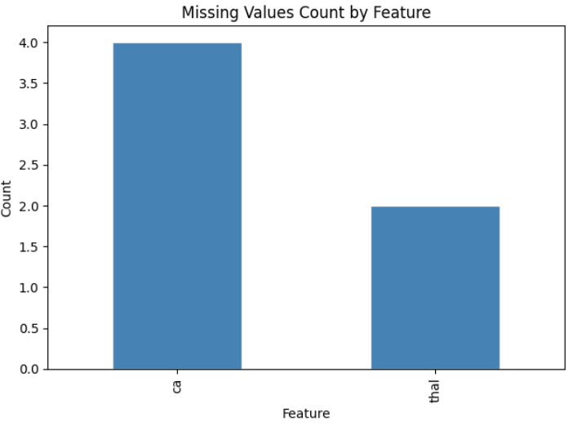
Figure 1: Missing Values Count for Features in the Dataset

4. ETHICAL CONSIDERATIONS
The Cleveland Heart Disease dataset is fully anonymised; patient names and social security numbers were removed prior to public release and replaced with dummy values (Detrano et al., 1989). The dataset is publicly available through the UCI Machine Learning Repository under a Creative Commons Attribution 4.0 International licence (CC BY 4.0), which permits academic use with attribution.
No human participants were directly involved in this study. All analyses were performed on pre-existing, de-identified data.
From a practical standpoint, any machine learning model intended for deployment in a clinical setting must be subjected to rigorous independent validation before clinical use. The models developed in this study are intended for research purposes only and should not be used as substitutes for professional medical diagnosis. Risks include demographic bias — the Cleveland dataset was collected at a single institution in the United States and may not generalise to other populations, particularly those with different age distributions, ethnicities, or clinical practices.
The use of explainable AI (SHAP) partially addresses ethical concerns around transparency, as it allows clinicians and patients to understand which features drove a given prediction, supporting informed consent and professional oversight.

5.METHODOLOGY
5.1 Data Preprocessing
Data preprocessing was performed in the following order, consistent with the implementation in the Jupyter notebook:
(1) loading the raw data with missing values marked as NaN.
(2) binarising the target variable.
(3) dropping the six rows with missing values.
(4) performing a stratified train-test split.
(5) applying SMOTE to the training set.
(6) scaling features for Logistic Regression.
5.1.1 Target Variable Binarisation
The target variable was transformed from its original ordinal scale (0–4) to a binary label: 0 (no disease) and 1 (presence of disease). All values greater than zero were mapped to 1, consistent with Cleveland dataset literature and implemented as: df['target'] = df['target'].apply(lambda x: 1 if x > 0 else 0).
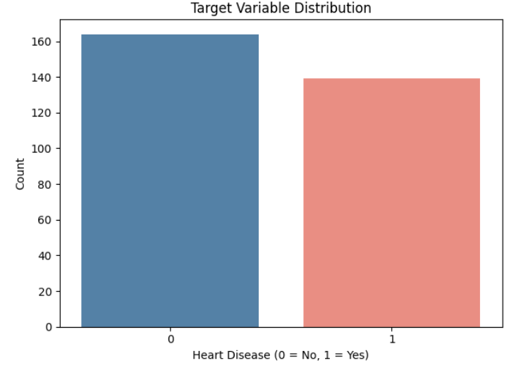
Figure 2: Target variable distribution
5.1.2 Handling Missing Values
Six rows containing missing values in ca and thal were removed after target binarisation. These features are categorical, making mean imputation methodologically inappropriate. Removal was performed prior to train-test splitting to prevent any information from missing-value rows leaking into the test set.
5.1.3 Train-Test Split
The cleaned dataset (297 records) was divided into training (80%, 237 records) and testing (20%, 60 records) sets using stratified sampling to preserve the class distribution in both subsets. Stratification ensures that the proportion of positive and negative cases is consistent across the split, which is particularly important given the moderate class imbalance.
5.1.4 SMOTE — Class Imbalance Handling
SMOTE (Synthetic Minority Over-sampling Technique) was applied to the training set only, after the train-test split, to prevent synthetic samples from appearing in the test set. SMOTE works by creating new minority-class samples by interpolating between existing minority observations and their k-nearest neighbours. The class distribution was examined before and after SMOTE to quantify the effect of resampling on training set balance.
Three model stages were subsequently compared: (1) No SMOTE — models trained on the raw imbalanced training set; (2) SMOTE before tuning — models trained on SMOTE-balanced data with default hyperparameters; (3) SMOTE + GridSearchCV tuning — the final tuned models.
5.1.5 Feature Scaling
Continuous numerical features were standardised using StandardScaler (zero mean, unit variance) for Logistic Regression, which is sensitive to feature magnitude because coefficients are estimated by gradient-based optimisation. Separate scalers were fitted: one on the SMOTE-balanced training data (X_train_sm_scaled) for the tuned Logistic Regression, and a consistent scaler applied to the test set (X_test_scaled). Random Forest and XGBoost are tree-based and invariant to monotonic feature transformations; scaling was not required for these models.
5.2 Exploratory Data Analysis (EDA)
Exploratory Data Analysis (EDA) was conducted to understand the structure of the dataset, identify patterns, detect anomalies, and guide preprocessing and model selection. The analysis included univariate analysis, bivariate analysis, categorical feature analysis, correlation analysis, and outlier detection.
5.2.1 Univariate Analysis
Univariate analysis was performed to examine the distribution of individual features. Histograms with KDE overlays were generated for numerical variables such as age, cholesterol, resting blood pressure, maximum heart rate, and ST depression.
The distribution of age appeared approximately normal, indicating balanced representation across age groups. Cholesterol values showed right-skewness, suggesting the presence of higher cholesterol levels in a subset of patients. Maximum heart rate displayed a wide distribution, which may contribute significantly to classification. ST depression values were concentrated at lower levels, indicating that severe ST depression occurs less frequently.
These observations helped determine that feature scaling would be necessary for numerical variables to ensure consistent model performance.
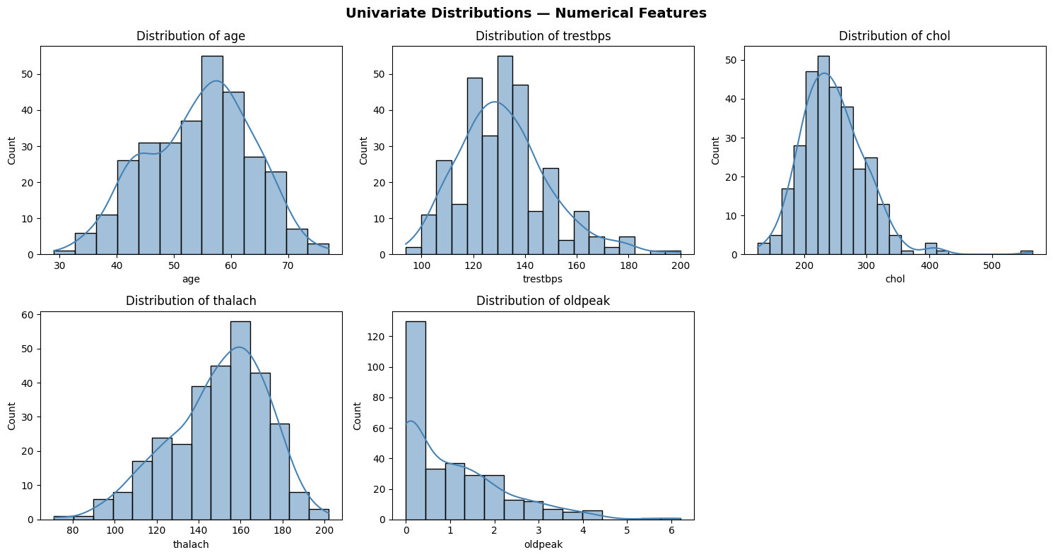
Figure 3: Univariate analysis over numerical features
5.2.2 Bivariate Analysis
Bivariate analysis was performed to examine the relationship between numerical features and heart disease status. Boxplots were used to compare the distributions of age, resting blood pressure, cholesterol, maximum heart rate achieved (thalach), and oldpeak for patients with and without heart disease.
The results showed that patients with heart disease generally had higher age and oldpeak values compared to those without heart disease. In contrast, patients with heart disease tended to have lower maximum heart rate (thalach) values. Resting blood pressure and cholesterol showed some differences between the two groups, although the distributions overlapped considerably.
Among the numerical features, thalach and oldpeak showed the clearest differences between patients with and without heart disease, suggesting that these variables may be important predictors in the classification models.
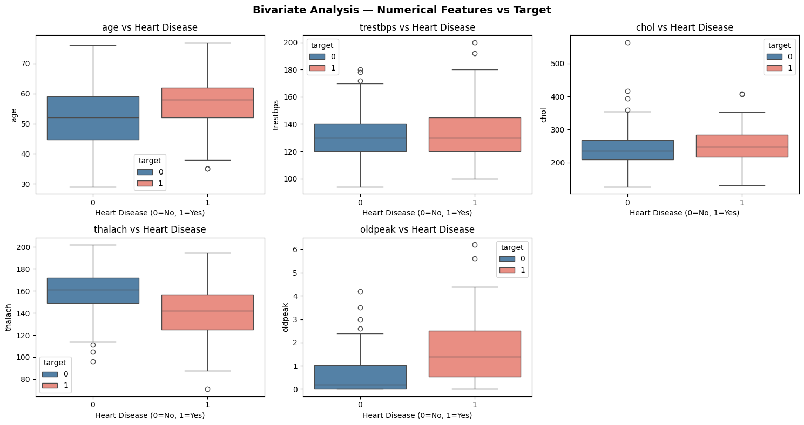
Figure 4: Bivariate analysis over numerical features
5.2.3 Categorical Feature Analysis
Count plots were generated for sex, chest pain type (cp), exercise-induced angina (exang), slope, and thal. The analysis showed that chest pain type and exercise-induced angina were strongly associated with heart disease. Differences were also observed in the distributions of slope and thal between the two classes. These findings suggest that categorical features provide useful information for heart disease prediction and were retained for modelling.
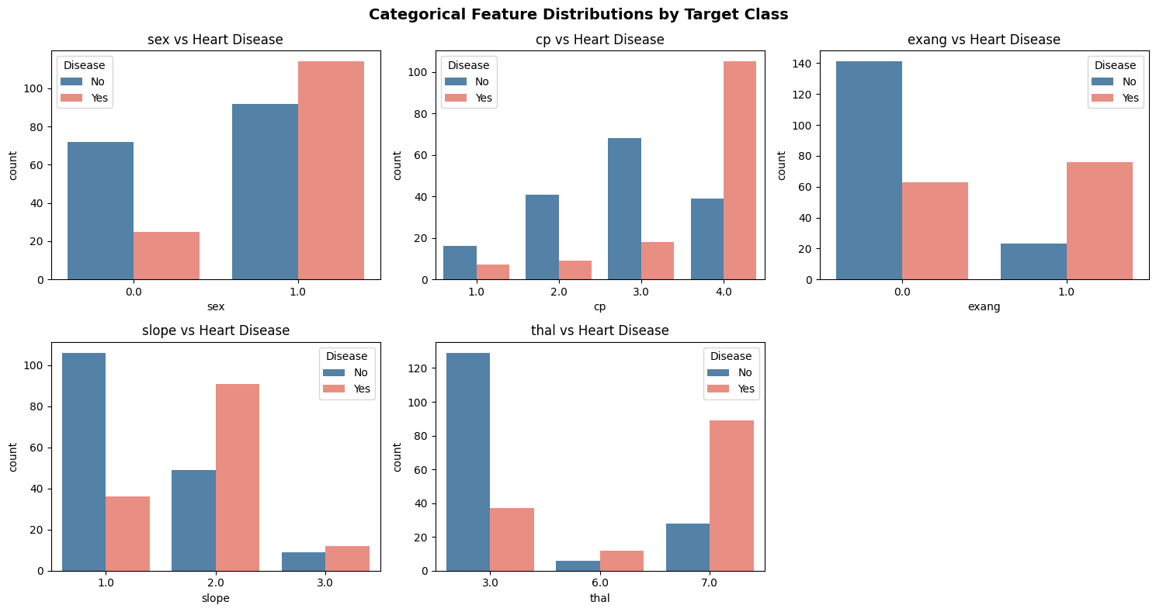
Figure 5: Categorical Feature analysis by Target class

5.2.4 Correlation Analysis
A Pearson correlation heatmap was generated to examine relationships between features and the target variable. The results showed that thal (-0.53), ca (0.46), oldpeak (0.42), exang (0.42), and chest pain type (cp) (0.41) had the strongest associations with heart disease. Maximum heart rate (thalach) showed a moderate negative correlation with the target (-0.42), indicating that lower heart rates were associated with a higher likelihood of heart disease.
Most feature pairs exhibited low to moderate correlations, suggesting limited multicollinearity within the dataset. Therefore, all features were retained for model training.
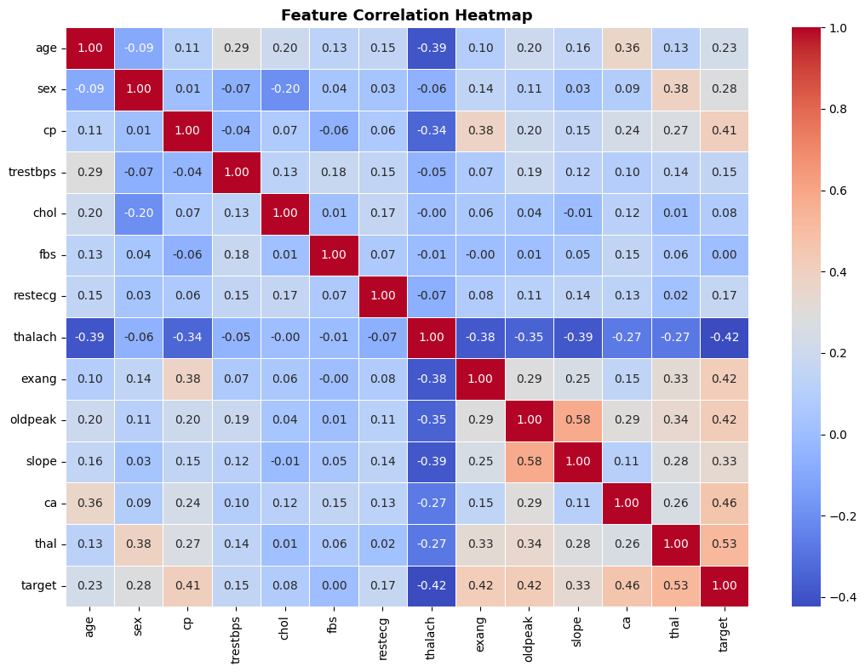
Figure 6: Correlation analysis heatmap for numerical variables
5.2.5 Outlier Analysis
Box plots were used to identify potential outliers in the numerical features. Outliers were observed mainly in cholesterol (chol), resting blood pressure (trestbps), and oldpeak. However, these values were retained because they represent realistic clinical measurements and may contain important information for predicting heart disease. No outlier removal was performed during data preprocessing.
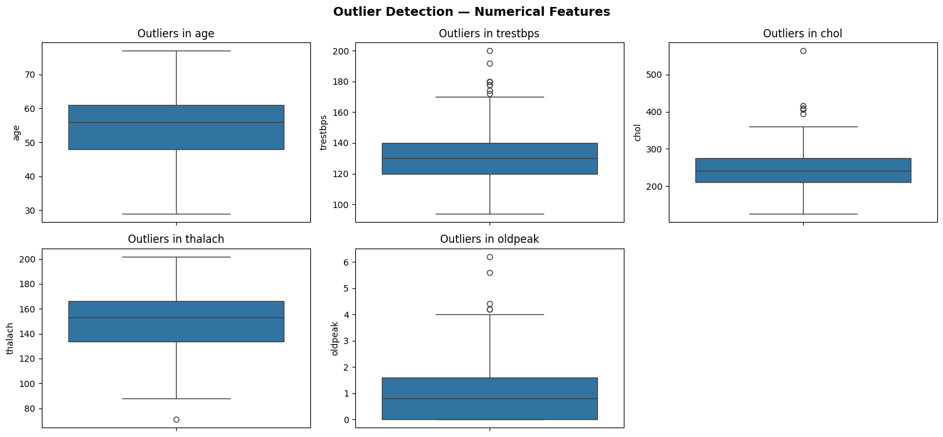
Figure 7: Outlier analysis for numerical variable
5.2.6 EDA Summary
Key findings: cp (chest pain type) and thalach (maximum heart rate) show the strongest visual separation between classes. oldpeak and ca are notably higher in disease-positive patients. Missing values exist only in ca (4) and thal (2) — handled by complete-case deletion. Mild class imbalance is present and is addressed with SMOTE in the modelling stage. These findings directly inform preprocessing choices and model selection.
5.3 Model Selection
Three models were selected to represent different learning paradigms: Logistic Regression (linear baseline), Random Forest (ensemble bagging), and XGBoost (ensemble boosting). This selection enables systematic comparison across model complexity while remaining interpretable through SHAP.
5.3.1 Logistic Regression
Logistic Regression models the probability of a binary outcome by applying the sigmoid function to a linear combination of input features. Each coefficient represents the change in log-odds of disease for a one-unit increase in that feature. It serves as the interpretable baseline: coefficients are directly readable as log-odds ratios, and LinearExplainer enables exact SHAP computation. Key hyperparameter: max_iter=1000 to ensure convergence.
5.3.2 Random Forest
Random Forest constructs multiple independent decision trees on bootstrap samples of the training data. At each node, only a random subset of features is considered. This double injection of randomness — in data sampling and feature selection — decorrelates trees, reducing variance compared to a single decision tree without significantly increasing bias. It handles nonlinear relationships without feature scaling and provides built-in feature importances that complement SHAP analysis. Key hyperparameters tuned: n_estimators, max_depth, min_samples_split, max_features, min_samples_leaf.
5.3.3 XGBoost
XGBoost (Extreme Gradient Boosting) builds trees sequentially, with each new tree correcting the residual errors of the current ensemble. It minimises a regularised objective function combining log-loss and a regularisation term penalising model complexity. Shrinkage (learning rate) and subsampling further control overfitting. Unlike Random Forest, XGBoost focuses successive trees on the hardest-to-predict samples, making it particularly effective on complex or imbalanced datasets. Key hyperparameters tuned: n_estimators, max_depth, learning_rate, subsample.
5.4 Model Evaluation Metrics
Five classification metrics were used to evaluate model performance comprehensively. Given the clinical context, recall and ROC-AUC were prioritised, as false negatives (patients with heart disease classified as healthy) are the most dangerous error type.
- Accuracy – Overall correctness.
$$Accuracy=\frac{TP+TN}{TP+TN+FP+FN}$$
- Precision – Predicted Positives, how many are truly positive.
$$Precision=\frac{TP}{TP+FP}$$

- Recall (Sensitivity) – Actual positives, how many are correctly identified. Most clinically critical metric in this context.
$$Recall=\frac{TP}{TP+FN}$$
- F1-Score – Harmonic mean balancing precision and recall.
$$F1=2⋅\frac{Precision⋅Recall}{Precision+Recall}$$
- ROC-AUC – Threshold-independent measure of model discrimination; used as the primary optimisation metric in GridSearchCV.
Confusion matrices were also generated for all three tuned models side by side, using ConfusionMatrixDisplay.from_predictions, to visualise the distribution of true positives, true negatives, false positives, and false negatives.
5.5 Hyperparameter Tuning
All three models were tuned using GridSearchCV with 5-fold cross-validation on the SMOTE-balanced training data. ROC-AUC was used as the scoring metric throughout, as it is threshold-independent and appropriate for imbalanced binary classification. Tuning was performed after SMOTE to ensure models learned from a balanced class distribution during cross-validation.
For Logistic Regression, the search space covered: C (0.001, 0.01, 0.1), penalty (L1, L2), solver (liblinear). The liblinear solver was used as it supports both L1 and L2 penalties and is efficient for small datasets.
For Random Forest, the hyperparameter grid covered: n_estimators (100, 200, 300), max_depth (None, 4, 6, 8), min_samples_split (2, 5, 10), max_features (sqrt, log2), min_samples_leaf (1, 2, 4).
For XGBoost, the grid covered: n_estimators (100, 200), max_depth (3, 4, 5), learning_rate (0.01, 0.05, 0.1), subsample (0.7, 0.85, 1.0).
5.6 Explainable AI using SHAP (Shapley Additive Explanations)
To improve model interpretability, SHAP (SHapley Additive Explanations) was applied to the tuned Logistic Regression, Random Forest, and XGBoost models. SHAP assigns each feature a contribution value, enabling the identification of variables that most strongly influence model predictions.
The SHAP feature importance analysis revealed that thal, ca, cp, exang, and oldpeak were the most influential predictors of heart disease. Among these, thal had the highest average impact on model predictions, followed by ca and cp. In contrast, fasting blood sugar (fbs), cholesterol (chol), and age had relatively low contributions to the final predictions.
The SHAP summary plots provided additional insights into the direction of feature effects. Higher values of thal, ca, oldpeak, and exang generally increased the probability of heart disease, while higher values of thalach tended to reduce it. This finding is consistent with the correlation analysis, where thalach showed a negative correlation with the target variable. Similarly, elevated oldpeak values were associated with a higher likelihood of heart disease, indicating the importance of ST-segment depression in cardiovascular diagnosis.
A comparison of SHAP results across the three models showed strong agreement regarding the most important features. All models consistently identified thal, ca, cp, thalach, and oldpeak as key predictors, demonstrating the robustness of these findings. The consistency between model architectures increases confidence that the models are learning clinically meaningful patterns rather than relying on random correlations.
Overall, the SHAP analysis improved transparency by explaining how individual features influenced predictions and by highlighting the clinical factors most strongly associated with heart disease. These results support the reliability and interpretability of the developed machine learning models for healthcare decision-support applications.

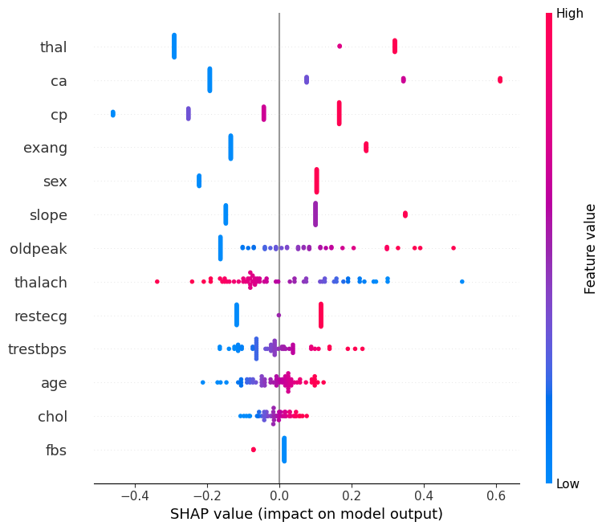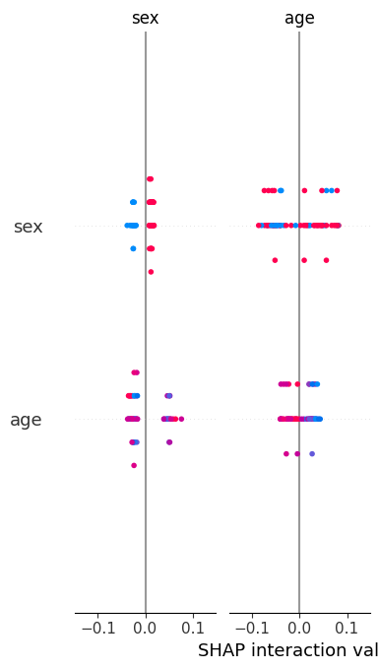
Figure 8: SHAP Summary Plot for LR Figure 9: SHAP Summary Plot RF
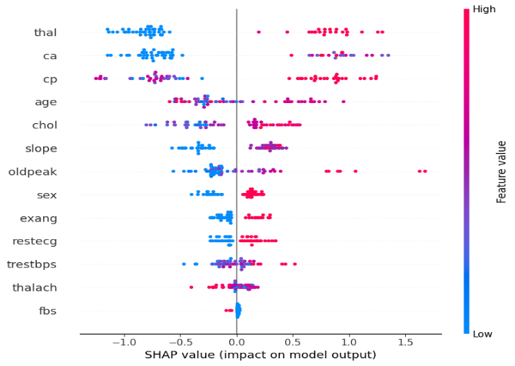
Figure 10: SHAP Summary Plot XGBoost

6. RESULTS
6.1 Comprehensive Model Performance Comparison
All three models were evaluated at three stages: (1) No SMOTE — trained on the raw imbalanced training set with default hyperparameters; (2) SMOTE before tuning — trained on SMOTE-balanced data with default hyperparameters; (3) SMOTE + Tuned — trained on SMOTE-balanced data with GridSearchCV-optimised hyperparameters.
Model | Stage | Accuracy | Precision | Recall | F1-Score | ROC-AUC
Logistic Regression | No SMOTE | 0.8333 | 0.8462 | 0.7857 | 0.8148 | 0.9487
Logistic Regression | SMOTE (Before Tuning) | 0.8333 | 0.8462 | 0.7857 | 0.8148 | 0.9464
Logistic Regression | SMOTE + Tuned | 0.8500 | 0.8519 | 0.8214 | 0.8364 | 0.9464
Random Forest | No SMOTE | 0.8667 | 0.8846 | 0.8214 | 0.8519 | 0.9453
Random Forest | SMOTE (Before Tuning) | 0.8333 | 0.8750 | 0.7500 | 0.8077 | 0.9275
Random Forest | SMOTE + Tuned | 0.8000 | 0.8333 | 0.7143 | 0.7692 | 0.9509
XGBoost | No SMOTE | 0.8667 | 0.8846 | 0.8214 | 0.8519 | 0.8917
XGBoost | SMOTE (Before Tuning) | 0.8667 | 0.8846 | 0.8214 | 0.8519 | 0.9051
XGBoost | SMOTE + Tuned | 0.8667 | 0.8846 | 0.8214 | 0.8519 | 0.9196

Table 3: Comprehensive model comparison across all three stages
Table 3 summarises the performance of Logistic Regression, Random Forest, and XGBoost before and after applying SMOTE and hyperparameter tuning.
Logistic Regression showed a slight improvement after tuning, with accuracy increasing from 83.33% to 85.00% and recall improving from 78.57% to 82.14%. Random Forest achieved strong baseline performance but experienced a decrease in accuracy after SMOTE and tuning, although it produced the highest ROC-AUC score of 0.9509.
XGBoost demonstrated the most consistent performance across all stages, maintaining an accuracy of 86.67%, precision of 88.46%, recall of 82.14%, and F1-score of 0.8519. Its ROC-AUC also improved after tuning from 0.8917 to 0.9196.
Overall, XGBoost provided the best balance between accuracy, precision, recall, and F1-score, while Random Forest achieved the highest ROC-AUC value. These results indicate that ensemble learning methods are effective for heart disease prediction, with XGBoost emerging as the most reliable model for this dataset.
6.2 ROC Curve Analysis
Figure 11 compares the ROC curves of the tuned Logistic Regression, Random Forest, and XGBoost models. All three models achieved high ROC-AUC values, indicating strong ability to distinguish between patients with and without heart disease.
Random Forest achieved the highest ROC-AUC score (0.951), followed closely by Logistic Regression (0.946). XGBoost obtained a ROC-AUC of 0.920, which also indicates good classification performance. All curves lie well above the diagonal reference line representing random classification, demonstrating that the models perform substantially better than chance.
Overall, the ROC analysis confirms that all three models are effective for heart disease prediction, with Random Forest showing the strongest discrimination ability among the tuned models.
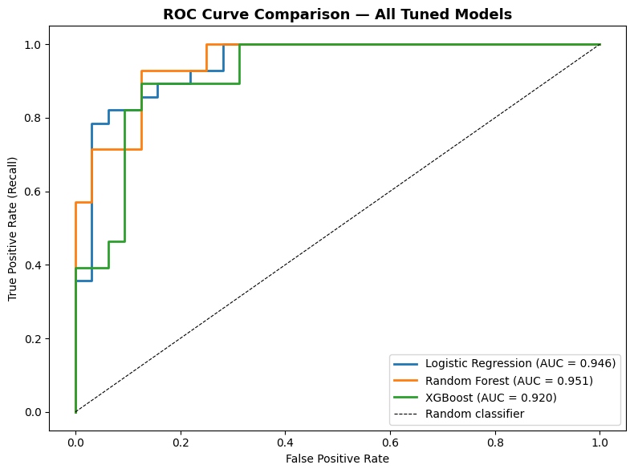
Figure 11: ROC Curve Comparison of Tuned Logistic Regression, Random Forest, and XGBoost Models.
6.3 Confusion Matrix Analysis
Figure 12 presents the confusion matrices for the tuned Logistic Regression, Random Forest, and XGBoost models. Logistic Regression correctly classified 28 non-disease cases and 23 disease cases, with 4 false positives and 5 false negatives. XGBoost achieved similar performance, correctly identifying 29 non-disease cases and 23 disease cases while producing only 3 false positives and 5 false negatives.
Random Forest correctly classified 28 non-disease cases and 20 disease cases but generated 8 false negatives, indicating that more patients with heart disease were incorrectly classified as healthy. In healthcare applications, false negatives are particularly important because they may lead to missed diagnoses and delayed treatment.
Overall, XGBoost produced the most favourable confusion matrix by maintaining a high number of correct classifications while generating the fewest false positives. This result supports its strong overall performance and suitability for heart disease prediction.
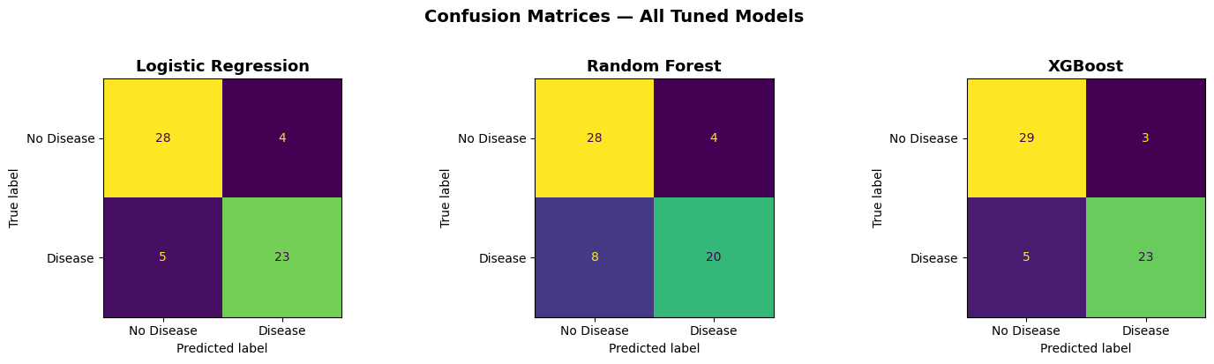
Figure 12: Confusion Matrices
6.4 SHAP Explainability Results
SHAP analysis was applied to the tuned Logistic Regression, Random Forest, and XGBoost models to identify the features that contributed most to heart disease predictions. The SHAP feature importance plots showed that thal, ca, cp, exang, and oldpeak were among the most influential predictors across the models, while fasting blood sugar (fbs) had the lowest impact.
The SHAP summary plots further revealed how feature values influenced predictions. Higher values of thal, ca, oldpeak, and exang generally increased the likelihood of heart disease, whereas higher values of thalach were associated with a lower predicted risk. This finding is consistent with the correlation analysis and established clinical knowledge.
Overall, the three models showed strong agreement regarding the most important predictors, particularly thal, ca, cp, oldpeak, and thalach. This consistency increases confidence in the reliability of the identified clinical risk factors and demonstrates that the models are learning meaningful patterns from the data rather than relying on model-specific behaviour.
6.5 Key Findings
- The three-stage comparison (No SMOTE, SMOTE before tuning, and SMOTE + tuned) enabled the impact of class balancing and hyperparameter optimisation on model performance to be evaluated.
- Logistic Regression showed improved performance after tuning, achieving an accuracy of 85.00% and a ROC-AUC of 0.9464.
- Random Forest achieved the highest ROC-AUC score (0.9509), demonstrating strong discrimination between patients with and without heart disease.
- XGBoost provided the most consistent overall performance, maintaining an accuracy of 86.67%, precision of 88.46%, recall of 82.14%, and F1-score of 0.8519 after tuning.
- SHAP analysis consistently identified thal, ca, cp, oldpeak, and thalach as the most influential predictors of heart disease across the models.
- The strong agreement between the models on the most important features increases confidence in the reliability of the identified clinical risk factors and demonstrates the robustness of the explainability results.

7. ANALYSIS AND DISCUSSION
7.1 Interpretation of Results
The results demonstrate that machine learning models can effectively predict heart disease using clinical features from the Cleveland Heart Disease dataset. All three models achieved strong classification performance, with ROC-AUC values above 0.90 after optimisation. This indicates that the selected clinical variables contain sufficient information to distinguish between patients with and without heart disease.
Among the evaluated models, XGBoost achieved the best overall balance of accuracy, precision, recall, and F1-score, while Random Forest achieved the highest ROC-AUC score. Logistic Regression also produced competitive results despite its simpler structure, suggesting that the dataset contains both linear and non-linear relationships.
7.2 Effect of SMOTE
SMOTE was applied to the training data to address class imbalance by generating synthetic minority-class samples. Before SMOTE, the training data contained 128 negative cases and 109 positive cases. After applying SMOTE, both classes contained 128 observations.
The use of SMOTE improved class representation during training and helped reduce bias towards the majority class. This contributed to more balanced model learning and supported the identification of patients with heart disease.
7.3 Model Comparison
Logistic Regression achieved strong performance with a ROC-AUC of 0.9464 after tuning and provided a highly interpretable baseline model. Random Forest achieved the highest ROC-AUC score (0.9509), demonstrating excellent discrimination between classes. However, its recall was lower than that of XGBoost.
XGBoost produced the most consistent overall results, achieving an accuracy of 86.67%, precision of 88.46%, recall of 82.14%, and F1-score of 85.19%. These results suggest that XGBoost offers the best balance between identifying positive cases and minimising false predictions.
7.4 Clinical Relevance
The identified predictors are consistent with established cardiovascular risk factors. Features such as chest pain type, maximum heart rate achieved, ST depression, number of major vessels, and thalassemia have well-documented associations with heart disease.
From a clinical perspective, recall is particularly important because false negatives may result in patients with heart disease being incorrectly classified as healthy. Therefore, models that maintain high recall while preserving overall accuracy are preferable for healthcare applications.
7.5 Explainability Discussion
SHAP analysis improved model transparency by explaining how individual features influenced predictions. Across all three models, thal, ca, cp, oldpeak, and thalach were consistently identified as the most important predictors of heart disease.
The strong agreement between Logistic Regression, Random Forest, and XGBoost increases confidence in these findings and suggests that the models learned clinically meaningful patterns rather than relying on model-specific behaviour. The consistency between the SHAP results, correlation analysis, and exploratory data analysis further supports the reliability of the developed models.
Overall, the combination of strong predictive performance and explainability highlights the potential of machine learning as a healthcare decision-support tool for heart disease risk assessment.
7.6 Limitations
Despite achieving strong predictive performance, this study has several limitations. First, the dataset was relatively small, containing only 303 patient records, which may limit the generalisability of the findings to broader and more diverse populations. Second, SMOTE generates synthetic minority-class samples, which may not fully represent real clinical cases and could introduce artificial patterns into the training data. Finally, the dataset is cross-sectional in nature and therefore cannot be used to establish causal relationships between risk factors and heart disease outcomes.

8. CONCLUSION
This study presented a comparative framework for heart disease risk prediction using three machine learning models: Logistic Regression, Random Forest, and XGBoost. The methodology incorporated SMOTE for class balancing, GridSearchCV with five-fold cross-validation for hyperparameter optimisation, and SHAP for model explainability.
A three-stage evaluation framework (No SMOTE, SMOTE before tuning, and SMOTE + tuned) was used to assess the impact of class balancing and hyperparameter optimisation on model performance. Logistic Regression achieved strong predictive performance with a ROC-AUC of 0.9464, while Random Forest achieved the highest ROC-AUC score of 0.9509. XGBoost demonstrated the most consistent overall performance, maintaining high accuracy (86.67%), precision (88.46%), recall (82.14%), and F1-score (85.19%) after tuning.
SHAP analysis identified thal, ca, cp, oldpeak, and thalach as the most influential predictors of heart disease across the models. The consistency of these findings across different model architectures increases confidence in their clinical relevance and supports established cardiovascular knowledge.
Overall, the results demonstrate that machine learning models can effectively predict heart disease risk using routinely collected clinical data. The combination of predictive performance and explainability highlights the potential of these models as decision-support tools for healthcare applications.

9. FUTURE WORK
- Validate the proposed models on larger, multi-centre datasets such as MIMIC-III and UK Biobank to improve generalisability across diverse patient populations.
- Explore deep learning approaches with built-in attention mechanisms and explainability, such as TabNet, and compare their performance with traditional machine learning models.
- Investigate LIME alongside SHAP to provide additional local explanations and assess the consistency of feature importance across explainability techniques.
- Evaluate model fairness and bias across demographic groups, such as age and sex, to ensure equitable performance in clinical applications.
- Apply repeated stratified k-fold cross-validation to obtain more robust performance estimates and reduce the impact of a single train-test split.
- Develop ensemble or stacking approaches that combine Logistic Regression, Random Forest, and XGBoost to determine whether predictive performance can be further improved.
- Deploy the final model as a clinical decision-support web application using frameworks such as Streamlit or Flask, incorporating real-time predictions and patient-level SHAP explanations for healthcare professionals.

REFERENCES
[1] Breiman, L. (2001) 'Random Forests', Machine Learning, 45(1), pp. 5–32. Available at: https://doi.org/10.1023/A:1010933404324
[2] Chen, T. and Guestrin, C. (2016) 'XGBoost: A scalable tree boosting system', Proceedings of the 22nd ACM SIGKDD International Conference on Knowledge Discovery and Data Mining, San Francisco, CA, 13–17 August 2016, pp. 785–794. Available at: https://doi.org/10.1145/2939672.2939785
[3] Janosi, A., Steinbrunn, W., Pfisterer, M. and Detrano, R. (1989) Heart Disease [Dataset]. UCI Machine Learning Repository. Available at: https://doi.org/10.24432/C52P4X
[4] Lundberg, S.M., Erion, G., Chen, H., DeGrave, A., Prutkin, J.M., Nair, B. and Lee, S.I. (2020) 'From local explanations to global understanding with explainable AI for trees', Nature Machine Intelligence, 2(1), pp. 56–67. Available at: https://doi.org/10.1038/s42256-019-0138-9
[5] Nahar, N. et al. (2026) 'Stacked ensemble model with explainable AI for early detection of heart disease', Analytical Science Advances. Available at: https://doi.org/10.1002/ansa.70072
[6] Banerjee, T. and Paçal, İ. (2025) ‘A systematic review of machine learning in heart disease prediction’, Turkish Journal of Biology, 49(5), pp. 600–634. Available at: https://doi.org/10.55730/1300-0152.2766
[7] Soni, J., Ansari, U., Sharma, D. and Soni, S. (2011) 'Predictive data mining for medical diagnosis: An overview of heart disease prediction', International Journal of Computer Applications, 17(8), pp. 43–48.
[8] Raman, S., Thakkar, D., Calixte, J., Kumar, R., Sporn, K., Marla, K., Goel, D., Gopali, R., Chetla, N., Pasha, S., Ravisankar, N., Lee, R. and Ionita, C. (2026) ‘Machine learning for coronary heart disease prediction: Comparative analysis of Framingham and Cleveland subset of the UCI dataset with SHAP-based interpretability’, Epidemiologia, 7(3), 75. Available at: https://doi.org/10.3390/epidemiologia7030075
[9] Yang, J. and Guan, X. (2022) 'A heart disease prediction model based on feature optimisation and SMOTE-XGBoost algorithm', Information, 13(10), p. 475. Available at: https://doi.org/10.3390/info13100475

APPENDIX
Code link: https://colab.research.google.com/github/kakarlarenusree/renu_project_Heart-Disease-Risk-Prediction/blob/main/heartdisease_final_d.ipynb
Figure A: shows the class distribution of the training data before and after the application of SMOTE. The technique generated synthetic minority-class observations to balance the dataset, reducing the impact of class imbalance during model training while maintaining a realistic test set for evaluation.
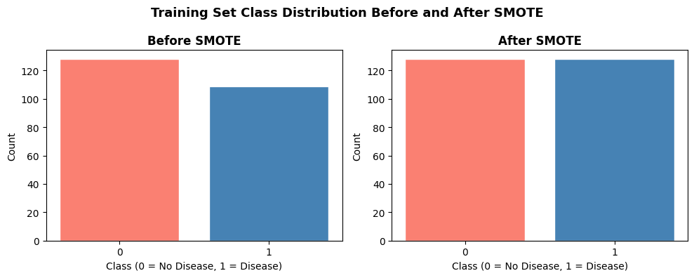
Fig A: Before Smote / After Smote
Effect of SMOTE and Hyperparameter Tuning
Figure B illustrates the impact of SMOTE and hyperparameter tuning on ROC-AUC and recall across the three machine learning models. The ROC-AUC scores remained consistently high across all stages, indicating strong classification performance regardless of preprocessing and optimisation techniques.
For Logistic Regression, hyperparameter tuning resulted in a slight improvement in recall while maintaining a high ROC-AUC score. Random Forest achieved the highest ROC-AUC after tuning; however, recall decreased compared with the baseline model. XGBoost maintained stable performance across all stages, with only minor changes in ROC-AUC and recall.
Overall, the results suggest that SMOTE and hyperparameter tuning influenced model behaviour differently depending on the algorithm. While the improvements were modest due to the relatively balanced dataset, these techniques contributed to more robust model development and enabled a fair comparison between models.
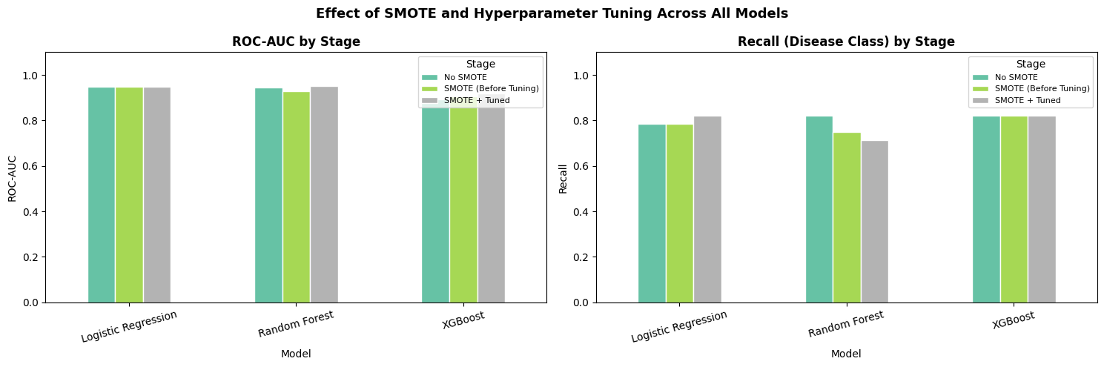
Figure B. Effect of SMOTE and Hyperparameter Tuning on ROC-AUC and Recall Across Logistic Regression, Random Forest, and XGBoost.

Comparative SHAP Analysis
Figure C compares the mean absolute SHAP values across Logistic Regression, Random Forest, and XGBoost. The results show strong agreement between the models regarding the most influential predictors of heart disease.
Across all three models, thal, ca, and cp consistently ranked among the most important features. XGBoost assigned the highest importance to these variables, while Logistic Regression and Random Forest identified similar patterns with lower SHAP magnitudes. Features such as oldpeak, slope, and exang also demonstrated notable contributions to model predictions. In contrast, fasting blood sugar (fbs) had the lowest importance across all models.
The consistency of feature rankings across different model architectures suggests that the identified predictors are robust and clinically meaningful. This agreement increases confidence in the reliability of the explainability results and supports the use of these features for heart disease risk prediction.
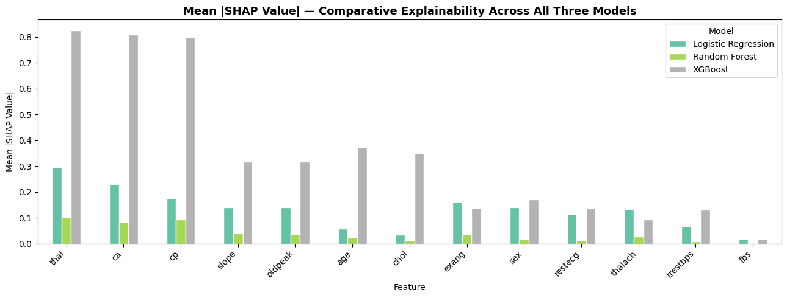
Figure C. Comparison of Mean Absolute SHAP Values Across Logistic Regression, Random Forest, and XGBoost Models.

