MAINCRAFTS TECHNOLOGY
TASK 2

“SMART TEMPERATURE
MONITORING SYSTEM”
Using Arduino Uno, TMP36 Sensor and 16×2 LCD

Submitted by
Yuvashri

1. Introduction
Temperature monitoring is a common embedded-systems application used to observe environmental conditions and generate a status indication when a measured value enters a defined range. This project implements a Smart Temperature Monitoring System in Tinkercad using an Arduino Uno, a TMP36 analog temperature sensor, and a 16×2 LCD. The program reads the sensor output, calculates temperature in degrees Celsius, and presents the reading and status on the LCD and Serial Monitor.

2. Objectives
- Set up and use an online embedded-circuit simulation environment.
- Interface an analog temperature sensor with a microcontroller analog input.
- Convert the analog-to-digital converter (ADC) reading into voltage and temperature.
- Display temperature readings on a 16×2 LCD and in the Serial Monitor.
- Implement NORMAL, WARNING, and CRITICAL status categories using temperature thresholds.

3. Components and Tools
Component / Tool | Purpose
Arduino Uno R3 | Reads the analog sensor value and executes the monitoring logic.
TMP36 temperature sensor | Produces an analog voltage related to temperature.
16×2 LCD | Displays the temperature and status message.
Potentiometer | Used to adjust LCD contrast in the circuit.
Resistor and jumper wires | Support circuit connections as implemented in the simulation.
Tinkercad Circuits | Online environment used to build and test the circuit.
Arduino C/C++ and LiquidCrystal library | Program the controller and drive the character LCD.

4. Circuit Diagram
Figure 1 shows the circuit created in Tinkercad. The TMP36 output is read through analog input A0. The LCD is controlled in 4-bit mode using Arduino digital pins 12, 11, 5, 4, 3, and 2, in the order RS, E, D4, D5, D6, and D7, as specified in the source code.
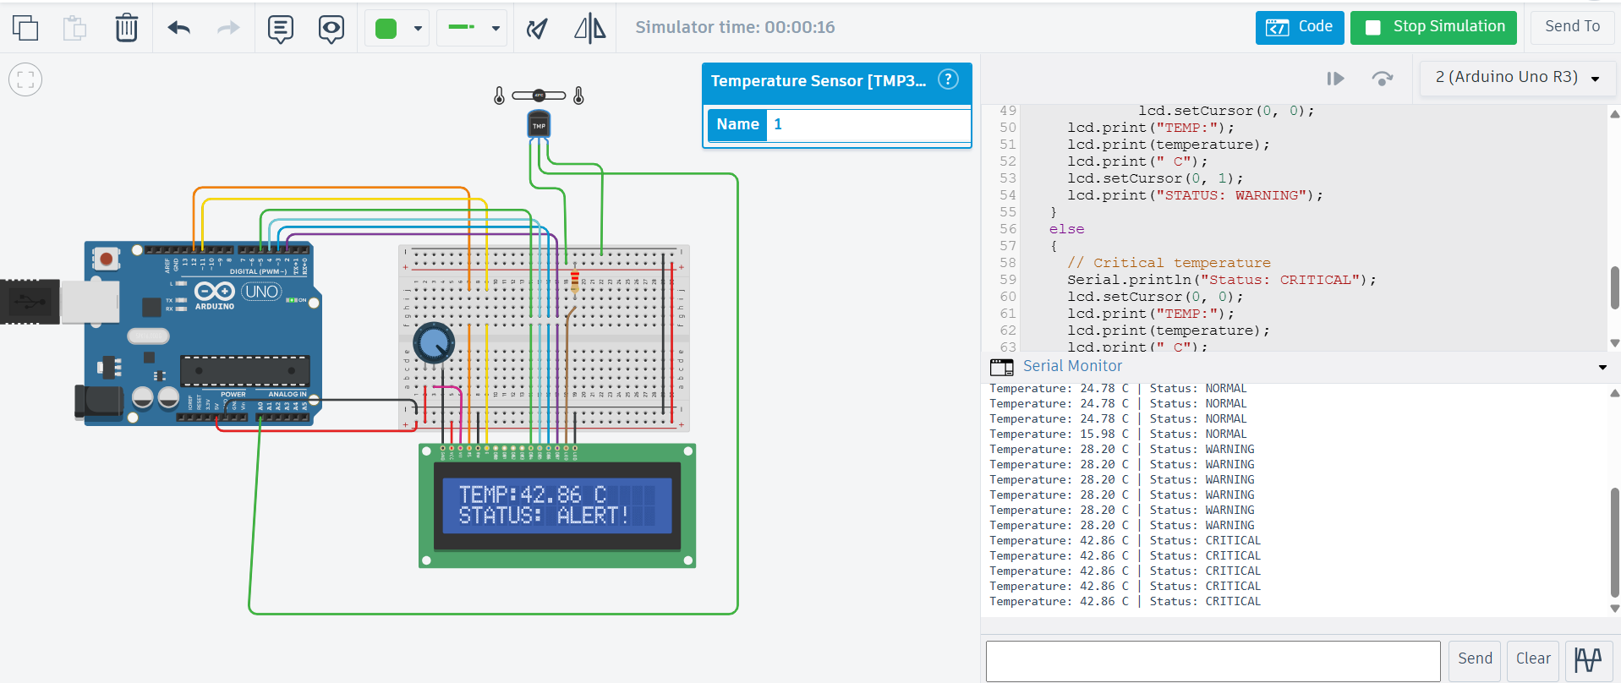

Figure 1. Smart Temperature Monitoring System circuit in Tinkercad.

5. Working Principle
The TMP36 sensor produces an output voltage that changes with temperature. The Arduino Uno reads this voltage through A0 using its 10-bit ADC. For the standard 5 V reference used in the program, the code estimates the input voltage as:
Voltage = ADC reading × (5.0 / 1023.0)
The TMP36 temperature conversion used in the program is:
Temperature (°C) = (Voltage − 0.5) × 100
After calculating the temperature, the program compares it with the configured limits. A reading below 25.0°C is labelled NORMAL. A reading from 25.0°C through 35.0°C is labelled WARNING. A reading above 35.0°C is labelled CRITICAL in the Serial Monitor and shown as ALERT! on the LCD. The program takes a new reading every 1,000 milliseconds.

6. Program Logic
- Initialize serial communication at 9600 baud and initialize the 16×2 LCD.
- Display a startup message for two seconds.
- Read the analog sensor value from A0.
- Convert the ADC value to voltage and then to temperature in Celsius.
- Print the temperature and status to the Serial Monitor.
- Display the temperature and corresponding status on the LCD.
- Wait one second and repeat the process.

7. Source Code
The following is the source code provided for this project. It is reproduced here for reference.
#include <LiquidCrystal.h>

// TMP36 connected to A0
const int temperaturePin = A0;

// LCD pins: RS, E, D4, D5, D6, D7
LiquidCrystal lcd(12, 11, 5, 4, 3, 2);

void setup()
{
// Initialize Serial Monitor
Serial.begin(9600);

// Initialize LCD
lcd.begin(16, 2);

// Startup message
lcd.setCursor(0, 0);
lcd.print("SMART TEMP");
lcd.setCursor(0, 1);
lcd.print("MONITOR");

Serial.println("Smart Temperature Monitor");
delay(2000);
lcd.clear();
}

void loop()
{
// Read TMP36 analog value
int sensorValue = analogRead(temperaturePin);

// Convert ADC reading into voltage
float voltage = sensorValue * (5.0 / 1023.0);

// Convert voltage into temperature in Celsius
float temperature = (voltage - 0.5) * 100.0;

// Display temperature in Serial Monitor
Serial.print("Temperature: ");
Serial.print(temperature);
Serial.print(" C | ");

lcd.clear();

if (temperature < 25.0)
{
// Normal temperature
Serial.println("Status: NORMAL");
lcd.setCursor(0, 0);
lcd.print("TEMP:");
lcd.print(temperature);
lcd.print(" C");
lcd.setCursor(0, 1);
lcd.print("STATUS: NORMAL");
}
else if (temperature <= 35.0)
{
// Warning temperature
Serial.println("Status: WARNING");
lcd.setCursor(0, 0);
lcd.print("TEMP:");
lcd.print(temperature);
lcd.print(" C");
lcd.setCursor(0, 1);
lcd.print("STATUS: WARNING");
}
else
{
// Critical temperature
Serial.println("Status: CRITICAL");
lcd.setCursor(0, 0);
lcd.print("TEMP:");
lcd.print(temperature);
lcd.print(" C");
lcd.setCursor(0, 1);
lcd.print("STATUS: ALERT!");
}

// Take a new reading every 1 second
delay(1000);
}

8. Testing and Results
The circuit was simulated in Tinkercad. The observed readings shared during testing included the following values. These are simulation observations, not measurements from physical hardware.
Observed temperature | Observed status | Expected display behavior
24.78°C | NORMAL | LCD displays temperature and STATUS: NORMAL.
28.20°C | WARNING | LCD displays temperature and STATUS: WARNING.
42.86°C | CRITICAL | LCD displays temperature and STATUS: ALERT!; Serial Monitor reports CRITICAL.

The threshold behavior in the supplied code is: NORMAL for temperature < 25.0°C; WARNING for 25.0°C ≤ temperature ≤ 35.0°C; and CRITICAL for temperature > 35.0°C. The warning and critical thresholds should be checked against the final code used in the submitted simulation.

9. Applications
- Environmental and indoor temperature monitoring.
- Temperature-based automation prototypes.
- Learning analog sensor interfacing and ADC conversion.
- Demonstrating threshold-based status reporting in embedded systems.

10. Limitations and Future Improvements
- This project was tested in simulation; physical sensor readings may vary due to wiring, calibration, supply voltage, and component tolerances.
- The current code reports status through the LCD and Serial Monitor; it does not control an alert LED or buzzer.
- Future work could add an LED or buzzer for critical temperature, improve display formatting, and transmit readings to an IoT dashboard.

11. Conclusion
The Smart Temperature Monitoring System was implemented and tested in Tinkercad using an Arduino Uno, TMP36 sensor, and 16×2 LCD. The program reads an analog input, converts the reading into temperature, and reports NORMAL, WARNING, or CRITICAL status according to programmed thresholds. The project demonstrates fundamental embedded-system skills in sensor interfacing, ADC processing, display control, serial debugging, and conditional logic.

