MAINCRAFTS TECHNOLOGY
TASK 3

SMART TEMPERATURE
CONTROL SYSTEM
Using Arduino Uno, TMP36 Sensor, LCD and Three LEDs

Submitted by
Yuvashri

1. Introduction
This project upgrades the Task 2 temperature-monitoring prototype into a smart temperature control system. An Arduino Uno reads an analog temperature signal from a TMP36 sensor, calculates temperature in degrees Celsius, and selects a status category. Three LEDs provide visual feedback: green for NORMAL, yellow for WARNING, and red for CRITICAL. The temperature and status are also displayed on a 16×2 LCD and the Serial Monitor.

2. Objectives
- Upgrade the existing temperature-monitoring prototype with automatic output control.
- Read the TMP36 analog output and convert it into temperature in degrees Celsius.
- Use IF/ELSE decision logic to classify the temperature.
- Control three LEDs automatically according to the detected temperature range.
- Display live temperature and status through the LCD and Serial Monitor.

3. Components and Tools
Component / Tool | Purpose
Arduino Uno R3 | Reads the sensor and executes the control logic.
TMP36 temperature sensor | Provides an analog voltage related to temperature.
16×2 LCD | Displays the temperature and current status.
Green LED | Indicates the NORMAL temperature range.
Yellow LED | Indicates the WARNING temperature range.
Red LED | Indicates the CRITICAL temperature range.
220 Ω resistors (one per LED) | Limit LED current.
Potentiometer | Adjusts LCD contrast.
Breadboard and jumper wires | Provide circuit connections.
Tinkercad Circuits | Used to build and simulate the circuit.

4. Circuit Diagram
Figure 1 shows the modified Tinkercad circuit. The TMP36 output is read through Arduino analog input A0. The LCD uses the LiquidCrystal library with pins RS=12, E=11, D4=5, D5=4, D6=3, and D7=2. The three LEDs are controlled through digital pins D8, D9, and D10, respectively, as assumed by the source code. Confirm the wire mapping matches these assignments before submission.
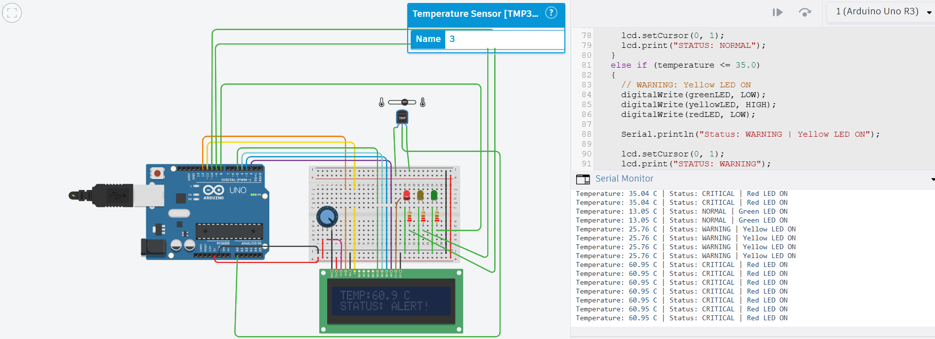

Figure 1. Modified Smart Temperature Control circuit in Tinkercad.

5. Working Principle
The TMP36 sensor produces an analog voltage that varies with temperature. The Arduino Uno's 10-bit ADC converts the input voltage into a digital reading from 0 to 1023. The program estimates voltage using the 5 V reference and calculates temperature using the TMP36 conversion formula.
Voltage = ADC reading × (5.0 / 1023.0)
Temperature (°C) = (Voltage − 0.5) × 100
The calculated temperature is compared with two thresholds. Below 25.0°C, the system sets NORMAL status and turns on the green LED. From 25.0°C through 35.0°C, it sets WARNING status and turns on the yellow LED. Above 35.0°C, it sets CRITICAL status, turns on the red LED, and displays ALERT! on the LCD. The other two LEDs are switched off in each range. A new reading is processed every second.

6. Automation Logic
- NORMAL: temperature < 25.0°C → green LED ON; yellow and red LEDs OFF.
- WARNING: 25.0°C ≤ temperature ≤ 35.0°C → yellow LED ON; green and red LEDs OFF.
- CRITICAL: temperature > 35.0°C → red LED ON; green and yellow LEDs OFF.

7. Source Code
The code below implements the three LED states and LCD/Serial Monitor feedback.
#include <LiquidCrystal.h>

const int temperaturePin = A0;
const int greenLED = 8;
const int yellowLED = 9;
const int redLED = 10;

// LCD pins: RS, E, D4, D5, D6, D7
LiquidCrystal lcd(12, 11, 5, 4, 3, 2);

void setup()
{
Serial.begin(9600);
lcd.begin(16, 2);

pinMode(greenLED, OUTPUT);
pinMode(yellowLED, OUTPUT);
pinMode(redLED, OUTPUT);

digitalWrite(greenLED, LOW);
digitalWrite(yellowLED, LOW);
digitalWrite(redLED, LOW);

lcd.setCursor(0, 0);
lcd.print("SMART TEMP");
lcd.setCursor(0, 1);
lcd.print("AUTO CONTROL");
Serial.println("Smart Temperature Control System");

delay(2000);
lcd.clear();
}

void loop()
{
int sensorValue = analogRead(temperaturePin);
float voltage = sensorValue * (5.0 / 1023.0);
float temperature = (voltage - 0.5) * 100.0;

Serial.print("Temperature: ");
Serial.print(temperature, 2);
Serial.print(" C | ");

lcd.clear();
lcd.setCursor(0, 0);
lcd.print("TEMP:");
lcd.print(temperature, 1);
lcd.print(" C");

if (temperature < 25.0)
{
digitalWrite(greenLED, HIGH);
digitalWrite(yellowLED, LOW);
digitalWrite(redLED, LOW);
Serial.println("Status: NORMAL | Green LED ON");
lcd.setCursor(0, 1);
lcd.print("STATUS: NORMAL");
}
else if (temperature <= 35.0)
{
digitalWrite(greenLED, LOW);
digitalWrite(yellowLED, HIGH);
digitalWrite(redLED, LOW);
Serial.println("Status: WARNING | Yellow LED ON");
lcd.setCursor(0, 1);
lcd.print("STATUS: WARNING");
}
else
{
digitalWrite(greenLED, LOW);
digitalWrite(yellowLED, LOW);
digitalWrite(redLED, HIGH);
Serial.println("Status: CRITICAL | Red LED ON");
lcd.setCursor(0, 1);
lcd.print("STATUS: ALERT!");
}

delay(1000);
}

8. Testing and Results
The circuit was tested in Tinkercad by changing the TMP36 simulated temperature. The following readings were visible in the Serial Monitor during the provided demonstration screenshot.
Observed temperature | Observed status | Expected LED behavior
13.05°C | NORMAL | Green ON; yellow and red OFF.
25.76°C | WARNING | Yellow ON; green and red OFF.
60.95°C | CRITICAL | Red ON; green and yellow OFF.
These are simulation readings, not measurements from physical hardware. The expected behavior is based on the temperature thresholds defined in the program.
Figure 2. Tinkercad simulation showing LCD and Serial Monitor output.

9. Applications
- Temperature status indication for rooms and equipment.
- Prototype for fan or cooling-system automation (with a suitable driver stage).
- Learning analog sensor interfacing and threshold-based control.
- Foundation for future IoT monitoring and cloud-dashboard projects.

10. Limitations and Future Improvements
- The current project is simulated in Tinkercad; physical hardware may require calibration and wiring checks.
- The LEDs indicate status only; the project does not currently drive a fan or relay.
- Future improvements could add a driver-controlled fan, buzzer, data logging, or an IoT dashboard using ESP32 and a suitable platform.

11. Conclusion
The Task 2 temperature monitor was upgraded into a smart temperature control prototype by adding three LEDs and conditional automation logic. The Arduino reads the TMP36 sensor, calculates temperature, updates the LCD and Serial Monitor, and activates the green, yellow, or red LED according to the configured NORMAL, WARNING, and CRITICAL ranges. The simulation demonstrates sensor interfacing, embedded decision-making, automatic output control, and feedback/monitoring.

