Hanfei Geng

hgeng4

September 17th, 2016

Report Item 1:

fs >= 2\*fmax

1000Hz >= 2\*fmax

fmax <= 500Hz

N = 8000/8 = 1000samples

1000/fs >1/fmin

fmin > 1Hz

Thus the maximum frequency it can captures is 500Hz;minimum is 1Hz

In order to prevent aliasing, one needs to sample above the nyquist rate and sample long enough to get enough samples. Both criteria indicate a large number of samples to be stored in the memory. Therefore it's memory intensive

Report Item 2:

The spectral copies in Xd(w) comes from sampling in the time domain. Sampling in the time domain equals the multiplication of the signal with the impulse train, which means the convolution of the CTFT of x(t) with the diric delta functions in the frequency domain. Therefore, Xd(w) has spectral copies. These copies are merely the mathematical by-products, which have no physical significance. Only Xd(w) in the range of [-π, π] has physical significance

Report Item 3:

To calculate one sample of DFT of length N, one needs to do N complex multiplication, and (N-1) complex addition. Thus N samples needs N^2 complex operations to complete the DFT.

Report Item 4:

There are 10 frequency tones

29.32Hz and -29.32Hz

142.4Hz and -142.4Hz

205.3Hz and -205.3Hz

280.6Hz and -280.6Hz

310Hz and -310Hz

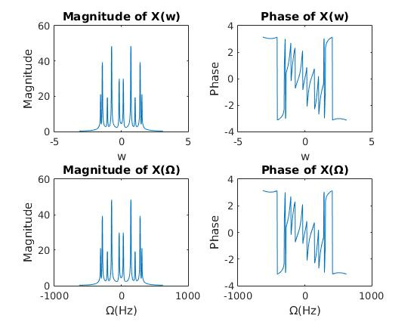

Report Item 5:

Original Spectrum

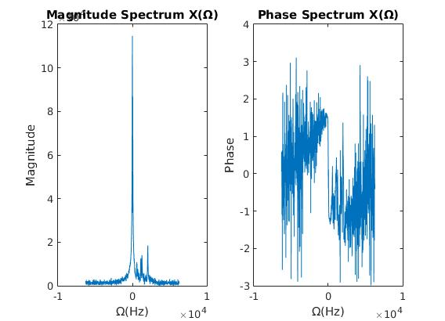

Zero-padding:

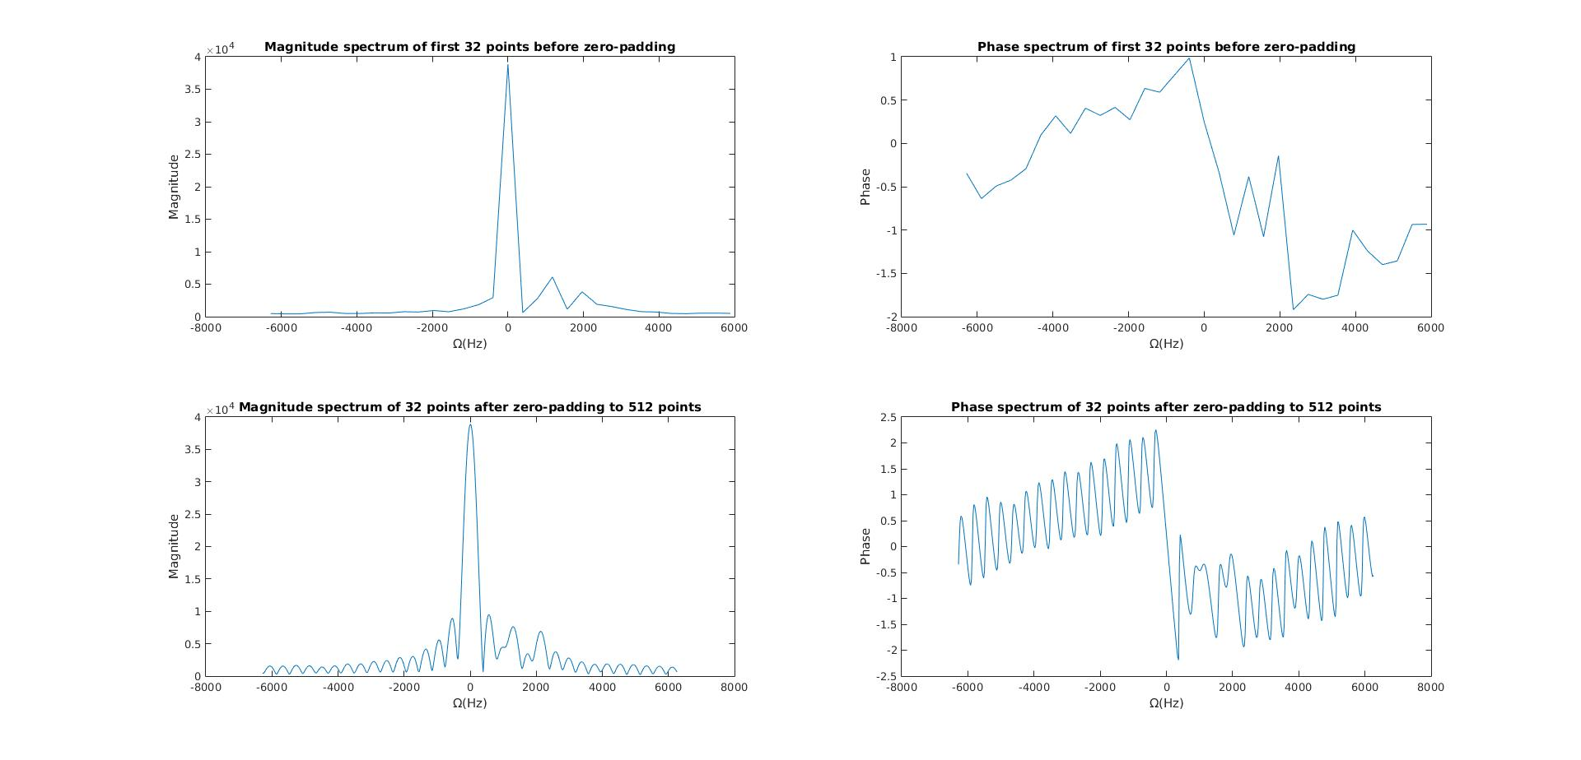

Before zero-padding, we cannot distinguish creating and chlorine. Zero-padding does help in terms of increasing the resolution of the spectrum, as there are more peaks present, but still not enough to distinguish 209Hz and 185Hz

Report Item 6:

Window functions and there spectra:

Rectangular:

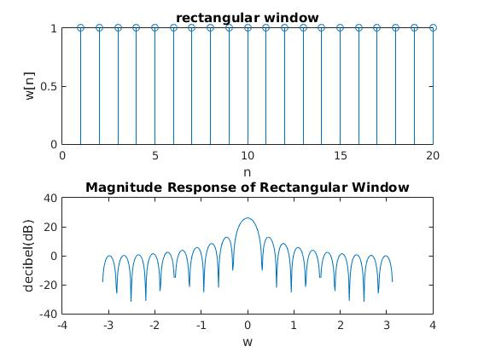

Triangular:

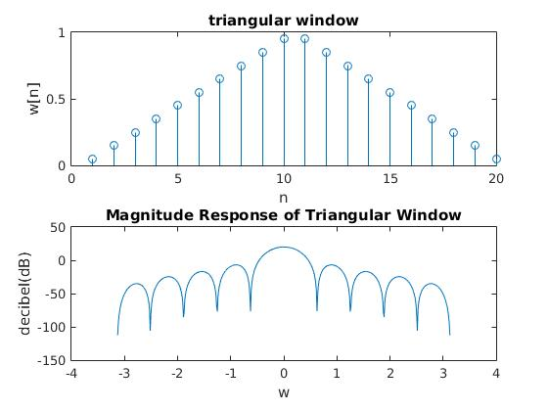

Hamming:

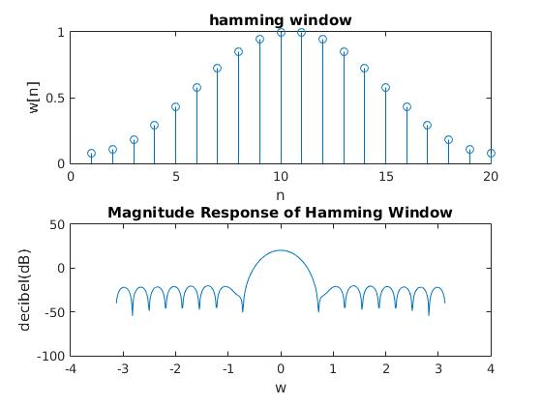

Hanning:

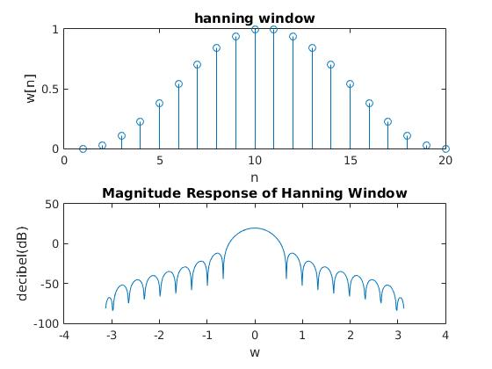

Kaiser

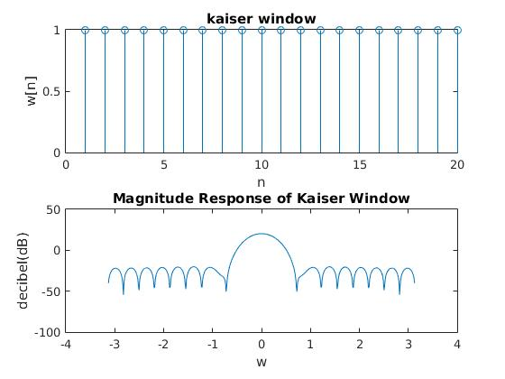

Rectangular window:

The side lobe height is 13dB lower than that of the main lobe

\The width of the main lobe is about 0.64 rad

Triangular window:

The side lobe is about 25 dB lower than that of the main lobe

The width of the main lobe is about 1.24 rad

Between the rectangular window and the hamming window, hamming window has lower side lobes.

Report Item 7:

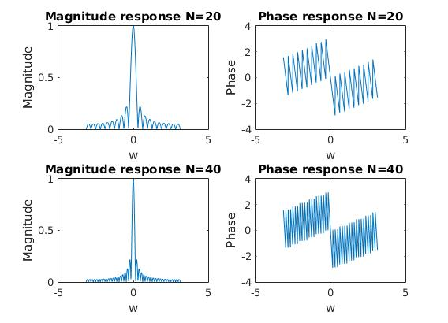

When N = 20, the main lobe has a width about 0.63 rad.

When N = 40

the main lobe has a width about 0.32 rad.

Report Item 8:

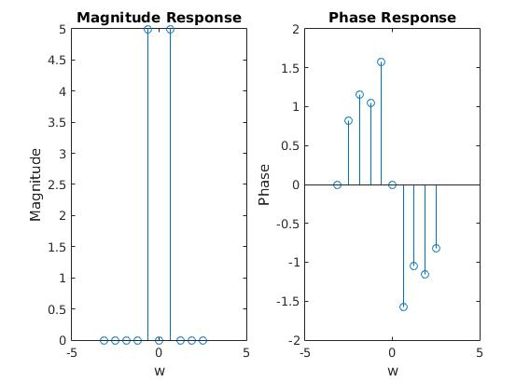

Nmin = T/Δt = 1/5/0.02 = 10