Hanfei Geng

hgeng4

Dec 10th, 2016

Q1

1)

code:

load('signal.mat')

signal = x

size = length(signal)

S = fft(signal,size);

S = fftshift(S)

w = fftshift([0:size-1]/size*2*pi)

w(1:size/2)=w(1:size/2)-2*pi

fs = 100

%plotting

freq = fs*w/2/pi;

subplot(121)

plot(freq,abs(S))

title('Magnitude Response')

xlabel('frequency(Hz)')

ylabel('Magnitude')

subplot(122)

plot(freq,phase(S))

title('Phase Response')

xlabel('Frequency(Hz)')

ylabel('Phase/Radian')

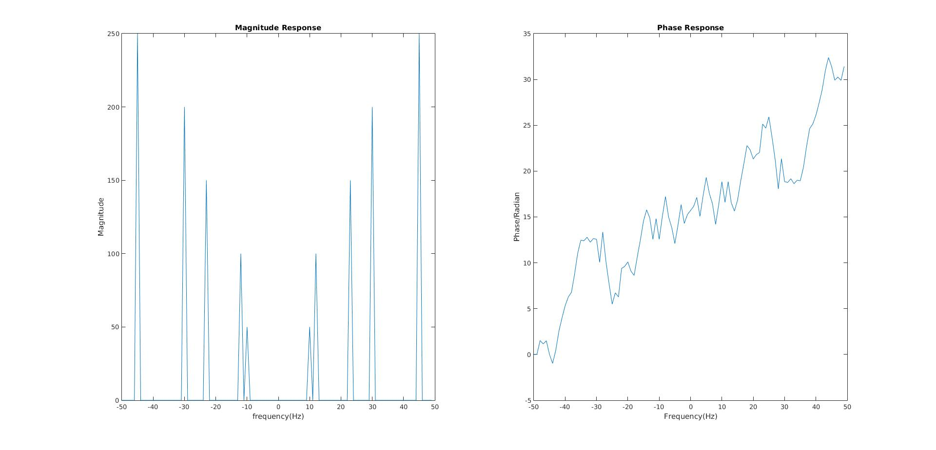

There are 5 tones. They are at 45Hz,30Hz,,23Hz,12Hz,10Hz.

Q2:

1)

code:

fs = 10000

fstop = 3600

fpass = 4000

rs = 50

rp = 1

f = [fstop fpass]

a = [0 1]

dev = [10^(-rs/20) (10^(rp/20)-1)/(10^(rp/20)+1)];

[n,fo,ao,w] = firpmord(f,a,dev,fs);

b = firpm(n,fo,ao,w);

freqz(b,1,1024,fs)

title('Highpass Filter Designed to Specifications')

The length of the filter:47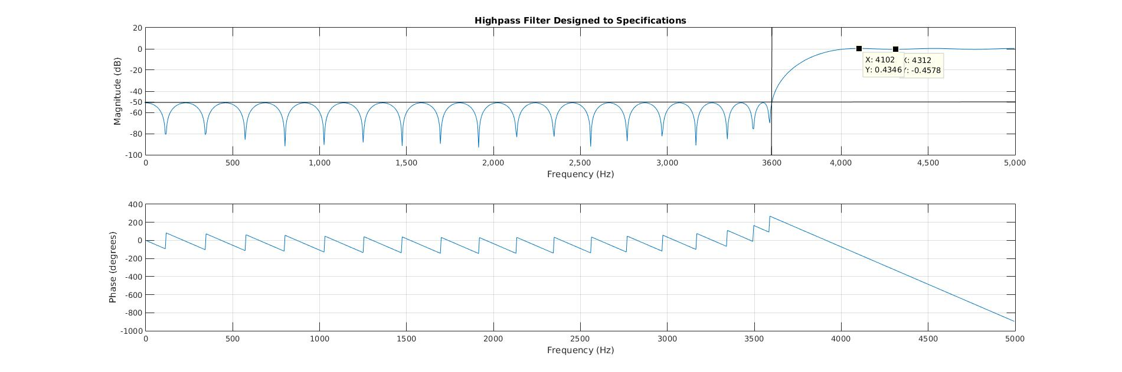

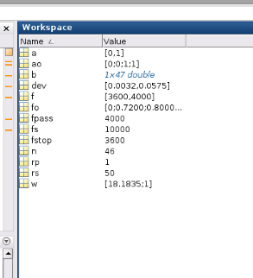

2)

code:

rs1 = 30

rs2 = 20

rp1 = 2

rp2 = 1

fs = 1

f = [0.125/2,0.15/2,0.25/2,0.3/2,0.45/2,0.5/2]

dev = [10^(-rs1/20),(10^(rp1/20)-1)/(10^(rp1/20)+1),10^(-rs2/20),(10^(rp2/20)-1)/(10^(rp2/20)+1)]

a = [0,1,0,1]

[n,fo,ao,w] = firpmord(f,a,dev,fs);

b = firpm(n,fo,ao,w);

freqz(b,1,1024)

Q3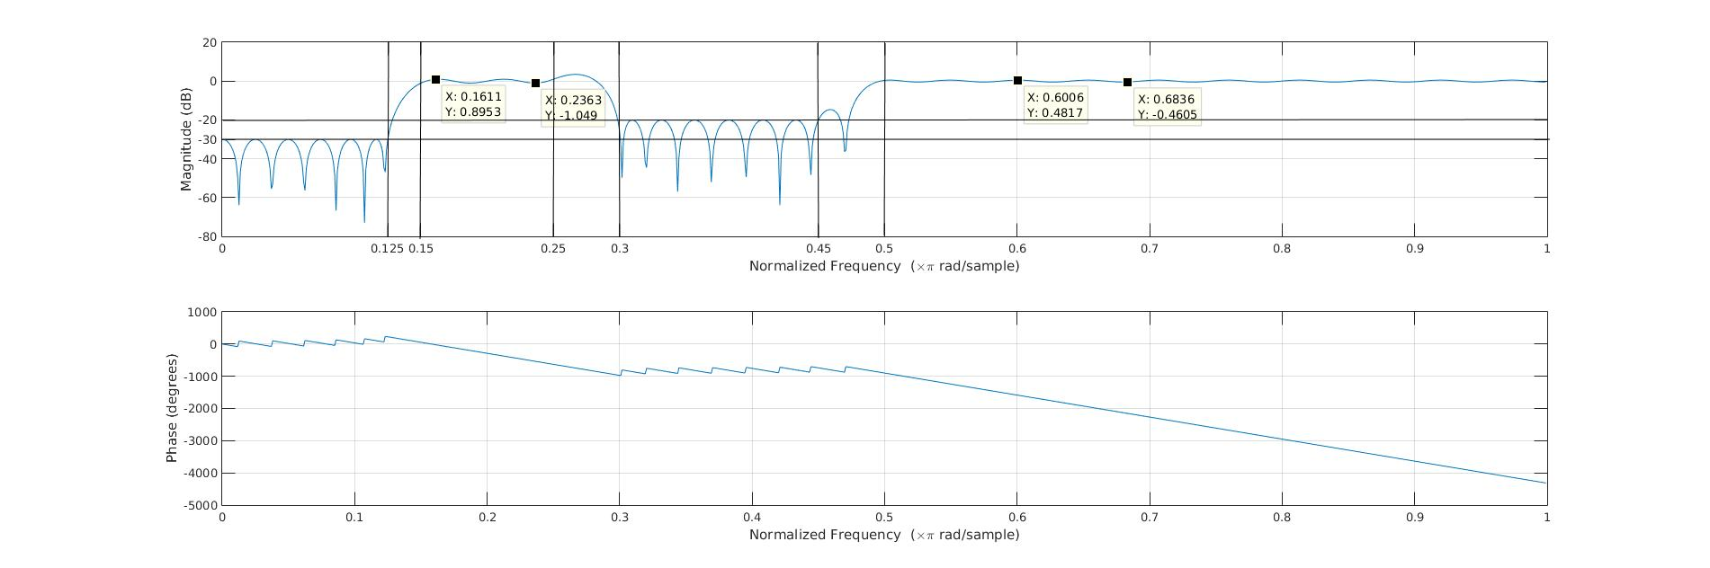

code:

load('samplerate.mat')

signal = x

%part1

size = length(signal)

S = fft(signal,size);

S = fftshift(S)

w = fftshift([0:size-1]/size*2*pi)

w(1:size/2)=w(1:size/2)-2*pi

fs = 40

%plotting

freq = fs*w/2/pi;

figure(1)

subplot(121)

plot(freq,abs(S))

title('Magnitude Response')

xlabel('frequency(Hz)')

ylabel('Magnitude')

subplot(122)

stem(signal)

title('Signal in time domain')

xlabel('n')

ylabel('signal')

%part2

U = 3

D = 5

signal_up = upsample(signal,U);

sizeU = length(signal_up);

SU = fftshift(fft(signal_up));

wU = fftshift([0:sizeU-1]/sizeU*2*pi);

wU(1:sizeU/2) = wU(1:sizeU/2) - 2*pi;

fsU = U*fs

freqU = fsU*wU/2/pi;

figure(2)

subplot(121)

plot(freqU,(abs(SU)))

title('Spectrum after upsampling before filtering')

xlabel('frequency(Hz)')

ylabel('Magnitude')

subplot(122)

stem(signal)

title('Upsampled Signal in time domain')

xlabel('n')

ylabel('signal')

%part3

filtered = zeros(length(SU),2);

filtered(:,1) = freqU;

filtered(:,2) = (SU(1,:))';

filtered(1:30,2) = 0;

filtered(92:120,2) = 0;

figure(3)

subplot(121)

filtered(:,2) = U * filtered(:,2);

plot(filtered(:,1),(abs(filtered(:,2))))

title('Upsampled spectrum after filtering')

xlabel('frequency(Hz)')

ylabel('Magnitude')

subplot(122)

signal_up_filter = ifft(ifftshift((filtered(:,2))))

stem(signal_up_filter)

title('Upsampled filtered signal in time domain')

xlabel('n')

ylabel('signal')

%part4

signal_down = downsample(real(signal_up_filter),D);

sizeD = length(signal_down);

SD = fftshift(fft(signal_down));

wD = fftshift([0:sizeD-1]/sizeD*2*pi);

wD(1:sizeD/2) = wD(1:sizeD/2) - 2*pi;

fsD = fsU/D

freqD = fsD*wD/2/pi;

figure(4)

subplot(121)

plot(freqD,(abs(SD)))

title('Final sample after downsampling')

xlabel('frequency(Hz)')

ylabel('Magnitude')

subplot(122)

stem(signal_down)

title('After Downsample')

xlabel('n')

ylabel('signal')

Part1:

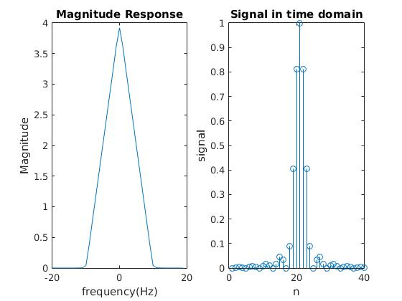

Part2:

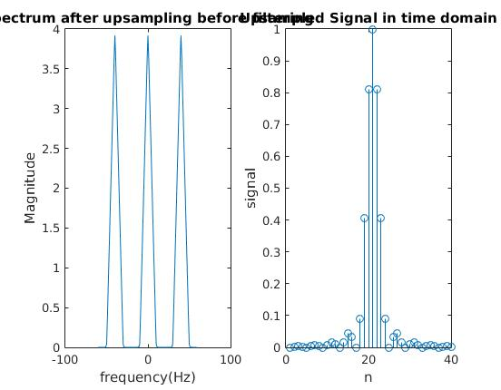

There are extra copies of the spectrum that the original spectrum does not have, because upsampling essentially shrinks the entire spectrum, causing extra copies to enter -pi to pi range, due to the scaling property of fourier transform.

Part3

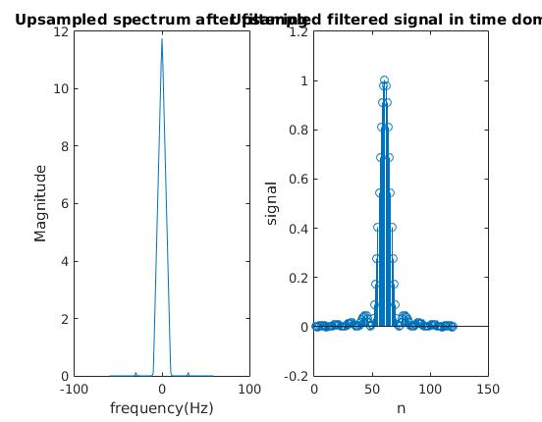

Part4

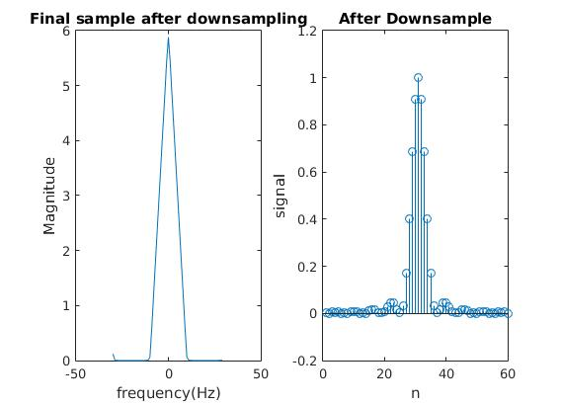

Final sample frequency: 60Hz

Maximum D:5

Q4:

Part1:

code:

image = imread('image1.jpg')

filter = [-1,-1,-1;

-1,8,-1;

-1,-1,-1]

filter_image = conv2(double(image),filter,'same');

imshow(uint8(filter_image));

spectrum = fft2(filter_image);

spectrum = fftshift(spectrum)

M = length(image)

N = length(image(1,:))

kX = fftshift([0:N-1]/N*2*pi)

kX(1:N/2) = kX(1:N/2) - 2*pi

kY = fftshift(([0:M-1]/M*2*pi))

kY(1:M/2) = kY(1:M/2) - 2*pi

figure(1)

colormap hsv

imagesc(kX,kY,mag2db(abs(spectrum)))

colorbar('Direction','reverse')

title('spectrum in dB')

xlabel('kx')

ylabel('ky')

figure(2)

inverted = ones(M,N)*256-filter_image;

imshow(uint8(inverted))

title('inverted image')

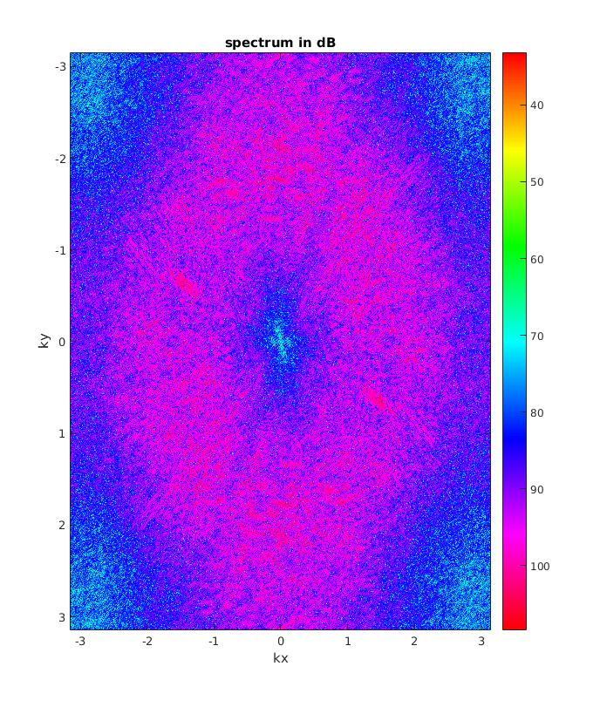



type: high pass filter

Part2:

code:

image = imread('image2.jpg')

filter = [1/16,1/8,1/16;

1/8,1/4,1/8;

1/16,1/8,1/16]

filter_image = conv2(double(image),filter,'same');

spectrum = fft2(filter_image);

spectrum = fftshift(spectrum)

M = length(image)

N = length(image(1,:))

kX = fftshift([0:N-1]/N*2*pi)

kX(1:N/2) = kX(1:N/2) - 2*pi

kY = fftshift(([0:M-1]/M*2*pi))

kY(1:M/2) = kY(1:M/2) - 2*pi

figure(2)

colormap hsv

imagesc(kX,kY,mag2db(abs(spectrum)))

colorbar('Direction','reverse')

title('spectrum in dB')

xlabel('kx')

ylabel('ky')

type:lowpass filter