Hanfei Geng

hgeng4

September 30th, 2016

Report Item 1:

Code:

function [y] = myDFTConv(x,h)

total = length(x)+length(h)-1;

X = fft(x,total);

H = fft(h,total);

Y = X .* H;

y = ifft(Y)

end

command script:

x = [-1,2,1,5,4]

h = [1,2,3,2]

y = myDFTConv(x,h)

y_ = conv(x,h)

stem(y)

title('x * h')

xlabel('n')

ylabel('output')

figure:

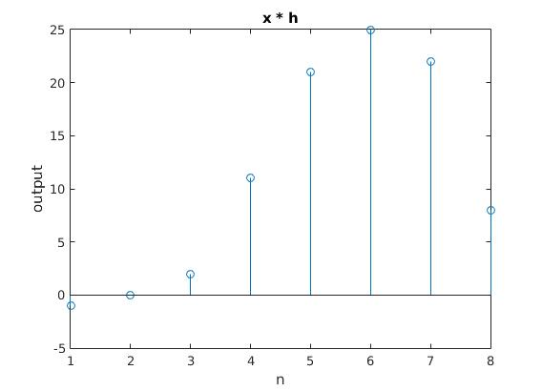

The order of complexity is 3NlogN

Report Item 2:

code:

function [y] = sys1(a,x)

B = [0.3,-2]

A = [1,-a]

y = filter(B,A,x)

end

command script:

n = [0:63]

delta = [n == 0]

output = sys1(2,delta)

stem(n,output);

title('Impulse Response a = 2')

xlabel('n')

ylabel('h(n)')

figure:

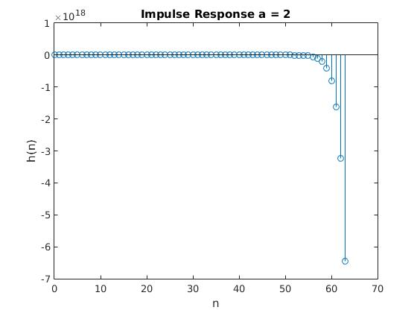

This system is not stable for the impulse response is not absolutely summable. The system is causal since it does not involve x(n+k) term where k > 0

Report Item 3:

code:

function [y] = sys2(a,x)

for i = 1:length(x)

if i == 1

y(i) = x(i) * x(i);

else

y(i) = a * y(i-1) + x(i) * x(i);

end

end

end

command script:

n = [0:63]

delta = [n == 0]

output = sys2(2,delta)

stem(n,output);

title('Impulse Response a = 2')

xlabel('n')

ylabel('h(n)')

figure(2)

output_ = sys2(0.5,delta);

stem(n,output_);

title('Impulse Response a = 0.5')

xlabel('n')

ylabel('h(n)')

figure:

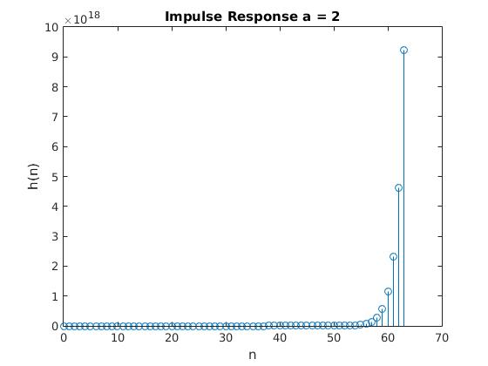

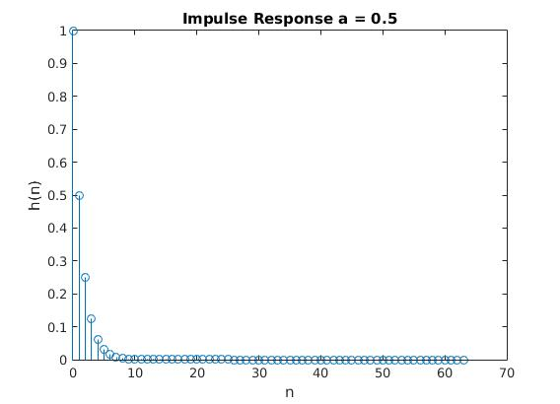

System is causal since it does not need to know future input regardless of the value of a. It's not stable when a = 2 for a delta function input results in an unbounded output. It's stable when a = ½ since the output is bounded. In neither case is the system linear since output involves a (x(n))^2 term. Therefore we cannot find the output to either system via convolution.

Report Item 4:

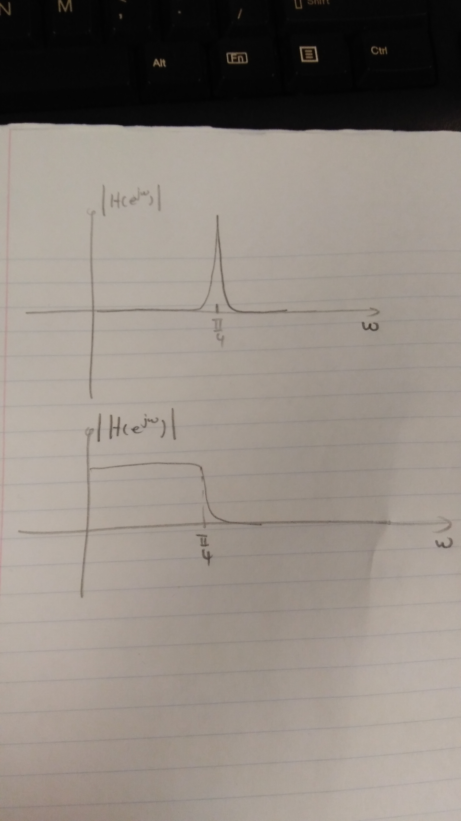

Report Item 5

code:

%H1

b1 = [2,0,5,4,0,0,-3]

a1 = [1]

H1 = tf(b1,a1,-1,'Variable','z^-1')

N = 20

figure(1)

subplot(121)

pzplot(H1)

subplot(122)

impz(b1,a1,N)

%H2

b2 = [3,2,0,-2]

a2 = [1]

H2 = tf(b2,a2,-1,'Variable','z^-1')

N = 20

figure(2)

subplot(121)

pzplot(H2)

subplot(122)

impz(b2,a2,N)

%H3\

b3 = [0,0,0,1,0,0,1,-2]

a3 = [12,1,0,4]

H3 = tf(b3,a3,-1,'Variable','z^-1')

N = 20

figure(3)

subplot(121)

pzplot(H3)

subplot(122)

impz(b3,a3,N)

figure:

H1:

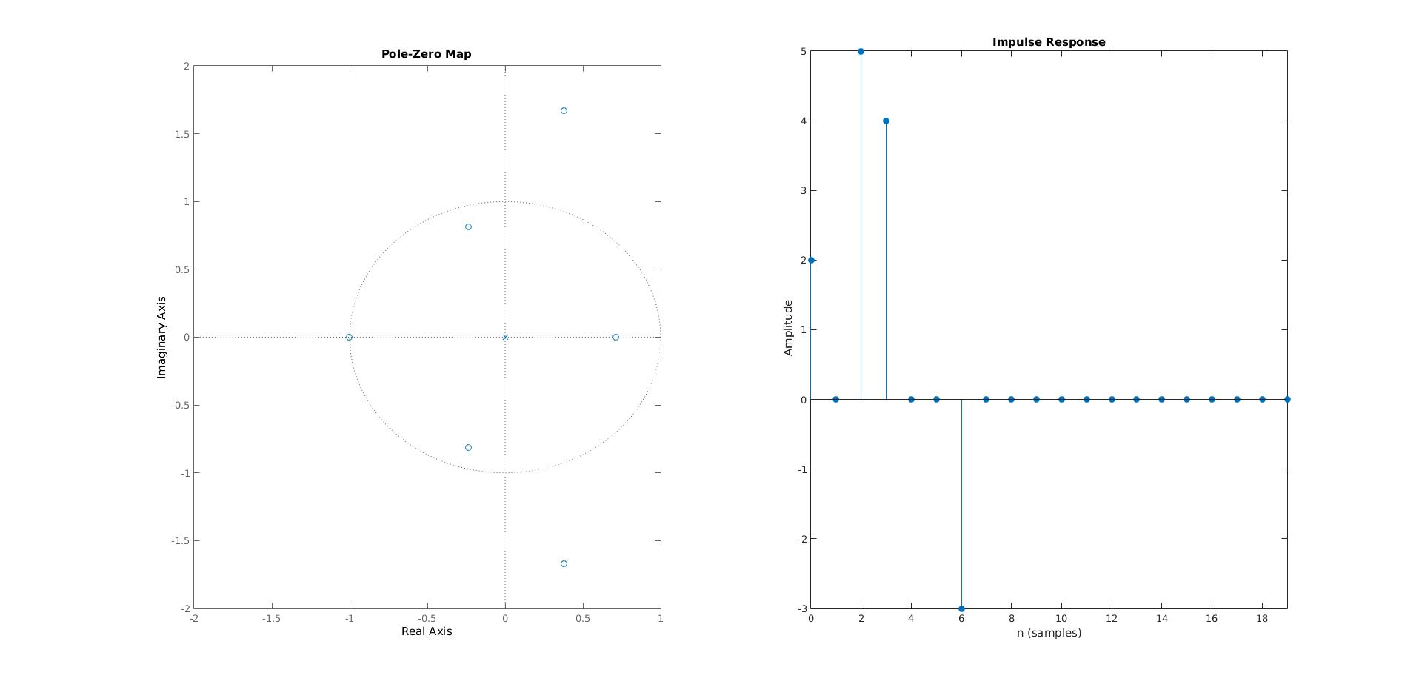

H2:

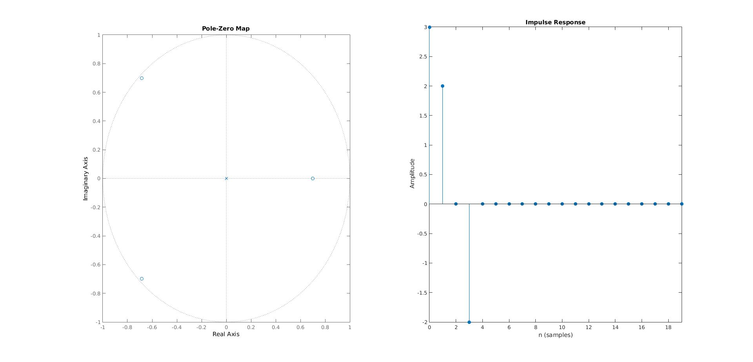

H3:

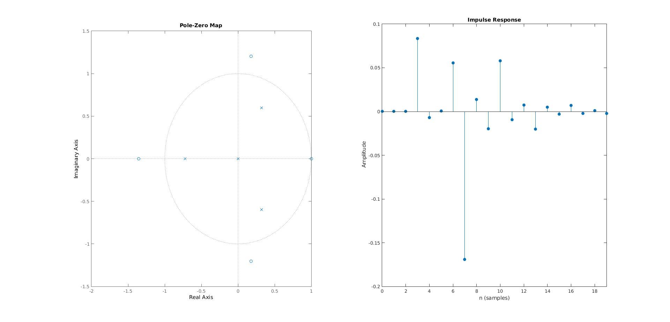

Stability:

H1: stable

H2: stable

H3: stable

All poles in each figure are inside the unit circle

Report Item 6:

The system is not BIBO stable since the there are poles on the unit circle. The system would be stable as long as the input does not have sinusoidal component with frequency of 8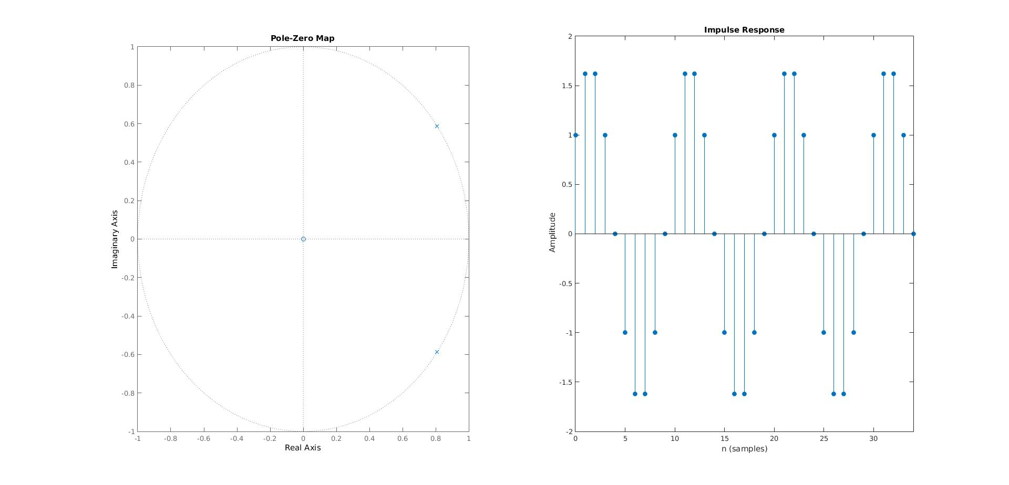π/10.