

DFK20013:

WEB DESIGN TECHNOLOGY

REPORT

SESSION :1 2025/2026

|  |  |  |
| --- | --- | --- |
| NAME | : | AINA BATRISYA BINTI SAIFUL |
| NO. MATRIX | : | 05DIT24F1051 |
| KELAS | : | DIT3C |
| LECTURE | : | NORAIMI BINTI MAHRAN |

Table of the contents

|  |  |  |
| --- | --- | --- |
| No. | contents | pages |
| 1. | Front Page | 1 |
| 2. | Table of the contents | 2 |
| 3. | Coding HTML | 3-8 |
| 4. | Output | 9-13 |

Coding HTML

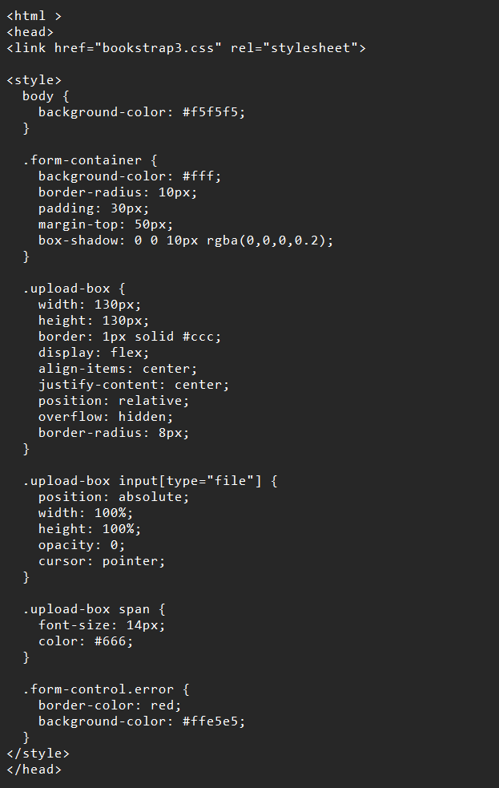

0utput question A and B

QUESTION A

Write HTML code for this form.

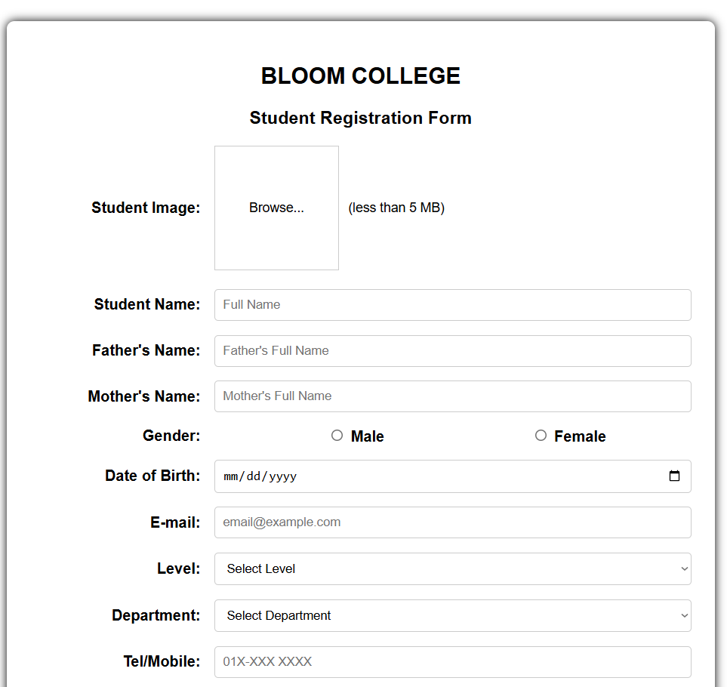

QUESTION B

i)

QUESTION B

ii)

QUESTION B

iii)

QUESTION B

Github Link

>https://github.com/kakashi3zzz/pw2-05dit24f1051.