DFK20013:

WEB DESIGN TECHNOLOGY
REPORT

SESSION :1 2025/2026

NAME | : | AINA BATRISYA BINTI SAIFUL
NO. MATRIX | : | 05DIT24F1051
KELAS | : | DIT3C
LECTURE | : | NORAIMI BINTI MAHRAN

Table of the contents

No. | contents | pages
1. | Front Page | 1
2. | Table of the contents | 2
3. | Coding HTML | 3-8
4. | Output | 9-13

Coding HTML
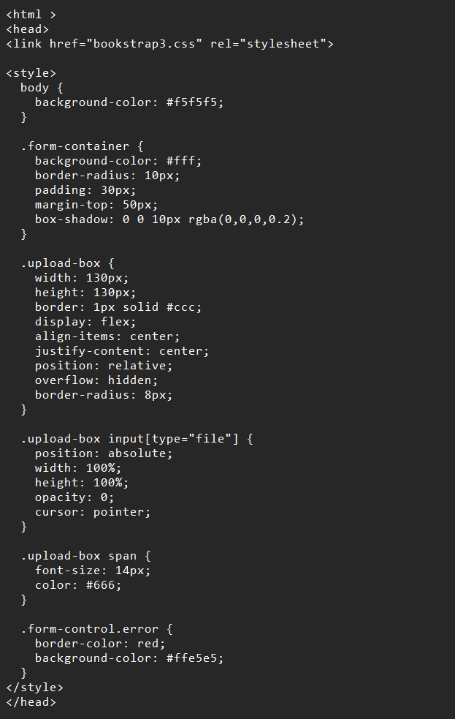
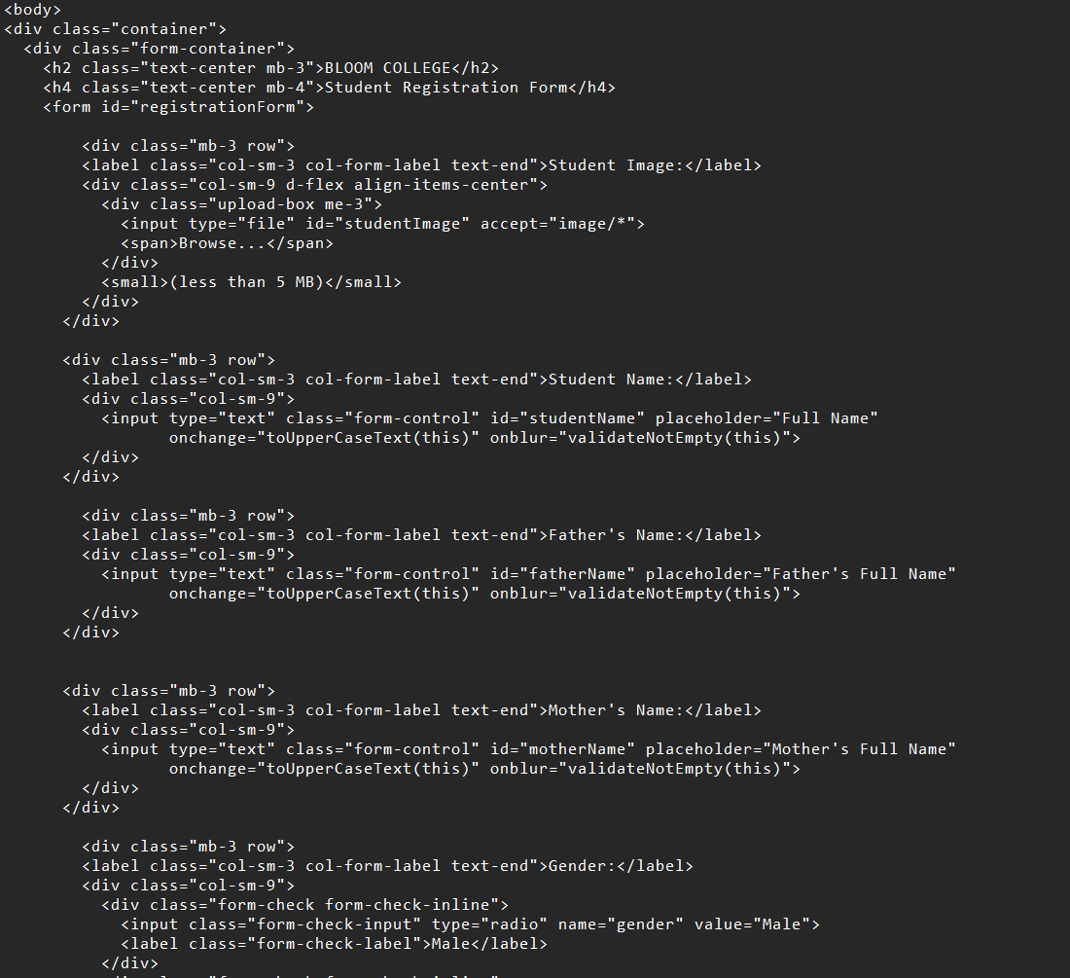
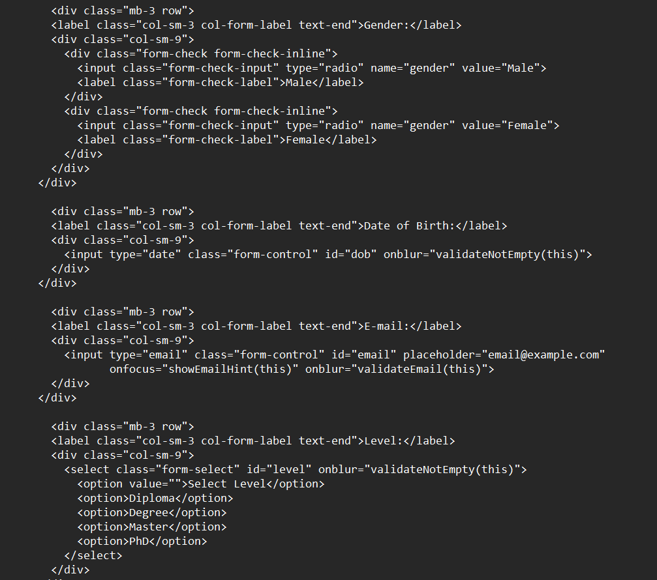

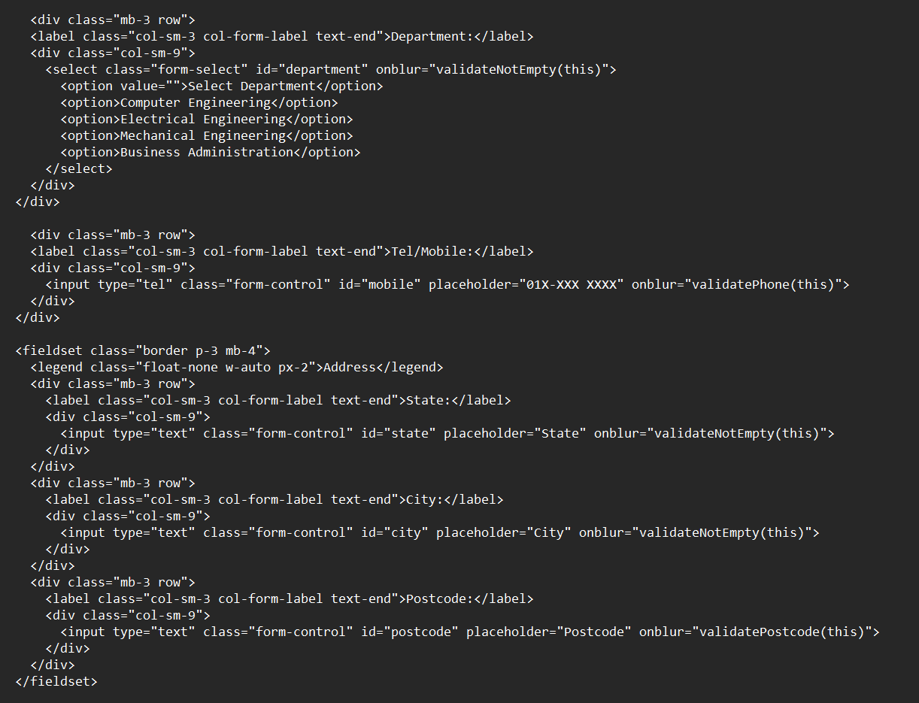
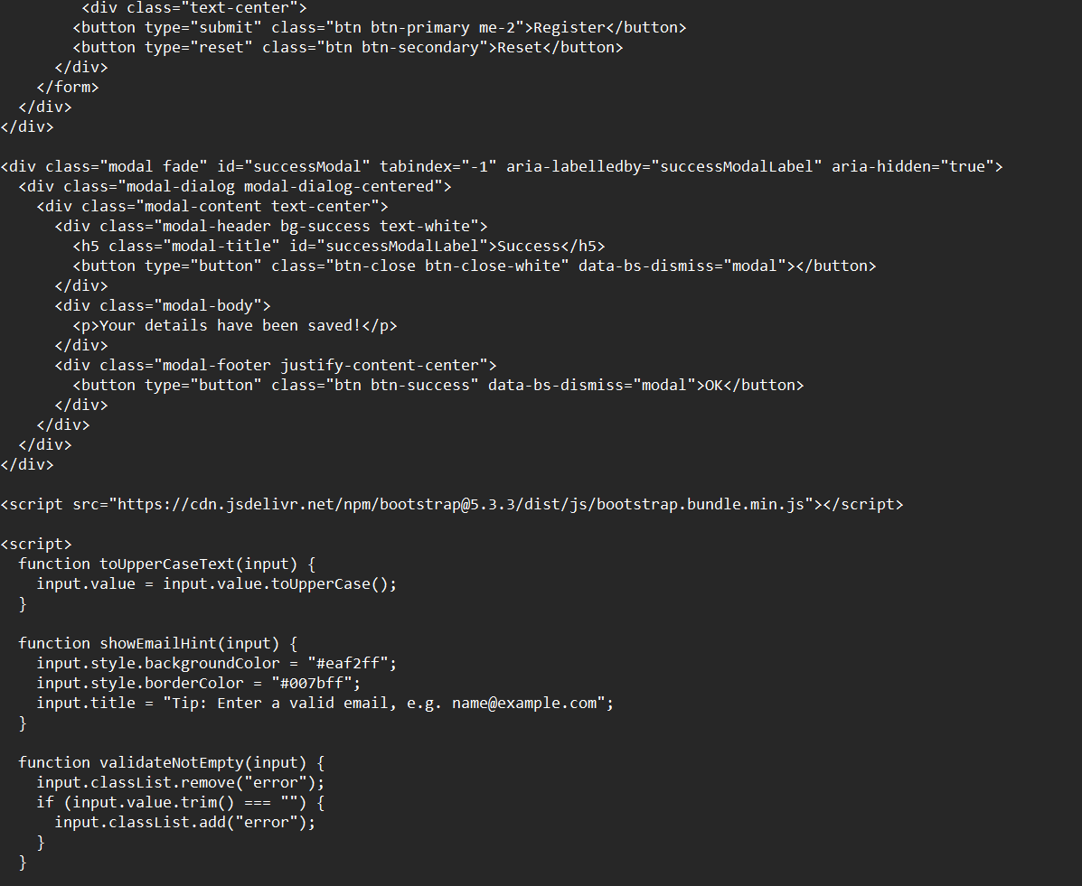

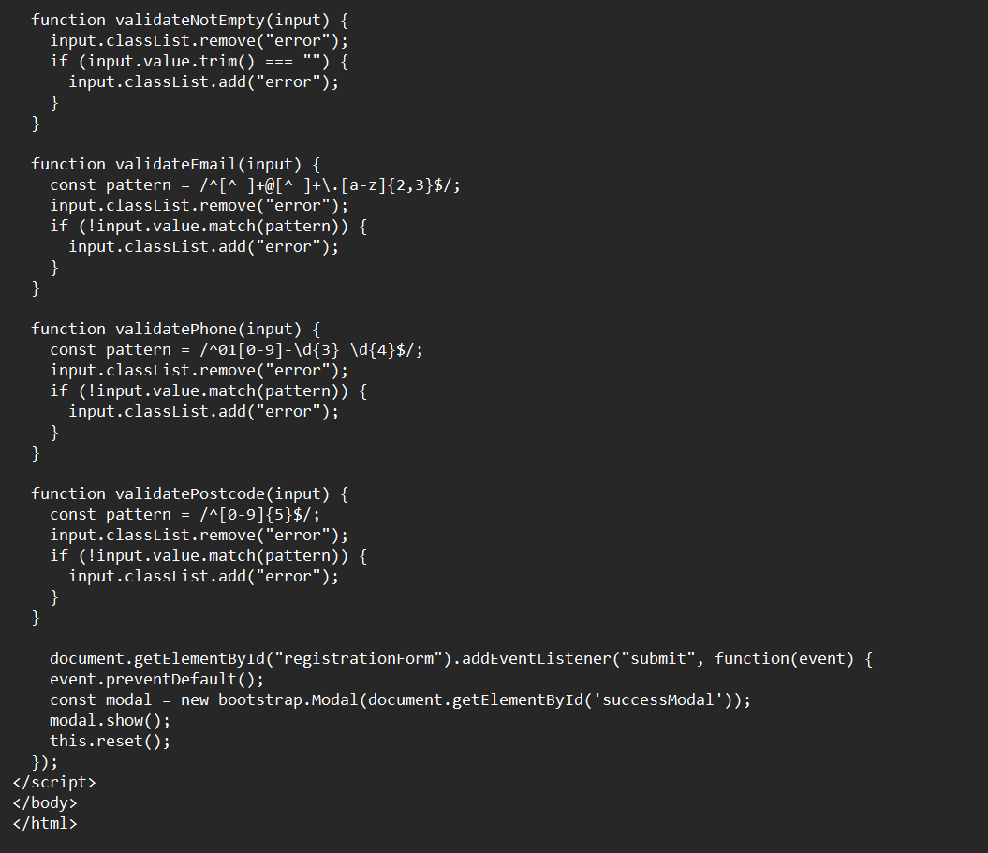 0utput question A and B

QUESTION A
Write HTML code for this form.
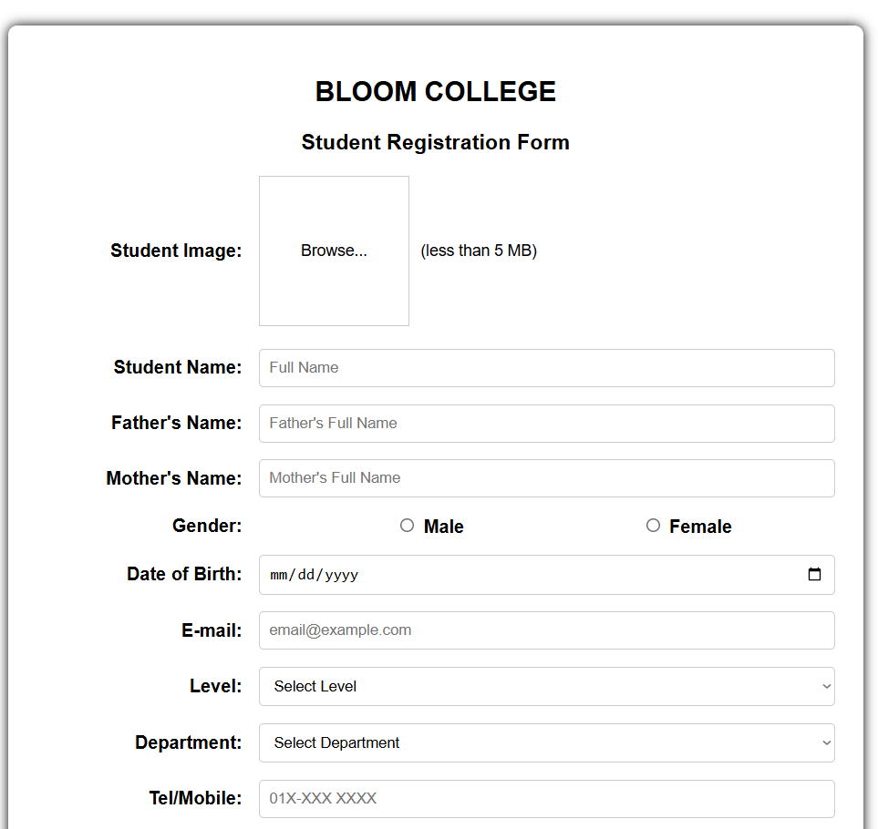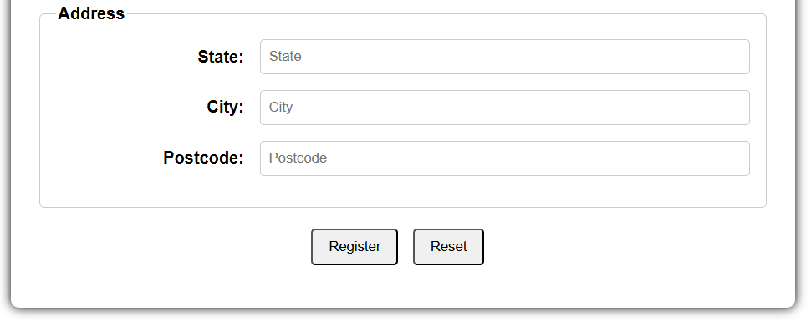

QUESTION B

i)
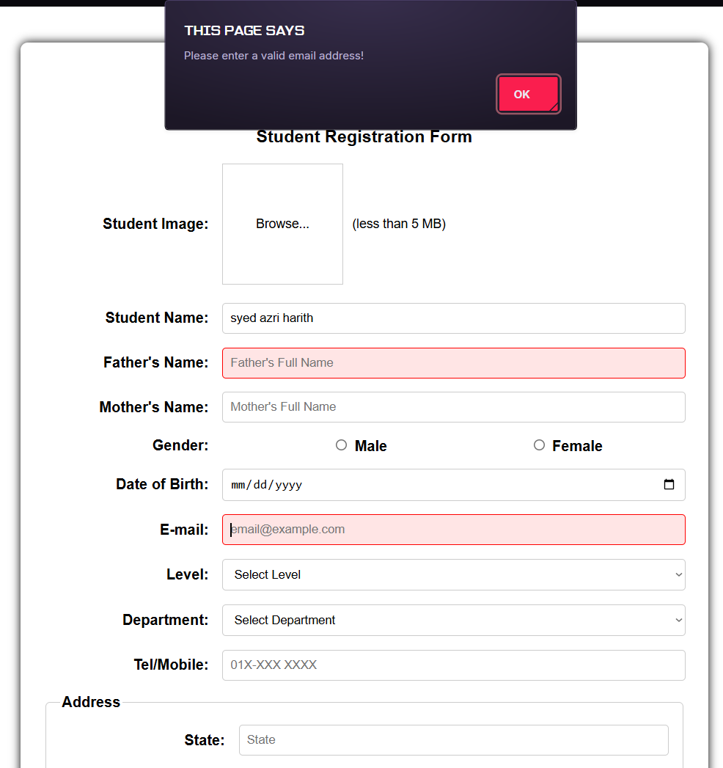

QUESTION B
ii)
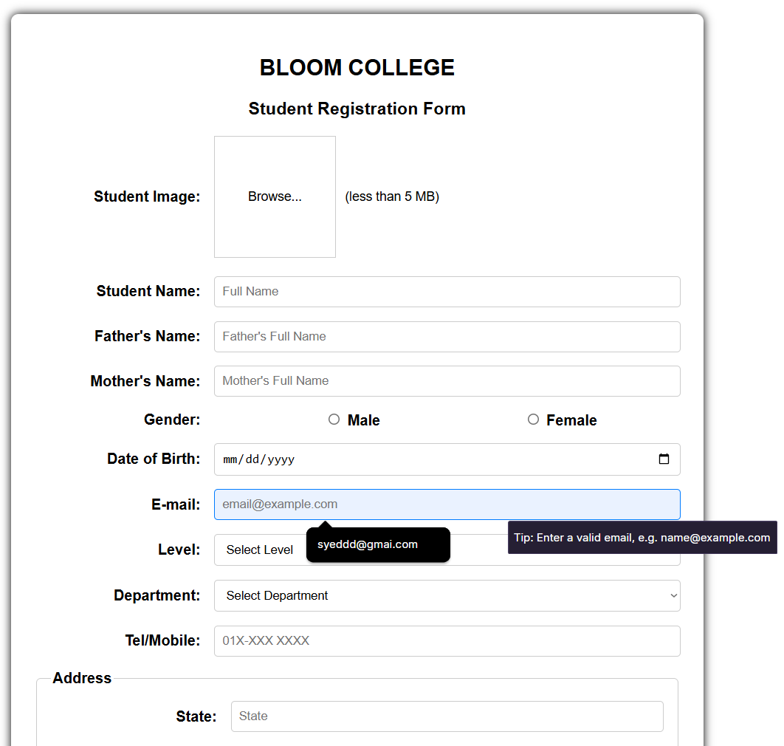

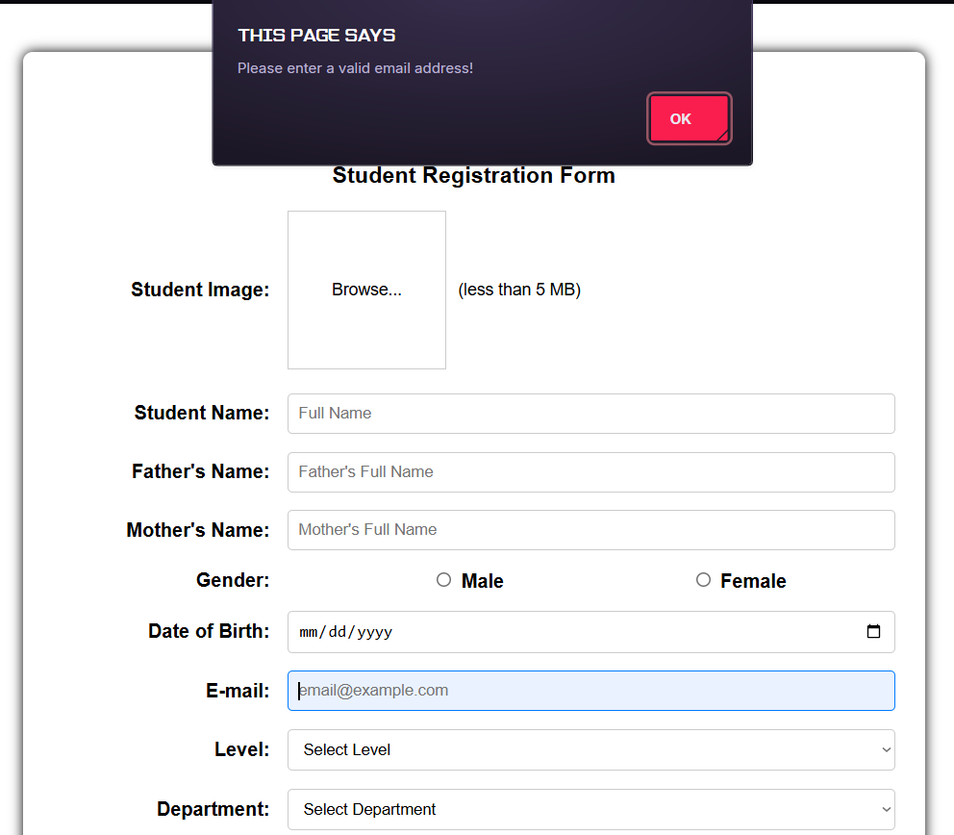

QUESTION B

iii)
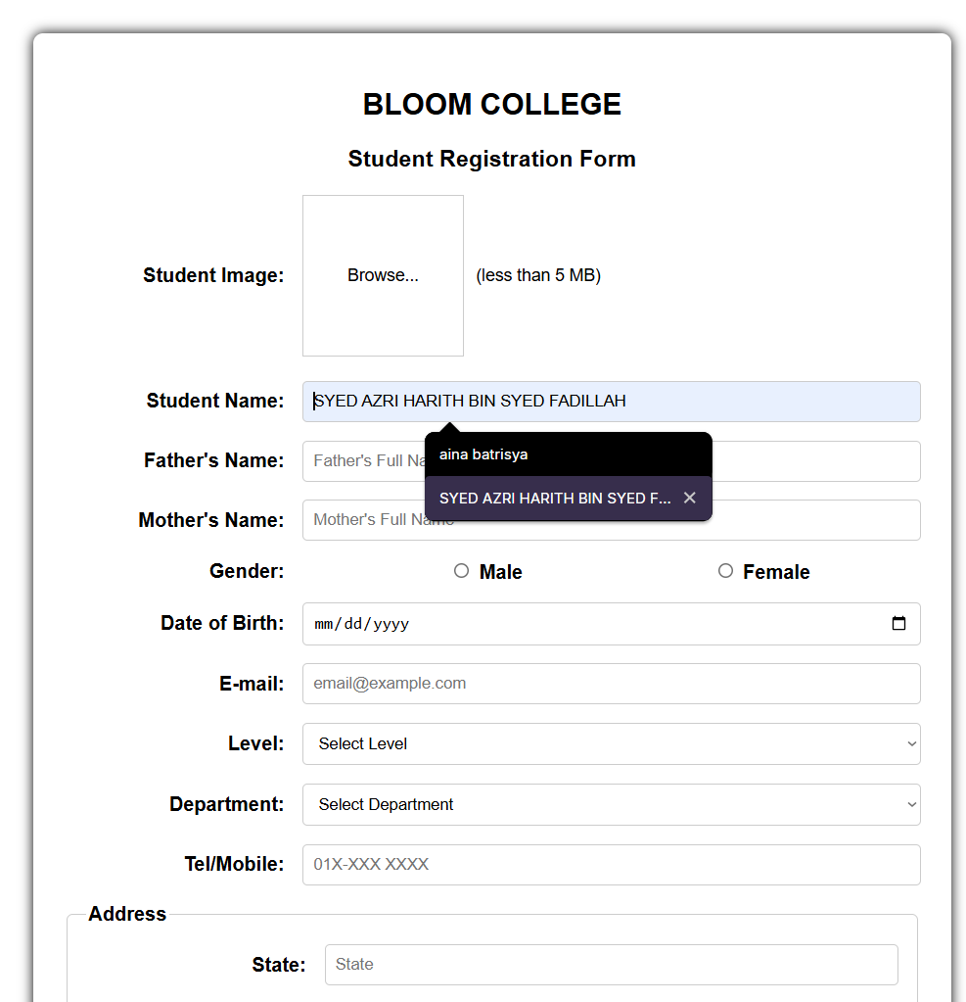

QUESTION B

iv) 