Software Requirements Specification

for

Cafeteria Management System

Version 1.0 approved

Prepared by Nabeel Yaseen

December 2nd,2022

Table of Contents

Table of Contents ii

Revision History ii

1. Introduction 1

1.1 Purpose 1

1.2 Document Conventions 1

1.3 Intended Audience and Reading Suggestions 1

1.4 Project Scope 1

1.5 References 1

2. Overall Description 2

2.1 Product Perspective 2

2.2 Product Features 2

2.3 User Classes and Characteristics 2

2.4 Operating Environment 2

2.5 Design and Implementation Constraints 2

2.6 User Documentation 2

2.7 Assumptions and Dependencies 3

3. System Features 3

3.1 System Feature 1 3

3.2 System Feature 2 (and so on) 4

4. External Interface Requirements 4

4.1 User Interfaces 4

4.2 Hardware Interfaces 4

4.3 Software Interfaces 4

4.4 Communications Interfaces 4

5. Other Nonfunctional Requirements 5

5.1 Performance Requirements 5

5.2 Safety Requirements 5

5.3 Security Requirements 5

5.4 Software Quality Attributes 5

6. Other Requirements 5

Appendix A: Glossary 5

Appendix B: Analysis Models 6

Appendix C: Issues List 6

Revision History

|  |  |  |  |
| --- | --- | --- | --- |
| **Name** | **Date** | **Reason For Changes** | **Version** |
| CMS | Dec 2nd | First Version | 1.0 |

# Introduction

## Purpose

Café Management System desktop application that aims to digitalize the process of cafeteria management operations including ordering and inventory management.

## Document Conventions

Throughout this document, All the user entities are written in capitalizations i.e. first letter as capital. Those terms which are significant (but not described in glossary) are bold in text.

## Intended Audience and Reading Suggestions

The purpose of this document is to give a detailed description of the requirements for the “Cafeteria” software. It will illustrate the purpose, scope and complete description for the development of system. This document is primarily intended to be proposed to a customer for its approval.   
As for suggestion customers are suggested to jump to section 3 and 4 for the list of requirements implemented.

## Project Scope

The project will have a cafeteria environment where the vendor can place order for students and staff. It will digitalize the process and hence reducing the burden and order notes off vendor’s shoulders.

## References

1. Sir Khurram’s Youtube channel

<https://www.youtube.com/c/ItsKhuramShahzad>

1. Stack overflow for different querries related C#.

# Overall Description

This section will give an overview of the Cafeteria application. The basic functionality of the system as well its context will be explored in detail. It also describes different kinds of stakeholders and user classes associated with the system and what functionality is available for each class. At last, the assumptions and dependencies for the system are presented.

## Product Perspective

Cafeteria app will attempt to replace the traditional manual ordering process. There will a desktop application connected with a database, which will have the data of items available at cafeteria and also the login info of vendor.

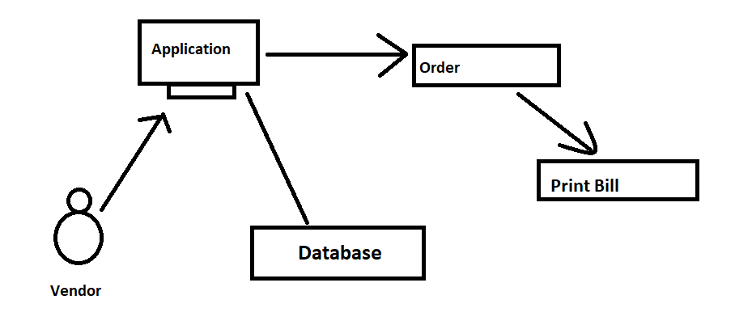

## Product Features

The Product will:

* Place order
* Display Menu
* Update price in Menu
* Add items to menu
* Delete items in menu
* Print Bill

## User Classes and Characteristics

There are 2 classes, 1 is order items where it will have info related Menu and other class will be of Admin who’ll be interacting with the system.

## Operating Environment

It’s operating environment will be the cafeteria where the vendor usually take orders. Students and staff may come to *kiosk* and place order. Which will then print the bill.

## Design and Implementation Constraints

1. **OS Constraint:**

It is useable on windows only.

## User Documentation

The software is accompanied by the following materials for further help:

* Cafeteria Management System SRS v1.0
* Email: p200486@pwr.nu.edu.pk

## Assumptions and Dependencies

It is assumed that the OS is running properly. Also, the printer is connected, else the bill would only be saved in the PC in PDF format.

# System Features

## Place Order

3.1.1 View Menu items

The items that can be orded are displayed in the form of a table with their respective prices on it which helps the customer choose the items.

3.1.2 Place order

After choosing the items it can be added to cart and it will sum up the total payable amount.

3.1.3 Print Bill

After the sum is done the vendor may ask the customer if they need to remove or add any item from the order after which the bill is printed from printer.

## Update Menu

1. Add items:
   1. The vendor can add new items to the Menu which will automatically be shown on the menu table.
2. Delete Items:
   1. The vendor can delete existing items from the Menu.
3. Update Price:
   1. The vendor can update the price of items in the Menu which will automatically be shown on the menu table.

# External Interface Requirements

## User Interfaces

User Interface would have first the login page.After logging in it would show a dashboard where the vendor can eiter place order or update the menu.

## Hardware Interfaces

After clicking on the print button, a new window will pop-up asking for the bill to be printed via printer.

## Software Interfaces

* For the database we use MSSM server.
* For installation window 7 or later version.

## Communications Interfaces

Cafeteria is a desktop application, and it will communicate with MySQL Server (which is a storage server provided by Microsoft developers).

# Other Nonfunctional Requirements

## Performance Requirements

The software should be interactive and should switch from 1 panel to the other on the dashboard in less than 5 seconds.

## Safety Requirements

The software is completely environmentally friendly and does not cause any safety violations.

## Security Requirements

The software must be password protected and only admin could make changes in Menu.

## Software Quality Attributes

#### **Adaptability**

#### **Availability**

#### **Correctness**

**4. Flexiblity**

Appendix A: Glossary

Interface : display window on screen

C# : programming language

Appendix B: Analysis Models

**ERD**

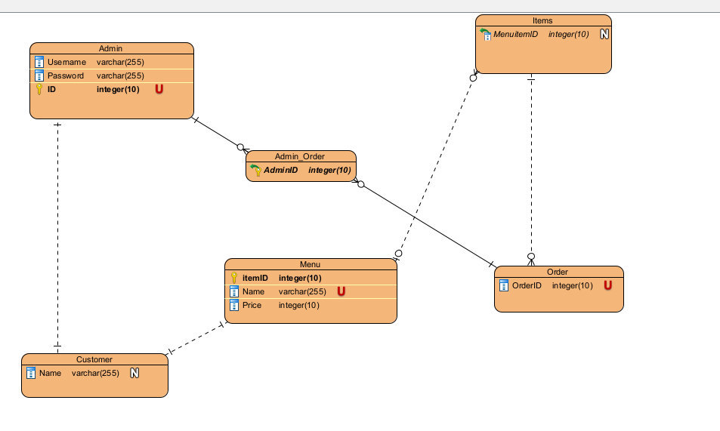

**Use Case Diagram:**

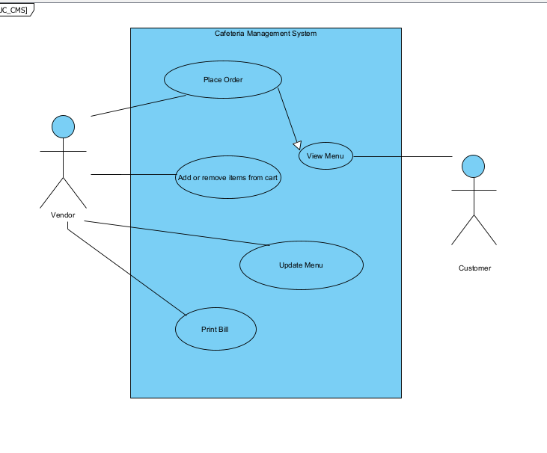

**Activity Diagram:**

