**Pay Per Parking**

A Project Phase - II Report

Submitted

in

partial fulfillment

for the award of the degree

of

**Bachelor of Technology**

**in**

**Information Technology**

By

**NIKHIL DASAR**

Under the Guidance

**Prof. SAMIKSHA SHUKLA**

**

to the

**GOVERNMENT ENGINEERING COLLEGE, BILASPUR**

**CHHATTISGARH SWAMI VIVEKANAND TECHNICAL**

**UNIVERSITY, BHILAI**

**Session 2022-23**

**DECLARATION**

We the undersigned solemnly declare that the report of the project work entitled “**Pay Per Parking**” is based on our own work carried out during the course of our study under the supervision of **Assistant Professor Samiksha Shukla**. We assert that the statements made and conclusions drawn are an outcome of the project work.

**Nikhil Dasar**

(Roll No - 300703319024)

**CERTIFICATE**

It is certified that the work contained in the report entitled “**Pay Per Parking**” by **Nikhil Dasar** (Roll No. - 300703319024) has been carried out under the supervision of **Assistant Professor Samiksha Shukla** and this work has been submitted for award of the degree of Bachelor of Technology in Information Technology.

Signature of the Project Incharge Signature of the Supervisor

**Dr. Awanish Kumar Upadhyay** **Prof. Samiksha Shukla**

Assistant Professor Assistant Professor

Information Technology Information Technology

GEC Bilaspur (C.G.) GEC Bilaspur (C.G.)

Signature of the Head of Department

**Dr. Awanish Kumar Upadhyay**

Professor & HOD

Information Technology

GEC Bilaspur (C.G.)

**CERTIFICATE BY THE EXAMINERS**

The report entitled **“Pay Per Parking”** submitted by **Nikhil Dasar** (Roll No. - 300703319024) has been examined by the undersigned as a part of the examination and is hereby recommended for the award of the degree of Bachelor of Technology in Information Technology to Chhattisgarh Swami Vivekanand Technical University.

Internal Examiner External Examiner

**ACKNOWLEDGEMENT**

The satisfaction that accompanies the success in completion of task would be incomplete without mentioning the people who made it possible, whose constant guidance and encouragement crowned my effort in success. I take this opportunity with much pleasure to thank all the people who have helped me through the course of my journey towards producing this project.

In the first place, I gratefully acknowledge myself, for working hard in this project with lot of patience and commitment.

I feel pleasure in conveying my profound thanks to my project supervisor **Samiksha Shukla Assistant Professor** (Dept. of IT), for her valuable guidance, patience and instant support and efforts during the entire period of my project work. Her innovative ideas, precise suggestions and timely discussion whenever there was some problem towards documentation and research paper she constantly guide us with her immense patience and efforts to resolving the problem. She shared some valuable sample papers and references throughout the entire project. I have been able to successfully complete this project because of excellent guidance, motivation and help extended by her.

I would like to express my sincere gratitude **Dr. Awanish Upadhyay HOD** (Dept. of IT), GEC Bilaspur for his assistance and useful comments. It is with great pleasure, I extend my gratitude and thanks to **Dr. B.S.Chawla** (Principal of GEC Bilaspur) for his constant encouragement and motivation throughout the project.

I am thankful to all the faculty members of IT Department, administration staff and management of GEC Bilaspur for their support.

Finally, Thanks to all who directly or indirectly have been supporting us and standing by all the times.

**Nikhil Dasar**

**Table of Contents**

|  |  |  |
| --- | --- | --- |
| **CHAPTER** | **TITLE** | **PAGE NO.** |
|  | List of Figures |  |
|  | List of Tables |  |
|  | List of Abbreviation |  |
|  | List of Symbols |  |
| **I** | **Introduction** | 1 |
| **II** | **Requirements** | 2 |
|  | 2.1 Hardware Requirements |  |
|  | 2.1.1 Software Requirements |  |
| **III** | **Methodology** | 3 - 12 |
|  | 3.1 Content of the application |  |
|  | 3.1.1 Overview of the application |  |
| **IV** | **Result and Performance Analysis** | 13 - 22 |
| **V** | **Conclusion & Further Work** | 23 |
|  | **References** | 24 |

**Chapter – I**

**Introduction**

**Introduction**

Pay Per Parking is the title of this project. It is an android app which runs on android platform such as android phones. Purpose of creating pay per parking app is to solve the daily life challenges of vehicle parking and booking.

Everyone is familiar with the parking problems in India. Whenever we went out, we don’t know where we should park our vehicle. In a new place it is even more difficult to search nearby spot to park our vehicle. It is a main objective of this android application. It will provide citizens true information about parking places near them.so they can make a good decision to park their vehicle without facing any difficulties.

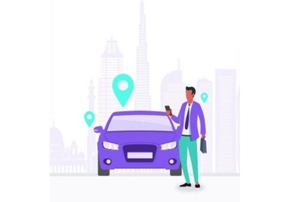This application helps to find the true information of the nearest parking spots where users can go with the help of the Google map navigation and check prices and park their vehicle.

**Chapter – II**

**Requirements**

**2.1 Hardware Requirements:**

* **Processor :** Intel i3 3rd gen or AMD A9 or equivalent
* **RAM :** 4GB or more
* **Storage :** 20GB or more for virtual machines
* **Android Phone:**32GB ROM and 4 GB RAM (Standard)

**2.1.1 Software Requirements**

* Android Studio
* Windows 7,8,10 or 11
* Android Phone (android 5.0 and above)
* Firebase Database & Plugins
* Dependencies
* Location
* Payment Gateways (Razorpay)
* Firebase
* Google Map API
* Modules:
* MAP API Key
* API & Firebase Dependenci

**Chapter – III**

**Methodology**

Pay Per Parking consists of :-

* First stage where user install the application.
* After installing the application user must need a internet connection and GPS so he/she can register themselves on this platform.
* After registration user will come to this stage where app require some permissions to work , after allowing the permission user redirected to the map activity where user can see all the nearest parking locations
* On map user will see all the nearest locations from its current location.
* Every parking spot on the map show some basic information about spot.
* After selecting the parking spot user can see the details about the spot and parking packages according to the service selection.
* After selection of package user can complete the payment through pay per parking gateway.
* Payment gateway provide various payment methods to complete the payment which is crucial in different network scenarios.
* After completing the payment user will redirected to the dialog box where user can see the payment details.
* By submission on dialog box user will redirected to payment receipt page where user can download the invoice of payment.
* Now user can go to the place through google map with the invoice he received and park vehicle on the particular parking spot.

Pay Per Parking In Phase – II :-

* After login and finding parking spots now user can see the parking area details.
* Now User can see the various price schemes also to take a best option available.
* User pay the Parking Charges according to the time duration,
* Save Favorite Parking Places,
* Nearby Places Distance Wise,
* Anyone who has a parking area can register their parking spot on this platform.

**3.1** **Contents of the application:**

1. Splash Screen
2. Registration Page
3. Guest Mode
4. Login
5. Permissions
6. Nearest Parking Spots
7. User Profile
8. Dashboard
9. Suggestion
10. **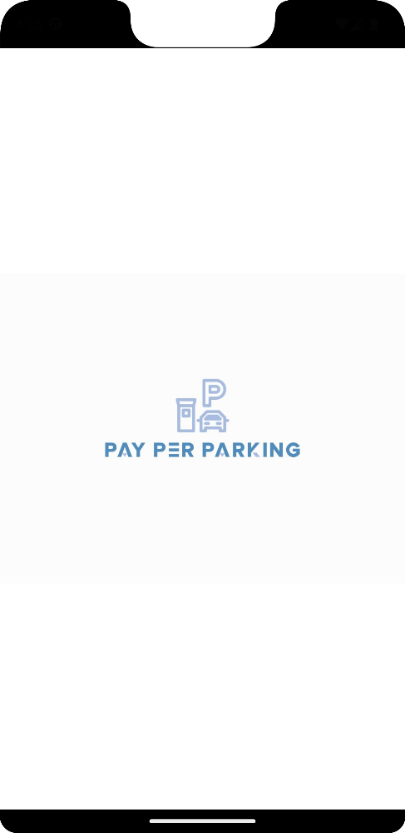Splash Screen :** After opening the application user will see the splash screen which will be disappeared instantly after few seconds.

**Figure**

**Splash Screen**

**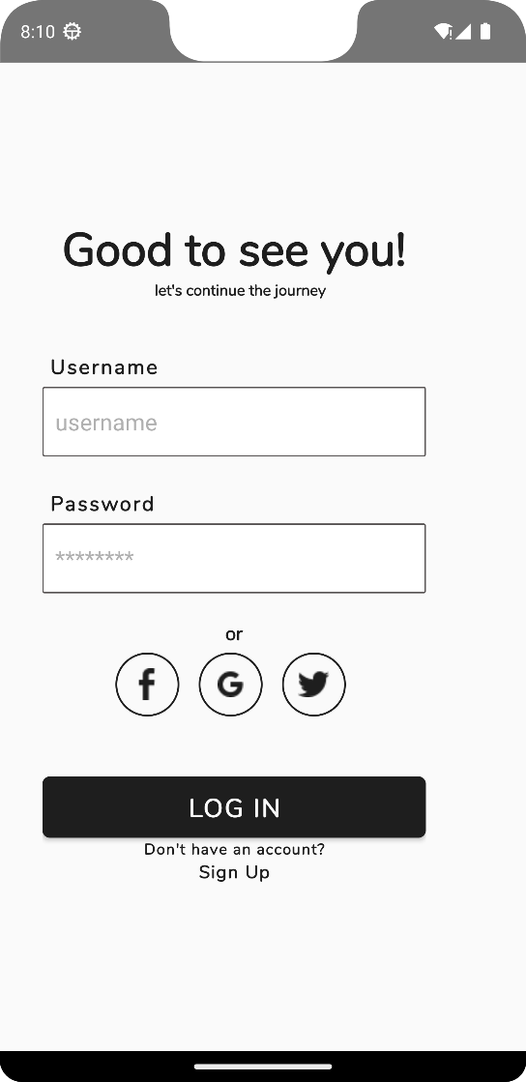**

1. **Login Page :** After registering themselves on the application user can login through username and password in the login page.

**Figure**

**Login Screen**

**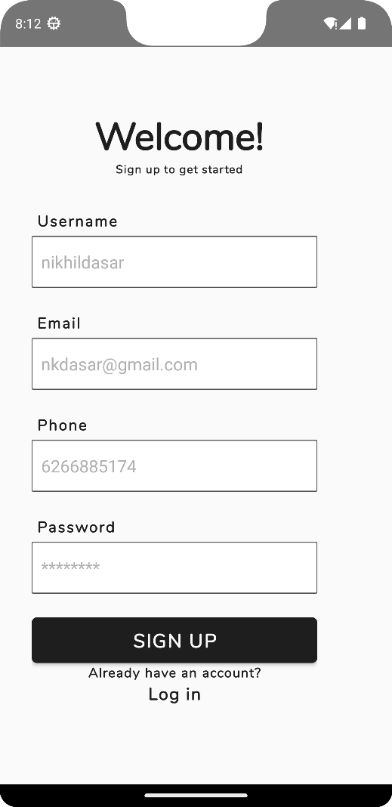**

1. **Registration :** Registration page comes after the splash screen is disappeared. If a user cannot register themselves on the application first user need to register himself/herself. After the registration user can login to application through is email and password.

**Figure**

**Sign Up Screen**

1. **Guest Mode :** If user want to know and explore the application without registering. Guest Mode helps user to directly run the application and see the features of the application.
2. **Permissions :** When user redirected to the application dashboard, application take some permissions/access (Storage, location etc.) from user to work.

**Access Pay Per Parking need to work :-**

1. **Device Storage Access**
2. **Device Location Access (GPS)**
3. **Internet Access (Mobile Data)**

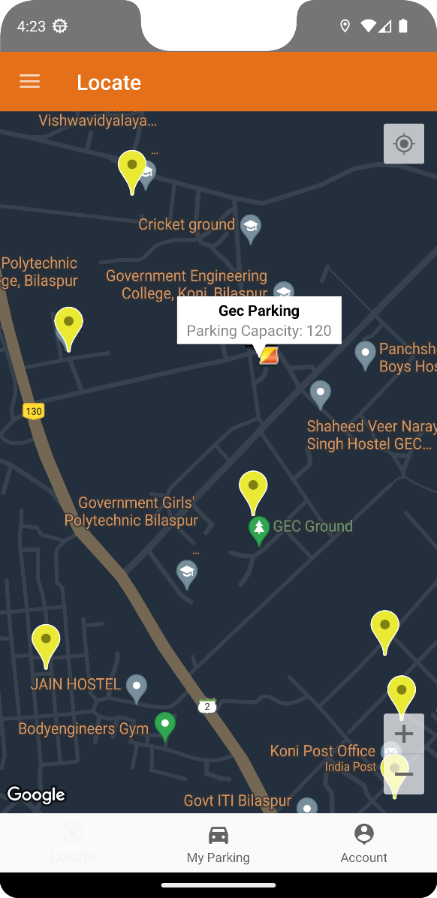

**6. Nearest Parking Spots :** It is a map activity where user can see all the parking spots near his/her location.

**Figure**

**Parking Spots**

**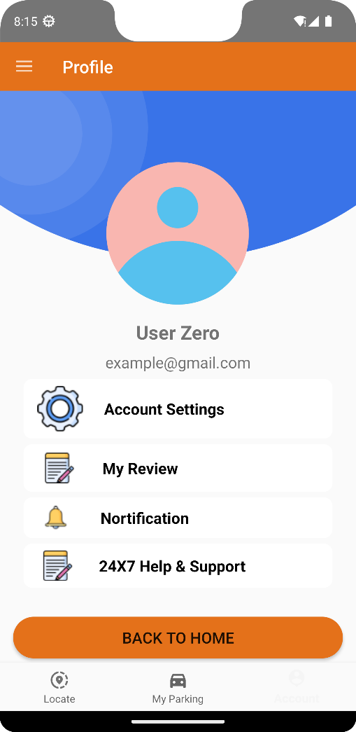**

1. **User Profile :** My Profile Section is used for managing user’s personal information, in this section user can edit or update their information.

**Figure**

**User Profile**

**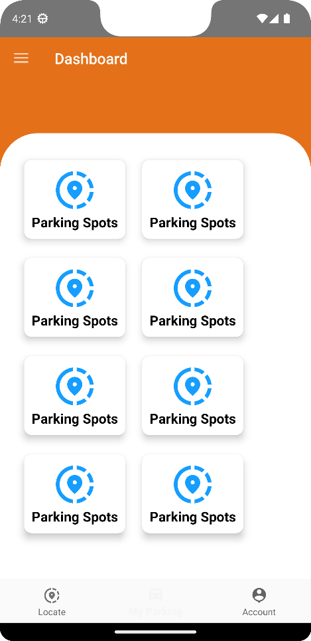**

1. **Dashboard :** Dashboard Section shows the latest features of the app and as well as all the recent history of the user.

**Figure**

**Dashboard**

**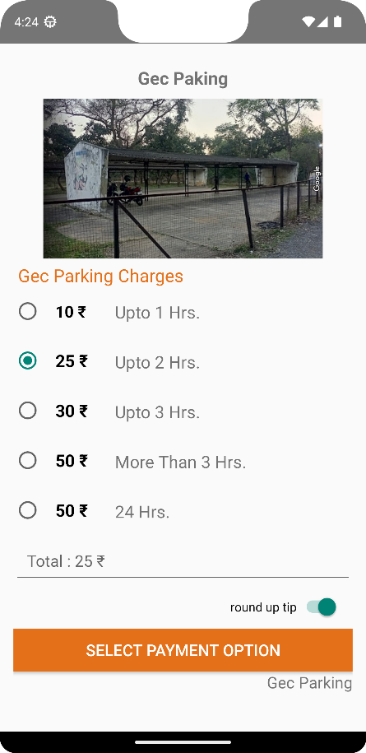**

1. **Parking Charges:** It is a parking package page where user can see all the parking charges according to the particular parking spot selection.

**Figure**

**Parking Charges**

**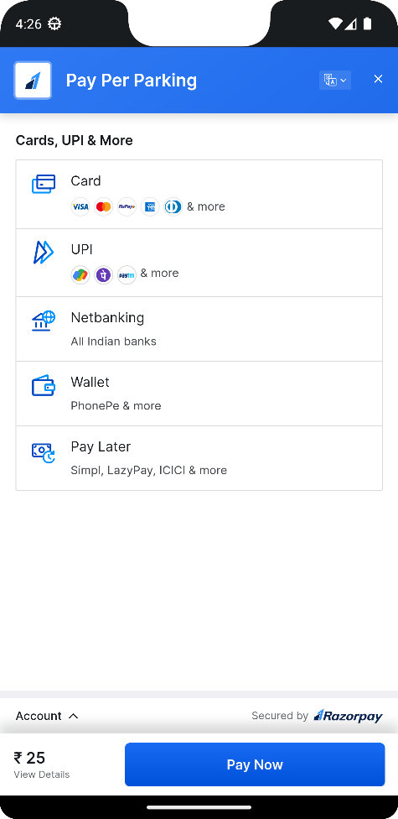**

1. **Payment Gateway:** Payment gateway provide a safe and multiple payment methods to complete the payments.

**Figure**

**Payment Gateway**

**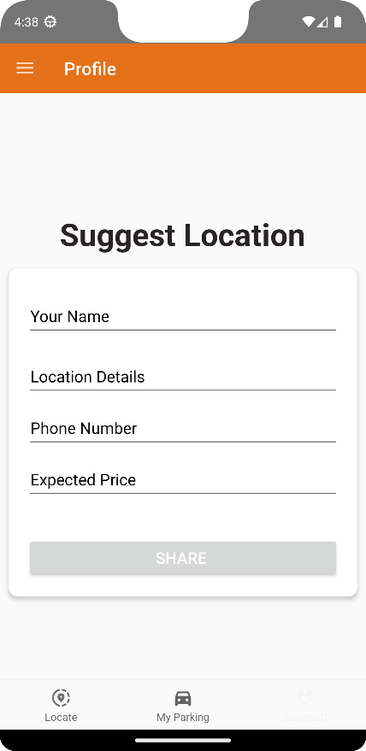**

1. **Suggestion :** It is a suggestion page where user suggest the location which is available for making it to a parking spot.

**Figure**

**Suggestion Page**

**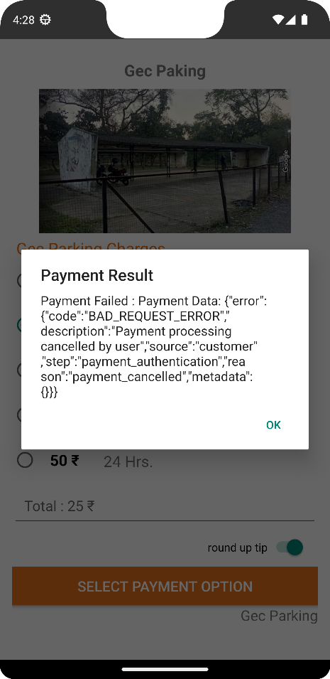**

1. **Payment Result :** Payment result alert dialog will show the payment status whether the payment is successful or not. If payment will succeed it will show you the payment details.

**Figure**

**Payment Result**

**3.1.1 Overview of the application:**

Pay Per Parking works on the basic approach of registering themselves on the application and sign in to their account to use this application. Everyone who has an Email or Mobile Number can register themselves on this app. During Signup user can also create their username and also sign in through it with the help of their password. After registration user should give location permission to app so it can detect user location and show user nearby parking spots.

* Register or Guest – User need to register himself/herself or can use guest mode to see the basic structure of the application.
* After registration user will come to this stage where app require some permissions to work , after allowing the permission user redirected to the map activity where user can see all the nearest parking locations
* On map user will see all the nearest locations from its current location.
* Every parking spot on the map show some basic information about spot.
* After selecting the parking spot user can see the details about the spot and parking packages according to the service selection.
* After selection of package user can complete the payment through pay per parking gateway.
* Payment gateway provide various payment methods to complete the payment which is crucial in different network scenarios.
* After completing the payment user will redirected to the dialog box where user can see the payment details.
* By submission on dialog box user will redirected to payment receipt page where user can download the invoice of payment.
* Now user can go to the place through google map with the invoice he received and park vehicle on the particular parking spot.

**Chapter – IV**

**Result and Performance Analysis**

**Result and Performance Analysis**

Pay Per Parking could create a safe and easy parking environment. It can work more efficiently in near feature and will also may provide some handy features.

[1. Two-Factor Authorization](https://opengeekslab.com/blog/parking-app-development/" \l "1_Two-Factor_Authorization)

[2. Location](https://opengeekslab.com/blog/parking-app-development/#2_Location)

[3. Searching Process](https://opengeekslab.com/blog/parking-app-development/#3_Searching_Process)

[4. Time Range](https://opengeekslab.com/blog/parking-app-development/#4_Time_Range)

[5. Booking](https://opengeekslab.com/blog/parking-app-development/#5_Booking)

[6. Multiple Payment Methods](https://opengeekslab.com/blog/parking-app-development/#6_Multiple_Payment_Methods)

[7. Parking History](https://opengeekslab.com/blog/parking-app-development/#7_Parking_History)

[8. Rating/Reviews](https://opengeekslab.com/blog/parking-app-development/#8_RatingReviews)

[9. Customer Support](https://opengeekslab.com/blog/parking-app-development/#9_Customer_Support)

[10. Push-Notifications](https://opengeekslab.com/blog/parking-app-development/#10_Push-Notifications)

These features will help users to trust parking environment and create a simple user interface with minimal complications.

Parking history will help user to track all the previous parking spots and their charges.

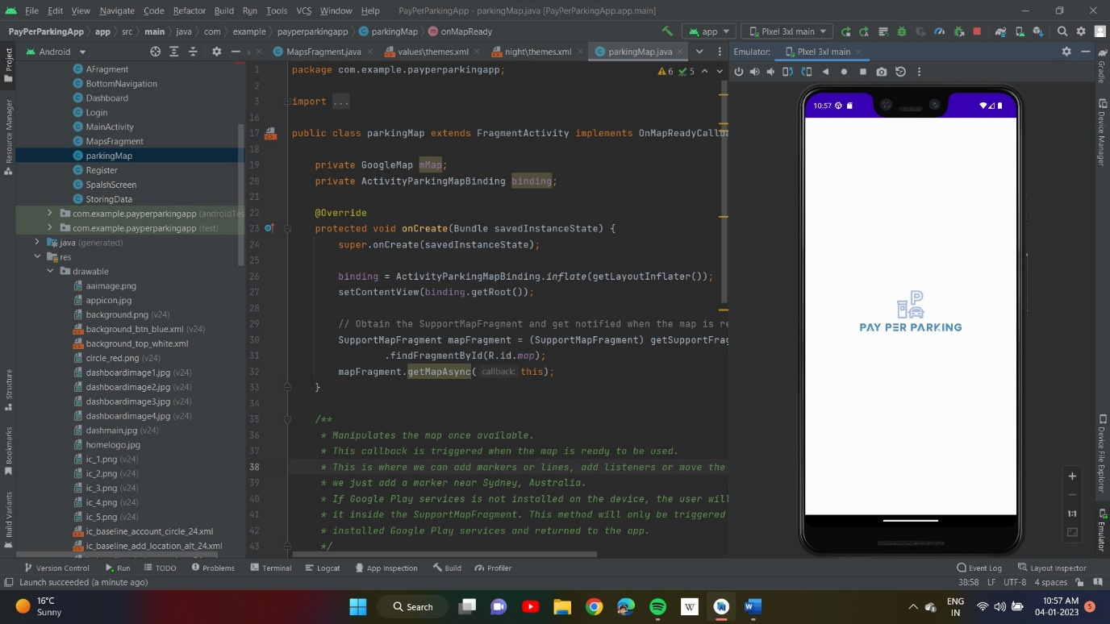

**Figure 1.1 – Splash Screen of Pay Per Parking**

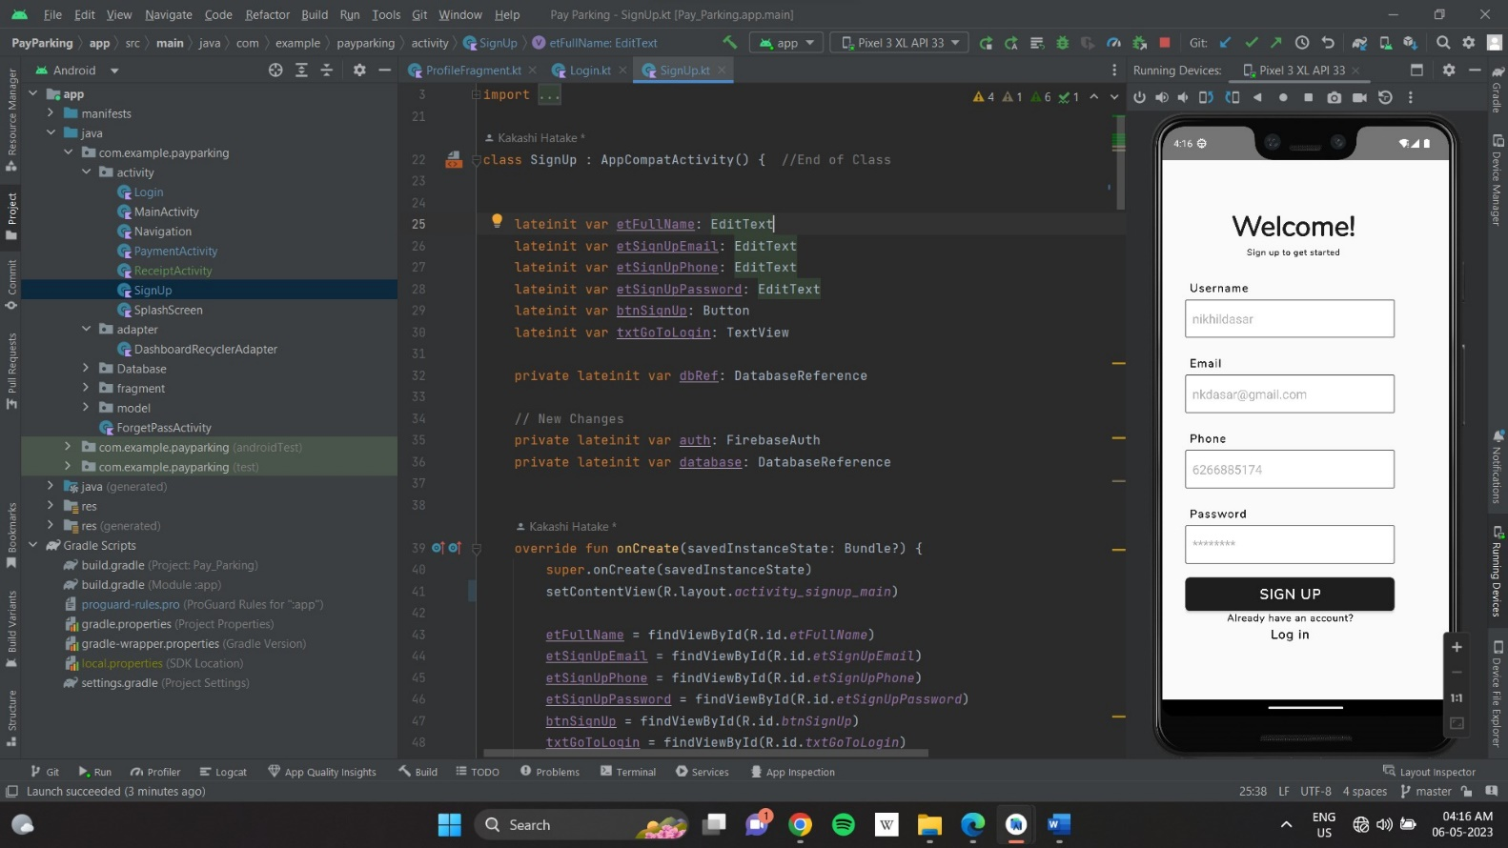

**Figure 2.1 – Registration Page of Pay Per Parking**

**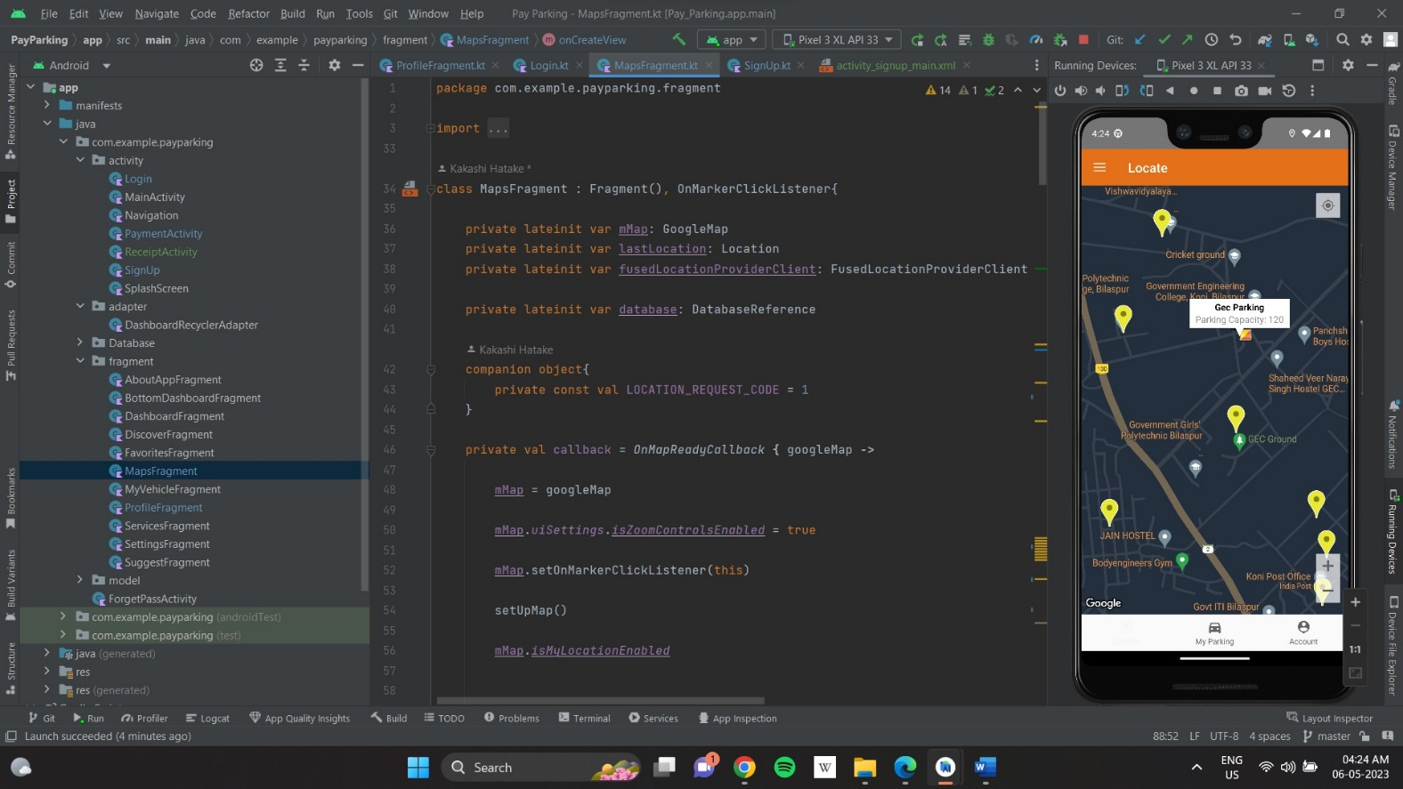**

**Figure 3.1 – Nearby Parking Locations**

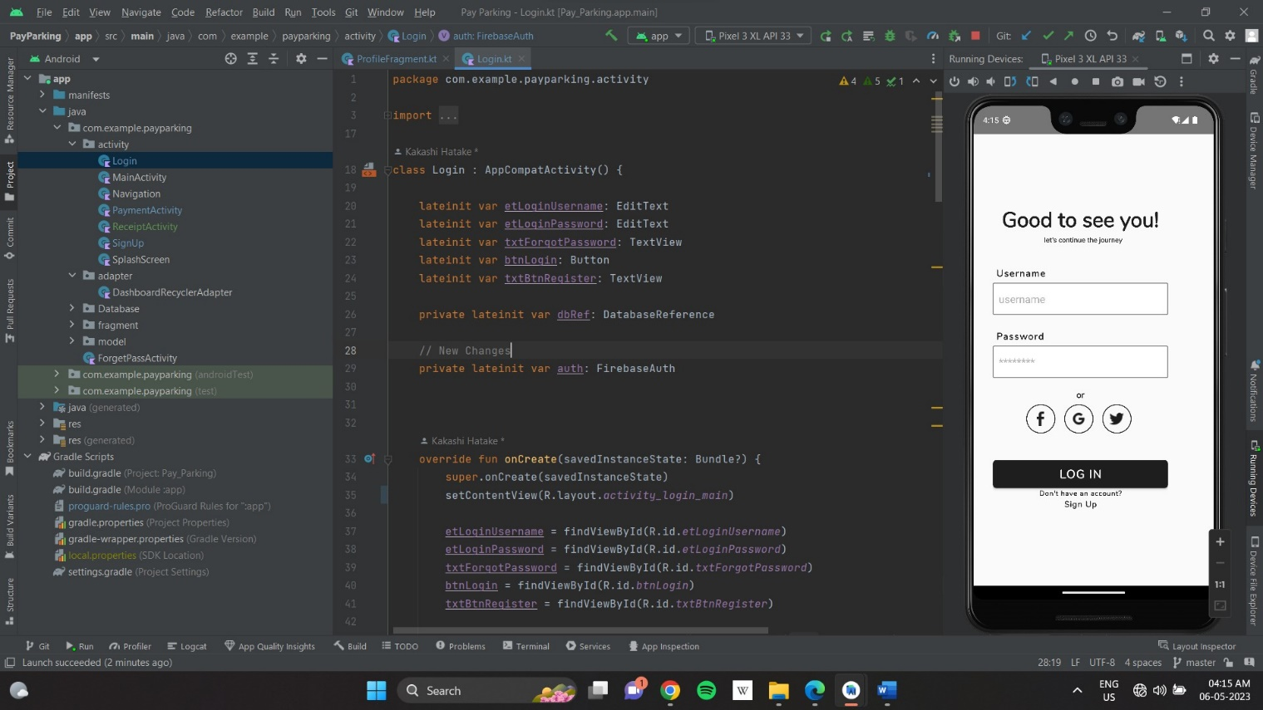

**Figure 4.1 – Login Page**

**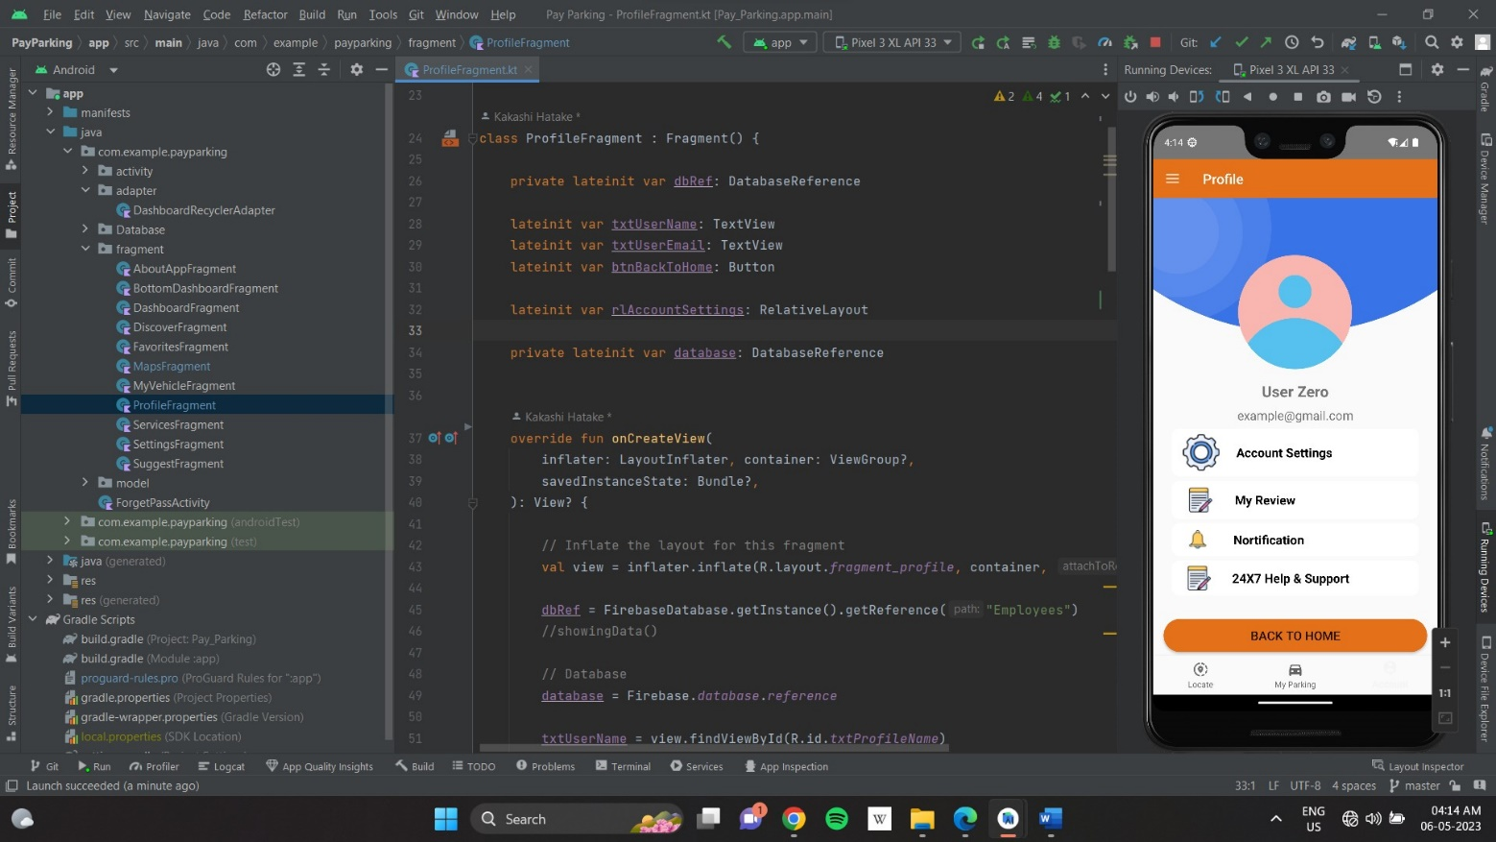**

**Figure 5.1 – User Profile Section**

**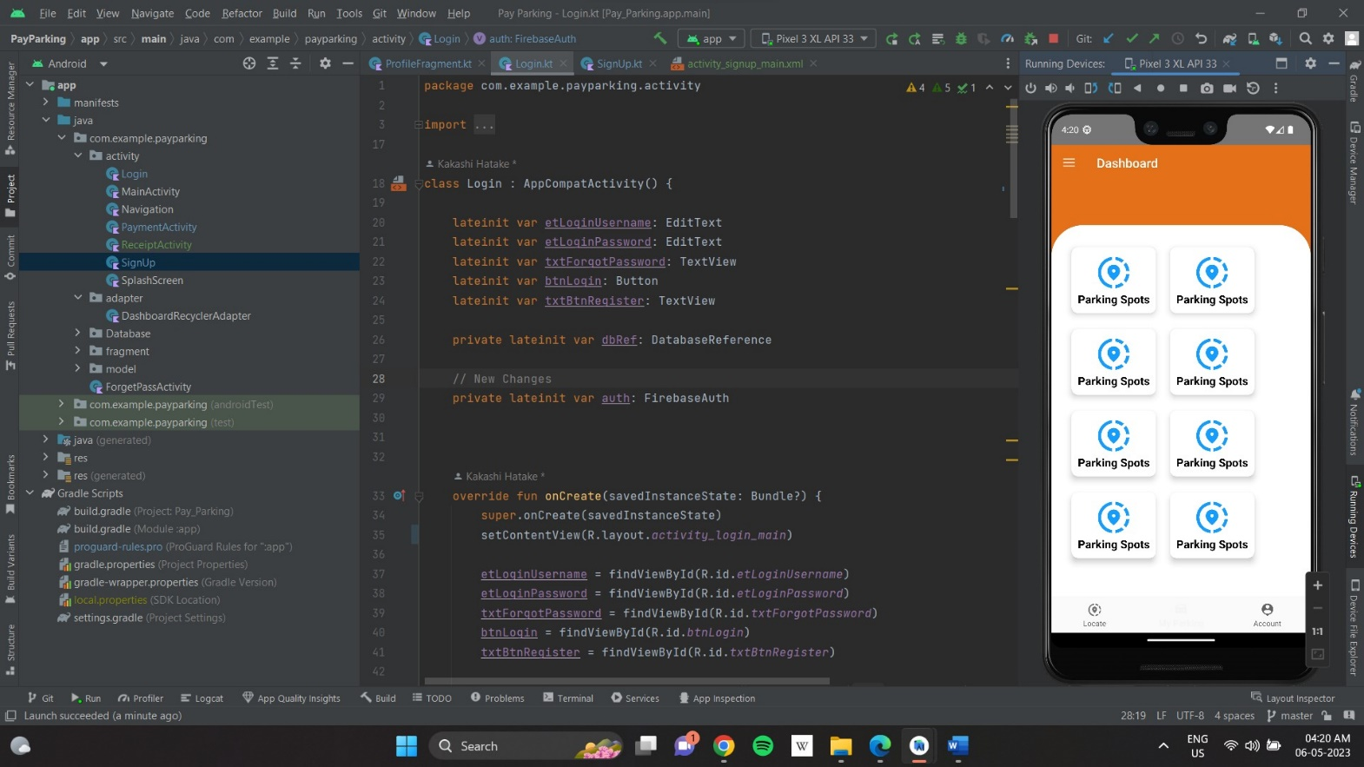**

**Figure 6.1 – Dashboard Section**

**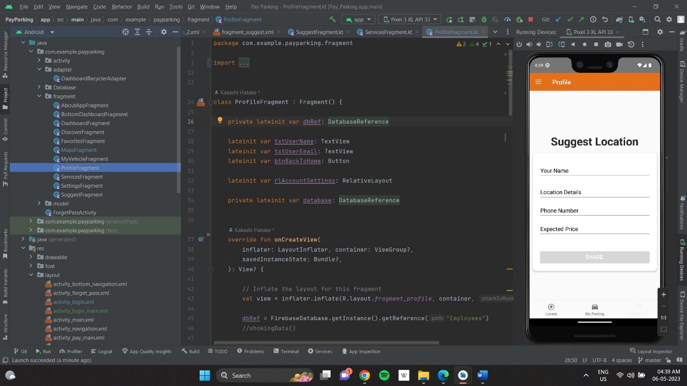**

**Figure 6.1 – Suggest a Location Page**

**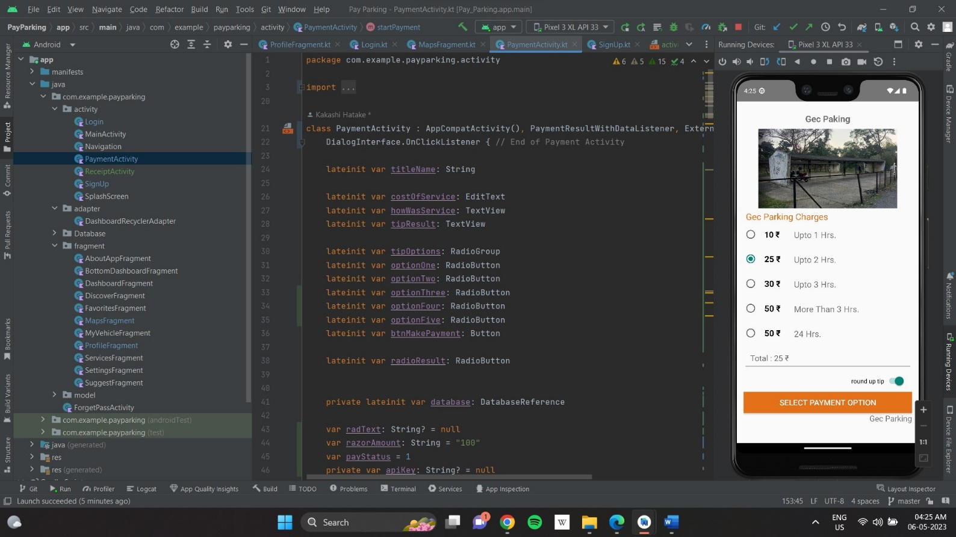**

**Figure 7.1 – Parking Package**

**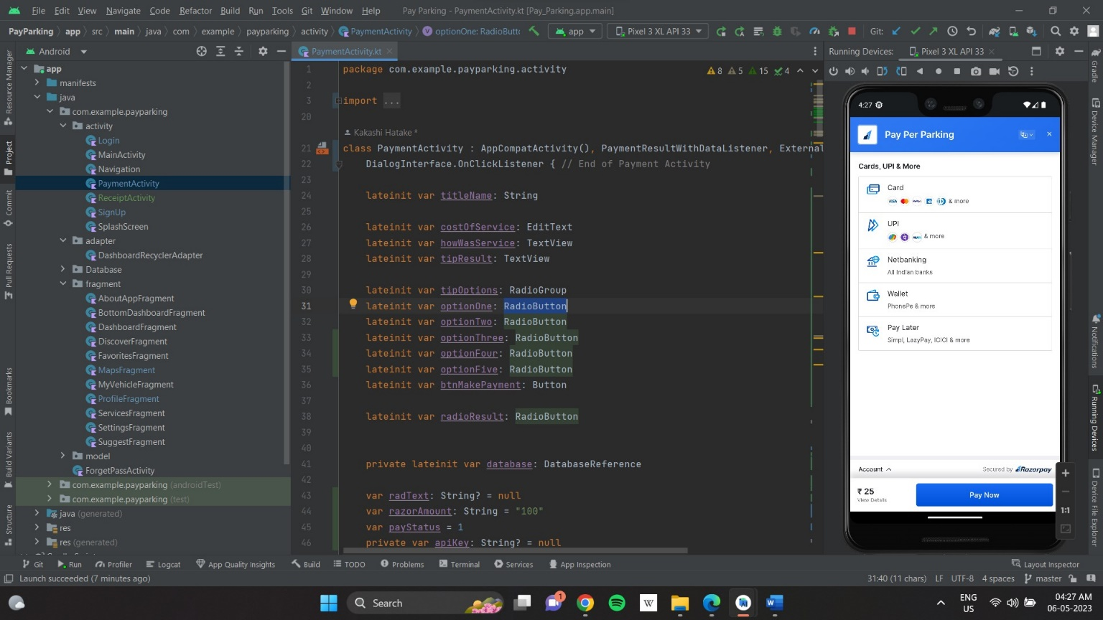**

**Figure 8.1 – Payment Gateway**

**Chapter – V**

**Result and Performance Analysis**

**Conclusion:**

Pay Per Parking provide a easy way to park vehicle through digital all over the places inside a city, it will reduce the cost of parking charges and problems across country and create a safe parking environment.

**In Future Pay Per Parking will provide some handy features like :-**

* Navigation through GPS,
* Save Favorite Parking Places,
* Parking History,
* Parking Charges according to the time duration,
* More Payment Methods,
* Push-Notification,
* Nearest parking spots (Distance wise),
* Anyone who has a parking area can register their parking spot on this platform,
* Customer Support,
* Ratings and Reviews.

**References**

* Android Studio Official Site – <https://developer.android.com>
* Quora – <https://www.quora.com/>
* W3schools – <https://www.w3schools.com/>
* Youtube – <https://www.youtube.com/>
* Wikipedia – <https://en.wikipedia.org/wiki/Main_Page/>
* LinkedIn – https://www.linkedin.com/