**Documentation**

**PMS User Manual V1**

by : Sambath Kakda

Date: September 02, 2013

# Developer Role/ Contractor Role

# 

* Go to PMS url
* (**Developer Role**) Enter your username/password (LDAP credential) if your user already input by the administrator
* (**Contractor Role**) If you are a contractor you will not get LDAP credential, so in order to login, you have to get one username/password provide by administrator.

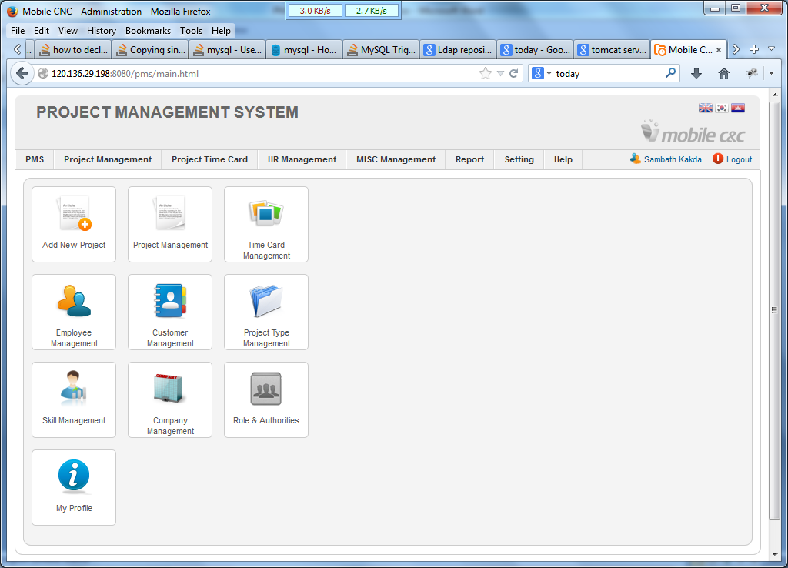

* If your credential is valid it will redirect to the main page

All of that management it’s not open to all the user levels. Please remember that developer/contractor can access only **(PMS -> My Profile and Project Time Card -> Time Card)**

* **PMS -> My Profile:** You can update your user information and change your own password except developer role as they get authorize by LDAP.
* **Project Time Card -> Time Card:**  Every Role has their own timecard. As you are a PMS user you have to fill your working hour into your projects daily and submit every weekend.
* **Time Card Follow up:** You will get time card follow up message send by system every Monday morning when you didn’t submit report for the last week. However, please remember that your time card that is submitted is readonly. To undo your submitted timecard please request to administrator.

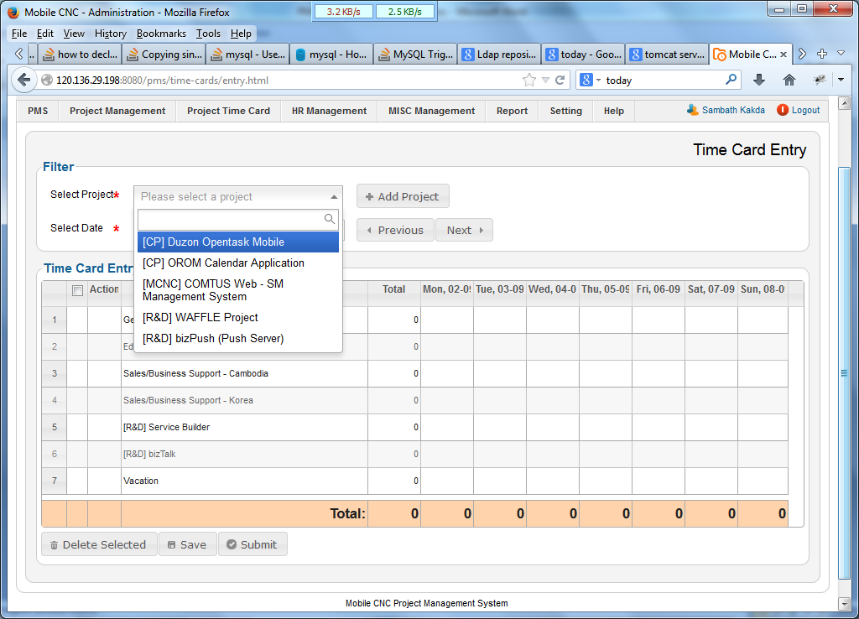

As you are a developer I think you know well about this operation. So I just brief introduction to this operation.

* **The select project** is the project that your project manager didn’t assign or you haven’t do it in the previous week. You can add these projects into your timecard report if you involved this. *Note: you have special permission to this project (Add/Delete)
* **Select Date:** Navigate the date to filter your timecard (Previous/Next also possible).
* **Timecard Entry:** fill your timecard in your response project (Remember it would not less than 8 hours a day)
* **Save:** After you already added your working hour please click save as system doesn’t auto save.
* **Submit:**  Please submit it every weekend when you are sure that your timecard entry is hundred percent correct.

# Project Manager Role

# Administrator