*Student Management System*

Introduction:
The program is a basic Login System implemented in C that supports two types of users: students and teachers. It requires users to enter their username and password to gain access. The credentials are checked a predefined list of users stored within the program. Upon successful login, the system identifies the user’s role and provides a tailored to that role.
For students, the menu includes options to view their personal information,course-taking page, and grades page. Teachers have different menu with options to view their personal information, student information page, and course-teaching page. Users can interact with these menus until they decide to log out, which ends their session. This design demonstrates role-based access control and simple user interaction using console input and output.
Overall, this program illustrates important programming concepts such as user authentication, conditional branching, loops for menu-driven interaction, and modular code structure through separate functions for each role’s menu. It serves as a useful foundation for understanding how to manage different user roles and build interactive console applications in C.

Algorithm:

1) Start the program.

2) Login:

Prompt user to input username and password.

3) Check User Role:

If user is Student, go to step 4.

Else if user is Teacher, go to step 8.

Else show invalid login message and go back to step 2 or end program.

4) Student Menu:

Ask if user wants to see Student Personal Information page.

If Yes, show Student Personal Information page.

Else ask if user wants to see Course-Taking page.

If Yes, show Course-Taking page.

Else ask if user wants to see Grades page.

If Yes, show Grades page.

After showing requested page, return to step 4 for another selection or log out.

5) Ask if user wants to Log out:

If Yes, go to step 11.

If No, return to step 4.

6) Teacher Menu:

Ask if user wants to see Teacher Personal Information page.

If Yes, show Teacher Personal Information page.

Else ask if user wants to see Student Information page.

If Yes, show Student Information page.

Else ask if user wants to see Course-Teaching page.

If Yes, show Course-Teaching page.

After showing requested page, return to step 6 for another selection or log out.

7) Ask if user wants to Log out:

If Yes, go to step 11.

If No, return to step 6.

8) Log out:

Perform log out operation (clear session or confirm log out).

9) End the program.

- FLOWCHART:

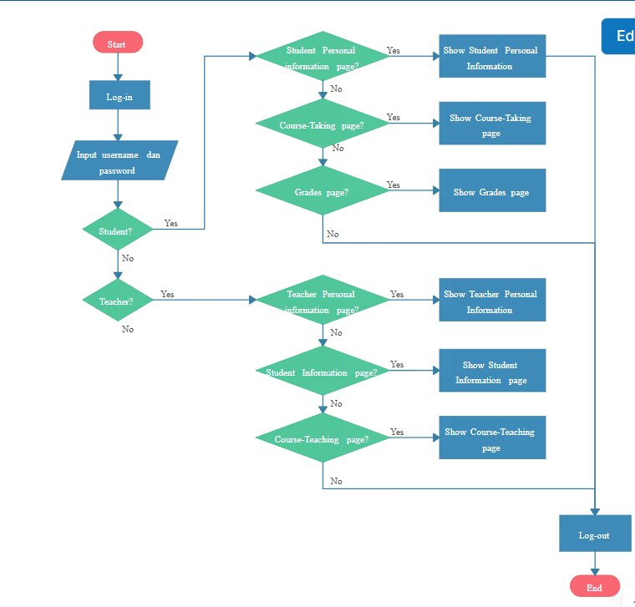

- PROGRAM

#include <stdio.h>
#include <string.h>

// Simple hardcoded users for demo
struct User {
char username[20];
char password[20];
char role[10]; // "student" or "teacher"
};

struct User users[] = {
{"student1", "pass123", "student"},
{"teacher1", "teach123", "teacher"}
};

int login(char *username, char *password, char *role) {
for (int i = 0; i < 2; i++) {
if (strcmp(username, users[i].username) == 0 && strcmp(password, users[i].password) == 0) {
strcpy(role, users[i].role);
return 1;
}
}
return 0;
}

void studentMenu() {
int choice;
while (1) {
printf("\n--- Student Menu ---\n");
printf("1. Personal Information\n");
printf("2. Course-Taking Page\n");
printf("3. Grades Page\n");
printf("4. Logout\n");
printf("Enter choice: ");
scanf("%d", &choice);

switch(choice) {
case 1:
printf("Showing Student Personal Information...\n");
break;
case 2:
printf("Showing Course-Taking Page...\n");
break;
case 3:
printf("Showing Grades Page...\n");
break;
case 4:
printf("Logging out...\n");
return;
default:
printf("Invalid choice, try again.\n");
}
}
}

void teacherMenu() {
int choice;
while (1) {
printf("\n--- Teacher Menu ---\n");
printf("1. Personal Information\n");
printf("2. Student Information Page\n");
printf("3. Course-Teaching Page\n");
printf("4. Logout\n");
printf("Enter choice: ");
scanf("%d", &choice);

switch(choice) {
case 1:
printf("Showing Teacher Personal Information...\n");
break;
case 2:
printf("Showing Student Information Page...\n");
break;
case 3:
printf("Showing Course-Teaching Page...\n");
break;
case 4:
printf("Logging out...\n");
return;
default:
printf("Invalid choice, try again.\n");
}
}
}

int main() {
char username[20], password[20], role[10];
int loggedIn = 0;

printf("=== Welcome to Login System ===\n");

while (!loggedIn) {
printf("Enter username: ");
scanf("%s", username);
printf("Enter password: ");
scanf("%s", password);

if (login(username, password, role)) {
printf("Login successful! Role: %s\n", role);
loggedIn = 1;
} else {
printf("Invalid username or password. Try again.\n");
}
}

if (strcmp(role, "student") == 0) {
studentMenu();
} else if (strcmp(role, "teacher") == 0) {
teacherMenu();
}

printf("=== End of Program ===\n");
return 0;
}

- OUTPUT

=== Welcome to Login System ===
Enter username: student1
Enter password: pass123
Login successful! Role: student

--- Student Menu ---
1. Personal Information
2. Course-Taking Page
3. Grades Page
4. Logout
Enter choice: 1
Showing Student Personal Information...

--- Student Menu ---
1. Personal Information
2. Course-Taking Page
3. Grades Page
4. Logout
Enter choice: 3
Showing Grades Page...

--- Student Menu ---
1. Personal Information
2. Course-Taking Page
3. Grades Page
4. Logout
Enter choice: 4
Logging out...
=== End of Program ===

THANK YOU

