A
MICROPROJECT REPORT
ON
“Zener diode and LED : Symbol, construction,Working , Applications.”

SUBMITTED IN PARTIAL FULFILLMENT OF THE REQUIREMENTS FOR THE AWARD
O
DIPLOMA IN

Department of Artificial Intelligence & Machine Learning

SUBMITTED TO
MAHARASHTRA STATE BOARD OF TECHNICAL EDUCATION, MUMBAI

Sr.no Student Name Roll no Enorllement No
01 | SOHAM SANTOSH KAMBLE | 16 | 225P10647
02 | KAMTHE HARSHADA NANDUKUMAR | 17 | 225P10441
03 | SWPNIL MADHUKAR KARALE | 18 | 225P10611
04 | DIGVIJAY TANAJI KARALE | 19 | 225P11200
05 | KARTIK PRABHAKAR KAKDE | 20 | 225P10560

ZES’S Zeal Polytechnic Pune

ACADEMIC YEAR 2025-26


MAHARASHTRA STATE BOARD OF TECHNICAL EDUCATION
Certificate

This is to certify that Mrs. SOHAM SANTOSH KAMBLE Roll No.16 of second Semester of Diploma in Artificial Intelligence & Machine Learning of Institute, Zeal Education Society’s Zeal Polytechnic, Pune (Institute Code: 0988) has completed the Micro Project satisfactorily in Subject Basic Electrical & Electronics Engineering (312302) for the Academic Year 2025-2026 as prescribed in the curriculum.

Place: Narhe,Pune Enrollment No: 225P106

Date: ……………………… Exam. Seat No: ………………………………

Subject Teacher Head of the Department Principal



MAHARASHTRA STATE BOARD OF TECHNICAL EDUCATION
Certificate

This is to certify that Ms. KAMTHE HARSHADA NANDUKUMAR Roll No. 17 of second Semester of Diploma in Artificial Intelligence & Machine Learning of Institute, Zeal Education Society’s Zeal Polytechnic, Pune (Institute Code: 0988) has completed the Micro Project satisfactorily in Subject Basic Electrical & Electronics Engineering (312302) for the Academic Year 2025-2026 as prescribed in the curriculum.

Place: Narhe,Pune Enrollment No: 225P10441
Date: ……………………… Exam. Seat No: ………………………………

Subject Teacher Head of the Department Principal



MAHARASHTRA STATE BOARD OF TECHNICAL EDUCATION
Certificate

This is to certify that Mr. SWPNIL MADHUKAR KARALE Roll No.18 of second Semester of Diploma in Artificial Intelligence & Machine Learning of Institute, Zeal Education Society’s Zeal Polytechnic, Pune (Institute Code: 0988) has completed the Micro Project satisfactorily in Subject Basic Electrical & Electronics Engineering (312302) for the Academic Year 2025-2026 as prescribed in the curriculum.

Place: Narhe,Pune Enrollment No: 225P10611

Date: ……………………… Exam. Seat No: ………………………………

Subject Teacher Head of the Department Principal



MAHARASHTRA STATE BOARD OF TECHNICAL EDUCATION
Certificate

This is to certify that Mr. DIGVIJAY TANAJI KARALE Roll No.19 of second Semester of Diploma in Artificial Intelligence & Machine Learning of Institute, Zeal Education Society’s Zeal Polytechnic, Pune (Institute Code: 0988) has completed the Micro Project satisfactorily in Subject Basic Electrical & Electronics Engineering (312302) for the Academic Year 2025-2026 as prescribed in the curriculum.

Place: Narhe,Pune Enrollment No: 225P11200
Date: ……………………… Exam. Seat No: ………………………………

Subject Teacher Head of the Department Principal



MAHARASHTRA STATE BOARD OF TECHNICAL EDUCATION
Certificate

This is to certify that Mr. KARATIK PRABHAKAR KAKDE Roll N0. 20 of second Semester of Diploma in Artificial Intelligence & Machine Learning of Institute, Zeal Education Society’s Zeal Polytechnic, Pune (Institute Code: 0988) has completed the Micro Project satisfactorily in Subject Basic Electrical & Electronics Engineering (312302) for the Academic Year 2025-2026 as prescribed in the curriculum.

Place: Narhe,Pune Enrollment No: 225P10560
Date: ……………………… Exam. Seat No: ………………………………

Subject Teacher Head of the Department Principal

Group Details

Sr. No | Name of Group Members | Roll No | Enrollment No | Seat No
01 | SOHAM SANTOSH KAMBLE | 16 | 225P10647
02 | HARSHADA NANDUKUMAR KAMTHE | 17 | 225P10441
03 | SWPNIL MADHUKAR KARALE | 18 | 225P10611
04 | DIGVIJAY TANAJI KARALE | 19 | 225P11200
05 | KARTIK PRABHAKAR KAKDE | 20 | 225P10560

INDEX

SR. NO. | CONTENTS | PAGE NO.
1 | TITLE OF MICROPROJECT
2 | OBJECTIVE
3 | PROBLEM DEFINITION
4 | BLOCK DIAGRAM
5 | HARDWARE/SOFTWARE/TOOLS USED
6 | STEP BY STEP METHODOLOGY
7 | OBSERVATIONS,RESULTS
8 | CONCLUSION
9 | LEARNING OUTCOMES
10 | REFERENCES

OBJECTIVE

- To study the symbol, construction, and working of a Zener diode and LED.

- To understand the voltage regulation property of Zener diode.

- To understand the light emission principle of LED.

- To learn the applications of semiconductor diodes in electronic circuits.

PROBLEM DEFINITION

Electronic circuits require stable voltage and indication systems for proper operation.
However, fluctuations in voltage can damage sensitive components. Also, circuits often need visual indicators to show whether they are operating or not.
This project studies Zener diode for voltage regulation and LED for visual indication, which are widely used in electronic devices.

INTRODUCTION

Electronics plays an important role in modern electrical and electronic systems. Most electronic devices use semiconductor components to control current and voltage. Among these components, diodes are widely used because they allow current to flow in one direction and block it in the opposite direction.

A Zener diode and Light Emitting Diode (LED) are special types of diodes that have important applications in electronic circuits. The Zener diode is designed to operate in the reverse breakdown region and is mainly used for voltage regulation. It helps maintain a constant output voltage even when the input voltage changes. Because of this property, Zener diodes are widely used in power supply circuits and voltage stabilizers.

A Light Emitting Diode (LED) is a semiconductor device that emits light when electric current flows through it in the forward direction. LEDs are very efficient, consume less power, and have a long life compared to traditional bulbs. They are commonly used as indicators, displays, lighting systems, and electronic devices.

In this micro project, we study the symbol, construction, working principle, and applications of Zener diode and LED. This project helps in understanding how these components are used in practical electronic circuits for voltage control and indication purposes.

BLOCK DIAGRAM

Zener Diode – Symbol
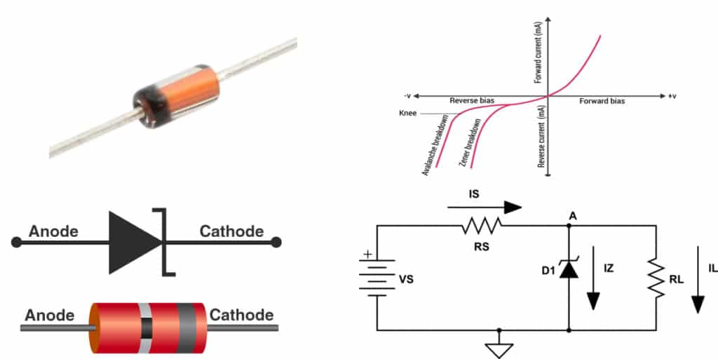

A Zener diode is a special type of semiconductor diode that is designed to operate in the reverse breakdown region. Unlike a normal diode, which only allows current to flow in the forward direction, a Zener diode can also allow current to flow in the reverse direction when the applied reverse voltage reaches a certain value called the Zener breakdown voltage (Vz).

LED (Light Emitting Diode) Symbol

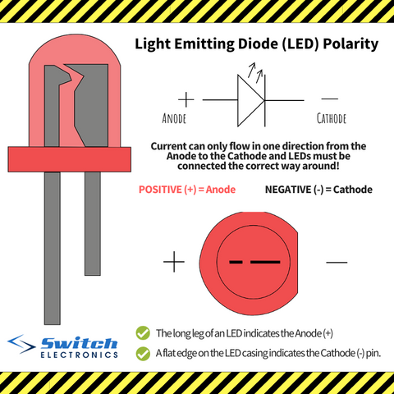

The symbol of an LED (Light Emitting Diode) is similar to the symbol of a normal diode, but it has two small arrows pointing outward from the diode symbol. These arrows represent the emission of light from the LED.

The symbol consists of two terminals: anode and cathode. The anode (positive terminal) is connected to the p-type region, and the cathode (negative terminal) is connected to the n-type region. When current flows from the anode to the cathode in forward bias, the LED emits light.

Zener Diode – Construction

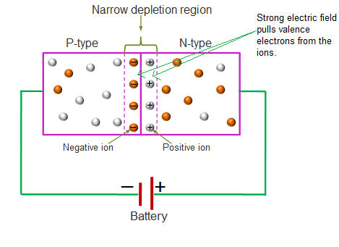

Zener Diode – Construction(explanation)

A Zener diode is constructed using a heavily doped p–n junction made from semiconductor material such as silicon. The heavy doping of both p-type and n-type regions makes the depletion layer very thin. Because of this thin depletion region, the diode can break down at a low reverse voltage, called the Zener voltage.

The p-region forms the anode and the n-region forms the cathode. Metal contacts are attached to both sides so the diode can be connected to an external circuit. The entire device is enclosed in a protective package made of glass or plastic.

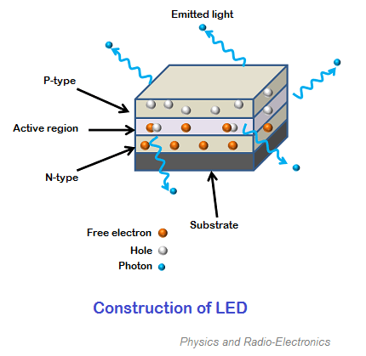

- LED – Construction(explanation)
- A Light Emitting Diode (LED) is a semiconductor device made from a p–n junction that emits light when electric current flows through it.
- The LED is constructed using semiconductor materials such as gallium arsenide (GaAs), gallium phosphide (GaP), or gallium arsenide phosphide (GaAsP) instead of silicon. These materials are used because they can produce light when current passes through them.
- An LED consists of two semiconductor layers:
- P-type layer (Anode)
- N-type layer (Cathode)
- These two layers form a p–n junction. When the LED is connected to a power supply in forward bias, electrons from the n-region and holes from the p-region recombine at the junction. During this recombination, energy is released in the form of light, which is the main working principle of the LED.
- The semiconductor chip is mounted on a reflective metal cup that helps direct the light outward. Two metal leads are connected to the p-type and n-type regions for electrical connection. The entire structure is enclosed in a transparent epoxy plastic case, which protects the diode and allows the light to pass through.

Zener Diode – Working

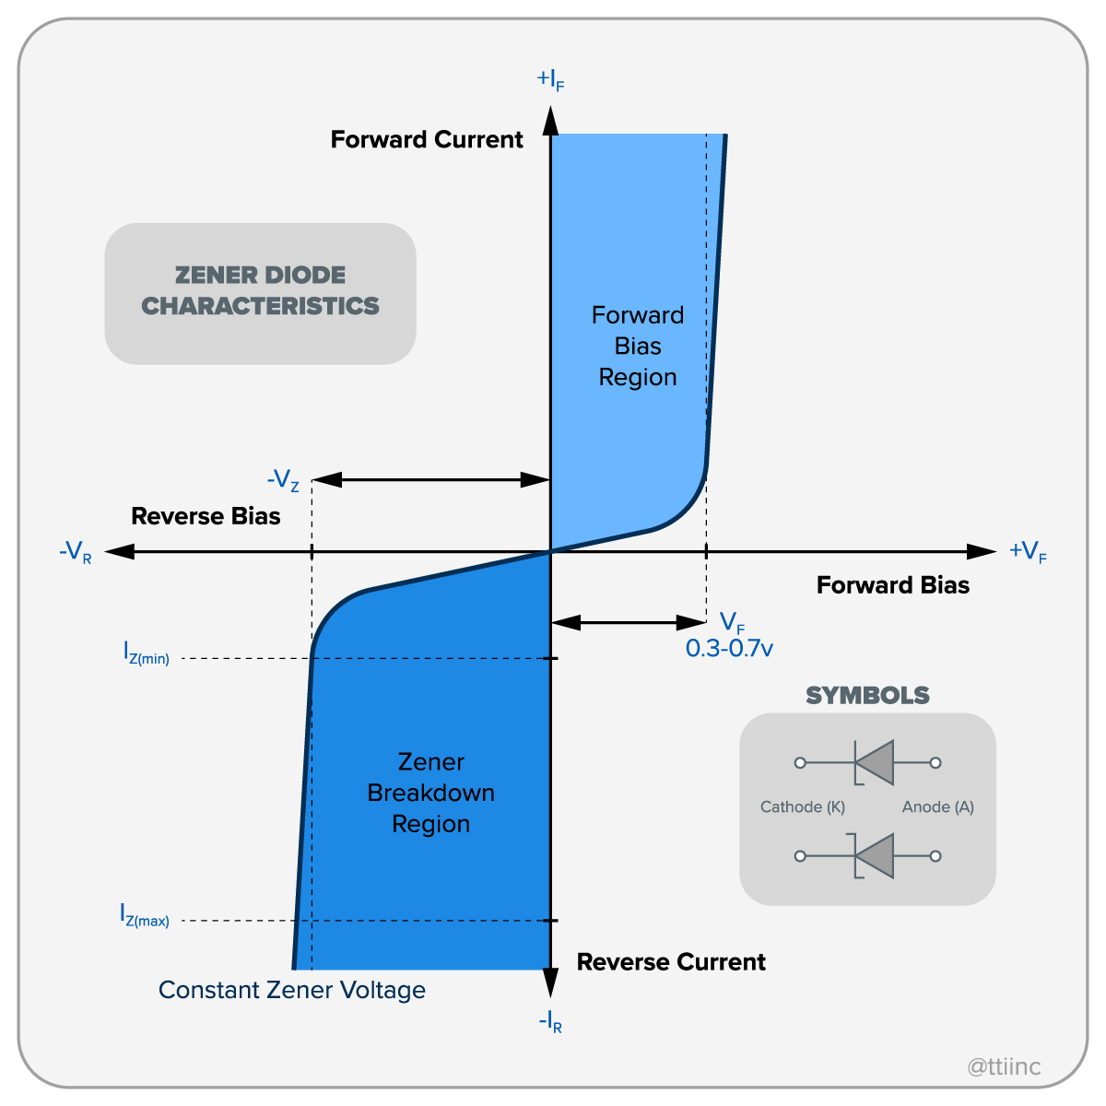

- Zener Diode – Working explanetion

The Zener diode works mainly in the reverse bias condition and is used to maintain a constant voltage in a circuit.

When the Zener diode is connected in forward bias, it behaves like a normal diode. Current flows from the anode to the cathode when the applied voltage is greater than about 0.7 V (for silicon).

When the Zener diode is connected in reverse bias, it blocks current initially and only a very small leakage current flows. As the reverse voltage increases, a point is reached where the voltage equals the Zener breakdown voltage (Vz). At this stage, the diode enters the breakdown region.

In the breakdown region, the Zener diode starts conducting current in the reverse direction, but the voltage across the diode remains almost constant. This constant voltage is called the Zener voltage.

Because of this property, the Zener diode is widely used as a voltage regulator. Even if the input voltage changes, the Zener diode maintains a stable output voltage across the load.

LED – Working
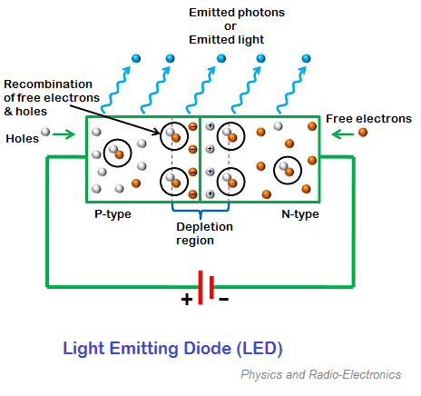

The Light Emitting Diode (LED) works on the principle of electroluminescence, which means light is produced when electric current passes through a semiconductor material.
When an LED is connected in forward bias, the p-type region is connected to the positive terminal and the n-type region is connected to the negative terminal of the power supply. Due to this, electrons from the n-region move toward the p-region and holes from the p-region move toward the n-region.
At the p–n junction, electrons and holes recombine with each other. During this recombination process, energy is released in the form of light. This light comes out through the transparent casing of the LED.
The color of the light produced depends on the semiconductor material used in the LED. For example, different materials can produce red, green, blue, or yellow light.
When the LED is connected in reverse bias, it does not allow current to flow and therefore no light is produced.

HARDWARE/SOFTWARE/
TOOLS USED

Hardware
- Zener Diode
- LED (Light Emitting Diode)
- Resistors
- DC Power Supply / Battery
- Breadboard
- Connecting Wires
Tools / Instruments
- Multimeter
- Soldering Iron (if circuit is permanent)
- Breadboard
Software (Optional for simulation)
- Proteus
- Multisim

STEP-BY-STEP METHODOLOGY

• Study the symbol and characteristics of Zener diode and LED.

• Collect required components such as diodes, resistors, power supply and breadboard.

• Build a simple circuit on breadboard with a Zener diode for voltage regulation.

• Connect the LED with a current limiting resistor.

• Apply DC input voltage to the circuit.

• Observe the voltage across the Zener diode.

• Check the LED glow which indicates proper current flow.

• Measure voltage and current using multimeter.

• Record observations.

OBSERVATIONS & RESULTS

Component | Observation
Zener Diode | Maintains nearly constant voltage after breakdown
LED | Emits light when forward biased
Resistor | Limits current through LED
Output Voltage | Remains stable due to Zener regulation

Result:
The Zener diode successfully regulates voltage, and the LED glows when current flows, demonstrating proper circuit operation.

CONCLUSION

From this project, we studied the construction, working, and applications of Zener diode and LED.
The Zener diode works as a voltage regulator, while the LED works as an efficient light indicator in electronic circuits.
Both components are widely used in modern electronic devices.

LEARNING OUTCOMES

After completing this micro project on Zener Diode and LED, the following learning outcomes were achieved:
- Understanding of semiconductor devices such as Zener diode and Light Emitting Diode (LED).
- Ability to identify and draw circuit symbols of Zener diode and LED.
- Knowledge of the construction and internal structure of Zener diode and LED.
- Understanding the working principle of Zener diode in reverse breakdown region.
- Understanding the working principle of LED based on electroluminescence.
- Knowledge about applications of Zener diode for voltage regulation and LED for indication and lighting.
- Development of basic skills in analyzing simple electronic circuits used in electrical and electronic systems.
- Improved ability to connect components and observe circuit behavior in practical experiments.

WEEKLY PROGRESS REPORT MICRO PROJECT
SR.NO. | WEEK | ACTIVITY PERFORMED | SIGN OF GUIDE | DATE
1 | 1st | Discussion and finalization of topic
2 | 2nd | Preparation and submission of Abstract
3 | 3rd | Literature Review
4 | 4th | Collection of Data
5 | 5th | Collection of Data
6 | 6th | Discussion and outline of Content
7 | 7th | Formulation of Content
8 | 8th | Editing and proof Reading of Content
9 | 9th | Compilation of Report And Presentation
10 | 10th | Seminar
11 | 11th | Viva voce
12 | 12th | Final submission of Micro Project

Sign of the Student Sign of the Faculty

References:

• Basic Electrical Engineering – V.K. Mehta

• Electronic Devices and Circuits – Boylestad

• Polytechnic BEE Notes

• Educational websites like electronics-tutorials.ws

Sources Used:

• V.K. Mehta and Rohit Mehta, Basic Electrical Engineering, S. Chand Publishing.
• Robert L. Boylestad and Louis Nashelsky, Electronic Devices and Circuit Theory, Pearson Education.
• Polytechnic Basic Electrical Engineering (BEE) Lecture Notes provided by the institute.
• Educational electronics tutorial websites such as Electronics Tutorials and All About Circuits for basic concepts of diodes.
• Laboratory manuals and practical guides for semiconductor devices and circuits.

