Q.1 Make HTML table with PHP Script (using echo statement). (Take 5 columns and 5 rows)
<html>
<head>
<title>Table</title>
</head>
<body>

<?php

echo "<table border='1'>";

echo "<tr>";
echo "<td>Name</td>";
echo "<td>City</td>";
echo "<td>Course</td>";
echo "<td>Sem</td>";
echo "<td>Marks</td>";
echo "</tr>";

echo "<tr>";
echo "<td>Nirali</td>";
echo "<td>Rajkot</td>";
echo "<td>BSc IT</td>";
echo "<td>2</td>";
echo "<td>85</td>";
echo "</tr>";

echo "<tr>";
echo "<td>Sejal</td>";
echo "<td>Morbi</td>";
echo "<td>BBA</td>";
echo "<td>3</td>";
echo "<td>98</td>";
echo "</tr>";

echo "<tr>";
echo "<td>Prachi</td>";
echo "<td>Gandhinagar</td>";
echo "<td>MBA</td>";
echo "<td>3</td>";
echo "<td>78</td>";
echo "</tr>";

echo "<tr>";
echo "<td>Hensi</td>";
echo "<td>Surat</td>";
echo "<td>MBA</td>";
echo "<td>2</td>";
echo "<td>86</td>";
echo "</tr>";

echo "<tr>";
echo "<td>Vishwa</td>";
echo "<td>Jamnagar</td>";
echo "<td>B.Tech</td>";
echo "<td>3</td>";
echo "<td>65</td>";
echo "</tr>";

echo "</table>";

?>

</body>
</html>
Output :1
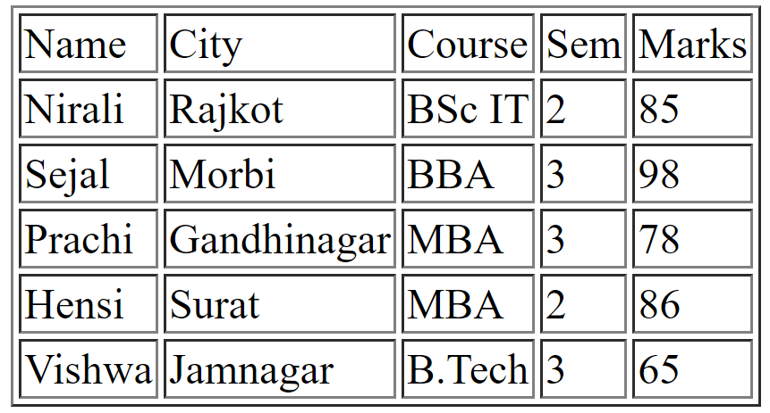

Q.2 Take four variables in PHP (Name, Contact, Address, Pincode)
$address = "University Road";
$pincode = "360007";

echo "Name : " . $name; <html>
<body>

<?php

$name = "bansi";
$contact = "9825295052";

echo "<br>";
echo "Contact : " . $contact;

?>

<br>

Address : <?php echo $address; ?>

<br>

Pincode : <?php echo $pincode; ?>

</body>
</html>
Output:2
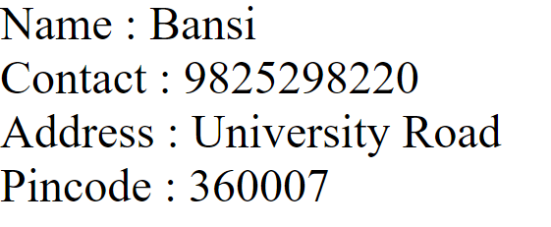

Question 3: Display values and operations within a table
<html>
<body>

<?php
$a = 20;
$b = 10;
?>

<table border="1">
<tr>
<th>Operations</th>
<th>Answer</th>
</tr>

<tr>
<td>Value of A</td>
<td><?php echo $a; ?></td>
</tr>

<tr>
<td>Value of B</td>
<td><?php echo $b; ?></td>
</tr>

<tr>
<td>Addition</td>
<td><?php echo $a + $b; ?></td>
</tr>

<tr>
<td>Subtraction</td>
<td><?php echo $a - $b; ?></td>
</tr>

<tr>
<td>Multiplication</td>
<td><?php echo $a * $b; ?></td>
</tr>

<tr>
<td>Division</td>
<td><?php echo $a / $b; ?></td>
</tr>

</table>

</body>
</html>
Output:3
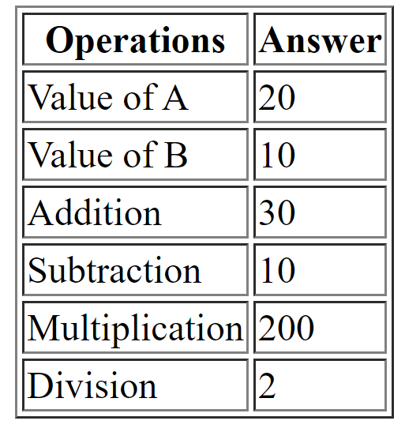

Q4. Check ODD or EVEN (Static Number)
<?php
$num = 10;

if($num % 2 == 0)
{
echo "Even Number";
}
else
{
echo "Odd Number";
}
?>
Output:4


Q5. Find Maximum of 3 Numbers (Static)
<?php
$a = 20;
$b = 35;
$c = 15;

if($a > $b && $a > $c)
{
echo "Maximum = ".$a;
}
elseif($b > $c)
{
echo "Maximum = ".$b;
}
else
{
echo "Maximum = ".$c;
}
?>
Output:5


Q6. Bill Amount with Discount
<?php
$amount = 2500;

if($amount > 2000)
{
$discount = $amount * 15 / 100;
}
elseif($amount > 1000)
{
$discount = $amount * 10 / 100;
}
elseif($amount > 500)
{
$discount = $amount * 5 / 100;
}
else
{
$discount = 0;
}

$final = $amount - $discount;

echo "Bill Amount = ".$amount."<br>";
echo "Discount = ".$discount."<br>";
echo "Final Amount = ".$final;
?>
Output:6
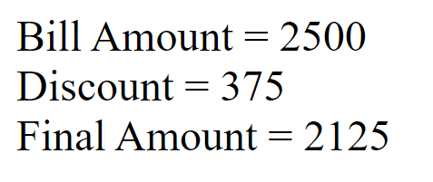

Q7. Maximum & Minimum using GET Method
<html>
<body>

<form method="get">
Number 1 : <input type="text" name="a"><br><br>
Number 2 : <input type="text" name="b"><br><br>
Number 3 : <input type="text" name="c"><br><br>

<input type="submit" value="Check">
</form>

<?php

if(isset($_GET['a']))
{
$a=$_GET['a'];
$b=$_GET['b'];
$c=$_GET['c'];

echo "Maximum = ".max($a,$b,$c);
echo "<br>";
echo "Minimum = ".min($a,$b,$c);
}

?>

</body>
</html>
Output:7
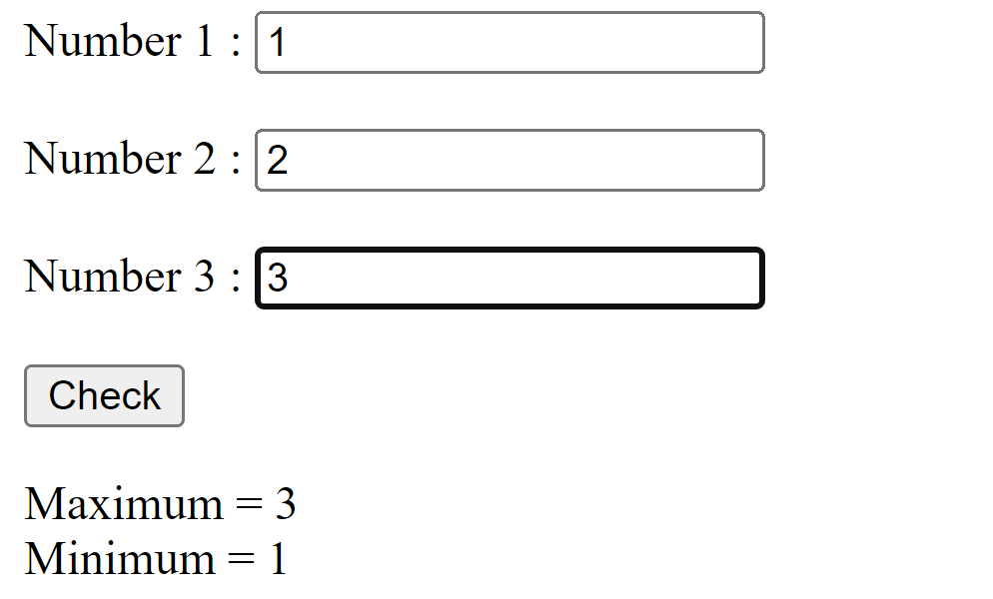

Q8. Two Numbers Operations (GET Method)
<html>
<body bgcolor="pink">

<form method="get">

Enter Number 1 :
<input type="text" name="a"><br><br>

Enter Number 2 :
<input type="text" name="b"><br><br>

<input type="submit" name="op" value="add">
<input type="submit" name="op" value="min"><br><br>

<input type="submit" name="op" value="div">
<input type="submit" name="op" value="mul">

</form>

<?php

if(isset($_GET['op']))
{
$a = $_GET['a'];
$b = $_GET['b'];

if($_GET['op']=="add")
{
echo "<h3>Answer = ".($a+$b)."</h3>";
}
elseif($_GET['op']=="min")
{
echo "<h3>Answer = ".($a-$b)."</h3>";
}
elseif($_GET['op']=="mul")
{
echo "<h3>Answer = ".($a*$b)."</h3>";
}
elseif($_GET['op']=="div")
{
echo "<h3>Answer = ".($a/$b)."</h3>";
}
}

?>

</body>
</html>
Output:8
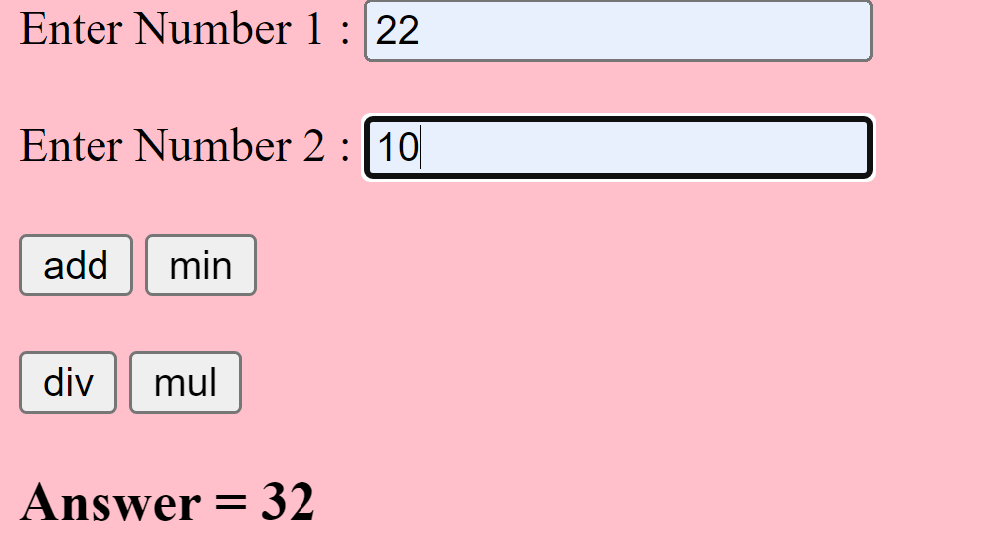

Q9. String with Font Choic
<html>
<body>

<form method="get">

Enter Text :
<input type="text" name="txt"><br><br>

<input type="radio" name="font" value="Arial">Arial
<input type="radio" name="font" value="Courier New">Courier
<input type="radio" name="font" value="Times New Roman">Times

<br><br>

<input type="submit" value="Show">

</form>

<?php

if(isset($_GET['txt']))
{
$text=$_GET['txt'];
$font=$_GET['font'];

echo "<h2 style='font-family:$font;'>$text</h2>";
}

?>

</body>
</html>
Output:9
