* [Ingredientspaedia](http://dooneyskitchen.com/ingredientspaedia/)

[How To's](http://dooneyskitchen.com/category/tricks-cheats/how-tos/)

**How to make Spring roll/Samosa Wrappers**

I swore I was not going to do this. Swore, swore, swore, but against my better judgement, the food blogger that I am, gave in. I found store bought spring roll wrappers and they just saved me the stress. I was looking at the pictures of the spring rolls I made and while giving myself a huge pat on the back, I thought oh dear, how about the people who don’t have access to store bought spring roll wrappers. I know that spring rolls are something a lot of people would like to make themselves at home and not rely on small chops at parties or buying them frozen, so off to google I went, which led to watching You Tube videos.

I saw two methods. One involved making the dough into a ball and them rubbing across a frying pan. I thought nah, no way in hell would I try that. It looked too complicated, hehehehehehehe. The other method was making a watery batter and then applying with a brush. Thank goodness, because if that dough ball version was the only method available, y’all can be rest assured that I would not have tried it, but nicely referred you to the You Tube video. I had all the ingredients at home, down to the corn flour, so try it I did. First, I tried the brush method, as that was what all the videos I found used, then it occurred to me again, that many people would likely not have a pastry brush at home, but a ladle spoon would be more ubiquitous in your cupboard, so despite never watching any video about using a ladle spoon to make this, I imagined that it couldn’t be that hard, so I tried it and it worked.

You see, I am nice like that. Loooool, don’t mind me. It was just my sense of adventure and not wanting to be boxed in by one method. So, whichever you try, you can stop staring lovingly at spring rolls at parties. The next time it is being served and you don’t get enough, just shake your head, flip your hair and go make some at home like the boss that you are. Loooool. I am using a recipe from [Bhavana’s Kitchen](http://bhavnaskitchen.com/" \t "_blank).

**You will need**

1/2 cup of plain flour  
1/4 of corn flour  
3/4 cup of water  
1/4 teaspoon of salt  
Pastry brush or non stick spoon  
Non stick frying pan

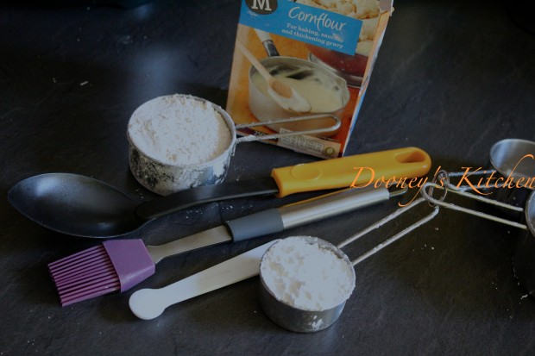

**Dooney’s Kitchen Tip:**For those who don’t have standard measuring cups at home, don’t fret. Let this be your measurement, the ratio of plain flour to corn flour is 2:1 i.e the corn flour should be half the amount of the plain flour. **If you also don’t have corn flour at home, I tried using flour and water, and it also worked.**

**How To**

**1.** Combine all the dry ingredient into a bowl

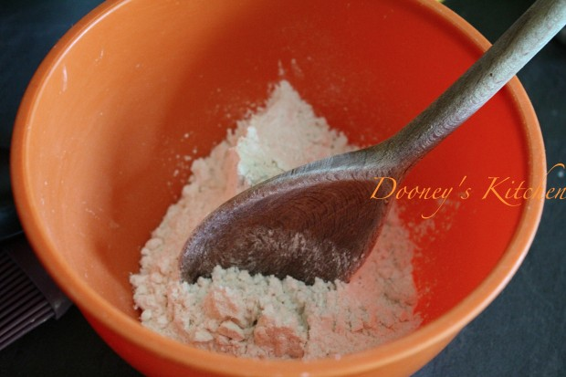

**2.** Add water to the bowl and mix until it is lump free. The bater should be smooth and very light. This is crucial

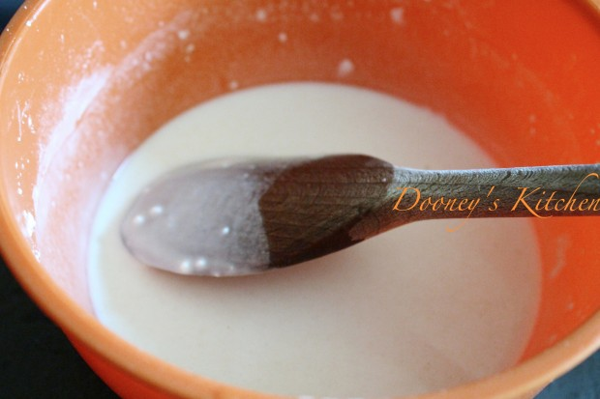

**3.** in a small cup, mix a little oil and water. You will soon know why you need this.

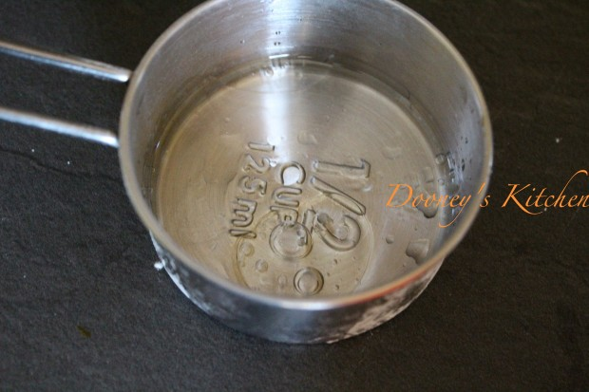

**4.** Get some kitchen paper towel, and dap it into the oil-water mixture

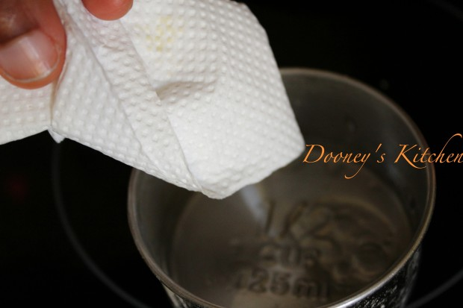

**5.** Rub it on a clean non stick frying pan. What this does is to coat the pan before you start, and to clean the pan between each wrapper. Another thing it does is to drop the temperature of the pan, so it is not too hot for the next wrapper

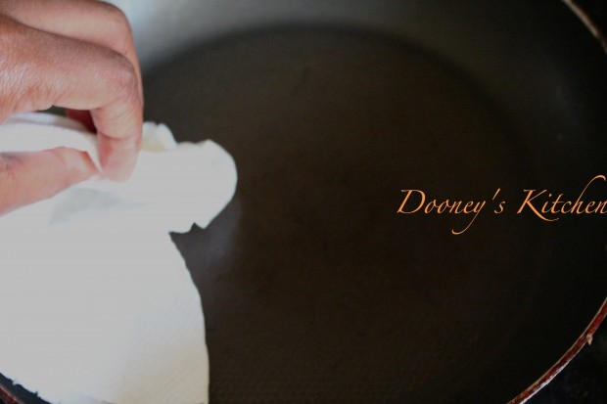

**6.** Take the brush and dip into the batter. Place the pan on very low heat. I used number 1 of my electric cooker. If the pan is too hot, the batter will start to set before you completely cover the pan, making the wrap uneven.

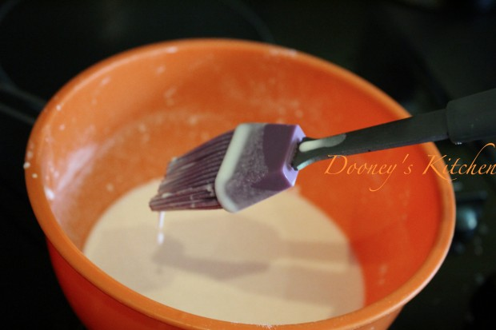

**7.** Brush the batter unto the frying pan in short strokes. Remember not to apply too much, what you want is just a light coating of the frying pan

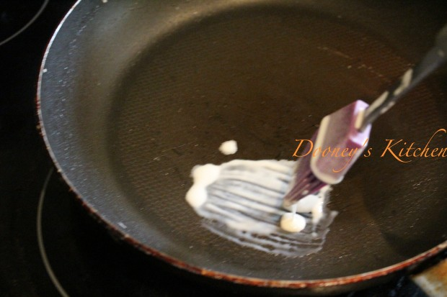

dip the brush back into the batter and repeat brushing on the frying pan in short strokes

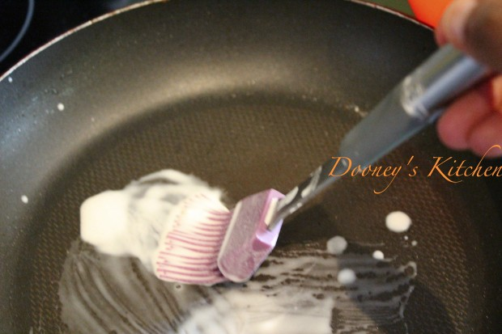

until you cover the pan completely with no gaps. I am showing you this picture below, because this was my first one. It wasn’t perfect as you can see the gaps peeking out here and there in the middle. When the pan was completely covered, i turned the heat up to 2. Still very low heat.

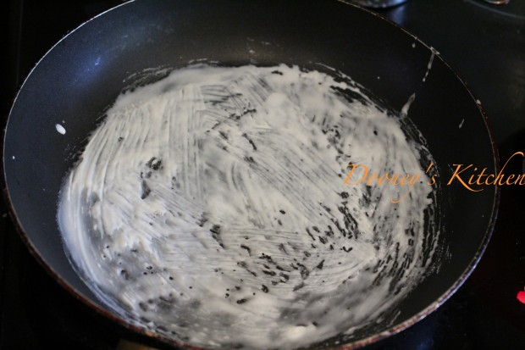

as the batter starts to cook, it will get dry and begin to come off the edges of the pan

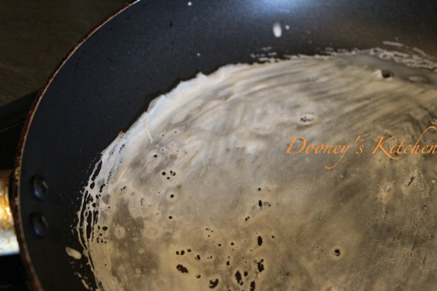

See?

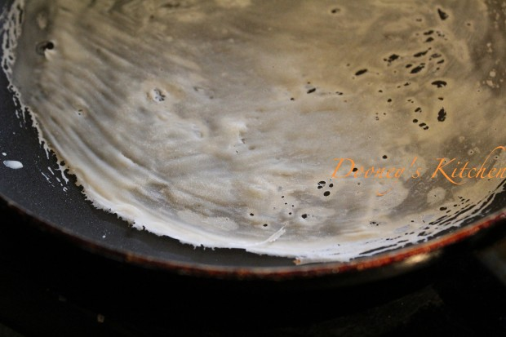

**8.** When it has cooked through, you should be able to easily lift the edge of the pan. It should come off cleanly, that is who you know it is ready. If it doesn’t come off that easily, just give it a little more time, don’t force it, it will come off the pan easily. Gently, and I mean gently, lift it off the pan. I found that it was easier to use two hands, hence no picture of me taking it off completely from the frying pan.

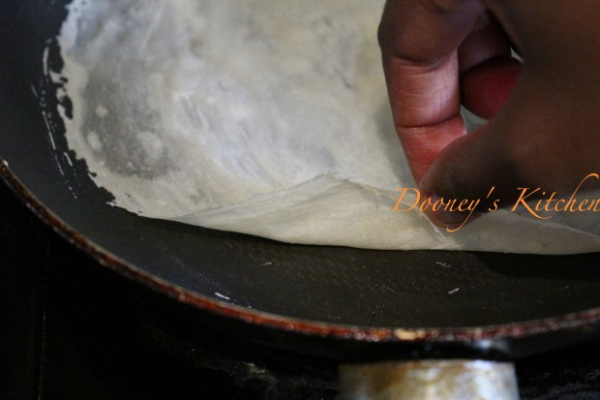

**9.** Lift it off completely from the pan and place on a damp kitchen cloth. It is important that the napkin is damp, otherwise the wrapper will dry out

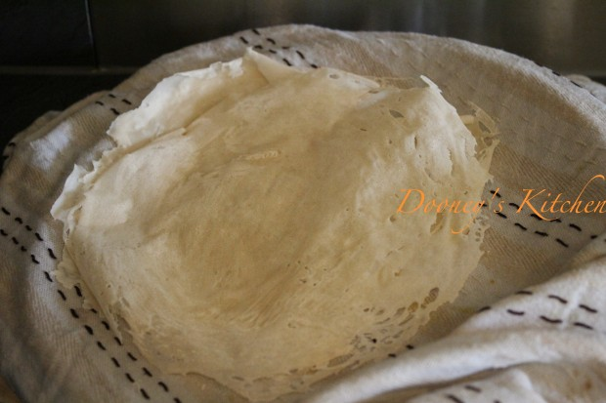

then cover with the damp kitchen cloth, protecting its integrity.

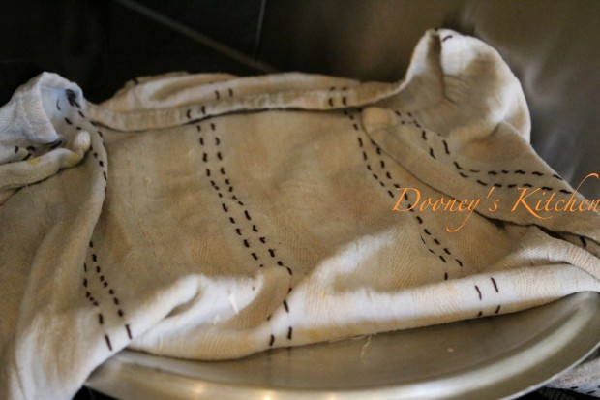

**10.** Once you take it off, turn the heat back down to 1, or the lowest on your cooker, this is to prevent the pan from over heating. Dip the tissue into the oil-water mix again and rub the pan. Repeat the process again. My second was quite wonky, but I got the third one perfectly.

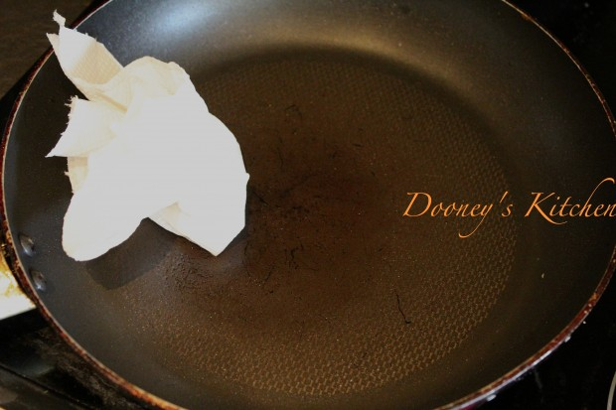

see, much better

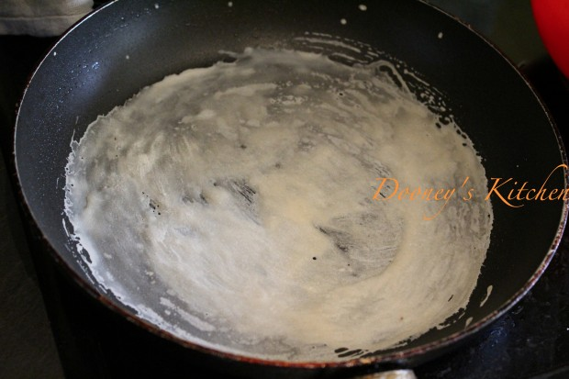

almost cooked

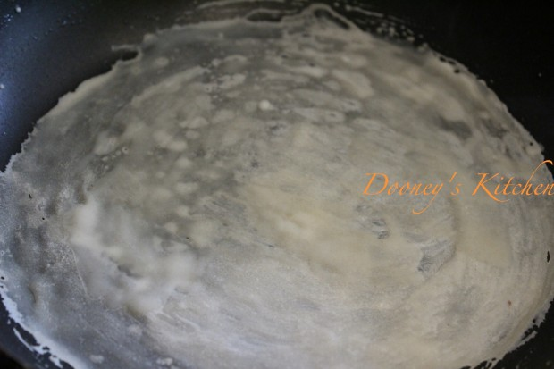

it came off the pan cleanly. No gaps in the middle, just a bit around the edges, and see how thin and transparent it is. You can see the tips of my fingers.

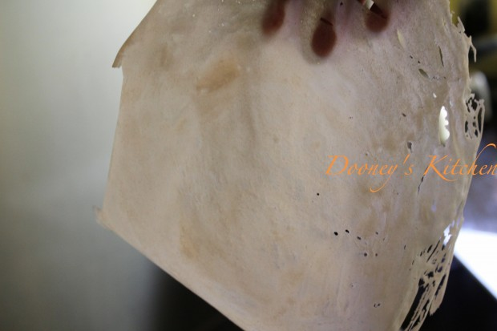

Place on top of a damp kitchen towel and cover. Repeat the process again until you exhaust the batter.

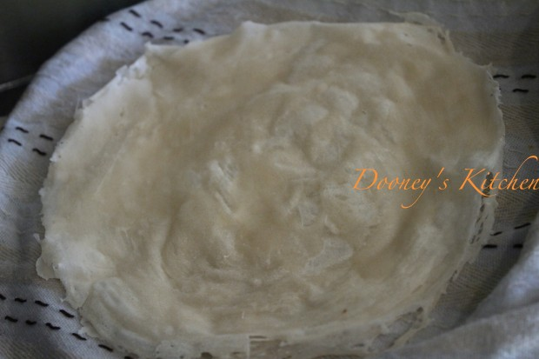

**Pitfalls to watch out for**

**1.** Not letting it to cook completely even though it came of easily on most areas. What will happen is you will leave some batter stuck to the pan. Not to worry, by the time you dip the wet tissue onto the pan, the burnt bits would come  off easily.

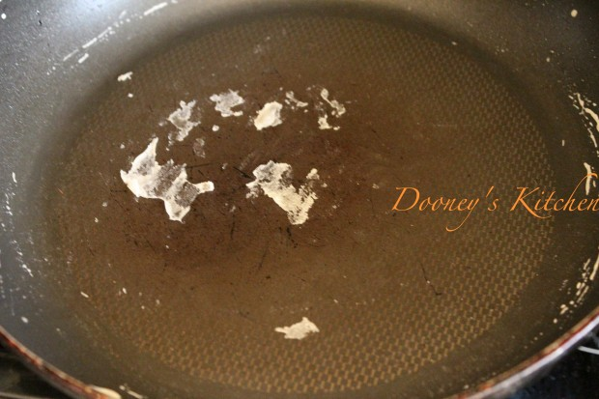

**2. I**n trying to brush lightly over the pan, you may end up with gaps, which will tear when you try to wrap a spring roll. As soon as you notice gaps, take the brush over it, even though the batter has started to cook and turn crisp. It is never too late to fill the gaps. It will all cook through in the end.

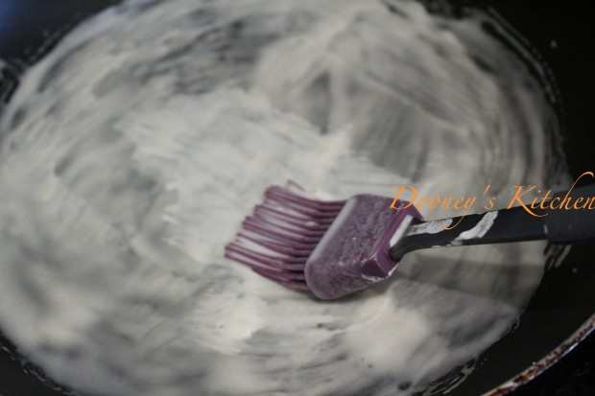

**For those with no pastry brush, use a non stick spoon**

**1.** Give the pan the wet tissue treatment, and then scoop the batter into the spoon

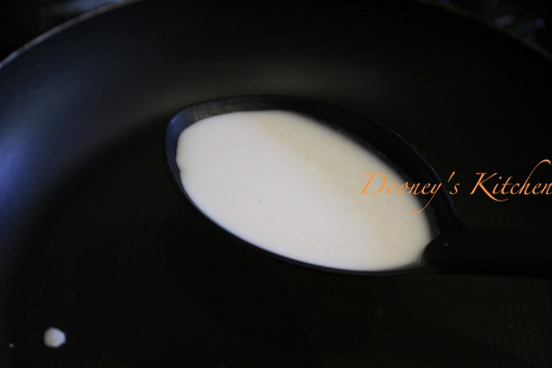

**2.** Lower the spoon unto the frying pan and gently and spill some batter unto the frying pan while using the base of the spoon to spread it around the pan

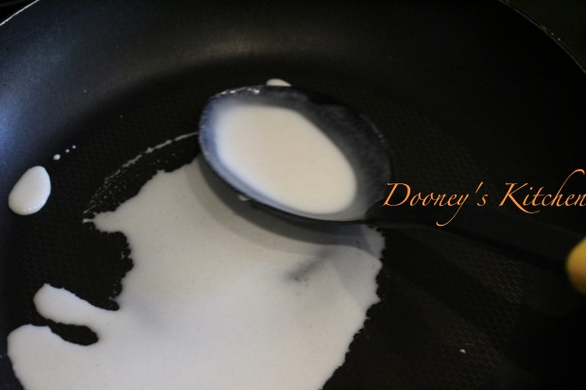

**3.** Keep going until you exhaust the batter in the spoon and the pan is totally covered. You can tilt the pan to help spread the batter too, like you would do with a pancake, this batter is obviously much thinner than pancake batter.

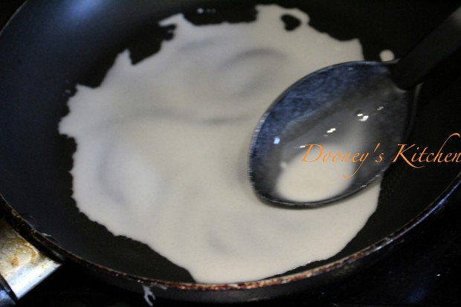

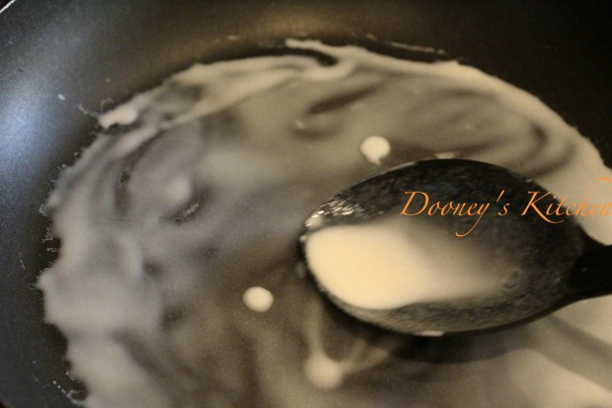

if you have any gaps peeking out, just add a little extra batter and use the base of the spoon to spread and cover it.

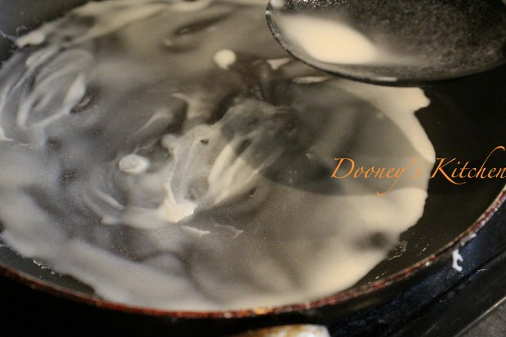

**4.** Leave the batter to cook

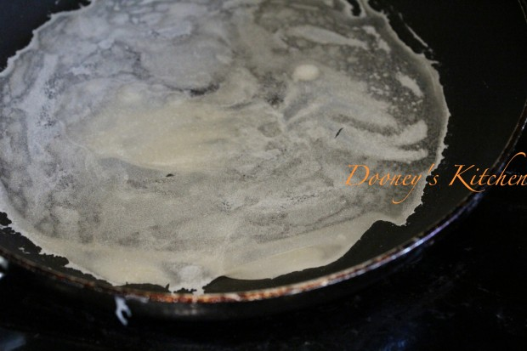

and gently lift it off the pan

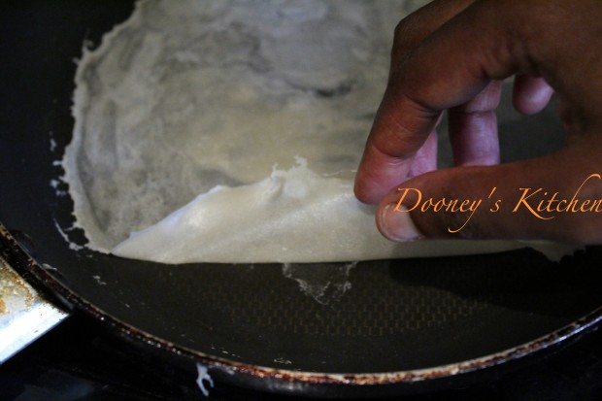

………..and that’s how to make spring rolls/samosa wrappers.

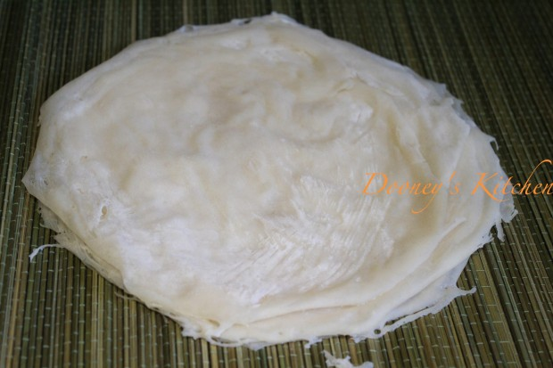

remember to always keep it moist.

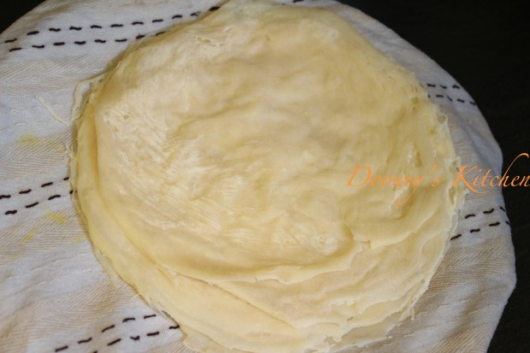

See how thin they are

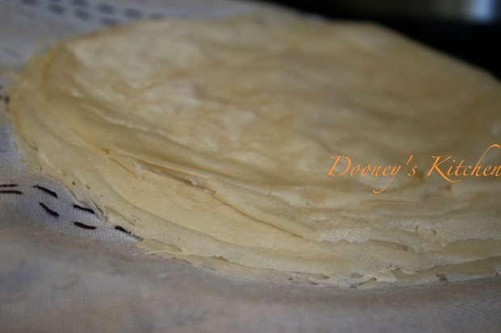

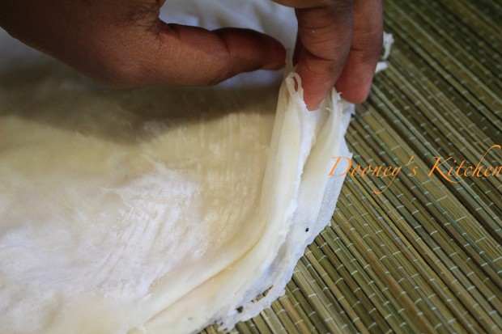

Time to make spring rolls and samosas. If you end up with leftover wraps, don’t throw them away. Spray or rub with a little oil, and freeze in a plastic bag. Ensure that the wrappers are not rolled, they must lie flat before you place in the freezer. When next you need them, let them defrost naturally. i.e. if you want to use them in the morning or afternoon, take it out of the freezer the night before.

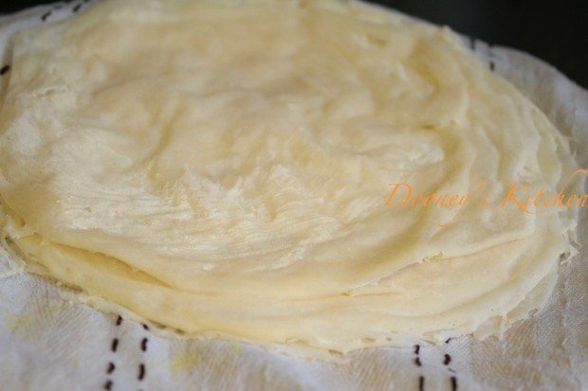

Simply, add the filling to the edge closest to you

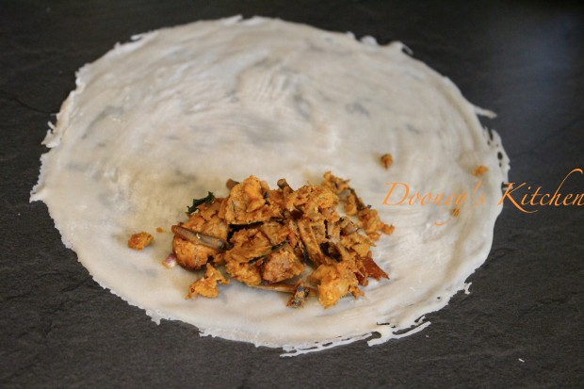

cover and roll

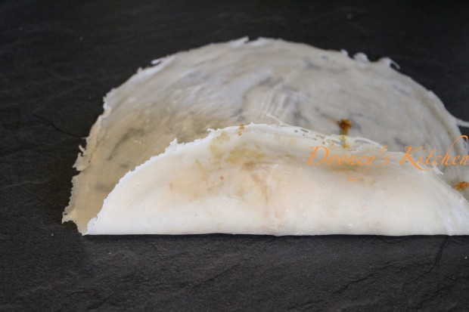

See, the roll is forming

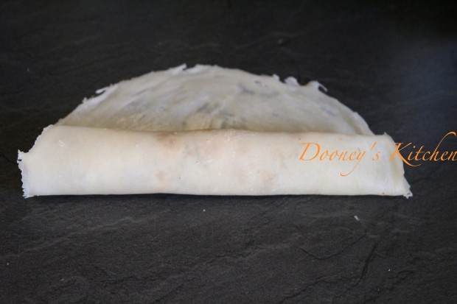

Then flip one corner over the roll, and flip the other corner till they both meet

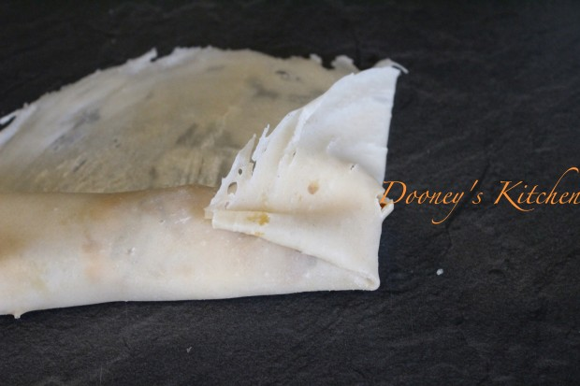

and then fold over. To see more details on how to wrap Spring Rolls, click [HERE](http://www.dooneyskitchen.com/2014/07/09/spring-rolls/" \t "_blank) and [HERE](http://www.dooneyskitchen.com/2014/07/09/spring-rolls-part-2-another-wrapping-method/" \t "_blank)

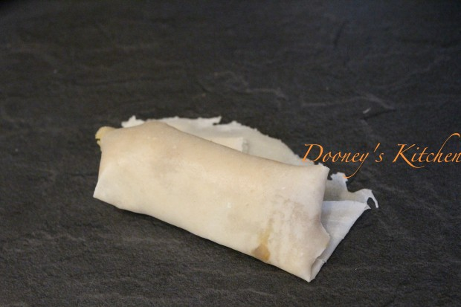

If you would rather prefer working with a square shape, cut out the thinner edges

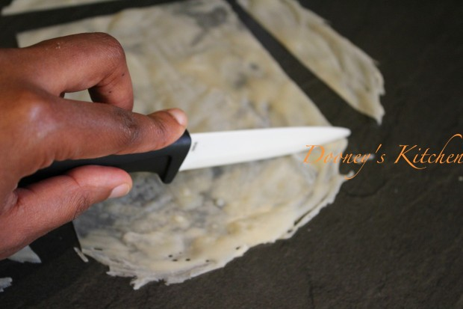

till you end up with a square.

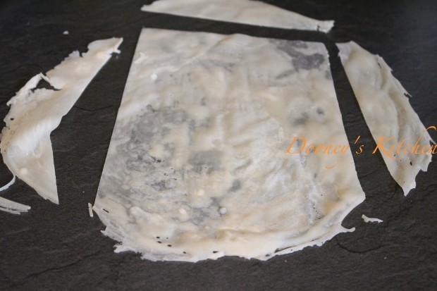

See, why I couldn’t have made a career in Surgery, and my art projects in primary school were much to my parents disbelief? I can’t even cut out a perfect square from a circle. Sigh!!!! My children had better not inherit the gene.

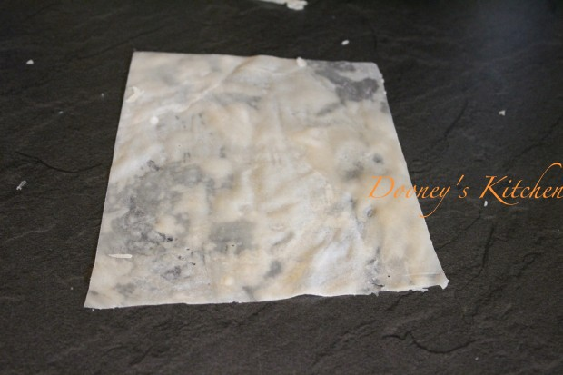

Next Stop, My Samosa. Have a lovely weekend folks!!!!

[65 Comments](http://dooneyskitchen.com/make-spring-rollsamosa-wrappers/" \l "comments)

**Subscribe**

Get all the latest recipes straight to your inbox

Top of Form

First Name Last Name E-Mail Address

Bottom of Form

FILED UNDER: [How To's](http://dooneyskitchen.com/category/tricks-cheats/how-tos/)

TAGGED WITH: [samosa wrappers](http://dooneyskitchen.com/tag/samosa-wrappers/), [spring roll wrappers](http://dooneyskitchen.com/tag/spring-roll-wrappers/)



**About Dooney**

Dooney is the blogger, recipe developer and photographer for Dooney's Kitchen. I spend my days trying to figure out creative ways to redefine Nigerian food, either by creating a new dish itself using ingredients in ways that have never been used before, or changing the approach to Nigerian cooking using kitchen gadgets.