**LAB ASSIGNMENT 3**

**UCS522: Computer Vision**

**SUBMITTED TO: SUBMITTED BY:**

Dr. Shailendra Tiwari Pranav Kakkar (401703019)



**THAPAR INSTITUTE OF ENGINEERING AND TECHNOLOGY**

**PATIALA, PUNJAB**

Develop an efficient Face recognition system using Principal Component Analysis (PCA)

**Algorithm:-**

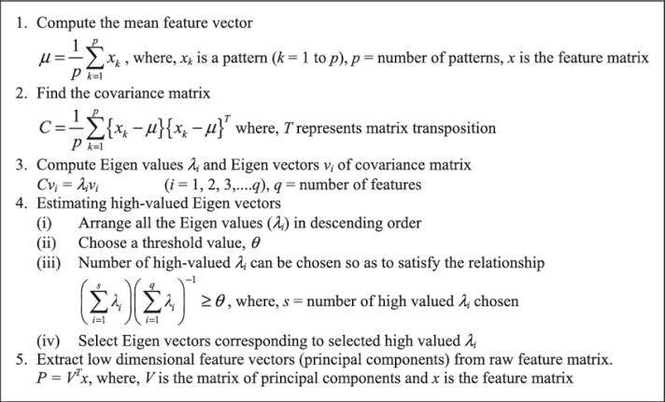

# **Results:-**

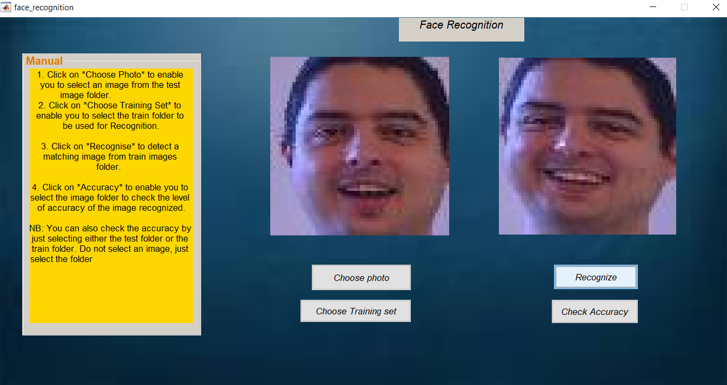

**Explanation:** We can see from the various tests made that we were able to detect images based on corresponding features. Some particular images had the similar features with other images and the accuracy found was 80%. This could be due to the face that they made similar gestures or they had the same dimensions. Other tests showed great results by identifying similar image and gave an accuracy of 100%. We realized that the recognition was based on similar gestures. This could be the smile made or the raising of the eye browse and could also be the wideness of the face. There could be many other reasons but in this case we know this was done due to the features corresponding to the sample images given. The level of accuracy given depends on the total number of database in which we have. Less database gives gives low accuracy level but the more the images in the test folder the higher that accuracy level.

**Code:-**

function varargout = face_recognition(varargin)

gui_Singleton = 1;

gui_State = struct('gui_Name', mfilename, ...

'gui_Singleton', gui_Singleton, ...

'gui_OpeningFcn', @face_recognition_OpeningFcn, ...

'gui_OutputFcn', @face_recognition_OutputFcn, ...

'gui_LayoutFcn', [] , ...

'gui_Callback', []);

if nargin && ischar(varargin{1})

gui_State.gui_Callback = str2func(varargin{1});

end

if nargout

[varargout{1:nargout}] = gui_mainfcn(gui_State, varargin{:});

else

gui_mainfcn(gui_State, varargin{:});

end

% End initialization code - DO NOT EDIT

% --- Executes just before face_recognition is made visible.

function face_recognition_OpeningFcn(hObject, eventdata, handles, varargin)

handles.output = hObject;

% create an axes that spans the whole gui

ah = axes('unit', 'normalized', 'position', [0 0 1 1]);

% import the background image and show it on the axes

bg = imread('wall.jpg'); imagesc(bg);

% prevent plotting over the background and turn the axis off

set(ah,'handlevisibility','off','visible','off')

% making sure the background is behind all the other uicontrols

uistack(ah, 'bottom');

% Update handles structure

guidata(hObject, handles);

% --- Outputs from this function are returned to the command line.

function varargout = face_recognition_OutputFcn(hObject, eventdata, handles)

varargout{1} = handles.output;

% --- Executes on button press in pushbutton1.

function pushbutton1_Callback(hObject, eventdata, handles)

global im;

[filename, pathname] = uigetfile({'*.jpg'},'choose photo');

str = [pathname, filename];

im = imread(str);

axes( handles.axes1);

imshow(im);

% --- Executes on button press in pushbutton2.

function pushbutton2_Callback(hObject, eventdata, handles)

% hObject handle to pushbutton2 (see GCBO)

% eventdata reserved - to be defined in a future version of MATLAB

% handles structure with handles and user data (see GUIDATA)

global im

global reference

global W

global imgmean

global col_of_data

global pathname

global img_path_list

im = double(im(:));

objectone = W'*(im - imgmean);

distance = 100000000;

for k = 1:col_of_data

temp = norm(objectone - reference(:,k));

if(distance>temp)

aimone = k;

distance = temp;

aimpath = strcat(pathname, '/', img_path_list(aimone).name);

axes( handles.axes2 )

imshow(aimpath)

end

end

pathname = uigetdir;

img_path_list = dir(strcat(pathname,'\*.jpg'));

img_num = length(img_path_list);

imagedata = [];

if img_num >0

for j = 1:img_num

img_name = img_path_list(j).name;

temp = imread(strcat(pathname, '/', img_name));

temp = double(temp(:));

imagedata = [imagedata, temp];

end

end

col_of_data = size(imagedata,2);

imgmean = mean(imagedata,2);

for i = 1:col_of_data

imagedata(:,i) = imagedata(:,i) - imgmean;

end

covMat = imagedata'*imagedata;

[COEFF, latent, explained] = pcacov(covMat);

i = 1;

proportion = 0;

while(proportion < 95)

proportion = proportion + explained(i);

i = i+1;

end

p = i - 1;

global W

global reference

col_of_data = 30;

pathname = uigetdir;

img_path_list = dir(strcat(pathname,'\*.jpg'));

img_num = length(img_path_list);

testdata = [];

if img_num >0

for j = 1:img_num

img_name = img_path_list(j).name;

temp = imread(strcat(pathname, '/', img_name));

temp = double(temp(:));

testdata = [testdata, temp];

end

end

col_of_test = size(testdata,2);

testdata = center( testdata );

object = W'* testdata;

error = 0;

for j = 1:col_of_test

distance = 1000000000000;

for k = 1:col_of_data;

temp = norm(object(:,j) - reference(:,k));

if(distance>temp)

aimone = k;

distance = temp;

end

end

if ceil(j/3)==ceil(aimone/4)

error = error + 1;

end

end

% calculating the accuracy

accuracy = ((1-(error/col_of_test))*100);

msgbox(['Accuracy level is : ', num2str(accuracy),sprintf('%%')],'accuracy')

% --- Executes during object creation, after setting all properties.

function listbox3_CreateFcn(hObject, eventdata, handles)

% hObject handle to listbox3 (see GCBO)

% eventdata reserved - to be defined in a future version of MATLAB

% handles empty - handles not created until after all CreateFcns called

% Hint: listbox controls usually have a white background on Windows.

% See ISPC and COMPUTER.

if ispc && isequal(get(hObject,'BackgroundColor'), get(0,'defaultUicontrolBackgroundColor'))

set(hObject,'BackgroundColor','white');

end

Scale Invariant Feature Transform (SIFT)

**Algorithm:-**

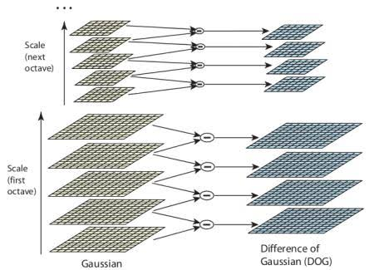

In general, SIFT algorithm can be decomposed into four steps:

1. Feature point (also called keypoint) detection
2. Feature point localization
3. Orientation assignment
4. Feature descriptor generation.

**Result:-**

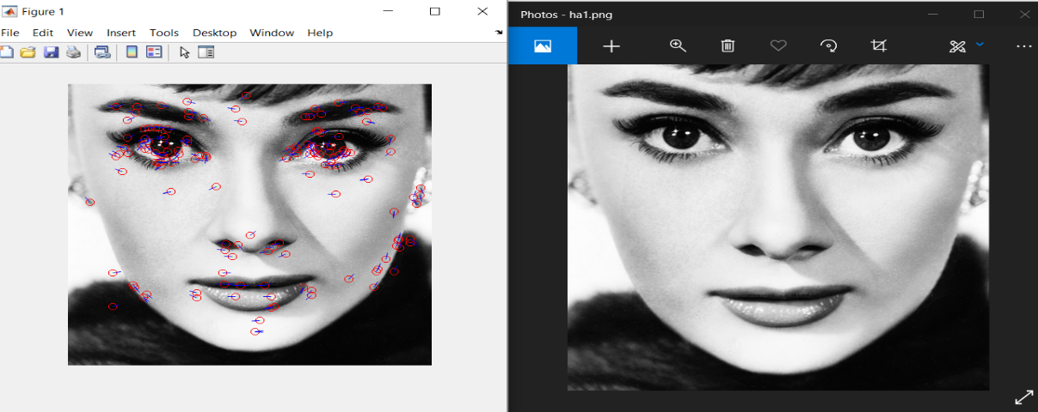

**Code:-**

clear;

clc;

image = imread('images/ha1.png');

image = rgb2gray(image);

image = double(image);

keyPoints = SIFT(image,3,5,1.3);

image = SIFTKeypointVisualizer(image,keyPoints);

imshow(uint8(image))

function Descriptors = SIFT(inputImage, Octaves, Scales, Sigma)

% This function is to extract sift features from a given image

%% Setting Variables.

Sigmas = sigmas(Octaves,Scales,Sigma);

ContrastThreshhold = 7.68;

rCurvature = 10;

G = cell(1,Octaves); % Gaussians

D = cell(1,Octaves); % DoG

GO = cell(1,Octaves); % Gradient Orientation

GM = cell(1,Octaves); % Gradient Scale

P = [];

Descriptors = {}; % Key Points

%% Calculating Gaussians

for o = 1:Octaves

[row,col] = size(inputImage);

temp = zeros(row,col,Scales);

for s=1:Scales

temp(:,:,s) = imgaussfilt(inputImage,Sigmas(o,s));

end

G(o) = {temp};

inputImage = inputImage(2:2:end,2:2:end);

end

%% Calculating DoG

for o=1:Octaves

images = cell2mat(G(o));

[row,col,Scales] = size(images);

temp = zeros([row,col,Scales-1]);

for s=1:Scales-1

temp(:,:,s) = images(:,:,s+1) - images(:,:,s);

end

D(o) = {temp};

end

%% Calculating orientation of gradient in each scale

for o = 1:Octaves

images = cell2mat(G(o));

[row,col,Scales] = size(images);

tempO = zeros([row,col,Scales]);

tempM = zeros([row,col,Scales]);

for s = 1:Scales

[tempM(:,:,s),tempO(:,:,s)] = imgradient(images(:,:,s));

end

GO(o) = {tempO};

GM(o) = {tempM};

end

%% Extracting Key Points

for o=1:Octaves

images = cell2mat(D(o));

GradientOrientations = cell2mat(GO(o));

GradientMagnitudes = cell2mat(GM(o));

[row,col,Scales] = size(images);

for s=2:Scales-1

% Weight for gradient vectors

weights = gaussianKernel(Sigmas(o,s));

radius = (length(weights)-1)/2;

for y=14:col-12

for x=14:row-12

sub = images(x-1:x+1,y-1:y+1,s-1:s+1);

if sub(2,2,2) > max([sub(1:13),sub(15:end)]) || sub(2,2,2) < min([sub(1:13),sub(15:end)])

% Getting rid of bad Key Points

if abs(sub(2,2,2)) < ContrastThreshhold

% Low contrast.

continue

else

% Calculating trace and determinant of hessian

% matrix.

Dxx = sub(1,2,2)+sub(3,2,2)-2*sub(2,2,2);

Dyy = sub(2,1,2)+sub(2,3,2)-2*sub(2,2,2);

Dxy = sub(1,1,2)+sub(3,3,2)-2*sub(1,3,2)-2*sub(3,1,2);

trace = Dxx+Dyy;

determinant = Dxx*Dyy-Dxy*Dxy;

curvature = trace*trace/determinant;

if curvature > (rCurvature+1)^2/rCurvature

% Not a corner.

continue

end

end

%% Calculating orientation and magnitude of pixels at key point vicinity

% Fixing overflow key points near corners and edges

% of image.

a=0;b=0;c=0;d=0;

if x-1-radius < 0;a = -(x-1-radius);end

if y-1-radius < 0;b = -(y-1-radius);end

if row-x-radius < 0;c = -(row-x-radius);end

if col-y-radius < 0;d = -(col-y-radius);end

tempMagnitude = GradientMagnitudes(x-radius+a:x+radius-c,y-radius+b:y+radius-d,s).*weights(1+a:end-c,1+b:end-d);

tempOrientation = GradientOrientations(x-radius+a:x+radius-c,y-radius+b:y+radius-d,s);

[wRows, wCols] = size(tempMagnitude);

% 36 bin histogram generation.

gHist = zeros(1,36);

for i = 1:wRows

for j = 1:wCols

% Converting orientation calculation window

temp = tempOrientation(i,j);

if temp < 0

temp = 360 + temp;

end

bin = floor(temp/10)+1;

gHist(bin) = gHist(bin) + tempMagnitude(i,j);

end

end

%% Extracting keypoint coordinates

% TODO: Interpolation for X and Y value to get

% subpixel accuracy.

%% Extracting keypoint orientation

% Marking 80% Threshold

orientationThreshold = max(gHist(:))*4/5;

tempP = [];

for i=1:length(gHist)

if gHist(i) > orientationThreshold

% Connrection both ends of the histogram

% for interpolation

if i-1 <= 0

X = 0:2;

Y = gHist([36,1,2]);

elseif i+1 > 36

X = 35:37;

Y = gHist([35,36,1]);

else

X = i-1:i+1;

Y = gHist(i-1:i+1);

end

% interpolation of Orientation.

dir = interpolateExterma([X(1),Y(1)],[X(2),Y(2)],[X(3),Y(3)])*10; % Orientation

mag = gHist(i); % Size

% Filtering points with the same

% orientation.

if ismember(dir,tempP(5:6:end)) == false

tempP = [tempP,x,y,o,s,dir,mag];

end

end

end

P = [P,tempP];

end

end

end

end

end

%% Creating feature Descriptors

% TODO: Extract Descriptors

weights = gaussianKernel(Sigmas(o,s),13);

weights = weights(1:end-1,1:end-1);

for i = 1:6:length(P)

x = P(i);

y = P(i+1);

oct = P(i+2);

scl = P(i+3);

dir = P(i+4);

mag = P(i+5);

directions = cell2mat(GO(oct));

directions = directions(x-13:x+12,y-13:y+12,scl);

magnitudes = cell2mat(GM(oct));

magnitudes = magnitudes(x-13:x+12,y-13:y+12,scl).*weights;

descriptor = [];

for m = 5:4:20

for n = 5:4:20

hist = zeros(1,8);

for o = 0:3

for p = 0:3

[newx,newy] = rotateCoordinates(m+o,n+p,13,13,-dir);

% Creating 8 bin histogram.

hist(categorizeDirection8(directions(newx,newy))) = magnitudes(newx,newy);

end

end

descriptor = [descriptor, hist];

end

end

descriptor = descriptor ./ norm(descriptor,2);

for j =1:128

if descriptor(j) > 0.2

descriptor(j) = 0.2;

end

end

descriptor = descriptor ./ norm(descriptor,2);

% Creating keypoint object

kp = KeyPoint;

kp.Coordinates = [x*2^(oct-1),y*2^(oct-1)];

kp.Magnitude = mag;

kp.Direction = dir;

kp.Descriptor = descriptor;

kp.Octave = oct;

kp.Scale = scl;

Descriptors(end+1) = {kp};

end

end

%% Function to extract Sigma values

function matrix = sigmas(octave,scale,sigma)

% Function to calculate Sigma values for different Gaussians

matrix = zeros(octave,scale);

k = sqrt(2);

for i=1:octave

for j=1:scale

matrix(i,j) = i*k^(j-1)*sigma;

end

end

end

%% Calculating Gaussian value given SD

function result = gaussianKernel(SD, Radius)

% Returns a gaussian kernet

% By default a radius will be chosen to so kernel covers 99.7 % of data.

if nargin < 2

Radius = ceil(3*SD);

end

side = 2*Radius+1;

result = zeros(side);

for i = 1:side

for j = 1:side

x = i-(Radius+1);

y = j-(Radius+1);

result(i,j)=(x^2+y^2)^0.5;

end

end

result = exp(-(result .^ 2) / (2 * SD * SD));

result = result / sum(result(:));

end

%% Interpolation - Fiting a parabola into 3 points and extracting more exact Exterma

function exterma = interpolateExterma(X, Y, Z)

% Exterpolation and Exterma extraction

% Each input is an array with 2 values, t and f(t).

exterma = Y(1)+...

((X(2)-Y(2))*(Z(1)-Y(1))^2 - (Z(2)-Y(2))*(Y(1)-X(1))^2)...

/(2*(X(2)-Y(2))*(Z(1)-Y(1)) + (Z(2)-Y(2))*(Y(1)-X(1)));

end

%% Function to assign bins to orientations

% 8 bin assignment

function bin = categorizeDirection8(Direction)

if Direction <= 22.5 && Direction > -22.5

bin = 1;

elseif Direction <= 67.5 && Direction > 22.5

bin = 2;

elseif Direction <= 112.5 && Direction > 67.5

bin = 3;

elseif Direction <= 157.5 && Direction > 112.5

bin = 4;

elseif Direction <= -157.5 || Direction > 157.5

bin = 5;

elseif Direction <= -112.5 && Direction > -157.5

bin = 6;

elseif Direction <= -67.5 && Direction > -112.5

bin = 7;

elseif Direction <= -22.5 && Direction > -67.5

bin = 8;

end

Linear Binary Pattern (LBP)

**Algorithm:-**

The LBP feature vector, in its simplest form, is created in the following manner:

* Divide the examined window into cells (e.g. 16x16 pixels for each cell).
* For each pixel in a cell, compare the pixel to each of its [8 neighbors](https://en.wikipedia.org/wiki/Pixel_connectivity) (on its left-top, left-middle, left-bottom, right-top, etc.). Follow the pixels along a circle, i.e. clockwise or counter-clockwise.
* Where the center pixel's value is greater than the neighbor's value, write "0". Otherwise, write "1". This gives an 8-digit binary number (which is usually converted to decimal for convenience).
* Compute the [histogram](https://en.wikipedia.org/wiki/Histogram), over the cell, of the frequency of each "number" occurring (i.e., each combination of which pixels are smaller and which are greater than the center). This histogram can be seen as a 256-dimensional [feature vector](https://en.wikipedia.org/wiki/Feature_vector).
* Optionally normalize the histogram.
* Concatenate (normalized) histograms of all cells. This gives a feature vector for the entire window.

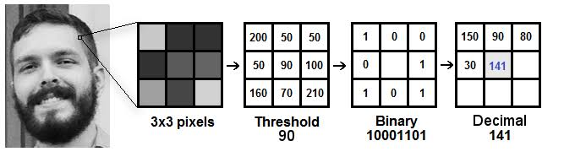

**Result:-**

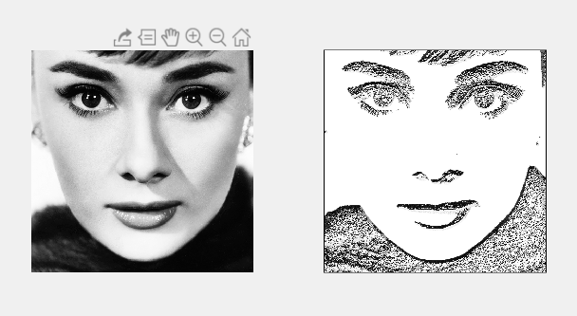

**Code:-**

clear all;

% load image

img = rgb2gray(imread('ha.png'));

% run descriptor

filtered_img = lbp(img);

% plot results

subplot(1,2,1);

imshow(img);

subplot(1,2,2);

imshow(filtered_img);

function filtered_img = lbp(img)

%% LBP image descriptor

[nrows, ncols] = size(img);

filtered_img = zeros(nrows, ncols, 'uint8');

for j = 2:ncols-1

for i = 2:nrows-1

nhood = nhood8(i, j);

for k = 1:size(nhood, 1)

filtered_img(i, j) = filtered_img(i, j) + ...

(int8(img(nhood(k, 1), nhood(k, 2)))-int8(img(i, j)) >= 0) * 2^(k-1);

end

end

end

end

function idx = nhood8(i, j)

%% Computes the 8-neighborhood of a pixel

idx = [

i-1, j-1;

i-1, j;

i-1, j+1;

i, j-1;

i, j+1;

i+1, j-1;

i+1, j;

i+1, j+1

];

End

K-mean/Fuzzy C-mean Clustering techniques in Image segmentation

**Algorithm:-**

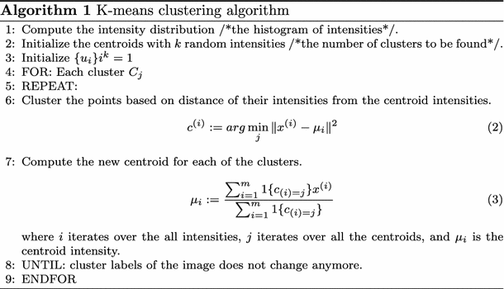

**Result:-**



**Code:-**

% function main

clc;

clear all;

close all;

im = imread('ha.png');

subplot(2,1,1),imshow(im);

subplot(2,1,2),imhist(im(:,:,1));

title('INPUT IMAGE HISTOGRAM');%figure,imhist(im(:,:,2)),title('blue');figure,imhist(im(:,:,3)),title('Green');

figure;

I = imnoise(rgb2gray(im),'salt & pepper',0.02);

subplot(1,2,1),imshow(I);

title('Noise adition and removal using median filter');

K = medfilt2(I);

subplot(1,2,2),imshow(K);

im = double(im);

s_img = size(im);

r = im(:,:,1);

g = im(:,:,2);

b = im(:,:,3);

% [c r] = meshgrid(1:size(i,1), 1:size(i,2));

data_vecs = [r(:) g(:) b(:)];

k= 4;

[ idx C ] = kmeansK( data_vecs, k );

% d = reshape(data_idxs, size(i,1), size(i,2));

% imagesc(d);

palette = round(C);

%Color Mapping

idx = uint8(idx);

outImg = zeros(s_img(1),s_img(2),3);

temp = reshape(idx, [s_img(1) s_img(2)]);

for i = 1 : 1 : s_img(1)

for j = 1 : 1 : s_img(2)

outImg(i,j,:) = palette(temp(i,j),:);

end

end

cluster1 = zeros(size(r));

cluster2 = zeros(size(r));

cluster3 = zeros(size(r));

cluster4 = zeros(size(r));

figure;

cluster1(find(outImg(:,:,1)==palette(1,1))) = 1;

subplot(2,2,1), imshow(cluster1);

cluster2(find(outImg(:,:,1)==palette(2,1))) = 1;

subplot(2,2,2), imshow(cluster2);

cluster3(find(outImg(:,:,1)==palette(3,1))) = 1;

subplot(2,2,3), imshow(cluster3);

cluster4(find(outImg(:,:,1)==palette(4,1))) = 1;

subplot(2,2,4), imshow(cluster4);

cc = imerode(cluster4,[1 1]);

figure,imshow(imerode(cluster4,[1 1]));

title('result image');

[label_im, label_count] = bwlabel(cc,8);

stats = regionprops(label_im, 'centroid');

for i=1:label_count

area(i) = stats(i).Area;

end

[maxval, maxid] = max(area);

label_im(label_im ~= maxid) = 0;

label_im(label_im == maxid) = 1;

figure,imshow(label_im);

title('lbp');

% outImg = uint8(outImg);

% imtool(outImg);

code_end = 1;