**Finding Users with the greatest Number of Tweet**

During analysis, finding the users who are interested in the topic we are taking under analysis might be required. This information can be used for purpose like targeting specific group of people for promotion and advertisement [9]. The query which will give us the user with maximum number of tweets is:

hive> CREATE VIEW L7 AS SELECT

screen_name,

count(id) AS cnt

FROM tweets_simple

GROUP BY screen_name

HAVING screen_name IS NOT NULL

ORDER BY cnt DESC LIMIT 10;

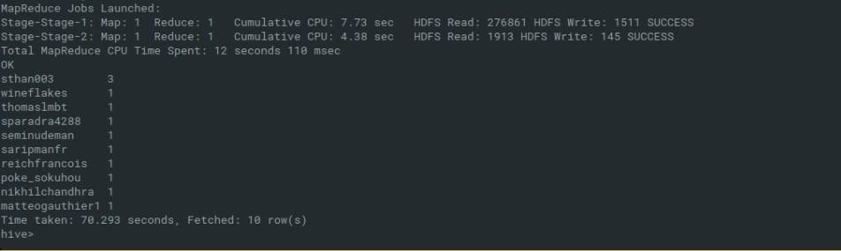**Output of the query is:**

*Fig: User with maximum number of tweets*