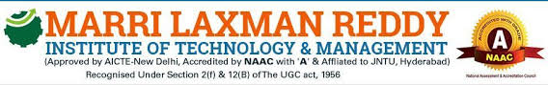

PROJECT TITLE:-CITY OFFERS

ABSTRACT

CITY OFFERS: city offers which includes offers in the city like mydala ,flipkart,etc it includes all the deals and offers in the city. Which includes the best deals in the city like electronic goods,restaurants,groceries,food items.every day new offers @deal of the day.

city offers which includes offers in the city like mydala ,flipkart,etc it includes all the deals and offers in the city. Which includes the best deals in the city like electronic goods,restaurants,groceries,food items.every day new offers @deal of the day.

city which includes offers in the city like mydala ,flipkart,etc it includes all the deals and offers in the city. Which includes the best deals in the city like electronic goods,restaurants,groceries,food items.every day new offers @deal of the day. offers which includes offers in the city like mydala ,flipkart,etc it includes all the deals and offers in the city. Which includes the best deals in the city like electronic goods,restaurants,groceries,food items.every day new offers @deal of the day.

city offers which includes offers in the city like mydala ,flipkart,etc it includes all the deals and offers in the city. Which includes the best deals in the city like electronic goods,restaurants,groceries,food items.every day new offers @deal of the day.