Katie Klein

CSD 340

31 May 2021

Assignment 1.2: GitHub Repository Setup

**GitHub Repository Link:**

<https://github.com/kaklein/csd-340>

**GitHub Repository Screenshot:**

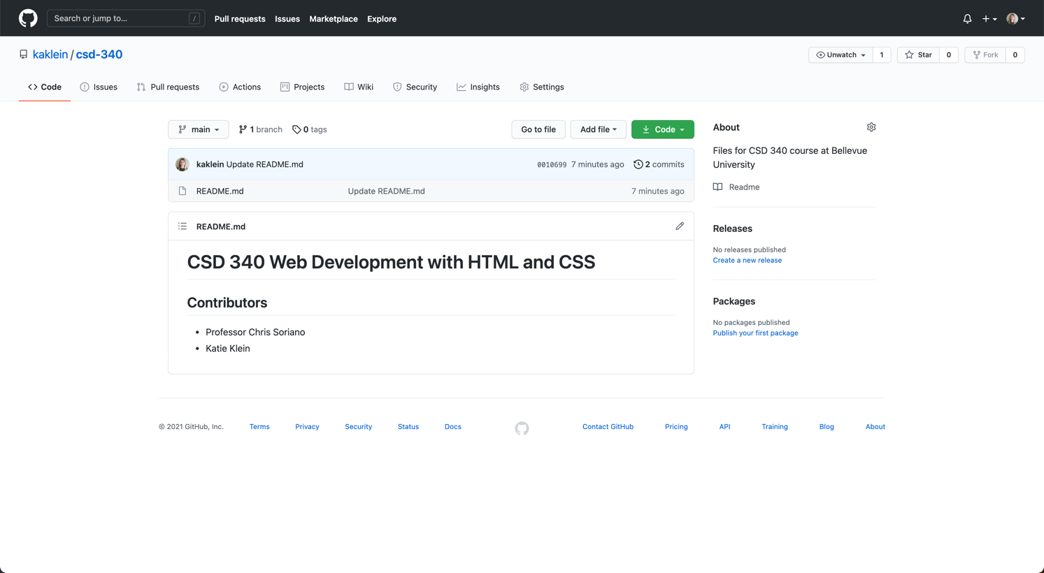

**Local Directory Screenshot:**

