Section I: Photos

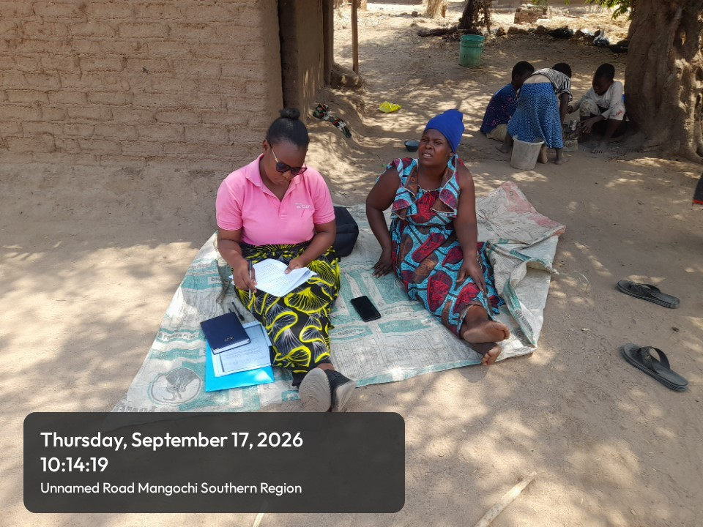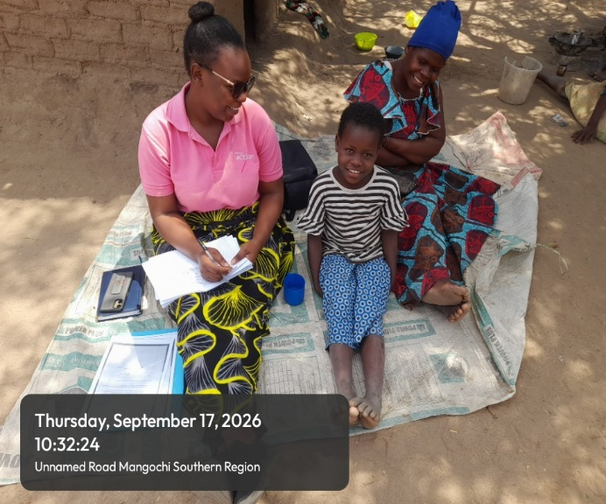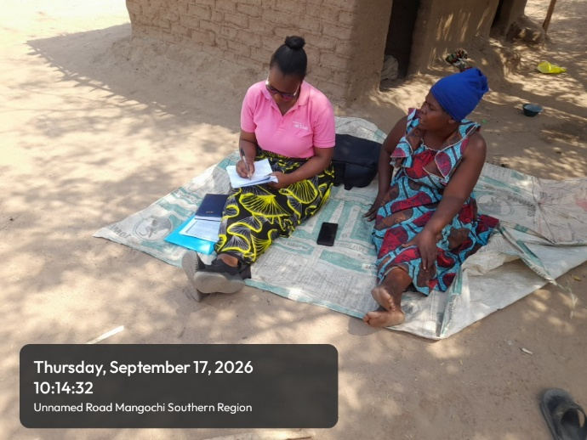

Fane Bonzo and her child testifying of what Evidence action chlorine dispensers have highly impacted in the family.

Section J: Consent & Submission Details
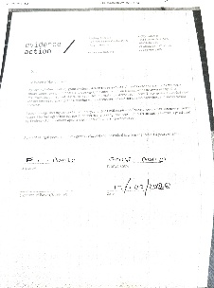
Fane Bonzo Consent Form

