**Laboratory work 7**

**We continue to work with the database from the previous laboratory works.**

**Take a full-page screenshot that covers the code and results of each task.**

**Tasks**:

1. Create an index on the actual_departure column in the flights table.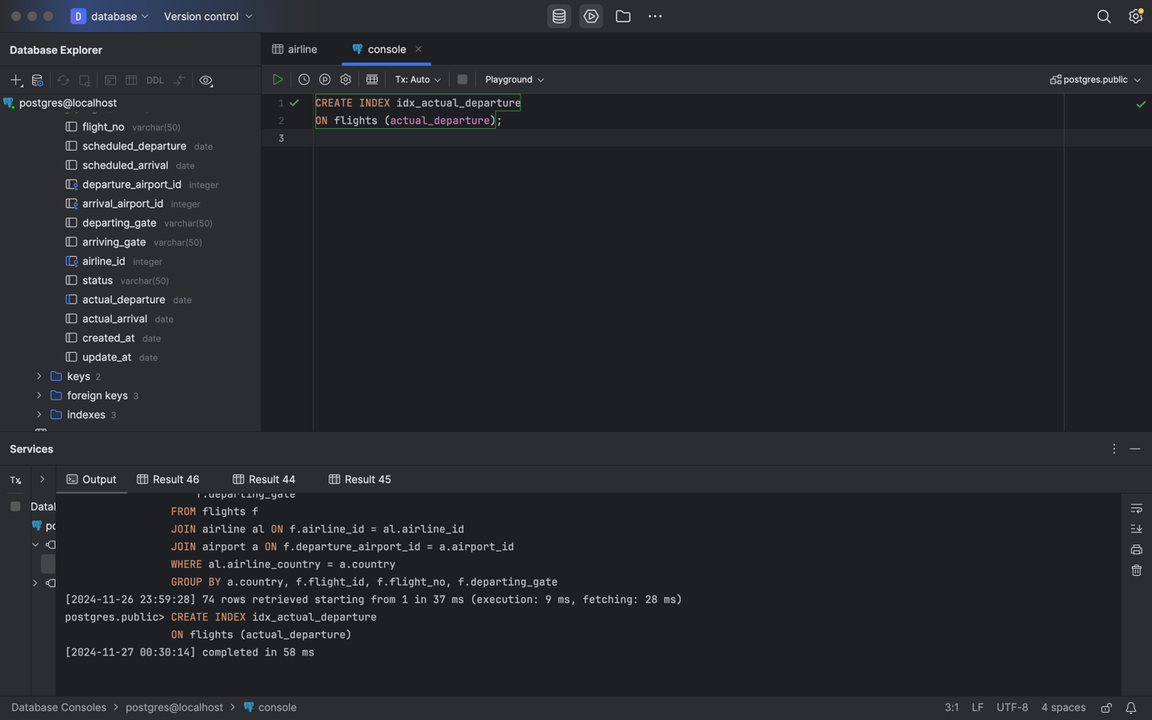
2. Create a unique index to ensure flight_no and scheduled_departure combinations are unique.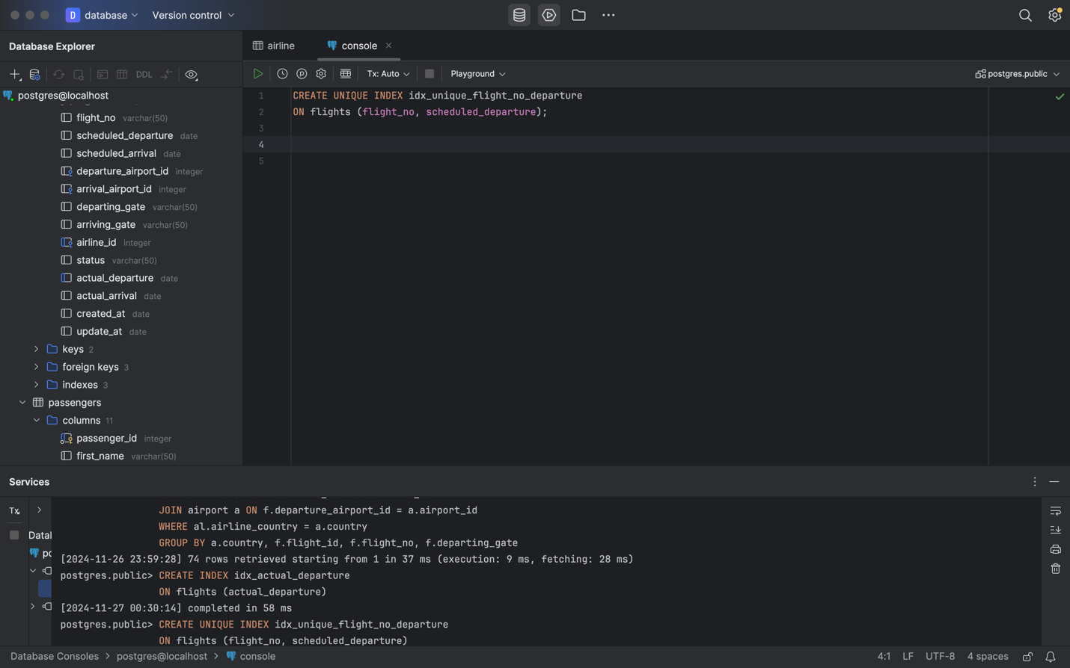
3. Create a composite index on the departure_airport_id and arrival_airport_id columns.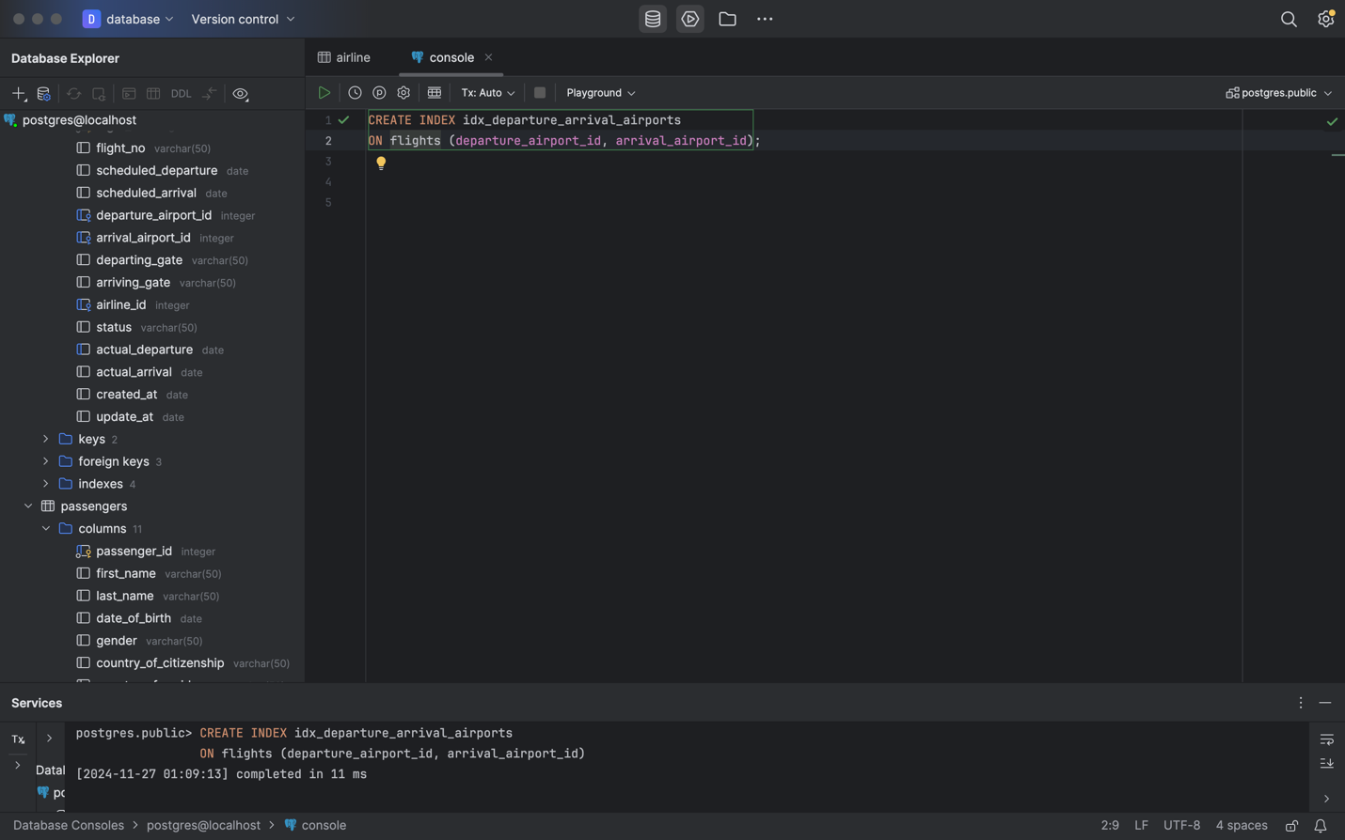
4. Evaluate the difference in query performance with and without indexes. Measure performance differences.

here we can first see the time before the index is 7ms, and after 4ms

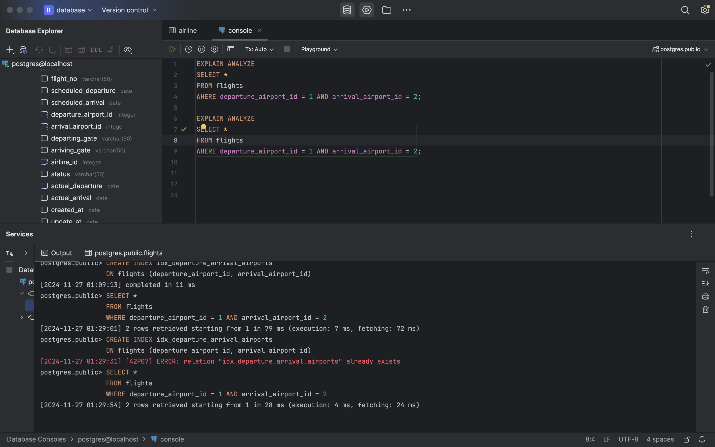

1. Use EXPLAIN ANALYZE to check index usage in a query filtering by departure_airport and arrival_airport.

here we can first see the time before the index is 7ms, and after 4ms



1. Create a unique index for the passport_number of the Passengers table. Check if the index was created or not. Insert into the table two new passengers.

Explain in your own words what is going on in the output?

A unique index imposes a constraint that ensures the uniqueness of the values ​​in the passport_number column.

When you INSERT with a duplicate passport_number value, PostgreSQL checks for a unique index. If a duplicate value is found, the insertion will be rejected and an error will be thrown with the message: "duplicate key value violates unique constraint". This happens because the passport_number must be unique for each passenger, and the unique index enforces this rule.

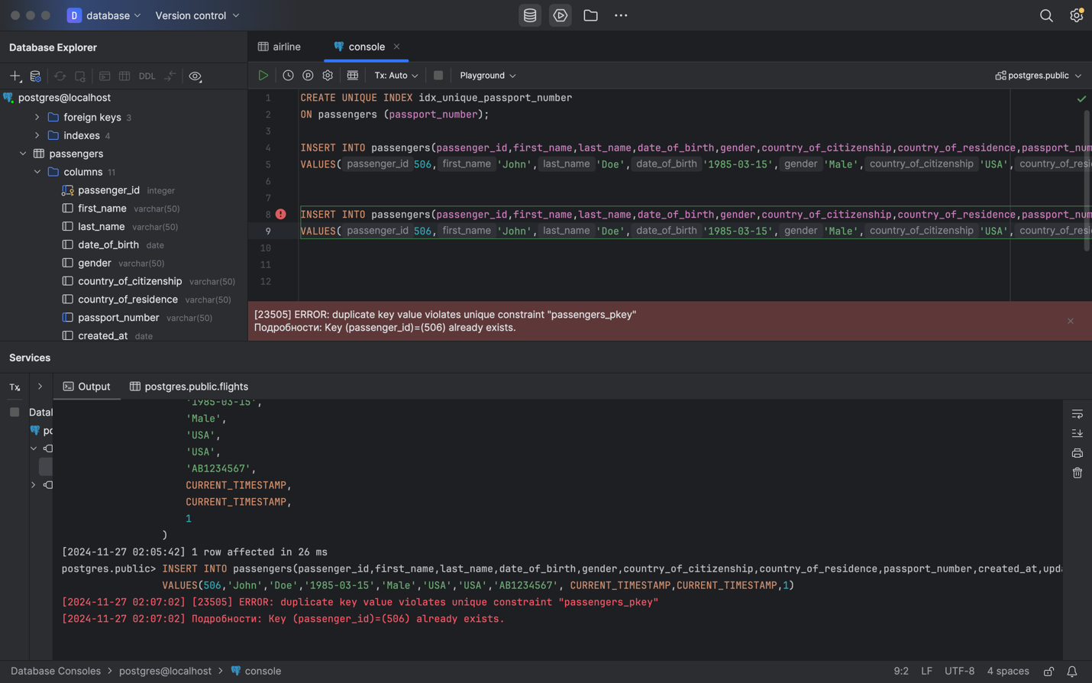

1. Create an index for the Passengers table. Use for that first name, last name, date of birth and country of citizenship. Then, write a SQL query to find a passenger who was born in Philippines and was born in 1984 and check if the query uses indexes or not. Give the explanation of the results.

Index Usage: The EXPLAIN ANALYZE output will indicate whether the index is used by the query planner.

Performance: If the index is being used, the query execution time will likely be faster, especially if there are many records in the Passengers table. The database will efficiently locate rows based on the indexed columns without scanning the entire table.

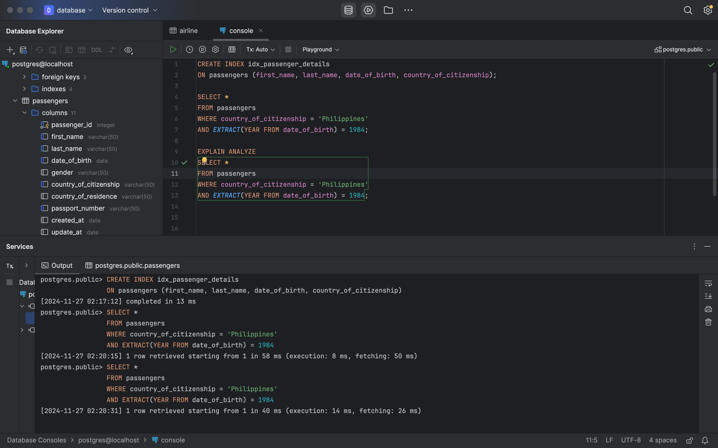

1. Write a SQL query to list indexes for table Passengers. After delete the created indexes. 