ULSTER UNIVERSITY
SUPPORTING MATERIALS
Privacy-Preserving Federated Learning on CIFAR-10: An Experimental Study of Client-Level Noise and Simulated Mask-Recovery Aggregation
Extended methodology, architecture, experimental evidence, reproducibility, and critical appraisal

Khawar Akram
akram-k@ulster.ac.uk | COM748 Masters Project
Code repository: [GITHUB REPOSITORY URL TO BE ADDED BEFORE PUBLIC RELEASE]
This document is submitted separately from the eight-page IEEE main paper.

Contents
- 1. Purpose and relationship to the main paper
- 2. Project lifecycle, methodology, and experimental controls
- 3. Executed architecture diagrams
- 4. Extended results, tables, and class-level evidence
- 5. Verification, validation, and evidence provenance
- 6. In-depth supplementary literature synthesis and positioning
- 7. Implementation tools and source-code organisation
- 8. Professional, ethical, social, and sustainability considerations
- 9. Critical appraisal, limitations, and future work
- 10. References

Evidence Guide
The reference submission demonstrates the value of front-matter navigation in a large evidence portfolio. The compact guide below provides the same function without duplicating the main paper or expanding this document into a second dissertation.
Table S1. Evidence groups and their locations in this document.
Evidence group | Items | Location
Research questions and contributions | Question-to-evidence map | Section 1.1
Lifecycle and requirements | Figure S1; Table S4 | Sections 2.1-2.2
Dataset and partition verification | Figures S2-S3; Tables S5-S6 | Section 2
Executed model and FL architectures | Figures S4-S7 | Section 3
Round-level utility and losses | Figures S8-S13; Table S7 | Section 4.1
Class-level error evidence | Figures S14-S18 | Section 4.2
Verification and provenance | Tables S8-S9 | Section 5
Literature synthesis and gap | Tables S10-S11 | Section 6
Tools, repository, and appraisal | Tables S12-S15 | Sections 7 and 9

Acronyms and Notation
Table S2. Acronyms and notation used throughout the supporting evidence.
Term | Meaning | Term | Meaning
FL | Federated learning | DP | Differential privacy
FedAvg | Federated Averaging | SA-1 | Simulated mask-recovery run
IID | Independent and identically distributed | CNN | Convolutional neural network
C | Client-update clipping norm | sigma | Gaussian noise multiplier
CUDA | GPU computing platform | cuDNN | CUDA deep-neural-network library

1. Purpose and Relationship to the Main Paper
The eight-page IEEE paper presents the research question, essential literature, executed method, principal results, and defensible conclusions. This supporting document contains material that is necessary for assessment and reproducibility but too detailed for the page-limited article. It should be read as an evidence companion, not as a second paper. Numerical claims use the same reconciled result register as the main manuscript.
Three boundaries apply throughout. First, the clipping and Gaussian-noise settings are implementation parameters rather than formal privacy budgets because no epsilon-delta accountant was retained. Second, SA-1 is a mask-cancellation simulation in which the server receives individual masks; it does not implement cryptographic secure aggregation. Third, the intended DP-2 run at noise multiplier 0.005 is supported at summary level, but its 30-round history and class predictions were not retained. No missing trajectory is reconstructed.

1.1 Research Questions and Contribution Map
The sample evidence portfolio evaluates its completed system against its original aims. The same principle is applied here by mapping each research question to retained evidence and a bounded answer.
Table S3. Research questions, supporting evidence, and bounded answers.
Research question | Primary evidence | Bounded answer
RQ1: What utility does FedAvg establish? | Round history, endpoint, losses, and class matrix | 88.55% round-30 accuracy under the registered five-client IID configuration.
RQ2: How does increasing update noise affect utility? | Registered sequence DP-1 to DP-4 | 0.001 preserved utility; 0.005 retained 85.08%; 0.010 and 0.020 produced marked degradation.
RQ3: How do class behaviour and endpoint stability change? | Loss curves, peak-to-end gaps, class matrices | Larger perturbations widened recall disparity and created late-round instability.
RQ4: What does the mask-recovery path demonstrate? | SA-1 architecture, source semantics, and output | Arithmetic mask cancellation and integration only; not cryptographic confidentiality.

1.2 Project Contributions
- A matched end-to-end FL implementation that holds the model, client pool, partitions, optimiser, and training schedule constant across the registered sequence.
- A reconciled evidence register that retains DP-2 in sequence while preventing an inconsistent later bundle from supporting trajectory or class-level claims.
- A combined endpoint, convergence, loss, and class-level evaluation that shows how increasing perturbation changes more than headline accuracy.
- An explicit separation between measured software behaviour, formal differential-privacy claims, and cryptographic secure-aggregation claims.

2. Project Lifecycle, Methodology, and Experimental Controls

2.1 Development Lifecycle and Project-Management Controls
The project followed an evidence-gated, iterative lifecycle. Literature synthesis established the problem and claim boundaries; the experimental protocol translated these into system requirements; modular implementation separated data, model, client, server, aggregation, privacy, evaluation, and reporting responsibilities; baseline and privacy-oriented experiments generated auditable artefacts; and a later reconciliation stage resolved conflicts before manuscript claims were frozen. This is a retrospective record supported by retained artefacts, not a claim that a formally instrumented Agile or PRINCE2 process was used.
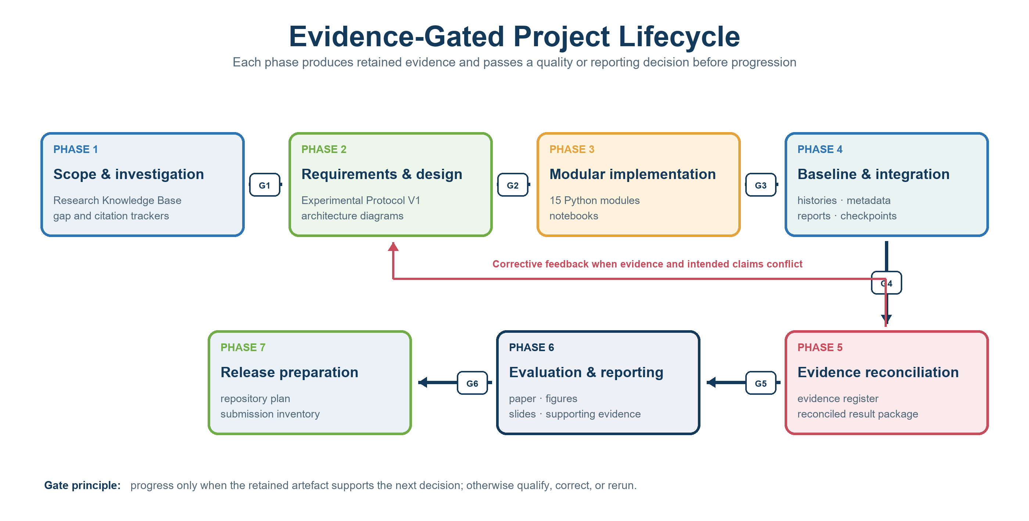
Figure S1. Evidence-gated project lifecycle, retained artefacts, phase decisions, and corrective feedback loop.

2.2 Requirements and Success Criteria
Requirements were evaluated at three levels: functional behaviour, experimental validity, and claim validity. A requirement is marked partial where the implemented behaviour is observable but the retained evidence cannot support a stronger guarantee. This prevents a successful software path from being misreported as a formal privacy or cryptographic result.
Table S4. Requirements, success criteria, evidence, and achieved status.
ID | Requirement and success criterion | Verification / validation evidence | Status
R1 | Partition 50,000 CIFAR-10 training images across five clients without loss; 10,000 images per client | Class-distribution table totals 10,000 per client and 5,000 per class | Verified
R2 | Use one shared CNN and matched training controls across the registered sequence | Model source, configuration, metadata, and retained histories | Verified with stated execution limits
R3 | Perform data-size-weighted FedAvg and evaluate the global model each round | Aggregation source and complete FedAvg history | Verified
R4 | Clip the complete trainable update to C and apply Gaussian noise with scale sigma C | Privacy source, method equation, configurations, and noise sequence | Functionally verified; no formal accountant
R5 | Demonstrate masking and arithmetic recovery in the integrated training path | Mask/recovery source, SA-1 architecture, history, and report | Functionally demonstrated; security not validated
R6 | Preserve results only when their provenance supports the intended claim | Reconciled register; DP-2 conflict and exclusion rules | Verified
R7 | Enable exact independent reproduction from a public package | Seed and modules retained; versions and deterministic execution incomplete | Partial; release action required

2.3 Experiment Sequence and Execution Plan
The experiment plan progresses from an unperturbed FedAvg reference through four registered noise settings and then a combined mask-recovery run. This ordering preserves the experimental narrative and makes the evidence status of DP-2 visible rather than removing it from the sequence.
Table S5. Registered experiment sequence and evidence status.
Stage | Run | Mechanism | Purpose | Evidence status
0 | FedAvg | No update noise | Non-private reference | Complete history and class evidence
1 | DP-1 | sigma = 0.001 | Low numerical perturbation | Complete history and class evidence
2 | DP-2 | sigma = 0.005 | Intermediate sequence point | Summary-level endpoint only
3 | DP-3 | sigma = 0.010 | Larger perturbation | Complete history and class evidence
4 | DP-4 | sigma = 0.020 | Severe perturbation | Complete history and class evidence
5 | SA-1 | sigma = 0.001 plus masks | Integration and recovery arithmetic | Complete but aggregation-confounded

2.4 Dataset and IID Partition Verification
CIFAR-10 provides 50,000 training images and 10,000 test images across ten classes. The training split was shuffled using seed 42 and divided into five synthetic clients with 10,000 images each. Every class is represented at every client. Client-level class-count coefficients of variation range from 2.29% to 3.21%, with a mean of 2.70%; the average maximum class deviation is 5.48%. The split is therefore approximately IID, although class counts are not perfectly identical.
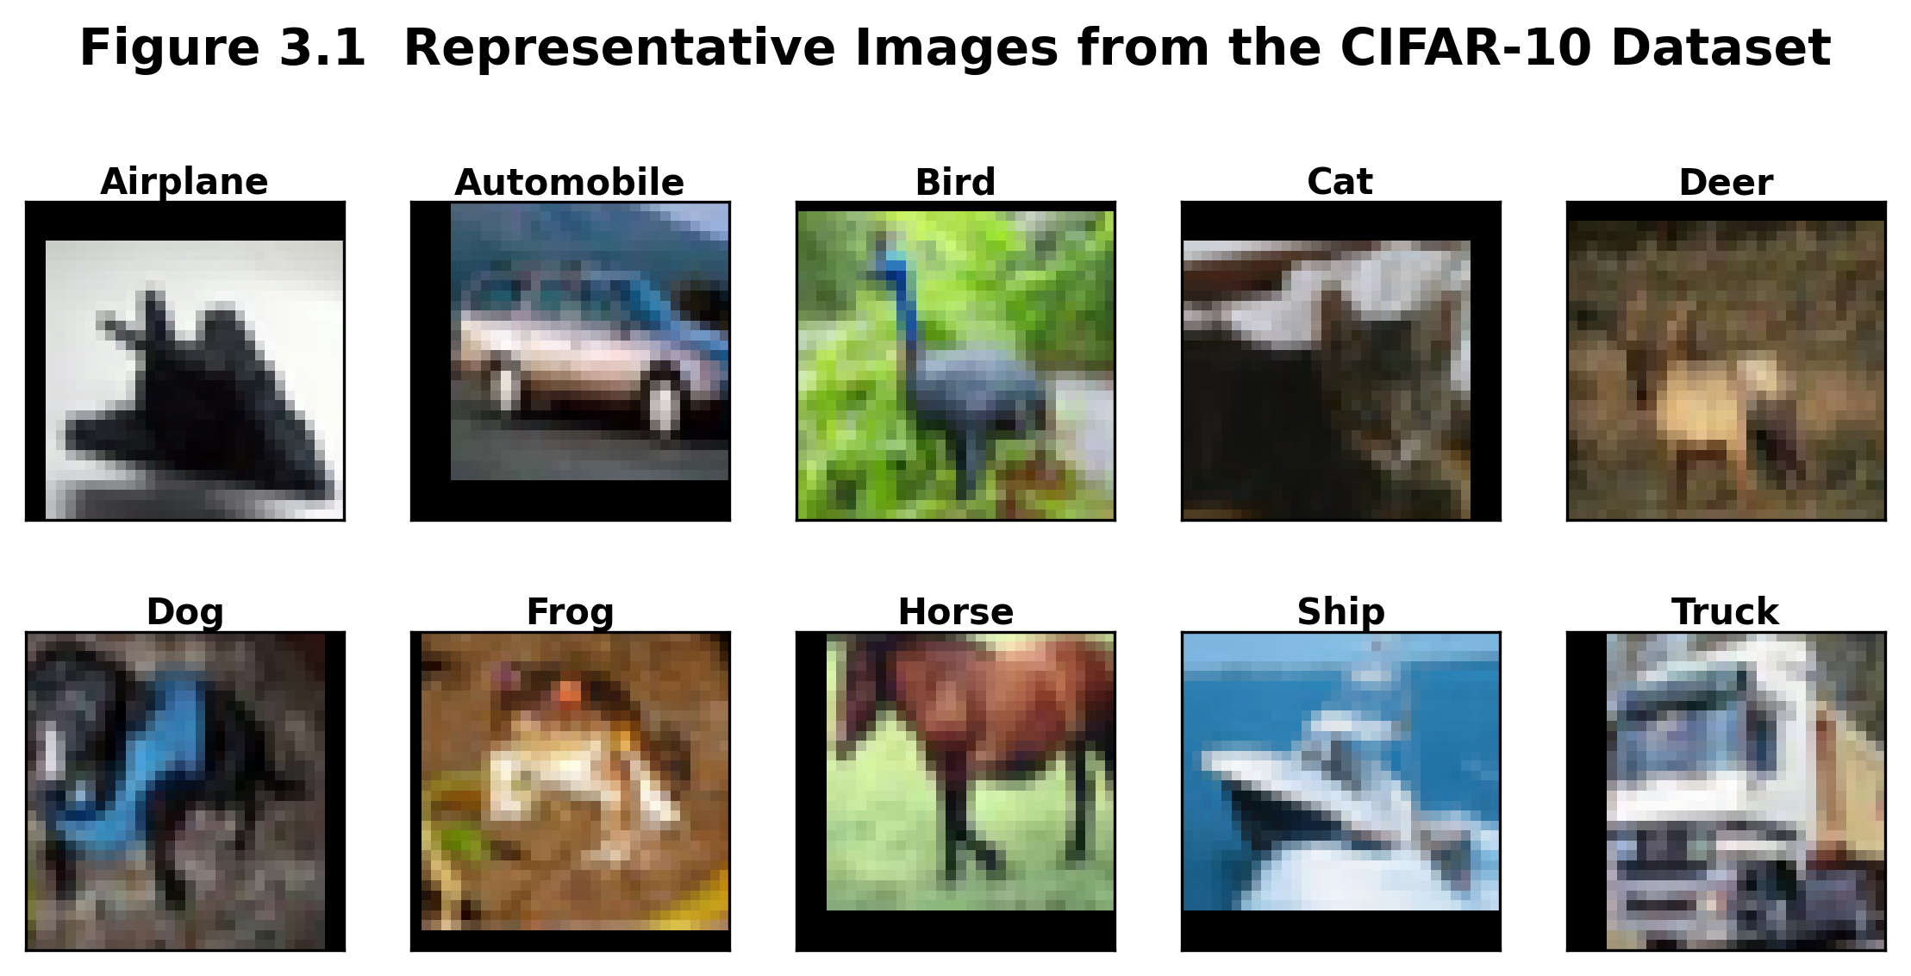
Figure S2. Retained CIFAR-10 sample visualisation.
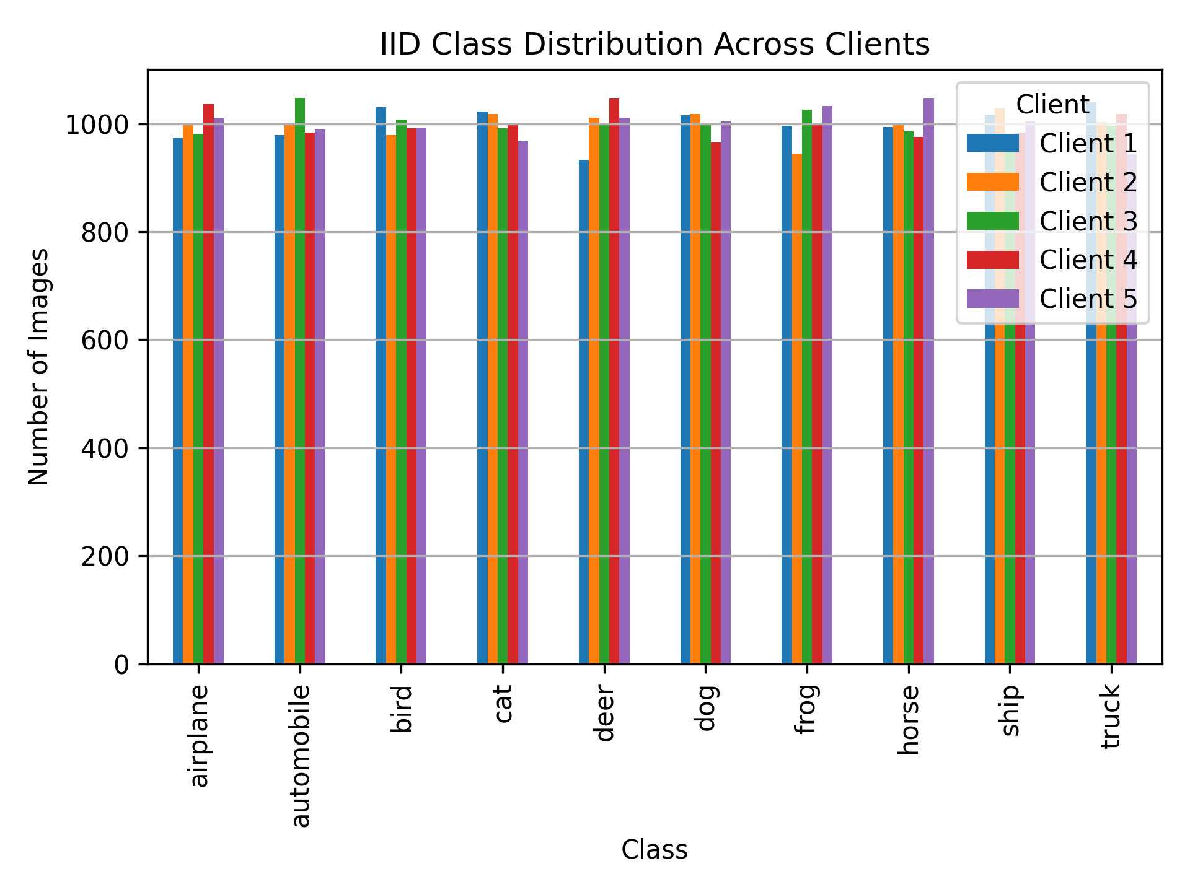
Figure S3. Class distribution across the five synthetic IID clients.

2.5 Preprocessing, Model, and Optimisation
Training images were randomly cropped to 32 x 32 after four-pixel padding and horizontally flipped with probability 0.5. Training and test images were converted to tensors and normalised using the channel statistics encoded in the dataset module; no random augmentation was applied to the test set. The BaselineCNN contains three convolutional stages (32, 64, and 128 channels), BatchNorm and ReLU operations, adaptive average pooling, and a 128-256-128-10 classifier with dropout 0.5 and 0.3. It contains 354,666 trainable parameters.
All retained experiments used five clients, 30 communication rounds, four local epochs, Adam with learning rate 0.001, weight decay 10^-4, and batch size 64. Clients participated in every round. The server evaluated the official test set after each round and restored the highest-test-accuracy checkpoint; peak values and confusion matrices are consequently test-selected diagnostics. Fixed round-30 accuracy is the principal endpoint whenever a complete history exists.
Table S6. Executed experimental configuration.
Parameter | Executed setting
Dataset | CIFAR-10; official 50,000/10,000 split
Clients / participation | 5 IID clients; 5/5 each round
Rounds / local epochs | 30 / 4
Batch / optimiser | 64 / Adam
Learning rate / weight decay | 0.001 / 10^-4
Primary clipping norm | 10
Noise multipliers | 0.001, 0.005, 0.010, 0.020
Recorded seed | 42; cuDNN deterministic mode disabled

2.6 Complete-Client-Update Perturbation
For client k at round t, the implementation forms the complete trainable model delta between the locally trained and received global state. A single L2 norm is calculated across that delta. The update is multiplied by min(1, C/||Delta||2), where C is the clipping norm, before independent elementwise Gaussian noise with standard deviation sigma C is added. BatchNorm running means, running variances, and batch counters are excluded from clipping and perturbation. The transformed delta is then added back to the global model state.
This design is inspired by client-level DP-FedAvg, but the available implementation does not define an adjacency relation, perform client sampling, compose privacy loss across rounds, or calculate epsilon and delta. The paper therefore reports a utility sensitivity study over numerical noise settings. The words low, moderate, and high privacy are avoided because they would imply a formal guarantee that was not measured.

2.7 Aggregation and Model-State Semantics
Ordinary FedAvg uses data-size weights. Equal client sizes make the recorded weights 1/5, although the implementation supports unequal sizes. The ordinary path averages floating state tensors and copies integer buffers. In SA-1, clients add independent random masks to trainable floating tensors and send both masked states and masks to the simulated server. The server calculates weighted sums and subtracts the weighted mask sum. Non-trainable values follow a different last-client retention path. This BatchNorm-buffer difference, simultaneous noise, and stochastic training confound the SA-1 comparison.

3. Executed Architecture Diagrams
The diagrams below were derived from the audited source modules. They distinguish the CNN architecture, the federated optimisation loop, the update transformation, and the simulated mask-recovery path.
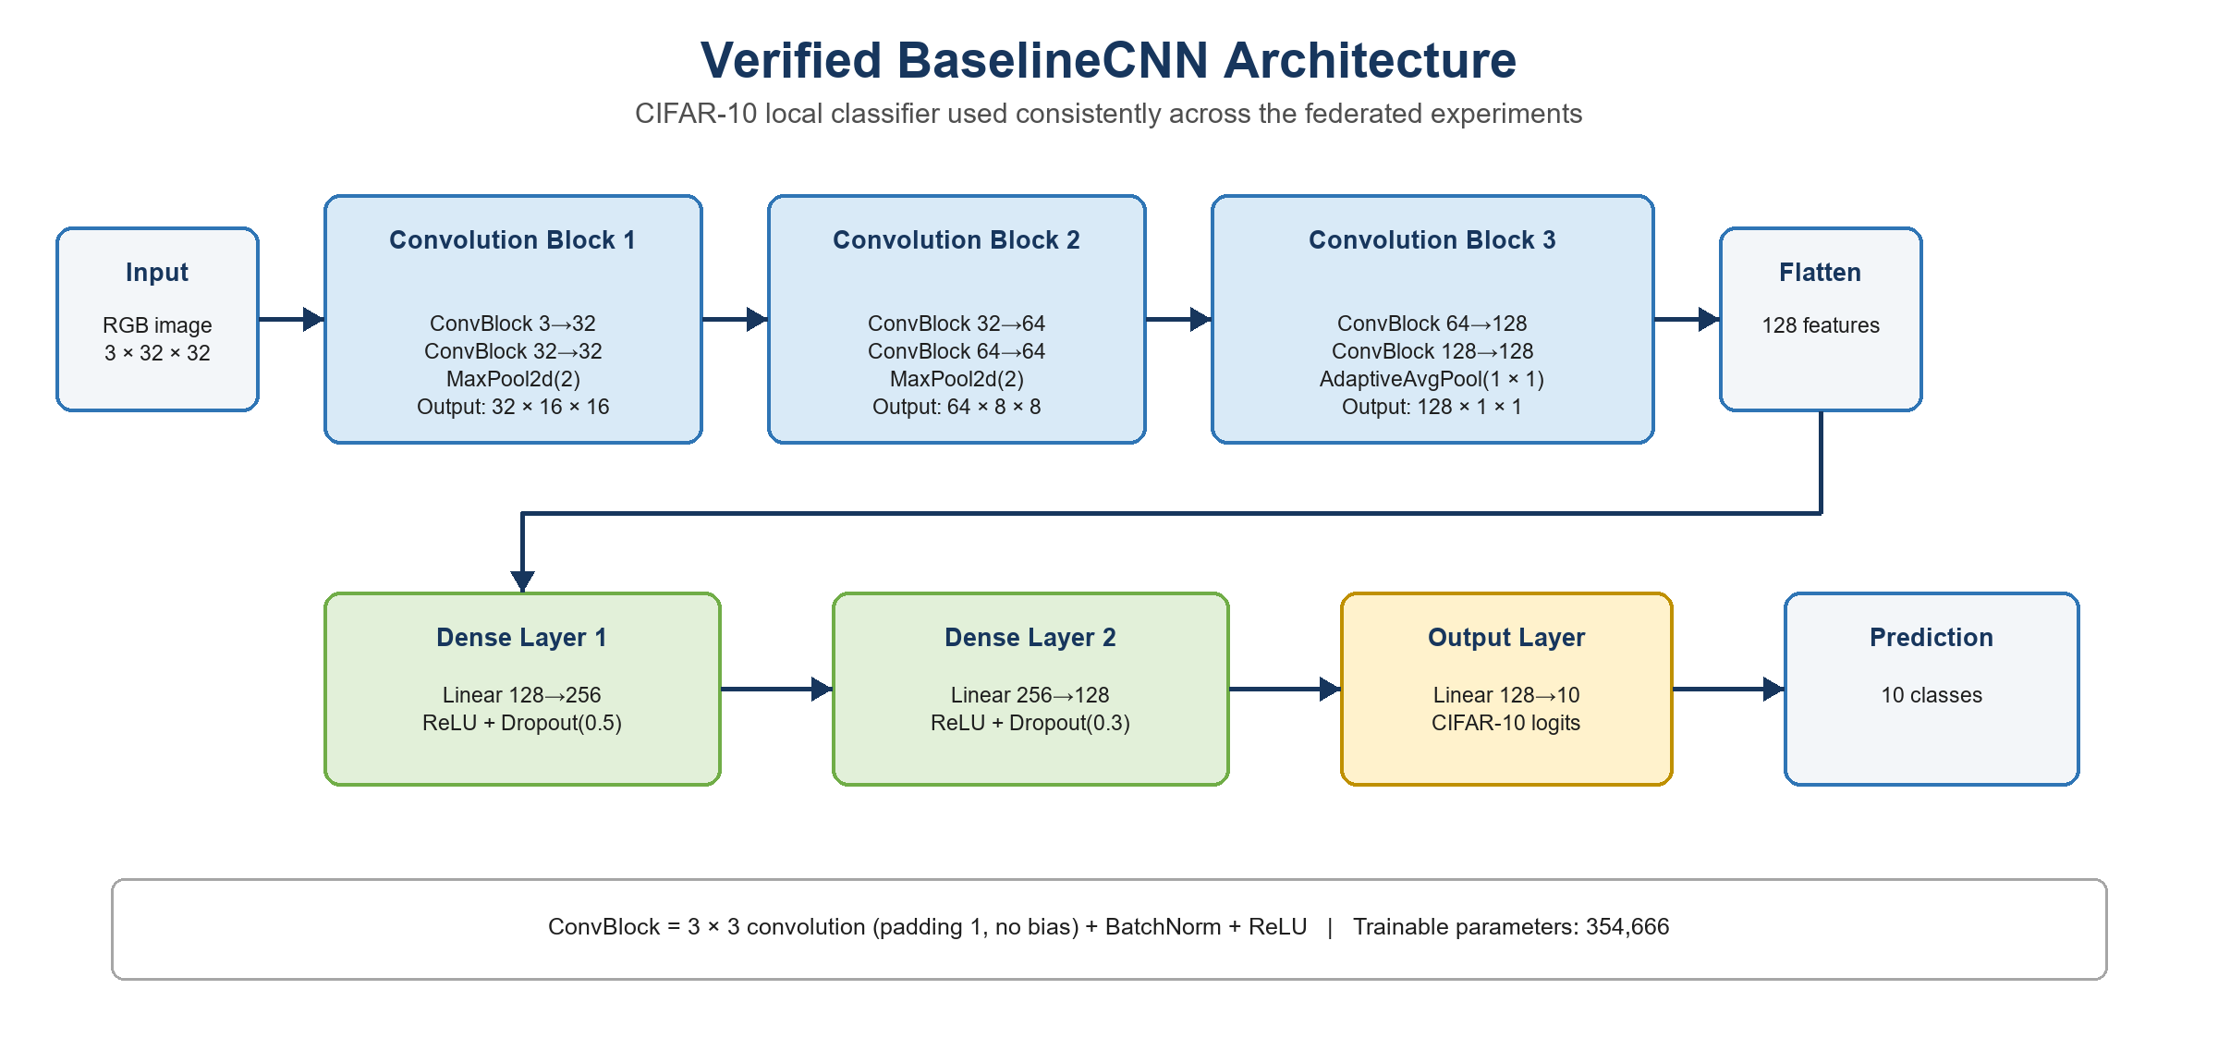
Figure S4. Verified BaselineCNN architecture shared by all retained experiments.
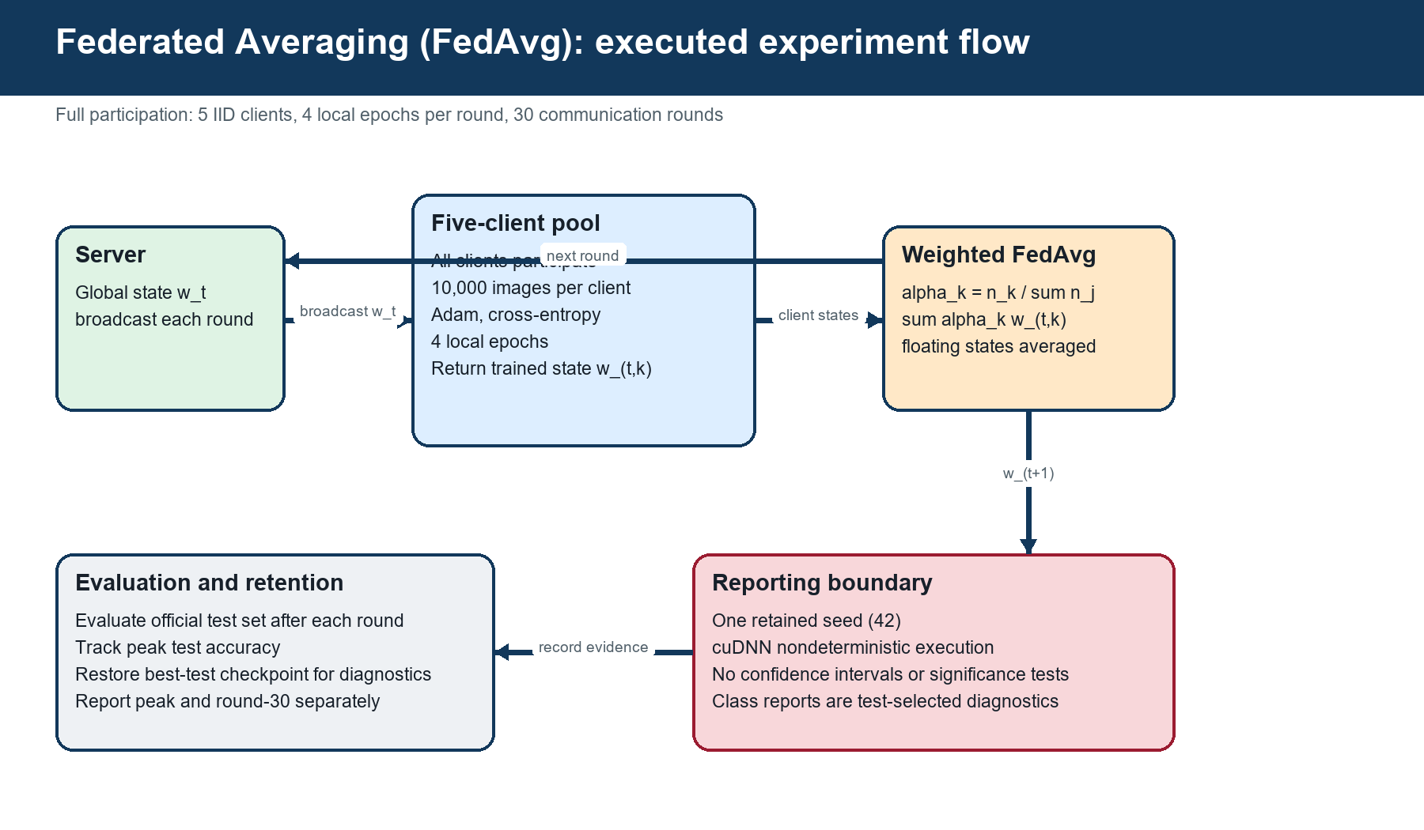
Figure S5. Executed FedAvg workflow and checkpoint-retention boundary.
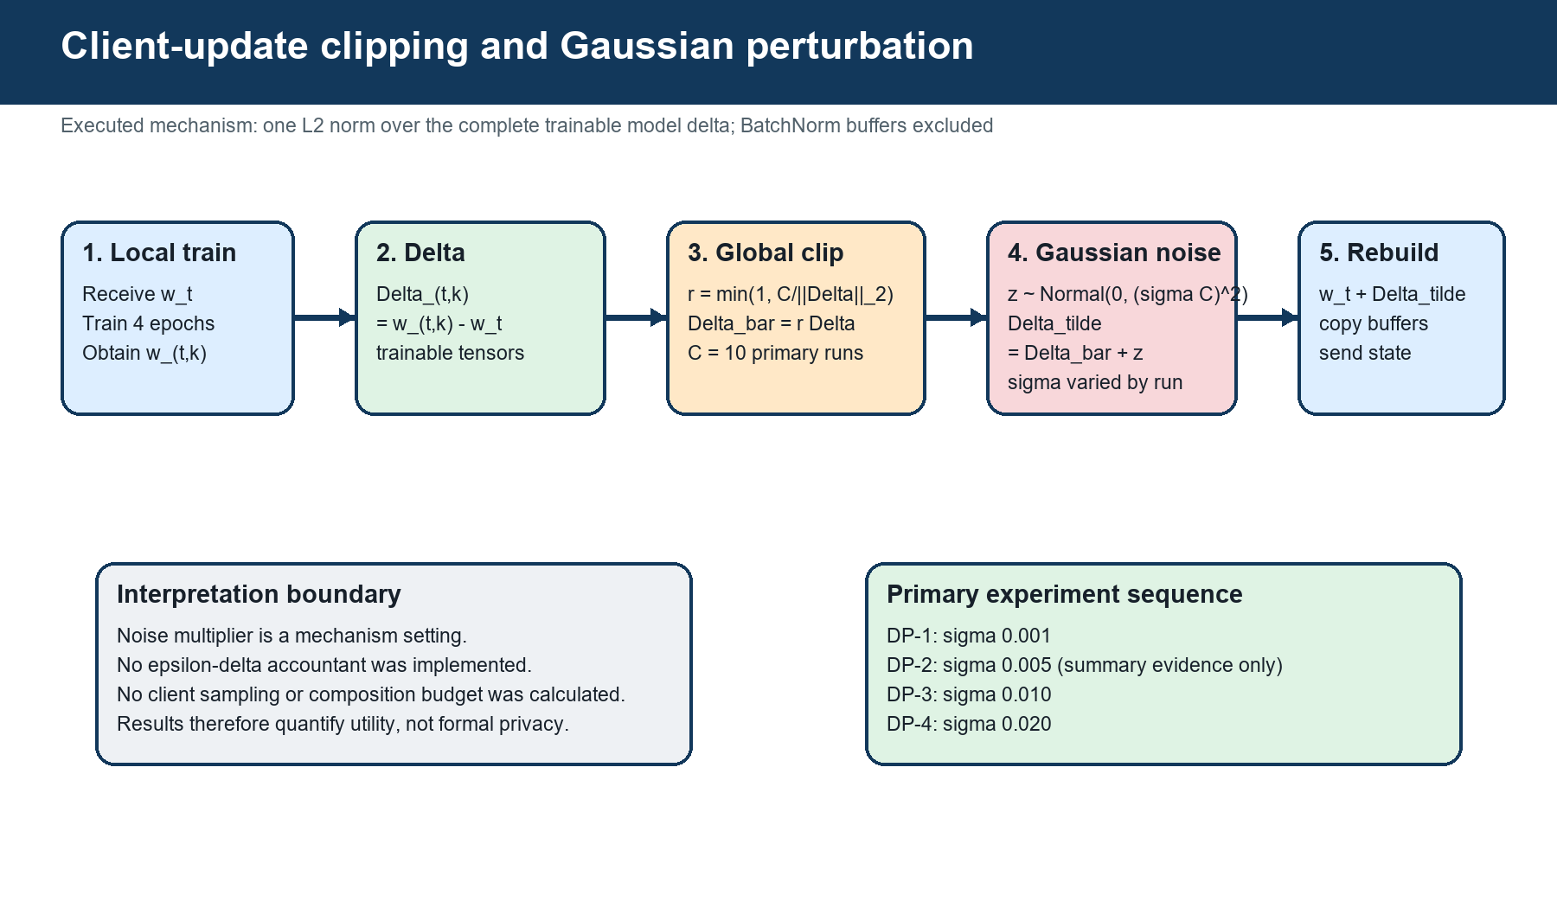
Figure S6. Complete-client-update clipping and Gaussian perturbation workflow.
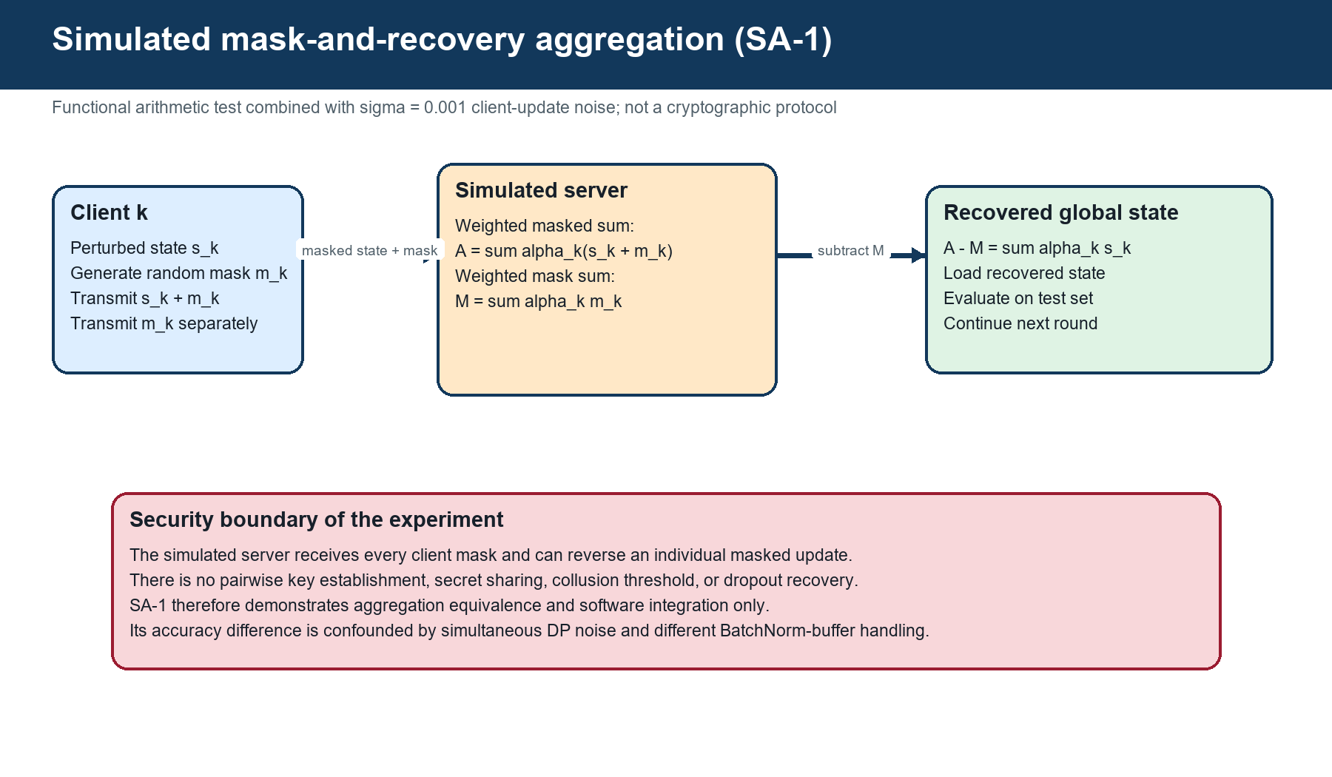
Figure S7. SA-1 mask-and-recovery simulation and security boundary.

4. Extended Results, Tables, and Class-Level Evidence

4.1 Reconciled experiment summary
Table S7. Reconciled endpoints, peaks, runtime, and evidence status.
Run | Noise | Final (%) | Peak (%) | Peak round | Time (min) | Evidence
FedAvg | 0 | 88.55 | 88.55 | 30 | 4.54 | Complete history
DP-1 | 0.001 | 88.80 | 88.80 | 30 | 4.61 | Complete history
DP-2 | 0.005 | 85.08 | 85.08 | - | 4.66 | Summary level
DP-3 | 0.010 | 63.57 | 74.18 | 27 | 4.73 | Complete history
DP-4 | 0.020 | 20.92 | 30.16 | 21 | 4.83 | Complete history
SA-1 | 0.001 | 79.36 | 86.42 | 28 | 4.68 | Combined path

FedAvg and DP-1 reached their maxima at round 30 and had comparable fixed-endpoint utility. The registered DP-2 endpoint remained above 85%, but its convergence shape cannot be assessed. DP-3 and DP-4 exhibited peak-to-round-30 declines of 10.61 and 9.24 percentage points, respectively, showing late-round instability. SA-1 peaked at 86.42% and ended at 79.36%; the difference from DP-1 cannot be assigned to masking alone.
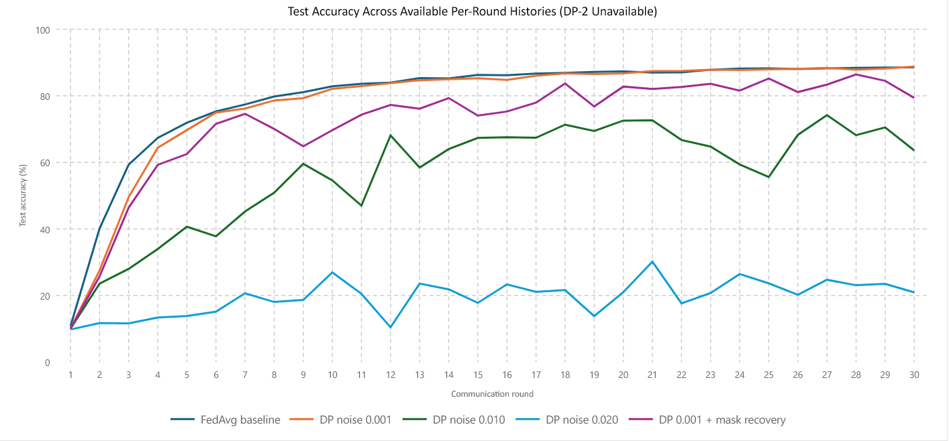
Figure S8. Accuracy over communication rounds for runs with verified histories.
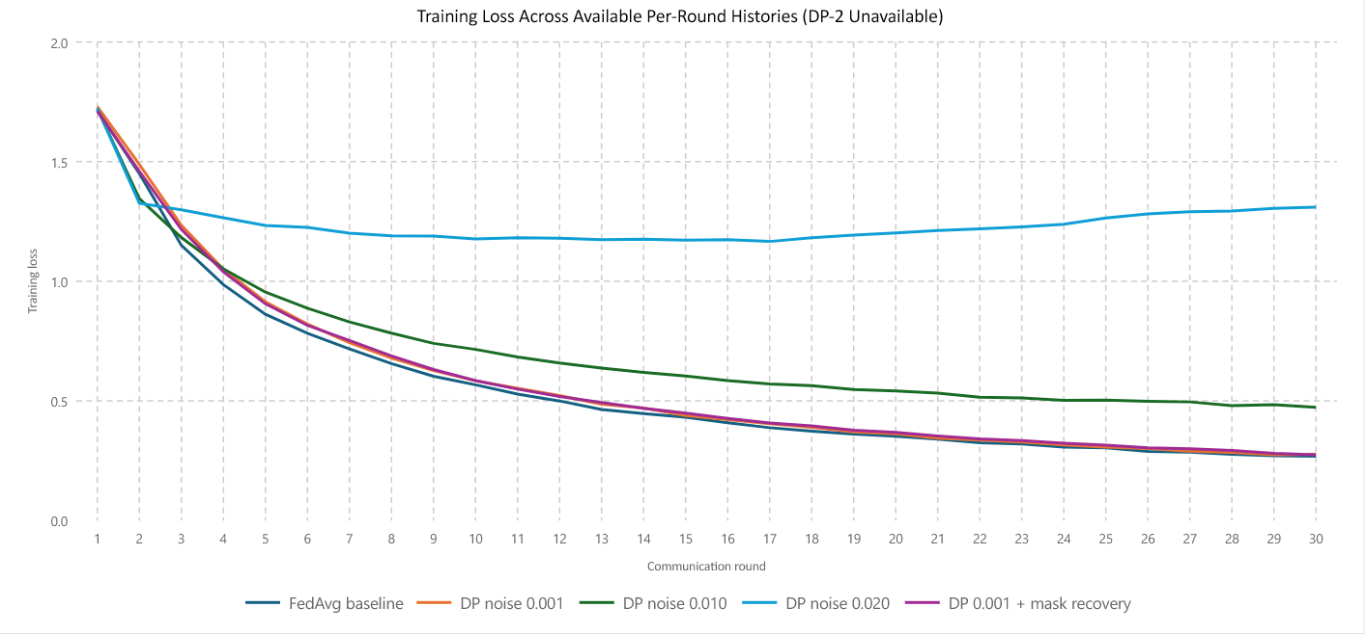
Figure S9. Training loss over communication rounds.
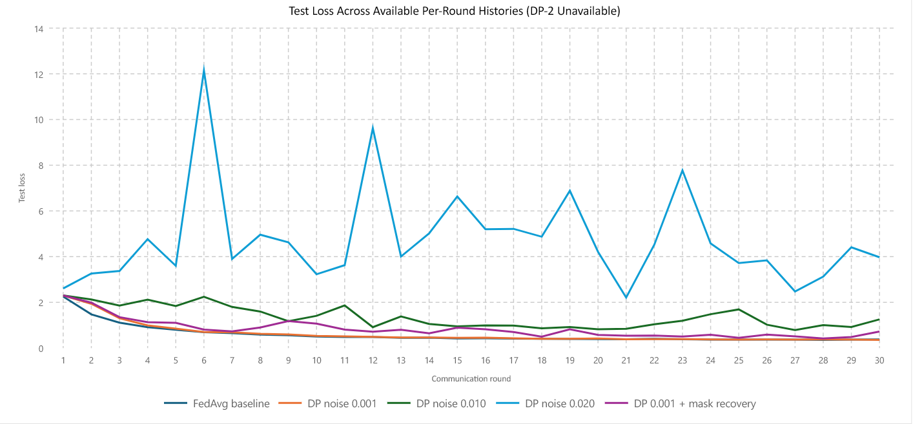
Figure S10. Test loss over communication rounds.
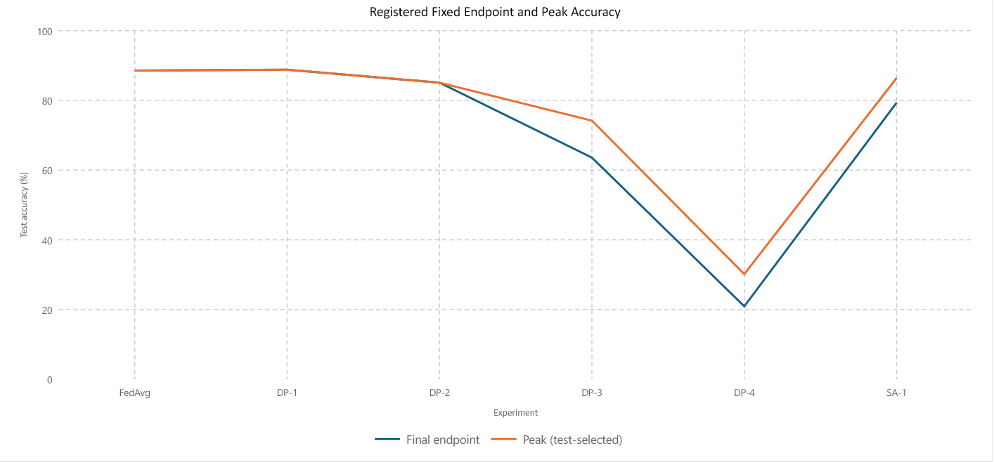
Figure S11. Fixed endpoint compared with test-selected peak accuracy.
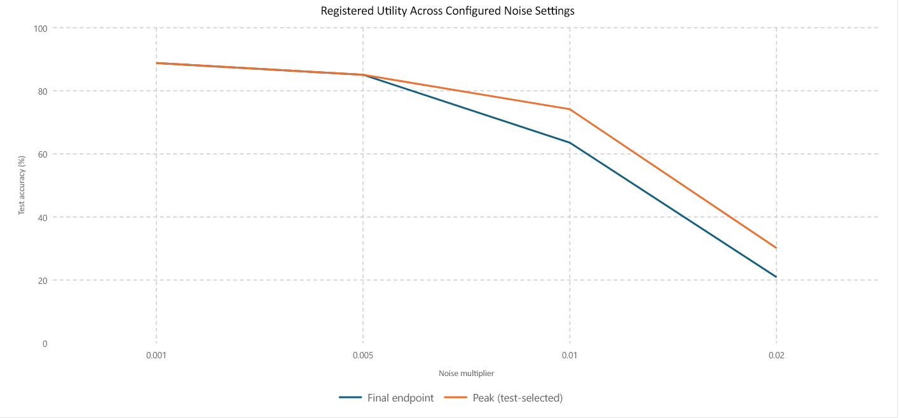
Figure S12. Registered noise setting against final and peak accuracy.
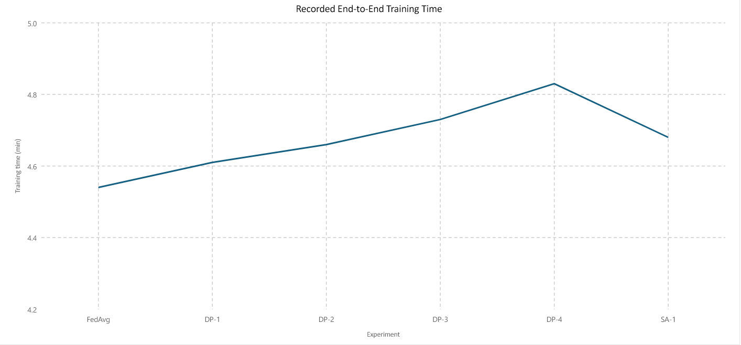
Figure S13. Recorded end-to-end training time.

4.2 Class-level diagnostics
The best-checkpoint confusion matrices show how degradation was distributed between classes. DP-1 retained a strong diagonal, with recall from 69.9% for cat to 95.1% for truck. At DP-3, frog and truck recall remained above 92%, while dog recall fell to 43.3%. DP-4 showed class-specific collapse: cat and ship recall were 0.4% and 0.5%, whereas truck recall remained 76.4%. These matrices are descriptive diagnostics because the checkpoint was selected through repeated test-set evaluation.
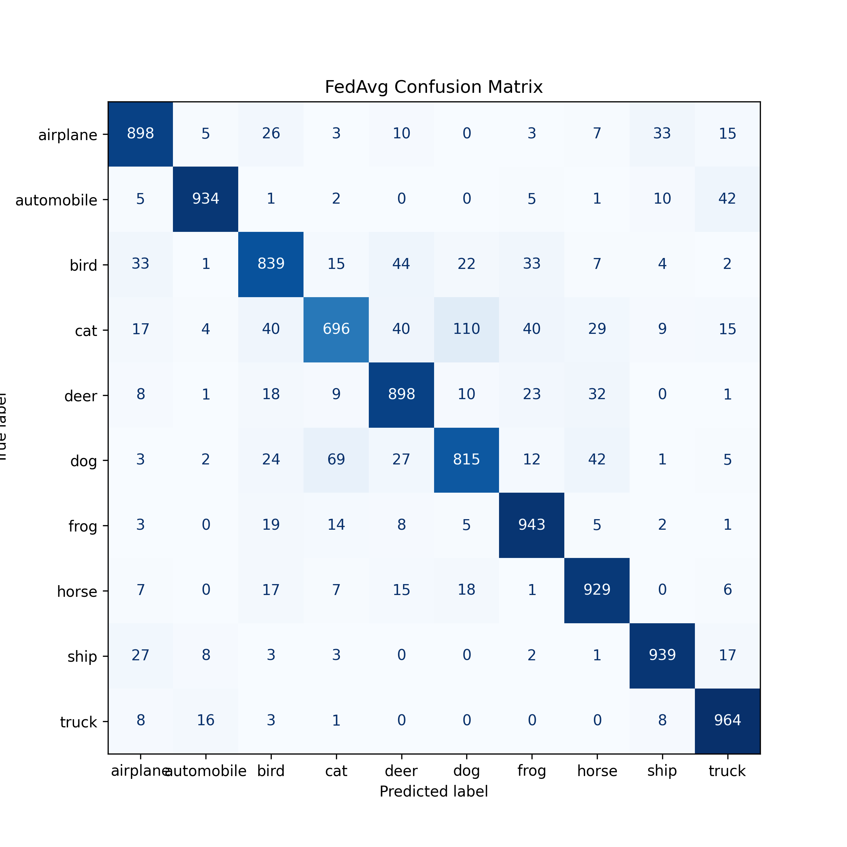
Figure S14. FedAvg best-checkpoint confusion matrix.
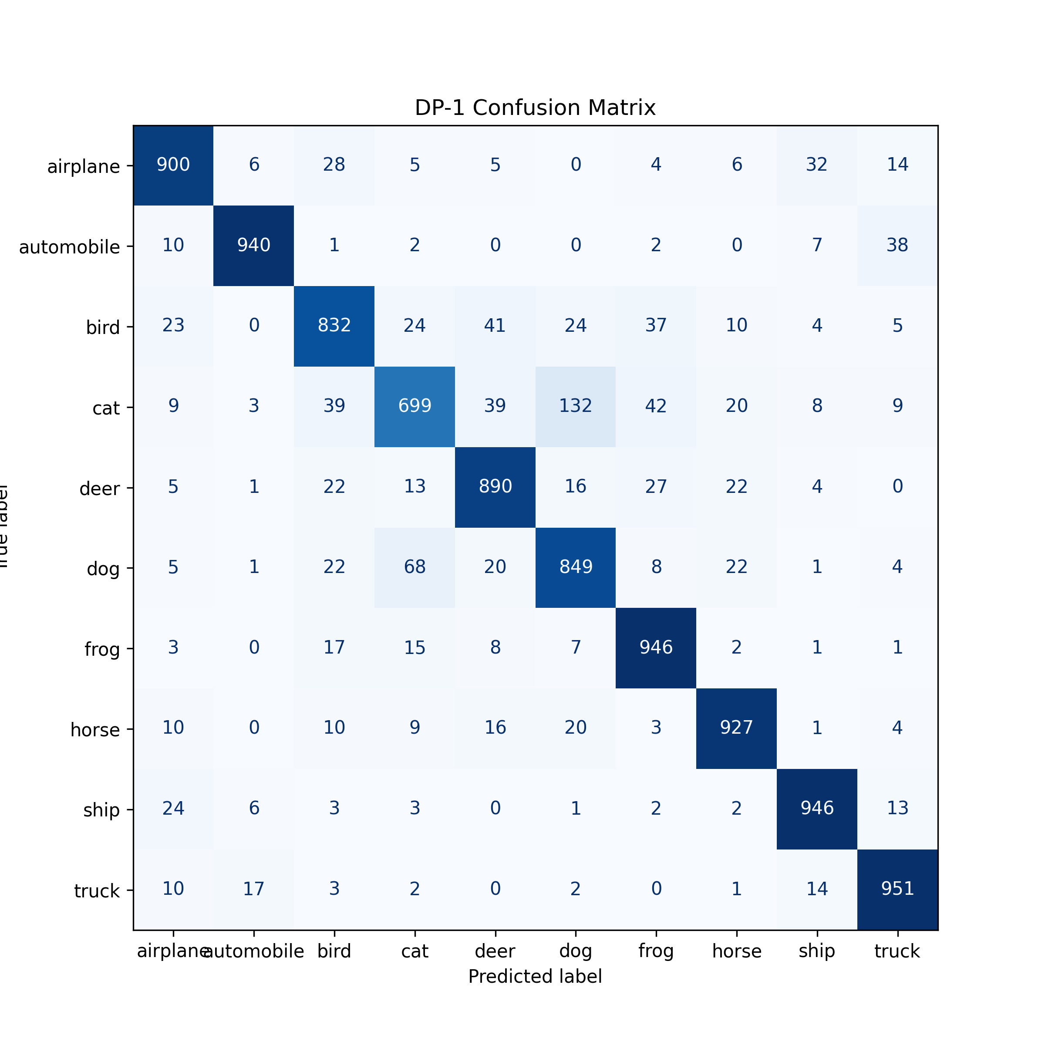
Figure S15. DP-1 best-checkpoint confusion matrix (sigma = 0.001).
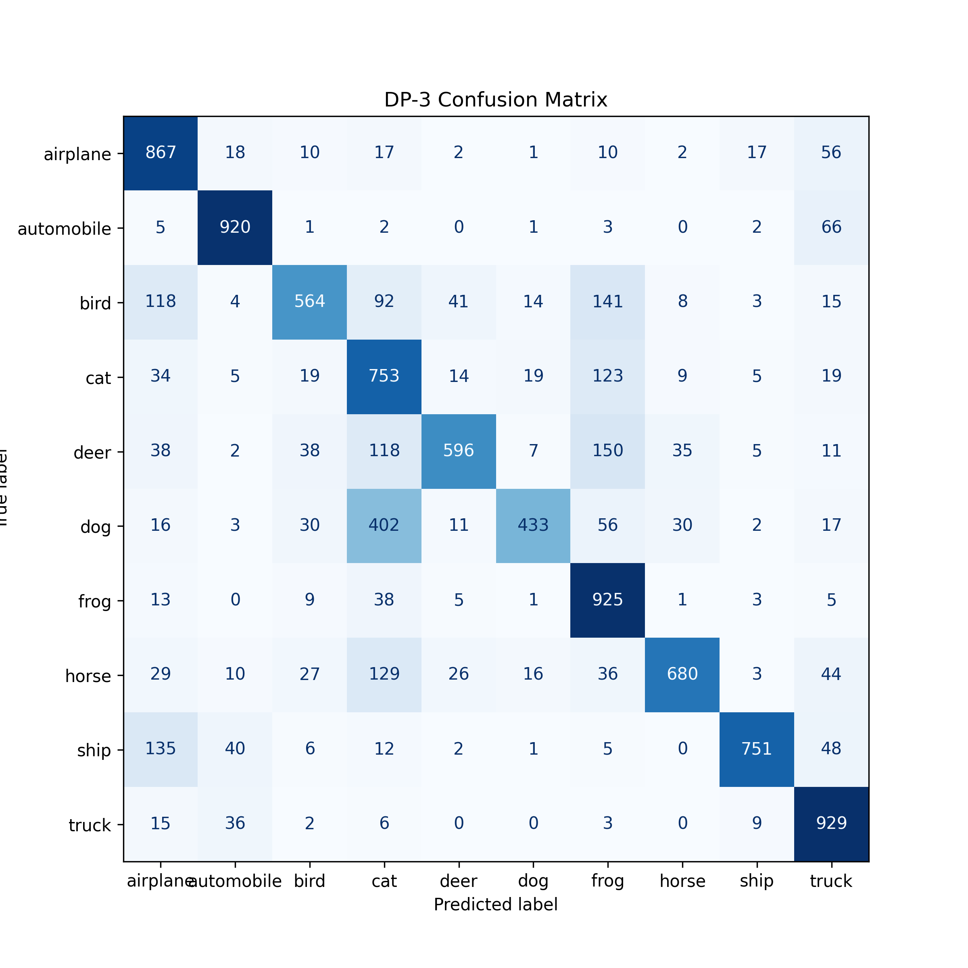
Figure S16. DP-3 best-checkpoint confusion matrix (sigma = 0.010).
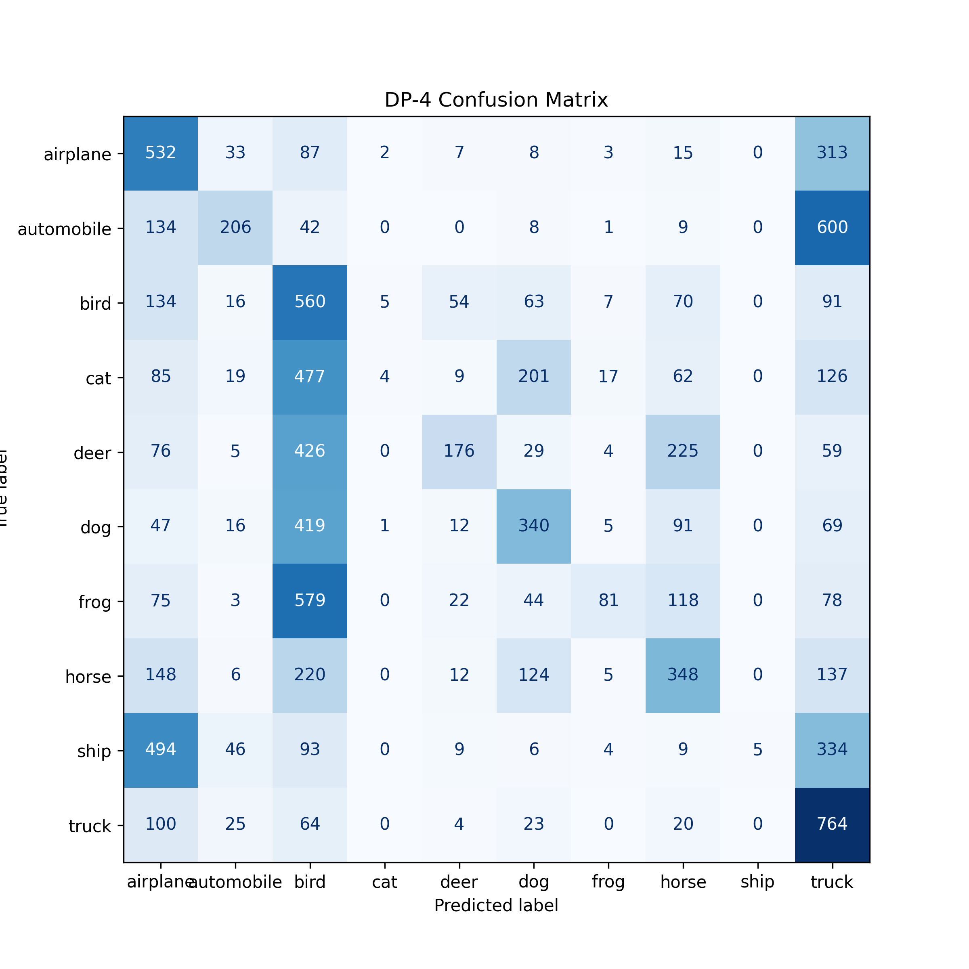
Figure S17. DP-4 best-checkpoint confusion matrix (sigma = 0.020).
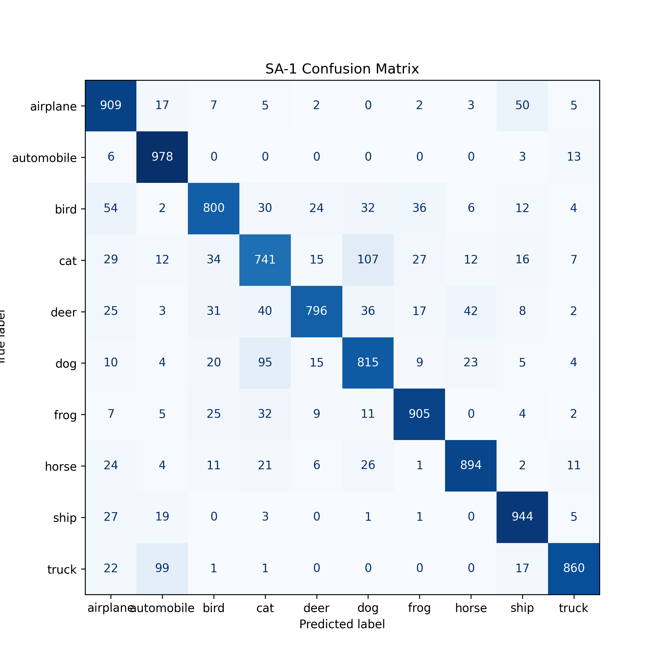
Figure S18. SA-1 combined-path best-checkpoint confusion matrix.

5. Verification, Validation, and Evidence Provenance

5.1 Verification and Validation Strategy
Verification asked whether the retained implementation performed its specified operations; validation asked whether the resulting evidence answered the research questions without exceeding its scope. The final audit combined static source inspection, data-integrity checks, configuration-to-log comparison, cross-file result reconciliation, visual inspection of figures, and claim-level review. Fifteen Python modules parsed successfully during the final static audit. Partition totals independently reconciled to 50,000 images, with 10,000 at every client and 5,000 in every class.
Table S8. Verification and validation register for the implemented system.
Layer | Question / check | Evidence and observed outcome | Judgement
Source verification | Are all retained modules syntactically parseable and responsibilities separated? | 15/15 Python modules parsed; configuration, data, training, aggregation, privacy, evaluation, and reporting are modular | Pass for static structure
Data verification | Are partitions complete and internally consistent? | Five client totals = 10,000; ten class totals = 5,000; grand total = 50,000 | Pass
FedAvg verification | Does aggregation use sample-count weights? | Source calculates num_samples / total_samples; equal executed sizes produce weights of 0.2 | Pass by source and executed configuration
Perturbation verification | Does the implementation calculate one trainable-update norm, clip to C, and add noise at sigma C? | Privacy source implements the norm, clipping coefficient, and configured noise scale; BatchNorm buffers are excluded | Pass for implemented numerical mechanism
Mask-path verification | Are random masks applied and subtracted during recovery? | Mask-generation and recovery operations are present; SA-1 completed 30 rounds | Pass for arithmetic workflow only
Experimental validation | Do endpoint, loss, class, and runtime evidence support RQ1-RQ3? | Complete histories support FedAvg, DP-1, DP-3, DP-4, and SA-1; DP-2 supports only its registered summary | Pass with DP-2 qualification
Security/privacy validation | Do the mechanisms establish formal DP or cryptographic confidentiality? | No accountant; server receives masks; no key exchange, dropout recovery, collusion test, or attack evaluation | Not established; claims explicitly bounded
Reproducibility validation | Can another researcher reproduce an identical run? | Seed and source retained, but package versions and deterministic cuDNN execution are absent | Partial

No retained automated unit-test suite or formal requirements test report was found. The register therefore does not relabel source inspection as unit testing. This absence is a development-process limitation. Future release work should add executable tests for weighted averaging, clipping boundaries, zero-noise identity, mask-recovery tolerance, partition conservation, checkpoint selection, and report generation.

5.2 Evidence Provenance and Reporting Validation
The analysis uses an explicit evidence hierarchy. Per-round claims require a retained history and matching metadata/report. Endpoint, timing, and macro-metric claims may use the federated experiment register when repeated summary exports agree. Class-level claims require retained predictions, a classification report, or a confusion matrix for the same run. When these requirements are not met, the claim is qualified or withheld.
Table S9. Evidence provenance and permitted claim types.
Evidence item | Use | Qualification
federated_experiment_log.csv | Noise sequence, endpoints, macro metrics, runtime | DP-2 supported only here and in repeated summaries
Reconciled_Round_History.csv | Peak round, round-30 values, losses | No intended DP-2 history
Classification reports / matrices | Per-class recall and error patterns | Best-test-selected checkpoints
Partition metadata and class table | Seed, client sizes, IID variation | Synthetic clients
Audited source modules | Transforms, optimiser, equations, state semantics | Versions not captured
Notebook outputs | CUDA path and analysis generation | Execution counts/package versions absent

DP-2 illustrates this rule. The register and six analysis exports consistently describe an intended 0.005 run with 85.08% accuracy and 4.66 min. A later bundle carrying the DP-2 filename instead describes a separate 0.020 run with 43.74% peak accuracy. The intended endpoint remains in the sequence, but the later history, report, metadata, and matrix are excluded from DP-2 trajectory and class-level analysis.

6. In-Depth Supplementary Literature Synthesis and Positioning

6.1 Federated Optimisation, Privacy, and Aggregation
FedAvg established iterative local training followed by sample-weighted server aggregation as the canonical optimisation pattern for decentralised data [1]. Later surveys show that the design space has expanded to include client selection, heterogeneous data, alternative aggregation, communication efficiency, fairness, poisoning resilience, and privacy [2], [3], [12], [13]. These dimensions interact: an aggregation rule that improves robustness or fairness may change convergence, while privacy controls can alter both update magnitude and class-level behaviour. The present study therefore fixes the client pool, model, partitions, optimiser, and schedule before varying the update-protection path.
Differential privacy provides a formal language for bounding the influence of protected records or users when adjacency, sampling, clipping, randomisation, composition, epsilon, and delta are defined [4], [5], [20]. Recent FL research emphasises client-level accounting, clipping calibration, and the optimisation damage caused by noise [15], [16], [21]. Adaptive clipping is particularly relevant because a fixed norm can either over-compress informative updates or require noise at an unnecessarily large scale [21]. This literature supports the implemented clipping-and-noise mechanism as an experimental sensitivity study, but it also explains why configured sigma values cannot be presented as privacy budgets without an accountant.
Secure aggregation addresses a different problem: it aims to reveal an aggregate while concealing each individual update from the coordinating server [6], [7]. Practical protocols require assumptions and mechanisms for key establishment, pairwise or secret-shared masks, collusion, client dropout, and recovery. Recent schemes add verification, blockchain governance, incentives, or attack resistance [8]-[11], [18]. Those studies demonstrate that confidentiality, integrity, availability, and governance are separate properties. SA-1 validates arithmetic integration of masking and recovery, but server-visible masks do not satisfy the protocol-level security objective described by Bonawitz et al. [6].
Integrated privacy-preserving FL consequently involves a three-way trade-off between statistical utility, formal privacy, and protocol security, with computation and communication as deployment constraints. Truex et al. combine differential privacy with secure multiparty computation [22]; Lei et al. emphasise lightweight verification [10]; and De Chaudhury et al. extend the problem to access control and incentives [11]. These systems are not directly comparable through CIFAR-10 accuracy because their datasets, models, adversaries, privacy units, and accounting assumptions differ. Their value here is methodological: they identify which guarantees and deployment measurements a complete system would need.

6.2 Method-Level Comparison
Cross-paper accuracy is not treated as a valid benchmark because the studies use different datasets, client populations, models, privacy units, adversaries, and accounting methods. The method-level comparison below shows what each study validates and where the present work remains deliberately bounded.
Table S10. Method-level comparison with peer-reviewed privacy-preserving FL studies.
Study | Privacy/accounting | Aggregation/security | Validation | Relationship
Bonawitz et al. [6] | No DP | Cryptographic secure sum; dropout/adversary assumptions | Protocol feasibility and overhead | Security target beyond SA-1
Andrew et al. [21] | User-level DP; adaptive clipping and joint analysis | Compatible with secure aggregation | Multiple FL tasks | Shows fixed clipping needs calibration
Truex et al. [22] | DP with trust-aware SMC | Secure multiparty computation | Three algorithms | Closest conceptual combination
De Chaudhury et al. [11] | Local-DP factor | Encryption, blockchain, access control | End-to-end HLF system | Adds governance and incentives
Lei et al. [10] | Masking rather than this noise sequence | LHH verification and blockchain | Verification/communication overhead | Shows deployment measurements absent here
Shi et al. [16] | Formal client-level DP treatment | Not primarily secure aggregation | Generalisation under DP | Addresses optimisation damage
Present work | Clipping/noise; no accountant | Server-known masks | CIFAR-10 utility and evidence audit | Transparent matched implementation

6.3 Gap Derivation and Original Position
The supplementary review narrows the research gap rather than claiming that the component mechanisms are new. FedAvg, DP, and secure aggregation are established. The original value lies in a matched, auditable implementation that exposes how a complete-client-update perturbation sequence changes endpoints, convergence, losses, and class behaviour, while recording exactly where the available evidence cannot support formal privacy or cryptographic-security claims.
Table S11. Literature-derived gap, project response, and remaining boundary.
Literature-derived issue | Project response | What remains unresolved
Headline accuracy can conceal instability and uneven class failure | Reports fixed endpoint, test-selected peak, train/test loss, macro metrics, and confusion matrices | Repeated seeds and uncertainty estimates are absent
Privacy parameters are often difficult to compare across incompatible accounting assumptions | Uses a matched sigma sequence under one implementation and avoids privacy-strength labels | No epsilon-delta accountant or empirical attack evaluation
Protocol papers and experimental simulations are easily conflated | Separates arithmetic mask recovery from cryptographic secure aggregation | No key establishment, collusion resistance, or dropout recovery
Evidence conflicts can silently distort the experimental narrative | Retains DP-2 in sequence but restricts it to repeated summary evidence | The intended DP-2 history and class predictions were not retained
Deployment claims require heterogeneity and operational measurements | Records configuration and runtime under a controlled IID simulation | Non-IID clients, communication bytes, energy, and distributed latency remain unmeasured

7. Implementation Tools and Source-Code Organisation
The code is organised as modular Python components for configuration, datasets, the CNN, local training, clients, the server, FedAvg, perturbation, mask generation/recovery, evaluation, reporting, plotting, experiment management, and analysis. This separation made it possible to trace each manuscript claim back to the relevant implementation path and retained artefact.
Table S12. Verified tools and their roles in the implementation.
Tool | Verified use
Python; Jupyter/IPython; Google Colab | Interactive experiment orchestration and modular execution
Google Drive | Datasets, source modules, notebooks, checkpoints, tables, figures, reports
PyTorch; CUDA; cuDNN | CNN, local optimisation, state operations, acceleration, checkpoints
torchvision | CIFAR-10 and train/test transforms
NumPy; pandas | Numerical handling, histories, logs, and tables
scikit-learn | Confusion matrices, reports, precision, recall, and F1
Matplotlib | Accuracy, loss, timing, distribution, and matrix figures
tqdm | Local-training progress output

7.1 Code repository and reproducibility package
The public repository will be linked below after the final project repository is created or confirmed. It should contain the source modules, environment specification, notebook entry points, a README with execution order, and a compact set of non-sensitive result tables. Large checkpoints and duplicate generated figures should be released through a tagged archive or project storage rather than committed directly to Git history.
GitHub repository: [GITHUB REPOSITORY URL TO BE ADDED BEFORE PUBLIC RELEASE]
Table S13. Planned public repository structure.
Repository component | Recommended content
README.md | Research scope, evidence limits, environment, reproduction sequence
src/ | aggregation, client, config, dataset, evaluation, federated, model, privacy, reporting, secure aggregation, server, training
notebooks/ | Environment setup and final orchestration notebooks
results/ | Reconciled summary, verified histories, evidence register, selected figures
docs/ | Eight-page paper and supporting-material metadata/readme
LICENSE and CITATION.cff | Reuse terms and citation metadata

8. Professional, Ethical, Social, and Sustainability Considerations

8.1 Professional practice
Professional responsibility in privacy-preserving machine learning includes accurate security communication, reproducible experiment management, and clear separation between implemented behaviour and claimed guarantees. The project follows this principle by labelling the update mechanism as clipping with Gaussian noise rather than formal DP, and the masking path as a simulation rather than cryptographic secure aggregation. Evidence conflicts are documented instead of silently resolved in favour of the most favourable result.

8.2 Ethical and privacy considerations
CIFAR-10 is a public benchmark and the five clients are synthetic partitions, so the recorded experiments do not process identifiable participant data. The ethical relevance lies in future deployment: an organisation could mistakenly treat data locality as complete privacy or assume that server-visible masks protect individual updates. A responsible extension must define the protected unit, threat model, privacy accountant, access controls, retention policy, and response to client compromise before sensitive data are used.

8.3 Social considerations
Federated learning can enable collaboration between organisations that cannot centralise data, but benefits may be uneven when client devices, connectivity, data volume, or class distributions differ. This study does not measure fairness or non-IID behaviour. Its balanced IID results should not be generalised to populations whose data are sparse or systematically different. Future evaluation should report subgroup and client-level utility alongside global accuracy.

8.4 Sustainability considerations
Local computation and repeated model exchange consume energy even when raw data remain on device. The recorded simulation reports wall-clock time but not energy, communication bytes, or carbon intensity. The small runtime spread is therefore not an environmental result. A deployment study should log transmitted bytes, client compute time, accelerator energy, dropout/retry costs, and the impact of compression or reduced participation.

9. Critical Appraisal, Limitations, and Future Work

9.1 Critical appraisal
The project succeeds in constructing a modular end-to-end FL implementation and exposing the utility sensitivity of complete-client-update perturbation. The matched design keeps the model, client count, partitions, optimiser, and schedule stable across the registered sequence. The evidence audit strengthens originality by making reporting provenance part of the research method. It also prevents the later DP-2 bundle from overwriting the intended experimental sequence.
The strongest empirical observation is the nonlinear deterioration after sigma exceeds 0.005 under the executed clipping rule. FedAvg and DP-1 remain near 88.6%, DP-2 records 85.08%, and the larger settings finish at 63.57% and 20.92%. Loss and class-level diagnostics show that the decline is not merely a small endpoint fluctuation. However, a single seed, nondeterministic cuDNN execution, repeated test-set model selection, and the missing DP-2 history prevent statistical or causal claims.

9.2 Challenges Encountered and Project Responses
The reference evidence portfolio records operational observations and sources of error alongside results. The table below applies that practice to the principal challenges encountered in this project.
Table S14. Challenges encountered, their evidential impact, and the response taken.
Challenge | Impact on interpretation | Response taken
DP-2 summary/history conflict | Could create an incorrect trajectory or class claim | Retained the repeated 0.005 summary endpoint; excluded the conflicting later bundle from trajectory and class analysis.
Single seed and nondeterministic cuDNN | Prevents confidence intervals and reliable superiority claims | Reported directional patterns and comparable utility rather than statistical improvement.
Test-set checkpoint selection | Peak scores and matrices may be optimistic | Reported fixed round-30 endpoints separately and labelled matrices as test-selected diagnostics.
Server-visible masks in SA-1 | Does not provide cryptographic confidentiality | Renamed the mechanism as simulated mask recovery and documented the security boundary.
Different BatchNorm-buffer paths | Confounds the SA-1 comparison | Withheld masking-only conclusions and proposed an identical-buffer zero-noise control.
Eight-page paper limit | Restricts detailed evidence in the main article | Moved architectures, full curves, matrices, tools, and provenance into this separate evidence companion.

9.3 Ranked Weaknesses, Impact, and Better Alternatives
Weaknesses were ranked by their effect on the validity of the principal conclusions, rather than by how easy they would be to correct. The ranking distinguishes threats to measured utility, reproducibility, privacy interpretation, security interpretation, and external validity.
Table S15. Ranked weaknesses and method alternatives.
Rank | Weakness and relative impact | Effect on conclusions | Preferred alternative / mitigation
1 | Repeated test-set checkpoint selection - very high risk to peak estimates | Peak accuracy and matrices may be optimistic; fixed round-30 comparisons remain more defensible | Create a validation split, select checkpoints on validation data, and evaluate the test set once
2 | Single seed with nondeterministic cuDNN - high reproducibility risk | Prevents confidence intervals, significance tests, and reliable superiority claims | Run at least three deterministic seeds and report mean, standard deviation, confidence intervals, and paired comparisons
3 | No privacy accountant - high claim-validity risk | Noise sensitivity is measured, but no formal client-level privacy guarantee can be stated | Define adjacency and sampling; calibrate clipping; use a reviewed RDP/PRV accountant to report epsilon for stated delta
4 | Server-known masks and no cryptographic protocol - high security-claim risk | SA-1 proves arithmetic integration, not confidentiality against the server or colluding clients | Implement a reviewed secure-aggregation protocol with key exchange, pairwise masking or secret sharing, collusion assumptions, and dropout recovery
5 | SA-1 changes BatchNorm-buffer handling and includes noise - medium causal-confounding risk | The SA-1 utility difference cannot be attributed to masking alone | Add zero-noise masking and unmasked controls with identical buffer semantics
6 | DP-2 lacks intended trajectory and class outputs - medium completeness risk | The endpoint remains usable, but convergence, loss, and class claims cannot be made | Rerun the registered 0.005 condition under the frozen protocol and retain immutable run identifiers
7 | Five equal IID synthetic clients - medium external-validity risk | Results cannot represent natural client heterogeneity, dropout, or unequal resources | Use Dirichlet non-IID partitions, unequal sizes, partial participation, dropout, and client-level reporting
8 | No energy, byte-volume, attack, or network-latency measurements - lower risk to current utility question | Limits deployment, sustainability, and adversarial-resilience conclusions | Instrument communication bytes, energy, latency, membership/gradient attacks, and poisoning robustness

9.4 Consolidated Limitations
- One retained seed and nondeterministic accelerator execution; no confidence intervals or significance tests.
- The test set was evaluated every round and used to restore the best checkpoint.
- DP-2 has summary-level evidence but no intended trajectory or class predictions.
- The five equal IID partitions do not represent natural user heterogeneity.
- No epsilon-delta accountant, privacy composition, or empirical privacy attack was implemented.
- SA-1 exposes masks to the server and lacks key exchange, collusion analysis, and dropout recovery.
- Communication volume, energy, fairness, poisoning robustness, and distributed-network latency were not measured.
- Exact software package versions were not retained in the available environment notebook.

9.5 Future Work
The immediate experimental extension should introduce a validation split for checkpoint selection, deterministic execution where possible, and at least three seeds per condition. Non-IID Dirichlet partitions, unequal client sizes, and partial participation should be added before drawing deployment conclusions. A zero-noise mask-only control with identical BatchNorm handling would isolate aggregation arithmetic from perturbation and state-buffer effects.
The privacy extension should define client-level adjacency, sampling, clipping calibration, and an accountant that reports epsilon for a stated delta across all rounds. Adaptive clipping is a strong candidate because the observed sensitivity shows that C is not a neutral constant. The security extension should replace server-known masks with a reviewed secure-aggregation protocol that includes key establishment, pairwise masking or secret sharing, collusion assumptions, and dropout recovery. Reproduction should be packaged through the GitHub repository with pinned dependencies and scripted experiment entry points.

10. References
[1] B. McMahan et al., “Communication-efficient learning of deep networks from decentralized data,” in Proc. AISTATS, 2017, pp. 1273–1282.
[2] Y. Feng et al., “A survey of security threats in federated learning,” Complex Intell. Syst., vol. 11, art. 165, 2025.
[3] J. Zhao et al., “The federation strikes back: A survey of federated learning privacy attacks, defenses, applications, and policy landscape,” ACM Comput. Surv., vol. 57, no. 9, art. 230, 2025.
[4] M. Abadi et al., “Deep learning with differential privacy,” in Proc. ACM CCS, 2016, pp. 308–318.
[5] H. B. McMahan et al., “Learning differentially private recurrent language models,” in Proc. ICLR, 2018.
[6] K. A. Bonawitz et al., “Practical secure aggregation for privacy-preserving machine learning,” in Proc. ACM CCS, 2017, pp. 1175–1191, doi: 10.1145/3133956.3133982.
[7] X. Zhang, Y. Luo, and T. Li, “A review of research on secure aggregation for federated learning,” Future Internet, vol. 17, no. 7, art. 308, 2025.
[8] B. S. Bari and K. Yelamarthi, “Defending against adversarial threats in federated learning: A security approach with differential privacy and secure aggregation,” in Proc. IEEE iSES, 2025.
[9] M. A. P. Putra et al., “Proof-of-authority-based secure and efficient aggregation with differential privacy for federated learning in industrial IoT,” Internet Things, vol. 25, art. 101107, 2024.
[10] X. Lei, S. Wang, and Y. Fan, “LPV-FL: A lightweight privacy-preserving and verifiable federated learning scheme,” IEEE Internet Things J., vol. 12, no. 24, pp. 51866–51876, 2025.
[11] S. De Chaudhury et al., “Blockchain based secure federated learning with local differential privacy and incentivization,” IEEE Trans. Privacy, vol. 1, pp. 31–44, 2024.
[12] N. Khan et al., “Optimizing federated learning with aggregation strategies: A comprehensive survey,” IEEE Open J. Comput. Soc., vol. 6, pp. 1227–1247, 2025.
[13] T. Z. Sana et al., “Advancing federated learning: A systematic literature review of methods, challenges, and applications,” IEEE Access, vol. 13, pp. 153817–153844, 2025.
[14] J. Ayeelyan et al., “Federated learning design and functional models: Survey,” Artif. Intell. Rev., vol. 58, art. 21, 2025.
[15] X. Wang et al., “A survey of differential privacy techniques for federated learning,” IEEE Access, vol. 13, pp. 6539–6555, 2025.
[16] Y. Shi et al., “Toward the flatter landscape and better generalization in federated learning under client-level differential privacy,” IEEE Trans. Pattern Anal. Mach. Intell., vol. 47, no. 12, pp. 11632–11643, 2025.
[17] C. Hu et al., “PriFairFed: A local differentially private federated learning algorithm for client-level fairness,” IEEE Trans. Mobile Comput., 2025.
[18] Q. Han et al., “Privacy preserving and secure robust federated learning: A survey,” Concurr. Comput.: Pract. Exper., vol. 36, no. 13, e8084, 2024.
[19] A. Krizhevsky, “Learning multiple layers of features from tiny images,” Univ. Toronto, Toronto, ON, Canada, Tech. Rep., 2009.
[20] R. C. Geyer, T. Klein, and M. Nabi, “Differentially private federated learning: A client level perspective,” arXiv:1712.07557, 2017.
[21] G. Andrew, O. Thakkar, H. B. McMahan, and S. Ramaswamy, “Differentially private learning with adaptive clipping,” in Adv. Neural Inf. Process. Syst., vol. 34, 2021, pp. 20461–20475.
[22] S. Truex et al., “A hybrid approach to privacy-preserving federated learning,” in Proc. 12th ACM Workshop Artif. Intell. Security (AISec), 2019, pp. 1–11, doi: 10.1145/3338501.3357370.

