ROIDTrends: Real-world Observations of Image & performance enhancing Drug Trends
The Problem: Emerging and novel illicit markets for anabolic-androgenic steroids (AAS) and other image- and performance-enhancing drugs (IPEDs) represent a substantial and largely invisible public health issue for Queenslanders (1). IPEDs are used by a diverse population for purposes including appearance enhancement, performance, recovery, and wellbeing (2), yet these substances remain peripheral within mainstream alcohol and other drug (AOD) surveillance, harm reduction, and health service frameworks (3). As a result, people who use IPEDs navigate risk in the absence of reliable information about emerging risks (4, 5). Instead, they turn to online forums or when making decisions, rather than community-partnered initiatives grounded in evidence (10). Drug checking has emerged globally as an effective harm reduction response to unregulated drug markets, supporting consumers to make more informed decisions and enabling early detection of emerging risks within the supply (11). While drug checking services are increasingly embedded within responses to opioids, stimulants, and festival drug use, their application to IPEDs has lagged significantly (8, 9). This gap reflects both structural stigma toward AAS use (12) and the absence of scalable systems capable of capturing meaningful data from dispersed, community-based testing practices.
OUR VISION: To create a sustainable system using community data to inform harm reduction, services, and public health policy.
The Critical Gap: In Australia, PEDTest is the only dedicated IPED checking service, allowing community members to use reagent-based testing kits and submit results to a centralised database (13). These submissions generate a unique and growing dataset reflecting substances actively circulating within unregulated IPED markets. However, without systematic aggregation and accompanying person-level data, the broader public health value of these reports remains underutilised. Despite the promise of this model, there remains limited empirical analysis of these community-generated data (13), particularly in relation to differences in product legitimacy across formulations and their implications for harm reduction. Understanding these patterns is critical for informing targeted responses, refining IPED checking interventions (14), and strengthening the evidence base for public health strategies which are contextually appropriate for IPEDs.

The Solution: ROIDTrends addresses this gap by converting community PEDTest reports into structured surveillance data on IPED markets. It integrates point-of-submission surveys to track consumer characteristics, behaviours, health access, and changes in decision-making over time.
- This research aims to: Utilise community-submitted data, collected through the ROIDTrends program, to examine novel and emerging IPEDs circulating within Queensland’s illicit market.
- Generate timely, actionable surveillance data that informs harm reduction responses, service planning, and evidence-based policy related to IPED use.
Research Plan and Methods
Design: This study combines repeated cross-sectional data with anonymously linked longitudinal reporting. Ethics approval will be sought from The University of Queensland.
Recruitment: Participants are members of the community who use IPEDs and voluntarily submit IPED checking results to PEDTest. Eligible participants are aged 18 years or older and choose to report the results of testing conducted using PEDTest reagent kits. Participation is open to individuals regardless of frequency of IPED use, experience with drug checking, or engagement with health services. No exclusion criteria are applied beyond age and voluntary participation.
Data Collection: Data are collected via PEDTest’s secure online reporting platform and transferred to UQ’s Trusted Research Environment. Submissions include drug type, formulation, labelled claims, and reagent testing outcomes, categorised as confirmed, swapped, bunk, or inconclusive. An embedded ROIDTrends survey, delivered using UQ infrastructure (e.g., Qualtrics) and REDCap, captures demographic information, IPED use patterns, novel and emerging trends, harm reduction practices, health service access, and selected health and wellbeing indicators. Participants with anonymous linking codes enable longitudinal data capture across submissions.
Data Analysis: Descriptive and inferential analyses will summarise legitimacy outcomes and examine associations by formulation type, with longitudinal analyses assessing within-person changes over time. Data will be analysed across two three-month cycles to identify trends and inform harm reduction, service delivery, and policy responses.
Significance and Outcomes
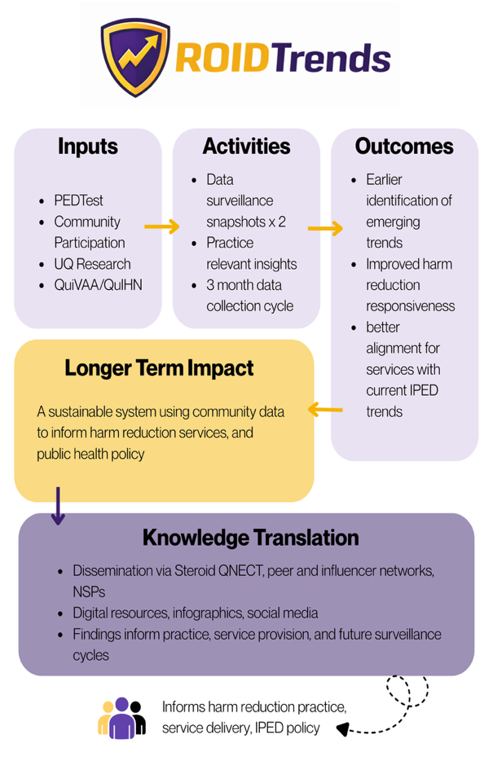
This project addresses a critical gap in alcohol and other drug surveillance by generating timely, real-world evidence on IPED use and emerging risks that are largely invisible within existing systems. By integrating community-submitted drug checking data with structured survey reporting and rapid analysis cycles, ROIDTrends will enable early identification of novel trends, formulation-specific risk patterns, and harm reduction needs. Following establishment, the UQ–PEDTest partnership will deliver two rolling surveillance snapshots over three-month periods, embedded within IPED policy advocacy and service delivery through QuIVAA and QuIHN. Key outputs include surveillance summaries detailing legitimacy outcomes and emerging trends, practice-relevant insights into how drug checking influences decision-making and service engagement, and peer-reviewed publications demonstrating the public health value of community-based surveillance. Findings will be disseminated through Steroid QNECT and metropolitan and regional NSPs using accessible formats, including infographics and online resources, to support responsive harm reduction.
Feasibility and Track Record
This project brings together an award-winning, gender-balanced team spanning senior (CIA Ferris), mid-career (CI Piatkowski), and emerging career researchers (CIs Akrigg, Bonenti, Ahmadinejad), alongside policy and AOD sector leaders (CIs Kill, Davey, Craven) who collectively oversee services with >$30M per annum in sector funding. CIA Ferris (>$70M competitive funding; >200 outputs) and CI Piatkowski (NHMRC Emerging Leadership Fellow; >$7.8M competitive funding; >175 outputs) are both nationally recognised award recipients and for the award-winning ROIDCheck program. The entire team has an established record of collaboration across peer-reviewed outputs and national technical reports, including joint work on IPED market contamination and legitimacy (13-18). Their partnership integrates secure data infrastructure and advanced analytics (Ferris, Bonenti, Ahmadinejad), lived-experience–led implementation and service translation (Piatkowski, Akrigg), and large-scale community service delivery and policy engagement (Kill, Davey, Craven). Collectively, the investigators have secured >$100M in competitive and commissioned funding and supervised 30+ students, demonstrating depth, succession planning, and sustained research capacity.
Timeline
Period | Key Activities and Milestones
Q1 (June–Aug 2026) | Ethics approval obtained; recruitment framework finalised; stakeholder engagement initiated with QuIVAA, QuIHN, PEDTest and service partners.
Q2 (Aug 2026–Jan 2027) | Platform launch and data collection cycle 1; interim analysis; first surveillance summary and service/community dissemination.
Q3 (Feb 2027–April 2027) | Data collection cycle 2; comparative analyses; second surveillance summary and targeted dissemination activities.
Q4 (April 2027–June 2027) | Cross-cycle synthesis; final report and policy brief; stakeholder briefings and knowledge translation. Dissemination of findings to stakeholders, including service partners and peer organisations, to inform practice and resource development.
References
1. Magnolini R, Falcato L, Cremonesi A, Schori D, Bruggmann P. Fake anabolic androgenic steroids on the black market–a systematic review and meta-analysis on qualitative and quantitative analytical results found within the literature. BMC Public Health. 2022;22(1):1-15.
2. Piatkowski T, Dunn M. Navigating Risks and Reducing Harm: A Gendered Analysis of Anabolic–Androgenic Steroid Users Within the Risk Environment Framework. Contemporary Drug Problems. 2024:00914509241249292.
3. Bonenti B, Kerswell N, Shuttlesworth G, Lim C, Ferris J, O’Connor T, et al. Confidence in Managing Use and Minimising Harm as Mediators of Quality of Life among Anabolic-Androgenic Steroid Consumers in Alcohol and Other Drug Treatment Settings. European Addiction Research. Under Review.
4. Piatkowski T, Havnes IA, Kill E, Barratt MJ. “The compounds for females are really commonly faked!”: Women's challenges in anabolic steroid acquisition and the place of drug checking interventions. Drug and Alcohol Review. 2024;43(7):1962-6.
5. Piatkowski T, Puljevic C, Ferris J, Francis C, Matthew D. They sent it away for testing and it was all bunk”: Exploring perspectives on drug checking among steroid consumers in Queensland, Australia. International Journal of Drug Policy. 2023.
6. Piatkowski T, Magnolini R. Toward a Coordinated Global Response to Anabolic‐Androgenic Steroid Consumption: Lessons From the World's Current Steroid Checking Initiatives. Drug and Alcohol Review. 2026;45(1):e70075.
7. Craven A, Ferris J, Nielsen S, Piatkowski T. Lead Astray? The Hidden Contaminants in Australian Anabolic–Androgenic Steroid Market and Their Potential Health Impact. Drug and Alcohol Review. 2025.
8. Piatkowski T, Coomber R, Francis C, Kill E, Davey G, Cresswell S, et al. The world's first anabolic-androgenic steroid testing trial: A two-phase pilot combining chemical analysis, results dissemination and community feedback. Addiction (Abingdon, England). 2025.
9. Magnolini R, Kaeppeli M, Schori D, Bruggmann P, Senn O. Evaluation of implementing drug checking services for anabolic androgenic steroids in Switzerland: a pilot study. Harm Reduction Journal. 2025;22(1):1-13.
10. Piatkowski T, Coomber R, Francis C, Kill E, Davey G, Cresswell S, et al. Anabolic-androgenic steroid testing as a tool for consumer engagement and harm reduction: a sequential explanatory mixed-method study. Harm Reduction Journal. 2025;22(1):114.
11. Maghsoudi N, Tanguay J, Scarfone K, Rammohan I, Ziegler C, Werb D, et al. Drug checking services for people who use drugs: a systematic review. Addiction. 2022;117(3):532-44.
12. Cox L, Piatkowski T, McVeigh J. “I would never go to the doctor and speak about steroids”: Anabolic androgenic steroids, stigma and harm. Drugs: Education, Prevention and Policy. 2024:1-13.
13. Bonenti B, Craven A, Ferris J, Walsh C, Armstrong M, Piatkowski T. Investigating the Legitimacy of Anabolic-Androgenic Steroids in Australia’s Unregulated Market Using Community Testing Data. Substance Use and Addiction Journal. 2026.
14. Piatkowski T, Weith S, Kill E, Francis C, Davey G, Coomber R, et al. Co-producing a peer-led health conversation tool for Australia’s harm reduction workforce to facilitate safer use of anabolic-androgenic steroids. Harm Reduction Journal. 2025.
15. Akrigg K, Grobler E, Reeve S, Coomber R, Barratt M, Francis C, Kill E, Walters BG, Cresswell S, Harding M, White A, Blakey K, Puljevic C, Ferris J, Piatkowski T. The world-first steroid checking trial: a technical report of the findings from a multi-wave mixed-methods program. Brisbane (AU): Griffith University; 2025. Available from: https://hi-ground.org/app/uploads/2025/05/The-World-First-Steroid-Checking-TrialWave-3-Report-2.pdf
16. Piatkowski T, Akrigg K, Cox L, Bradshaw A, Vigorous S. Anything but androgens: how image and performance enhancing drug consumers manage body composition and health through off-label use of medicines. Performance Enhancement & Health. 2025;0(0):1–14.
17. Piatkowski T, Kill E, Keating C, Brown G. Understanding the experiences of a new drug diversion program among people who use drugs in Queensland, Australia. Journal of Drug Issues. 2025;0(0):1–21.
18. Piatkowski T, Kill E, Keating C, Brown G. Understanding the experiences of a new drug diversion program among people who use drugs in Queensland, Australia. Journal of Drug Issues. 2025;0(0):1–21.

19. Mamic J, Davey G, Kill E, Reeve S, Cooper E, Panahi I, Spurling G, Brown G, Piatkowski T. “A never-ending cycle”: the structural, economic and social (re)production of blood-borne virus transmission and bacterial infection amongst people who inject drugs in Queensland prisons. International Journal of Drug Policy. 2026;148:105126.

