***Few observations:***

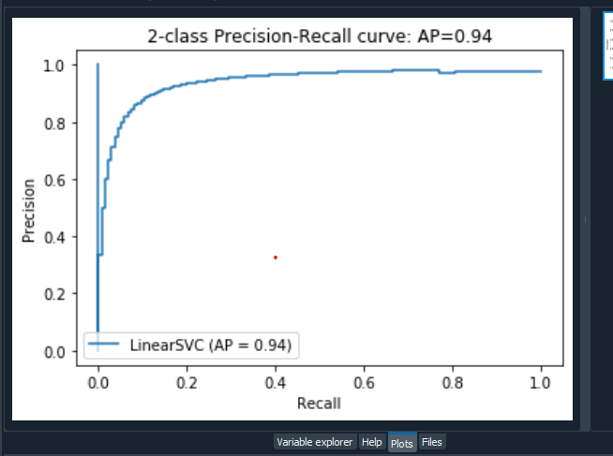

**Accelerometer mean and audio level mean:**

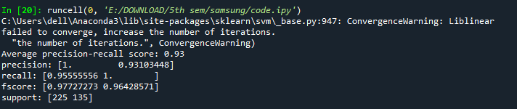

**Light sensor mean and accelerometer mean**

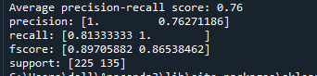

**Proximity and accelerometer mean**

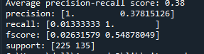

**Screen mode and accelerometer mean**

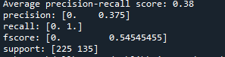

**Audio mean and light**

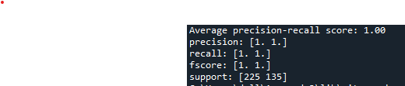

**Audio mean and proximity**

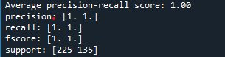

**Audio mean and screen mode**

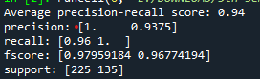

**Light mean and proximity**

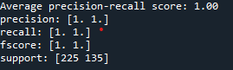

**Light mean and screen mode**

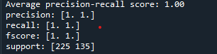

**Proximity and screen mode**

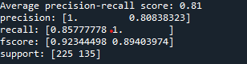

***3 feature 2 min window***

**Audio mean, accelerometer mean, light mean**

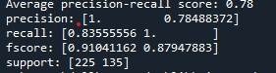

**Audio mean, accelerometer mean, proximity**

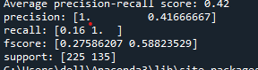

**Audio mean, accelerometer mean, screen mode**

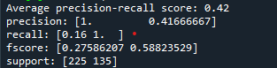

**Light mean, accelerometer mean, proximity**

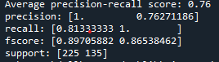

**Light mean, accelerometer mean, screen mode**

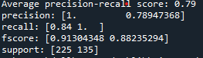

**Proximity, screen mode, accelerometer mean**

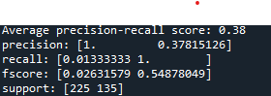

**Audio mean, proximity, light mean**

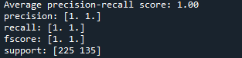

**Audio mean, light sensor mean, screen mode**

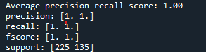

**Audio level mean, screen mode, proximity**

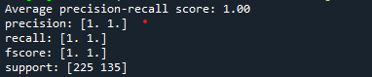

**Light sensor mean, screen, proximity**

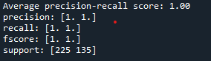

**4 feature window**

**Audio level mean, accelerometer mean, light sensor mean, proximity**

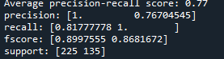

**Audio level mean, accelerometer , light , screen**

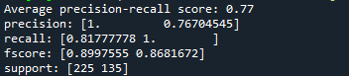

**Audio, accelerometer, proximity, screen mode**

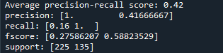

**Light, accelerometer, proximity, screen mode**

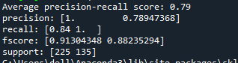

**Audio level mean, accelerometer, proximity , screen mode**

