ESI6613 Applied Data Intelligence

Project Name : Network Intrusion Detection Using Machine Learning
1. Project Description
This project develops a classification model to detect cyberattacks from network flow data. The dataset contains 429,735 samples and 79 columns (78 numerical predictors and one target variable). The target consists of 8 classes: BENIGN, DoS GoldenEye, DoS Hulk, DoS Slowhttptest, DoS slowloris, FTP Patator, Heartbleed, and SSH Patator. The objective is to evaluate multiple models and select the best one to predict attack types on unseen data.
2. Data Visualization
Descriptive statistics (mean, median, standard deviation, min, max, IQR, variance, skewness, outlier counts) were computed for all 78 numerical features to understand the distribution, scale, and spread of each variable. This step helped identify features with zero variance, detect outliers, and reveal scale differences confirming the need for standardization. It also allowed us to detect the most significant predictors highly correlated with the target variable, guiding feature selection.
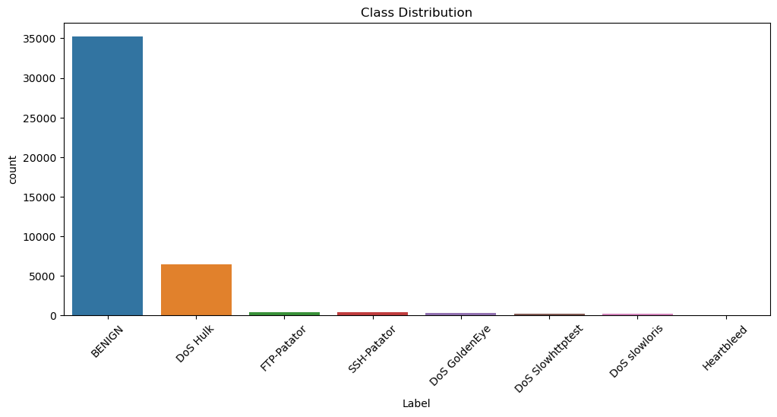
2.1 Class Distribution

The class distribution reveals a severely imbalanced dataset, with BENIGN traffic dominating at over 35,000 samples, followed by DoS Hulk at approximately 6,000. The remaining attack types have significantly fewer samples, some barely visible on the chart. This imbalance justifies the use of weighted F1 score as the primary evaluation metric

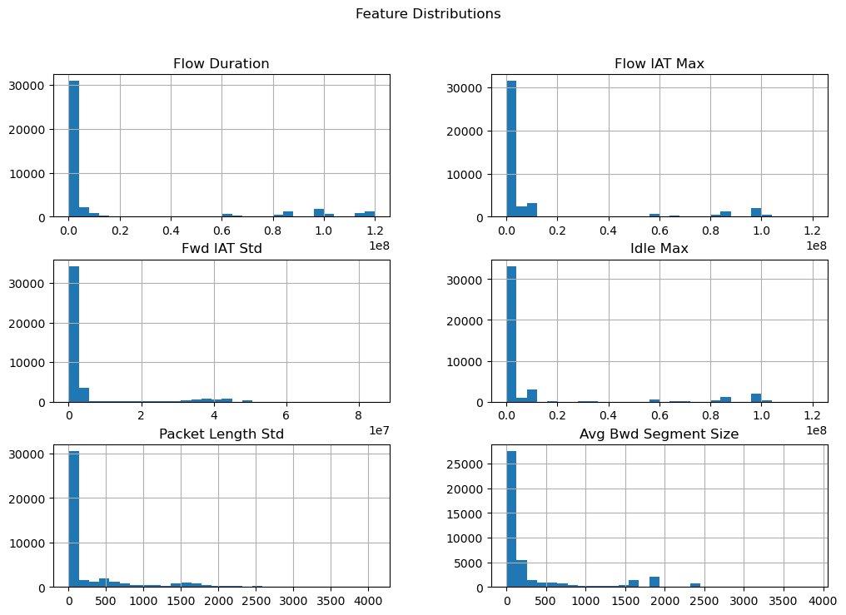
2.2 Histograms
Histograms were plotted for Flow Duration, Flow IAT Max, Fwd IAT Std, Idle Max, Packet Length Std, and Avg Bwd Segment Size. These features were selected because they showed the highest correlation with the target variable. All six exhibit heavily right skewed distributions with values concentrated near zero and long tails, indicating outliers and confirming that most flows are short while a small number produce unusually large values.

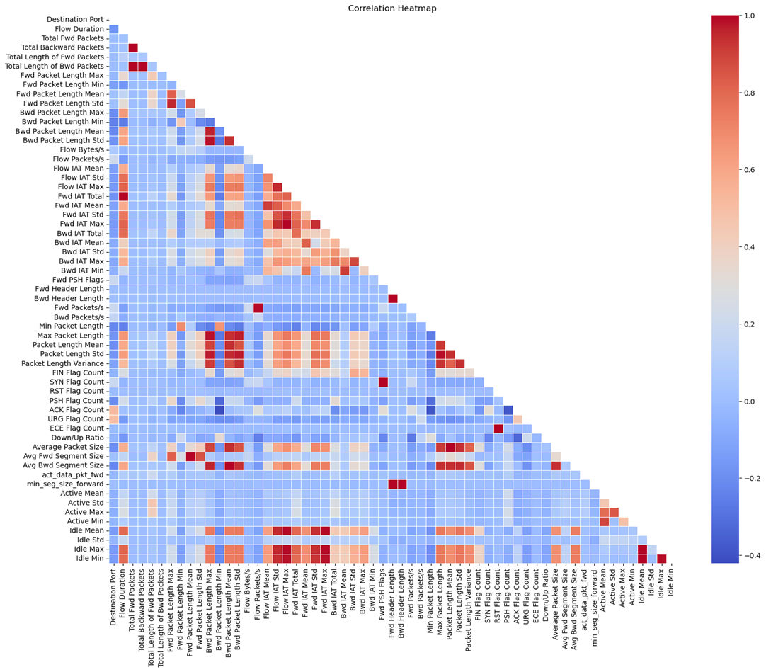
2.3 Correlation Heatmap

The heatmap reveals clusters of highly correlated features such as packet length variables and inter arrival time features. Idle Mean, Idle Max, and Idle Min are nearly perfectly correlated. These redundant feature groups informed the decision to drop duplicate columns during preprocessing to reduce multicollinearity.

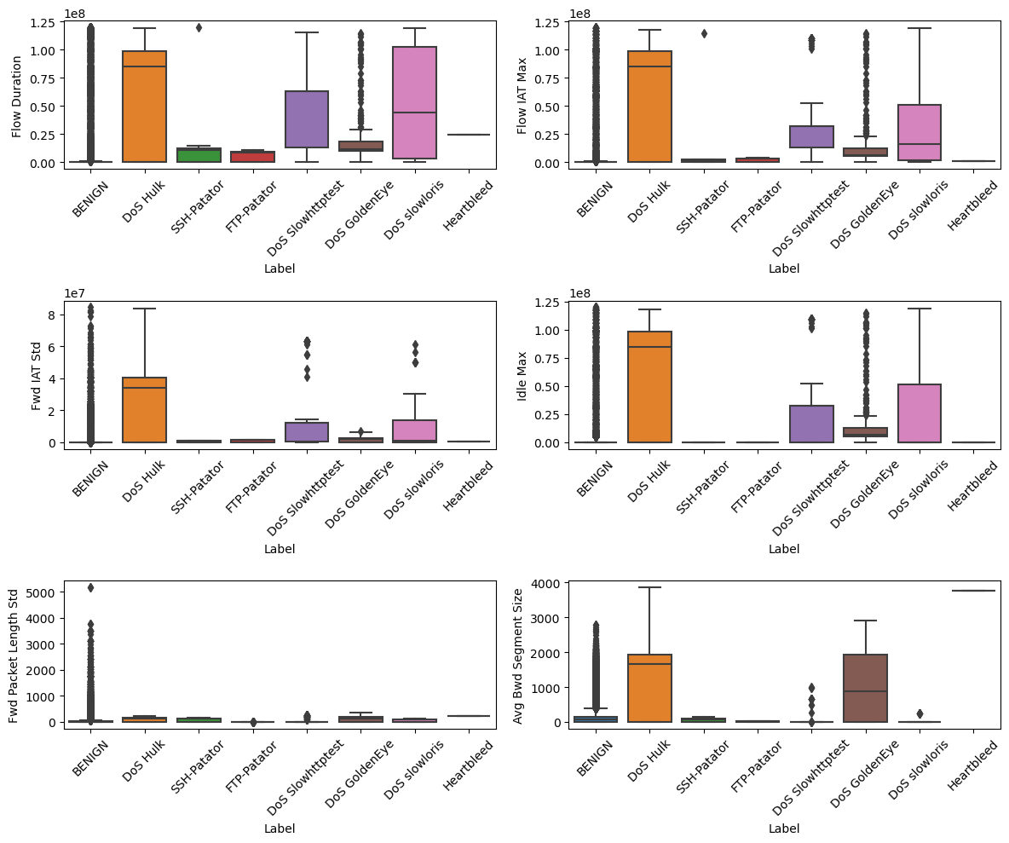
2.4 Boxplots

Box plots grouped by attack type show distinct patterns: BENIGN and DoS Hulk have the widest spread in Flow Duration, Flow IAT Max, and Idle Max, while brute force attacks (SSH Patator, FTP Patator) remain concentrated near zero. These differences confirm the discriminative power of the selected features.
3. Data Pre-Processing and Data Splitting
Column names were stripped of whitespace. 19 redundant features were dropped including duplicates (Fwd Header Length.1), zero variance columns (Bwd PSH Flags, Fwd URG Flags, Bwd URG Flags, CWE Flag Count, all bulk rate features), redundant subflow features, and highly correlated pairs (Flow IAT Min, Fwd IAT Min, Init_Win_bytes_forward, Init_Win_bytes_backward). Non numeric entries were coerced to NaN and rows with missing values were dropped. The target variable was encoded 0 through 7 using LabelEncoder. The data was split 70/30 with random_state=55. A stratified subsample of 50,000 rows was drawn from the training set to keep runtimes manageable while preserving class proportions. StandardScaler was applied for distance based and linear models (KNN, SVM, Logistic Regression, Naive Bayes). Tree based models (Random Forest, Gradient Boosting) used unscaled data as they are scale invariant.
4. Description of Models
4.1 Model Selection: Six models were evaluated spanning different algorithmic families: KNN (n_neighbors = 3, distance weighted, ball_tree), Random Forest (100 trees, max_depth = 10), Histogram Gradient Boosting (200 iterations, max_depth = 6, learning_rate = 0.1), Linear SVM (squared hinge loss), Logistic Regression (saga solver, multinomial, max_iter = 3000), and Gaussian Naive Bayes. This covers distance based, tree based, ensemble, linear, and probabilistic approaches.
4.2 Resampling Method: Stratified subsampling of 50,000 rows from the training set preserves original class proportions while significantly reducing training time for expensive models like KNN and SVM. The full 30% test set was used for evaluation.
4.3 Performance Metric: Weighted F1 score was chosen as the primary metric. It balances precision (false alarm cost) and recall (missed attack cost), weighted by class size to account for severe imbalance between BENIGN and rare attack types like Heartbleed.

5. Visual Representation of Results
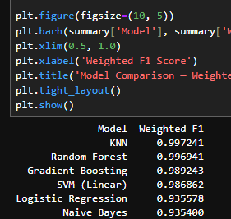
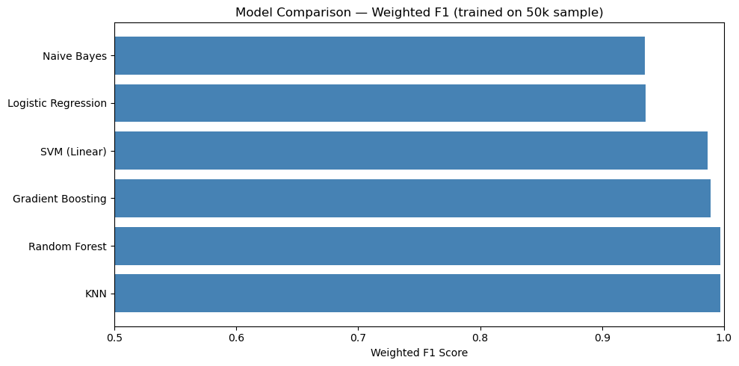
5.1 Model Comparison

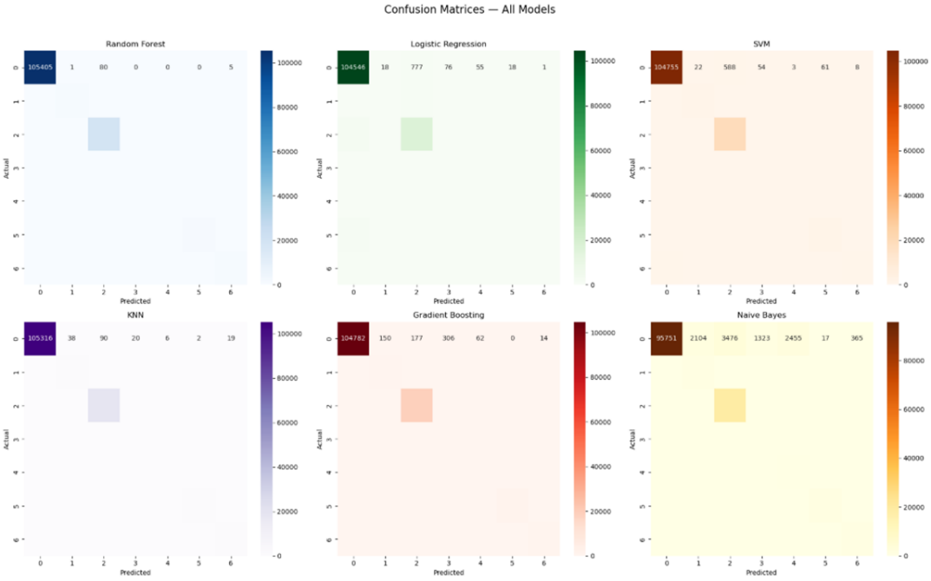
5.1 Confusion Matrices
Confusion matrices for all six models show that BENIGN and DoS Hulk are classified accurately across all models due to their large sample sizes. Minority classes (DoS Slowhttptest, DoS slowloris, Heartbleed) show more misclassifications, particularly in Logistic Regression and Naive Bayes.

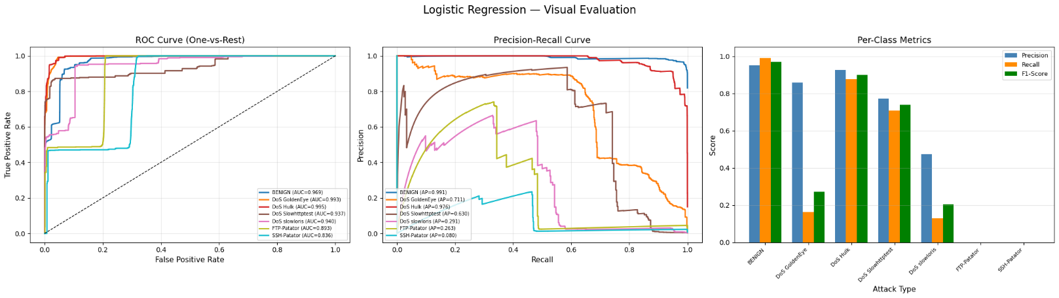
5.3 ROC Curve, Precision Recall Curve, and Per Class Metrics

ROC curves (One vs Rest) showed AUC near 1.0 for most classes, confirming strong discriminative ability with slightly lower values for minority attack types. Precision Recall curves confirmed reduced performance on rare classes where fewer training examples were available. The per class grouped bar chart identified DoS Slowhttptest, DoS slowloris, and Heartbleed as the weakest classes across precision, recall, and F1 score.

6. Conclusion
KNN achieved the highest weighted F1 score of 0.9972, making it the best performing model. This strong performance is attributed to the nature of network traffic data: similar attack types generate similar patterns in flow duration, packet lengths, and inter arrival times. KNN classifies based on proximity to known examples, and distance weighting gives closer neighbors more influence, which aligns with how network attacks form distinct clusters as confirmed by the boxplots.
Random Forest performed nearly as well (0.9969) by capturing nonlinear feature interactions through ensemble decision trees. Gradient Boosting (0.9892) and Linear SVM (0.9869) also performed strongly, though SVM's linear kernel limits its capacity for complex decision boundaries.
Logistic Regression and Naive Bayes ranked lowest at approximately 0.93. Logistic Regression assumes linear separability, which does not hold for this data. Naive Bayes suffers from its feature independence assumption, violated here as features like forward and backward packet lengths are correlated, as shown in the heatmap.
All models struggled with minority classes due to severe class imbalance. KNN was retrained on the full training set and predictions were exported in CSV format.

