Assignment 2: Writeup

Kyle Kurkela

11/12/2020

## Descriptive Statistics

The PISA data had observations from 4997 Russian students from 184 schools. Each school contributed, on average, 27.16 students with a standard deviation of 9.45. The number of students per school ranged from 1 to 35, with the half of schools contributing more than 31 students. See Figure 1 for a histogram of the distribution the number of students per school. Descriptive statistics for the following variables of interest are summarised in Table 1: Math interest, Math utility, Math confidence, Cognitive learning strategy, and Metacognitive learning strategy.

## Modeling

Three different models were run to investigate the effect of Math interest, Math utility, and Math confidence on Metacognitive learning strategy: Model 1: a model with a random intercept and fixed effects, Model 2: a model with a random intercept and random slopes for Math utility and Math confidence, and Model 3: a model with random intercept and random slopes for Math utility and math confidence nested within schools using a variance component covariance structure (see Table 2).

Models 1, 2, and 3 all revelaed similar effects of …

## Figures

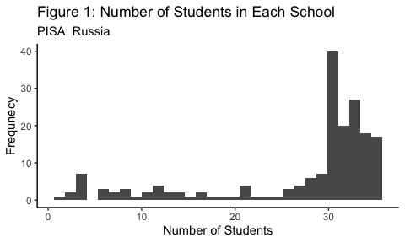

## Tables