**INTRODUCTION**

The portal is based on Flask (Python Web Framework ) and as backend on MongoDB.

**Framework :Flask( Python)**

**Database : MongoDB.**

The portal is about handling visiting users.

**About Database**

The documents of MongoDB contain various fields like uid, name, company name, address & phone number.

**Screenshots**

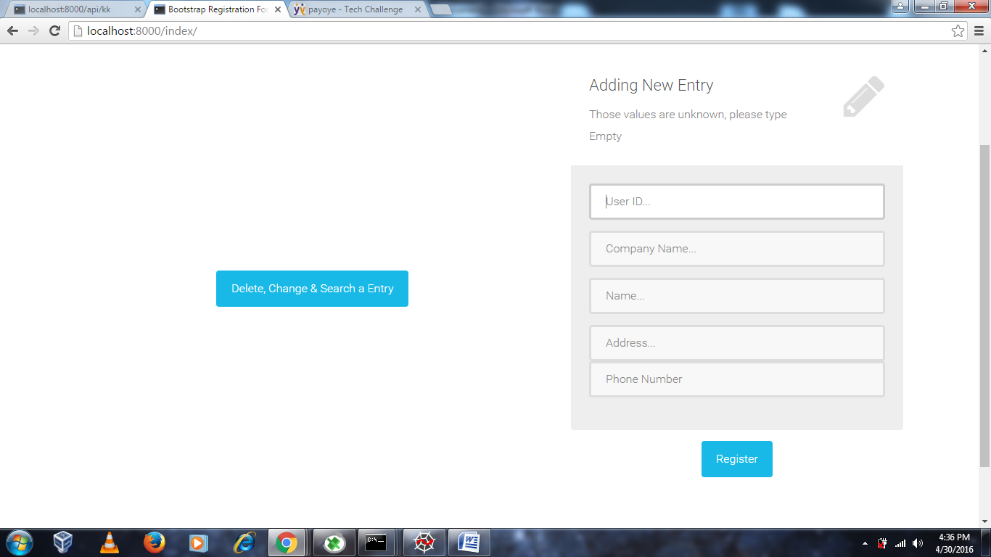

This screenshot is about adding new entries.

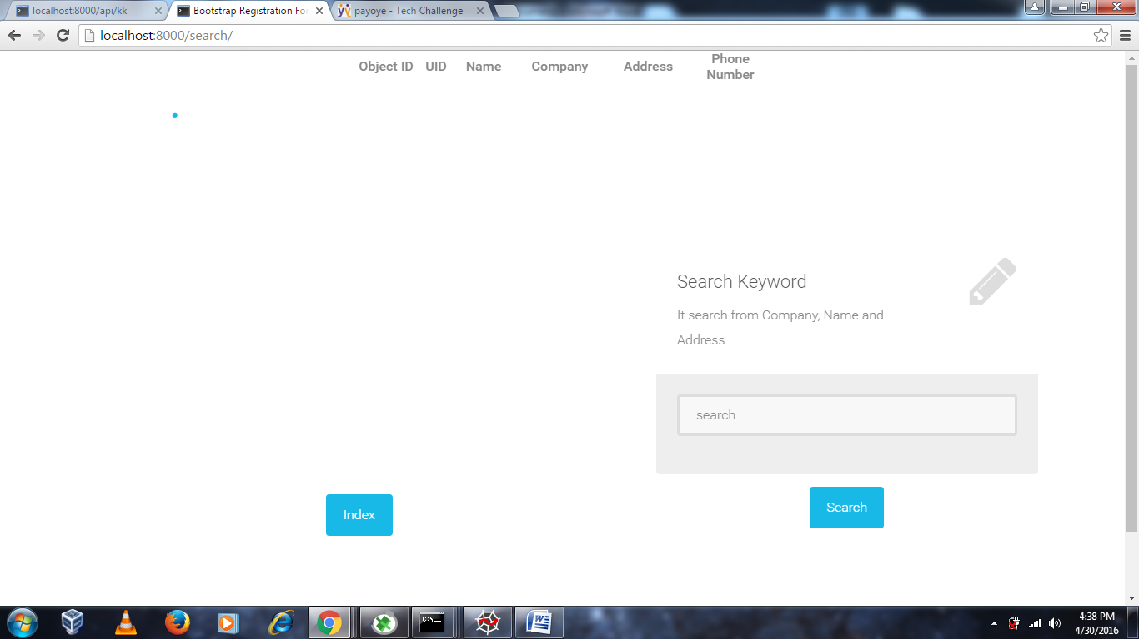

This screenshot about searching the keyword, the search query search from company, name and Address.

The search query use regex so it also can search from partial exact keywords.



Search query in MongoDB.

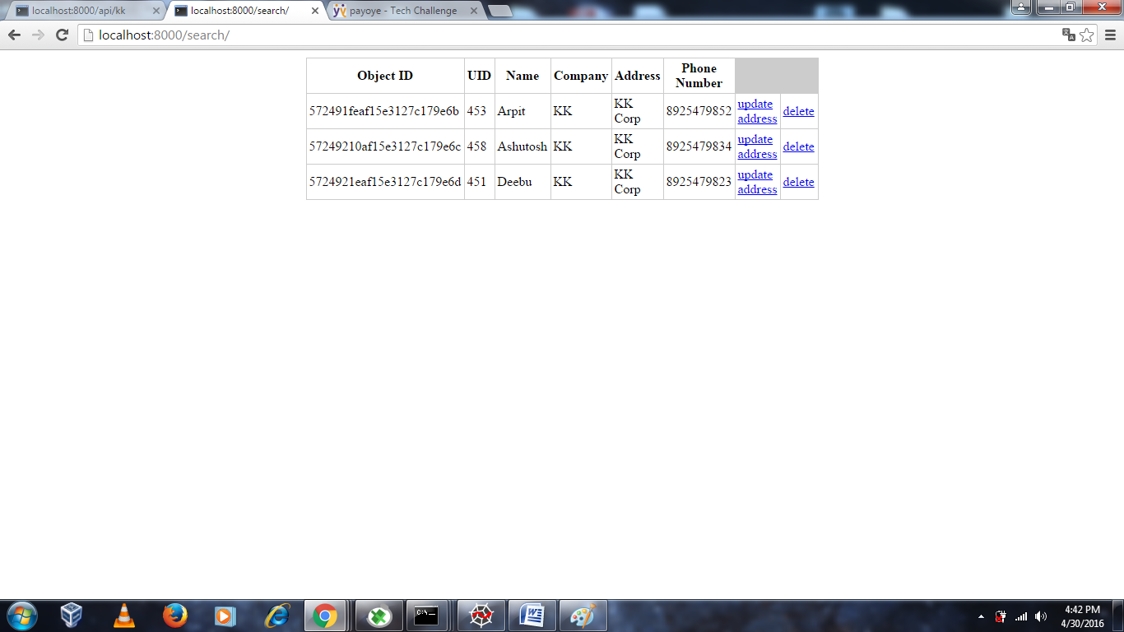

The above search query is result of “KK” that searched from company field. From there we can delete or change the address from a field.

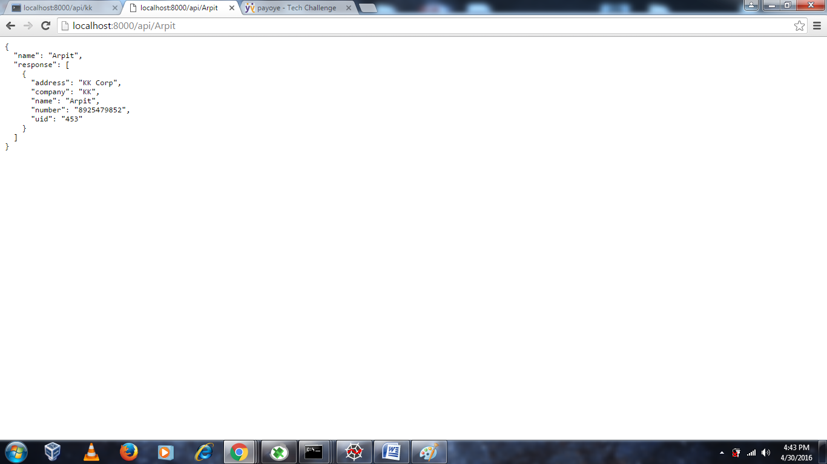

The above page is about Restful-API, I used Flask Restful to built a simple RESTful API

. In this we can get the data by adding name of any person. And it return the data in JSON.