Apartments.com scrape

**Website URL:** <https://www.apartments.com/atlanta-ga/min-1-bedrooms/7/?bb=mg1r966uiI254_-noC>

**What you would like to scrape:** We want to scrape all United States listings on apartments.com.

**Frequency:** Daily

Apartments.com contains listings for residential spaces for rent in the United States. We want to scrape all listed buildings on the site, and metadata about each listing.

Some listings will have more metadata for others… if a listing doesn’t have some of the metadata listed below, that attribute of the listing can be left blank.

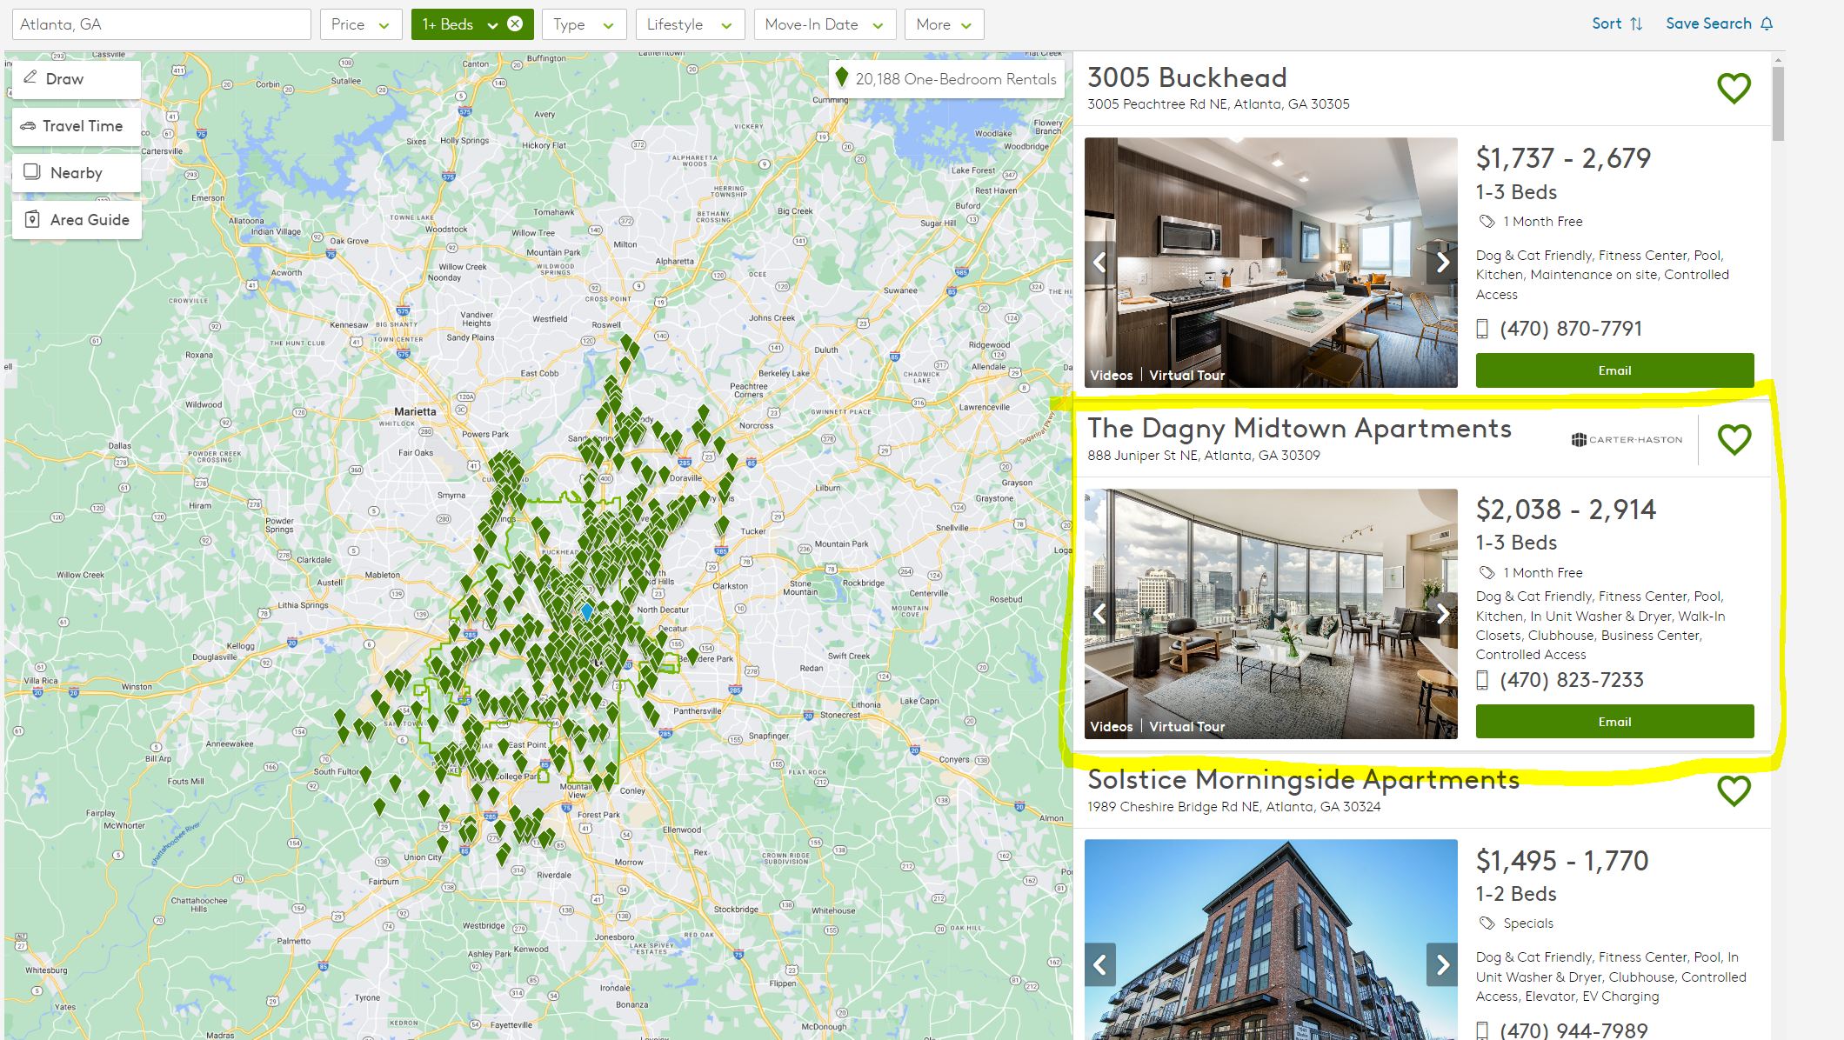

The intended schema is outlined below – and the top listing on the above page is included as an example.

|  |  |  |  |
| --- | --- | --- | --- |
| **Column name** | **Example value** | **Notes** | **Type** |
| SCRAPE_TIME | 2024-01-01 1:00 PM EST | The time the scrape takes place | Datetime |
| REQUEST_TIME | 2022-09-01 1:01 PM EST | When the actual request takes place | Datetime |
| LISTING_NAME | The Dagny Midtown Apartments | Title of the listing or building | String |
| LISTING_LINK | https://www.apartments.com/the-dagny-midtown-apartments-atlanta-ga/pfsrw7t/ | Hyperlink attached to the listing | String |
| LISTING_USE | Office | Office or medical | String |
| LISTING_ADDRESS | 888 Juniper St NE, Atlanta, GA 30309 | Location of listing | String |
| LISTING_DESCRIPTION | “Dog & Cat Friendly, Fitness Center, Pool, Kitchen, In Unit Washer & Dryer, Walk-In Closets, Clubhouse, Business Center, Controlled Access | Advertising description, if available (if not available, null) | String |
| HAS_VIDEOS | TRUE | TRUE if the listing has videos attached (this will show up as text “Videos” on the bottom left of the listing) | String |
| HAS_VIRTUAL_TOUR | TRUE | TRUE if the listing has a virtual tour attached (this will show up as text “Virtual Tour” on the bottom left of the listing) | String |
| HAS_EMAIL | TRUE | TRUE if the listing has a button to email agent (this is the big green button at the bottom of the listing) | String |
| PRICE | $2,038 – 2,914 | Price range of units in listing, if avaialbe | String |
| PHONE_NUMBER | (470) 823-7233 | Phone number displayed on the listing, if available |  |
| HAS_IMAGE | TRUE | TRUE if the listing has at least one image displayed |  |
| SPECIALS_TEXT | 1 Month Free | Text containing specials for the listing (this will look like “1 month free” or “Specials”). If there are no specials in the listing, this will be blank |  |