# Project Design Phase Solution Architecture

|  |  |
| --- | --- |
| Date | 30June2025 |
| TeamID | LTVIP2025TMID46415 |
| ProjectName | Enchanted wings: marvels of butterfly species |
| MaximumMarks | 4 Marks |

**Solution Architecture:**

Solutionarchitectureisacomplexprocess–withmanysub-processes–thatbridges the gap between business problems and technology solutions. Its goals are to:

* Find the best tech solution to solve existing business problems.
* Describethestructure,characteristics,behavior,andotheraspectsofthe software to project stakeholders.
* Define features, development phases, and solution requirements.
* Providespecificationsaccordingtowhichthesolutionisdefined,managed, and delivered.

# Example - Solution Architecture Diagram:

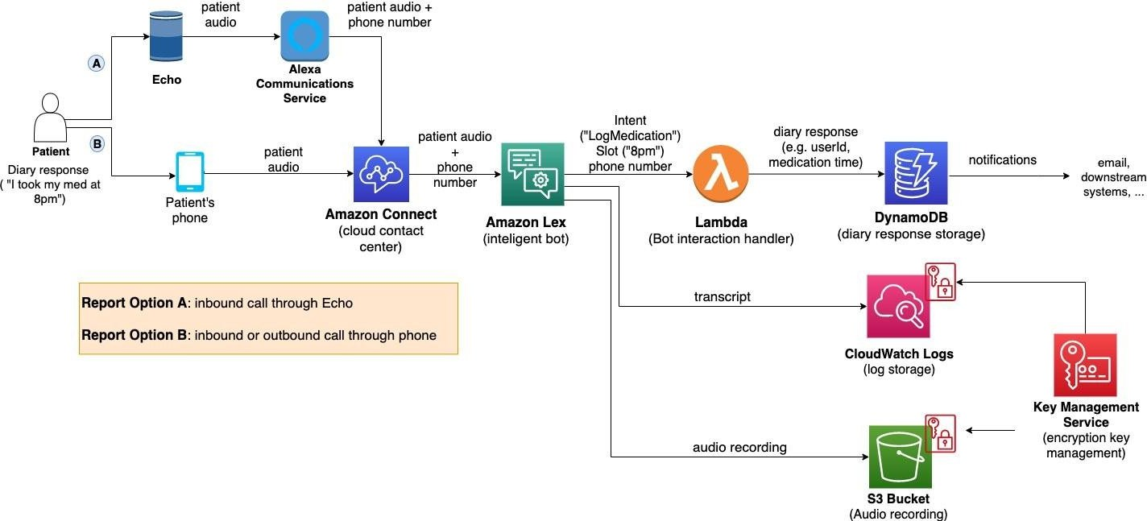

*Figure1:Architectureanddataflowofthevoicepatientdiarysampleapplication*

**Reference:**

**<https://aws.amazon.com/blogs/industries/voice-applications-in-clinical-research-powered-by-ai-on-aws-part-1-architecture-and-design-considerations/>**