R Notebook

# Question 1

The histogram below has a normal distribution.

sample_mean <- rep(0,10000) #Create a vector with 5000 elements, all equal to 0  
  
for(experiment in 1:10000){  
 sample_data <- rnorm(10,mean=0,sd=1) #Draw 10 numbers from a Normal(0,1) distribution   
 sample_mean[experiment] <- mean(sample_data) #Calculate and store the mean  
}  
  
hist(sample_mean,breaks = 100, freq=FALSE) #Plot the histogram

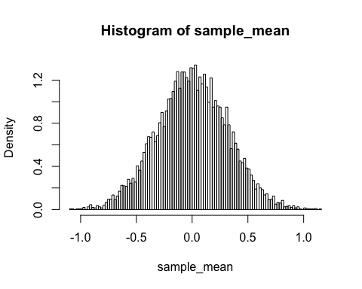 #Question 2 The histogram below has shrunk in its sample mean distribution by becoming closer to zero and increased in denstiy.

sample_mean <- rep(0,10000) #Create a vector with 5000 elements, all equal to 0  
  
for(experiment in 1:10000){  
 sample_data <- rnorm(100,mean=0,sd=1) #Draw 100 numbers from a Normal(0,1) distribution   
 sample_mean[experiment] <- mean(sample_data) #Calculate and store the mean  
}  
  
hist(sample_mean,breaks = 100, freq=FALSE) #Plot the histogram

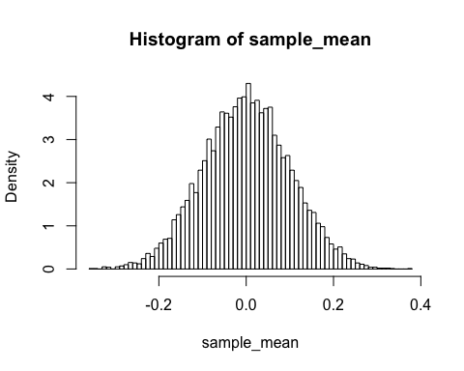 #Question 3 Compared to the graph on question 2 this graph has gotten even closer to zero while keeping its normal distribution and increasing its density, and even more so than question 1's graph.

sample_mean <- rep(0,10000) #Create a vector with 5000 elements, all equal to 0  
  
for(experiment in 1:10000){  
 sample_data <- rnorm(1000,mean=0,sd=1) #Draw 100 numbers from a Normal(0,1) distribution   
 sample_mean[experiment] <- mean(sample_data) #Calculate and store the mean  
}  
  
hist(sample_mean,breaks = 100, freq=FALSE) #Plot the histogram

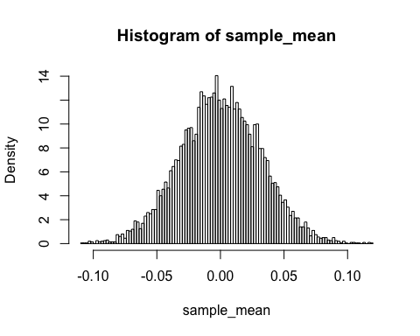

# Question 3

The histogram below with expoential distribution of 10 random numbers is right skewed.

sample_mean <- rep(0,10000) #Create a vector with 5000 elements, all equal to 0  
  
for(experiment in 1:10000){  
 sample_data <- rexp(10, rate = 1) #Draw 10 numbers from a exponential distribution   
 sample_mean[experiment] <- mean(sample_data) #Calculate and store the mean  
}  
  
hist(sample_mean,breaks = 100, freq=FALSE) #Plot the histogram

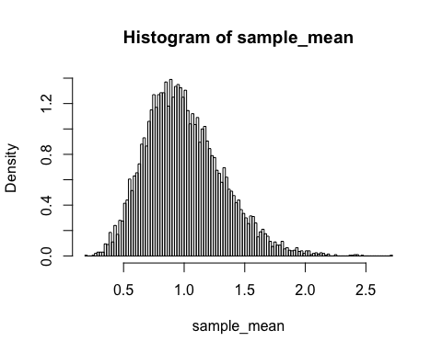 The histogram below is shown to have increased density due to increasing the amount of numbers drawn. It also seems to be shifting to a more normal distribution.

sample_mean <- rep(0,10000) #Create a vector with 5000 elements, all equal to 0  
  
for(experiment in 1:10000){  
 sample_data <- rexp(100, rate = 1) #Draw 100 numbers from a exponential distribution   
 sample_mean[experiment] <- mean(sample_data) #Calculate and store the mean  
}  
  
hist(sample_mean,breaks = 100, freq=FALSE) #Plot the histogram

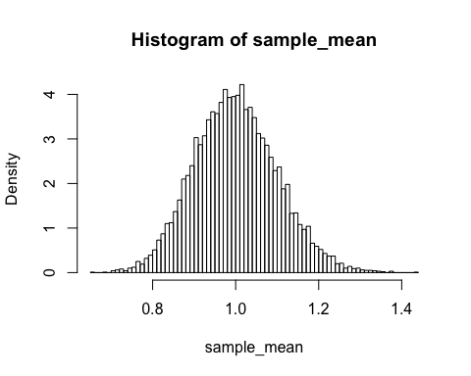

The histogram below has a normal distribution since the number of draws is 1000 with an exponenetial distribution.

sample_mean <- rep(0,10000) #Create a vector with 5000 elements, all equal to 0  
  
for(experiment in 1:10000){  
 sample_data <- rexp(1000, rate = 1) #Draw 1000 numbers from a exponential distribution   
 sample_mean[experiment] <- mean(sample_data) #Calculate and store the mean  
}  
  
hist(sample_mean,breaks = 100, freq=FALSE) #Plot the histogram

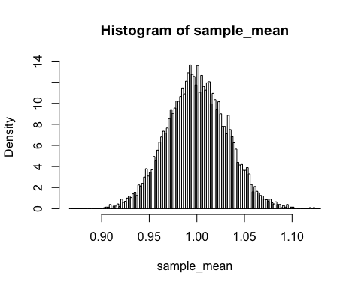

# Question 5

The graph below shows a very large denisty and the graph shows a fairly spread distribution as well since the x axis is shown as a scale from about -10,000 to 30,000.

sample_mean <- rep(0,10000) #Create a vector with 5000 elements, all equal to 0  
  
for(experiment in 1:10000){  
 sample_data <- rcauchy(10, location = 0, scale = 1) #Draw 10 numbers from a cauchy distribution   
 sample_mean[experiment] <- mean(sample_data) #Calculate and store the mean  
}  
  
hist(sample_mean,breaks = 100, freq=FALSE) #Plot the histogram

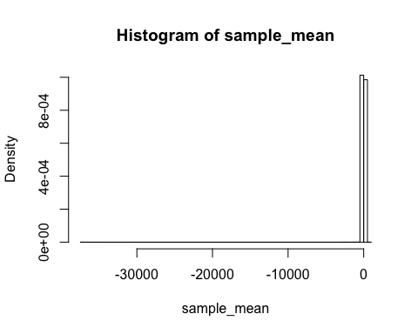

The graph below shows the histogram with a very small denisty in comparison to previous graphs and a fairly spread distribtion along the x-axis.

sample_mean <- rep(0,10000) #Create a vector with 5000 elements, all equal to 0  
  
for(experiment in 1:10000){  
 sample_data <- rcauchy(100, location = 0, scale = 1) #Draw 100 numbers from a cauchy distribution   
 sample_mean[experiment] <- mean(sample_data) #Calculate and store the mean  
}  
  
hist(sample_mean,breaks = 100, freq=FALSE) #Plot the histogram

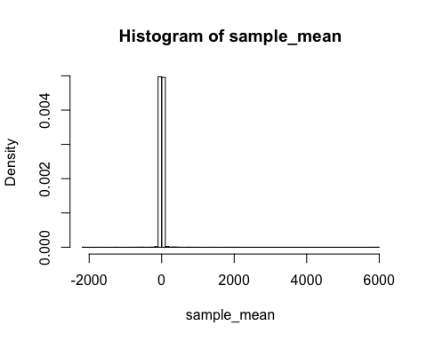

The histogram below is similiar to the previous one except it has a smaller distribtution spread on the axis due to picking more random numbers in the cauchy distribution.

sample_mean <- rep(0,10000) #Create a vector with 5000 elements, all equal to 0  
  
for(experiment in 1:10000){  
 sample_data <- rcauchy(1000, location = 0, scale = 1) #Draw 1000 numbers from a cauchy distribution   
 sample_mean[experiment] <- mean(sample_data) #Calculate and store the mean  
}  
  
hist(sample_mean,breaks = 100, freq=FALSE) #Plot the histogram

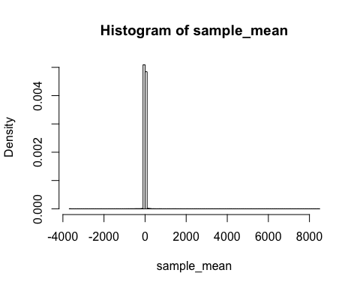 #PART B #Question 1

data("sunspots")  
sunspots

## Jan Feb Mar Apr May Jun Jul Aug Sep Oct Nov  
## 1749 58.0 62.6 70.0 55.7 85.0 83.5 94.8 66.3 75.9 75.5 158.6  
## 1750 73.3 75.9 89.2 88.3 90.0 100.0 85.4 103.0 91.2 65.7 63.3  
## 1751 70.0 43.5 45.3 56.4 60.7 50.7 66.3 59.8 23.5 23.2 28.5  
## 1752 35.0 50.0 71.0 59.3 59.7 39.6 78.4 29.3 27.1 46.6 37.6  
## 1753 44.0 32.0 45.7 38.0 36.0 31.7 22.2 39.0 28.0 25.0 20.0  
## 1754 0.0 3.0 1.7 13.7 20.7 26.7 18.8 12.3 8.2 24.1 13.2  
## 1755 10.2 11.2 6.8 6.5 0.0 0.0 8.6 3.2 17.8 23.7 6.8  
## 1756 12.5 7.1 5.4 9.4 12.5 12.9 3.6 6.4 11.8 14.3 17.0  
## 1757 14.1 21.2 26.2 30.0 38.1 12.8 25.0 51.3 39.7 32.5 64.7  
## 1758 37.6 52.0 49.0 72.3 46.4 45.0 44.0 38.7 62.5 37.7 43.0  
## 1759 48.3 44.0 46.8 47.0 49.0 50.0 51.0 71.3 77.2 59.7 46.3  
## 1760 67.3 59.5 74.7 58.3 72.0 48.3 66.0 75.6 61.3 50.6 59.7  
## 1761 70.0 91.0 80.7 71.7 107.2 99.3 94.1 91.1 100.7 88.7 89.7  
## 1762 43.8 72.8 45.7 60.2 39.9 77.1 33.8 67.7 68.5 69.3 77.8  
## 1763 56.5 31.9 34.2 32.9 32.7 35.8 54.2 26.5 68.1 46.3 60.9  
## 1764 59.7 59.7 40.2 34.4 44.3 30.0 30.0 30.0 28.2 28.0 26.0  
## 1765 24.0 26.0 25.0 22.0 20.2 20.0 27.0 29.7 16.0 14.0 14.0  
## 1766 12.0 11.0 36.6 6.0 26.8 3.0 3.3 4.0 4.3 5.0 5.7  
## 1767 27.4 30.0 43.0 32.9 29.8 33.3 21.9 40.8 42.7 44.1 54.7  
## 1768 53.5 66.1 46.3 42.7 77.7 77.4 52.6 66.8 74.8 77.8 90.6  
## 1769 73.9 64.2 64.3 96.7 73.6 94.4 118.6 120.3 148.8 158.2 148.1  
## 1770 104.0 142.5 80.1 51.0 70.1 83.3 109.8 126.3 104.4 103.6 132.2  
## 1771 36.0 46.2 46.7 64.9 152.7 119.5 67.7 58.5 101.4 90.0 99.7  
## 1772 100.9 90.8 31.1 92.2 38.0 57.0 77.3 56.2 50.5 78.6 61.3  
## 1773 54.6 29.0 51.2 32.9 41.1 28.4 27.7 12.7 29.3 26.3 40.9  
## 1774 46.8 65.4 55.7 43.8 51.3 28.5 17.5 6.6 7.9 14.0 17.7  
## 1775 4.4 0.0 11.6 11.2 3.9 12.3 1.0 7.9 3.2 5.6 15.1  
## 1776 21.7 11.6 6.3 21.8 11.2 19.0 1.0 24.2 16.0 30.0 35.0  
## 1777 45.0 36.5 39.0 95.5 80.3 80.7 95.0 112.0 116.2 106.5 146.0  
## 1778 177.3 109.3 134.0 145.0 238.9 171.6 153.0 140.0 171.7 156.3 150.3  
## 1779 114.7 165.7 118.0 145.0 140.0 113.7 143.0 112.0 111.0 124.0 114.0  
## 1780 70.0 98.0 98.0 95.0 107.2 88.0 86.0 86.0 93.7 77.0 60.0  
## 1781 98.7 74.7 53.0 68.3 104.7 97.7 73.5 66.0 51.0 27.3 67.0  
## 1782 54.0 37.5 37.0 41.0 54.3 38.0 37.0 44.0 34.0 23.2 31.5  
## 1783 28.0 38.7 26.7 28.3 23.0 25.2 32.2 20.0 18.0 8.0 15.0  
## 1784 13.0 8.0 11.0 10.0 6.0 9.0 6.0 10.0 10.0 8.0 17.0  
## 1785 6.5 8.0 9.0 15.7 20.7 26.3 36.3 20.0 32.0 47.2 40.2  
## 1786 37.2 47.6 47.7 85.4 92.3 59.0 83.0 89.7 111.5 112.3 116.0  
## 1787 134.7 106.0 87.4 127.2 134.8 99.2 128.0 137.2 157.3 157.0 141.5  
## 1788 138.0 129.2 143.3 108.5 113.0 154.2 141.5 136.0 141.0 142.0 94.7  
## 1789 114.0 125.3 120.0 123.3 123.5 120.0 117.0 103.0 112.0 89.7 134.0  
## 1790 103.0 127.5 96.3 94.0 93.0 91.0 69.3 87.0 77.3 84.3 82.0  
## 1791 72.7 62.0 74.0 77.2 73.7 64.2 71.0 43.0 66.5 61.7 67.0  
## 1792 58.0 64.0 63.0 75.7 62.0 61.0 45.8 60.0 59.0 59.0 57.0  
## 1793 56.0 55.0 55.5 53.0 52.3 51.0 50.0 29.3 24.0 47.0 44.0  
## 1794 45.0 44.0 38.0 28.4 55.7 41.5 41.0 40.0 11.1 28.5 67.4  
## 1795 21.4 39.9 12.6 18.6 31.0 17.1 12.9 25.7 13.5 19.5 25.0  
## 1796 22.0 23.8 15.7 31.7 21.0 6.7 26.9 1.5 18.4 11.0 8.4  
## 1797 14.4 4.2 4.0 4.0 7.3 11.1 4.3 6.0 5.7 6.9 5.8  
## 1798 2.0 4.0 12.4 1.1 0.0 0.0 0.0 3.0 2.4 1.5 12.5  
## 1799 1.6 12.6 21.7 8.4 8.2 10.6 2.1 0.0 0.0 4.6 2.7  
## 1800 6.9 9.3 13.9 0.0 5.0 23.7 21.0 19.5 11.5 12.3 10.5  
## 1801 27.0 29.0 30.0 31.0 32.0 31.2 35.0 38.7 33.5 32.6 39.8  
## 1802 47.8 47.0 40.8 42.0 44.0 46.0 48.0 50.0 51.8 38.5 34.5  
## 1803 50.0 50.8 29.5 25.0 44.3 36.0 48.3 34.1 45.3 54.3 51.0  
## 1804 45.3 48.3 48.0 50.6 33.4 34.8 29.8 43.1 53.0 62.3 61.0  
## 1805 61.0 44.1 51.4 37.5 39.0 40.5 37.6 42.7 44.4 29.4 41.0  
## 1806 39.0 29.6 32.7 27.7 26.4 25.6 30.0 26.3 24.0 27.0 25.0  
## 1807 12.0 12.2 9.6 23.8 10.0 12.0 12.7 12.0 5.7 8.0 2.6  
## 1808 0.0 4.5 0.0 12.3 13.5 13.5 6.7 8.0 11.7 4.7 10.5  
## 1809 7.2 9.2 0.9 2.5 2.0 7.7 0.3 0.2 0.4 0.0 0.0  
## 1810 0.0 0.0 0.0 0.0 0.0 0.0 0.0 0.0 0.0 0.0 0.0  
## 1811 0.0 0.0 0.0 0.0 0.0 0.0 6.6 0.0 2.4 6.1 0.8  
## 1812 11.3 1.9 0.7 0.0 1.0 1.3 0.5 15.6 5.2 3.9 7.9  
## 1813 0.0 10.3 1.9 16.6 5.5 11.2 18.3 8.4 15.3 27.8 16.7  
## 1814 22.2 12.0 5.7 23.8 5.8 14.9 18.5 2.3 8.1 19.3 14.5  
## 1815 19.2 32.2 26.2 31.6 9.8 55.9 35.5 47.2 31.5 33.5 37.2  
## 1816 26.3 68.8 73.7 58.8 44.3 43.6 38.8 23.2 47.8 56.4 38.1  
## 1817 36.4 57.9 96.2 26.4 21.2 40.0 50.0 45.0 36.7 25.6 28.9  
## 1818 34.9 22.4 25.4 34.5 53.1 36.4 28.0 31.5 26.1 31.7 10.9  
## 1819 32.5 20.7 3.7 20.2 19.6 35.0 31.4 26.1 14.9 27.5 25.1  
## 1820 19.2 26.6 4.5 19.4 29.3 10.8 20.6 25.9 5.2 9.0 7.9  
## 1821 21.5 4.3 5.7 9.2 1.7 1.8 2.5 4.8 4.4 18.8 4.4  
## 1822 0.0 0.9 16.1 13.5 1.5 5.6 7.9 2.1 0.0 0.4 0.0  
## 1823 0.0 0.0 0.6 0.0 0.0 0.0 0.5 0.0 0.0 0.0 0.0  
## 1824 21.6 10.8 0.0 19.4 2.8 0.0 0.0 1.4 20.5 25.2 0.0  
## 1825 5.0 15.5 22.4 3.8 15.4 15.4 30.9 25.4 15.7 15.6 11.7  
## 1826 17.7 18.2 36.7 24.0 32.4 37.1 52.5 39.6 18.9 50.6 39.5  
## 1827 34.6 47.4 57.8 46.0 56.3 56.7 42.9 53.7 49.6 57.2 48.2  
## 1828 52.8 64.4 65.0 61.1 89.1 98.0 54.3 76.4 50.4 54.7 57.0  
## 1829 43.0 49.4 72.3 95.0 67.5 73.9 90.8 78.3 52.8 57.2 67.6  
## 1830 52.2 72.1 84.6 107.1 66.3 65.1 43.9 50.7 62.1 84.4 81.2  
## 1831 47.5 50.1 93.4 54.6 38.1 33.4 45.2 54.9 37.9 46.2 43.5  
## 1832 30.9 55.5 55.1 26.9 41.3 26.7 13.9 8.9 8.2 21.1 14.3  
## 1833 11.3 14.9 11.8 2.8 12.9 1.0 7.0 5.7 11.6 7.5 5.9  
## 1834 4.9 18.1 3.9 1.4 8.8 7.8 8.7 4.0 11.5 24.8 30.5  
## 1835 7.5 24.5 19.7 61.5 43.6 33.2 59.8 59.0 100.8 95.2 100.0  
## 1836 88.6 107.6 98.1 142.9 111.4 124.7 116.7 107.8 95.1 137.4 120.9  
## 1837 188.0 175.6 134.6 138.2 111.3 158.0 162.8 134.0 96.3 123.7 107.0  
## 1838 144.9 84.8 140.8 126.6 137.6 94.5 108.2 78.8 73.6 90.8 77.4  
## 1839 107.6 102.5 77.7 61.8 53.8 54.6 84.7 131.2 132.7 90.8 68.8  
## 1840 81.2 87.7 55.5 65.9 69.2 48.5 60.7 57.8 74.0 49.8 54.3  
## 1841 24.0 29.9 29.7 42.6 67.4 55.7 30.8 39.3 35.1 28.5 19.8  
## 1842 20.4 22.1 21.7 26.9 24.9 20.5 12.6 26.5 18.5 38.1 40.5  
## 1843 13.3 3.5 8.3 8.8 21.1 10.5 9.5 11.8 4.2 5.3 19.1  
## 1844 9.4 14.7 13.6 20.8 12.0 3.7 21.2 23.9 6.9 21.5 10.7  
## 1845 25.7 43.6 43.3 56.9 47.8 31.1 30.6 32.3 29.6 40.7 39.4  
## 1846 38.7 51.0 63.9 69.2 59.9 65.1 46.5 54.8 107.1 55.9 60.4  
## 1847 62.6 44.9 85.7 44.7 75.4 85.3 52.2 140.6 161.2 180.4 138.9  
## 1848 159.1 111.8 108.9 107.1 102.2 123.8 139.2 132.5 100.3 132.4 114.6  
## 1849 156.7 131.7 96.5 102.5 80.6 81.2 78.0 61.3 93.7 71.5 99.7  
## 1850 78.0 89.4 82.6 44.1 61.6 70.0 39.1 61.6 86.2 71.0 54.8  
## 1851 75.5 105.4 64.6 56.5 62.6 63.2 36.1 57.4 67.9 62.5 50.9  
## 1852 68.4 67.5 61.2 65.4 54.9 46.9 42.0 39.7 37.5 67.3 54.3  
## 1853 41.1 42.9 37.7 47.6 34.7 40.0 45.9 50.4 33.5 42.3 28.8  
## 1854 15.4 20.0 20.7 26.4 24.0 21.1 18.7 15.8 22.4 12.7 28.2  
## 1855 12.3 11.4 17.4 4.4 9.1 5.3 0.4 3.1 0.0 9.7 4.3  
## 1856 0.5 4.9 0.4 6.5 0.0 5.0 4.6 5.9 4.4 4.5 7.7  
## 1857 13.7 7.4 5.2 11.1 29.2 16.0 22.2 16.9 42.4 40.6 31.4  
## 1858 39.0 34.9 57.5 38.3 41.4 44.5 56.7 55.3 80.1 91.2 51.9  
## 1859 83.7 87.6 90.3 85.7 91.0 87.1 95.2 106.8 105.8 114.6 97.2  
## 1860 81.5 88.0 98.9 71.4 107.1 108.6 116.7 100.3 92.2 90.1 97.9  
## 1861 62.3 77.8 101.0 98.5 56.8 87.8 78.0 82.5 79.9 67.2 53.7  
## 1862 63.1 64.5 43.6 53.7 64.4 84.0 73.4 62.5 66.6 42.0 50.6  
## 1863 48.3 56.7 66.4 40.6 53.8 40.8 32.7 48.1 22.0 39.9 37.7  
## 1864 57.7 47.1 66.3 35.8 40.6 57.8 54.7 54.8 28.5 33.9 57.6  
## 1865 48.7 39.3 39.5 29.4 34.5 33.6 26.8 37.8 21.6 17.1 24.6  
## 1866 31.6 38.4 24.6 17.6 12.9 16.5 9.3 12.7 7.3 14.1 9.0  
## 1867 0.0 0.7 9.2 5.1 2.9 1.5 5.0 4.9 9.8 13.5 9.3  
## 1868 15.6 15.8 26.5 36.6 26.7 31.1 28.6 34.4 43.8 61.7 59.1  
## 1869 60.9 59.3 52.7 41.0 104.0 108.4 59.2 79.6 80.6 59.4 77.4  
## 1870 77.3 114.9 159.4 160.0 176.0 135.6 132.4 153.8 136.0 146.4 147.5  
## 1871 88.3 125.3 143.2 162.4 145.5 91.7 103.0 110.0 80.3 89.0 105.4  
## 1872 79.5 120.1 88.4 102.1 107.6 109.9 105.5 92.9 114.6 103.5 112.0  
## 1873 86.7 107.0 98.3 76.2 47.9 44.8 66.9 68.2 47.5 47.4 55.4  
## 1874 60.8 64.2 46.4 32.0 44.6 38.2 67.8 61.3 28.0 34.3 28.9  
## 1875 14.6 22.2 33.8 29.1 11.5 23.9 12.5 14.6 2.4 12.7 17.7  
## 1876 14.3 15.0 31.2 2.3 5.1 1.6 15.2 8.8 9.9 14.3 9.9  
## 1877 24.4 8.7 11.7 15.8 21.2 13.4 5.9 6.3 16.4 6.7 14.5  
## 1878 3.3 6.0 7.8 0.1 5.8 6.4 0.1 0.0 5.3 1.1 4.1  
## 1879 0.8 0.6 0.0 6.2 2.4 4.8 7.5 10.7 6.1 12.3 12.9  
## 1880 24.0 27.5 19.5 19.3 23.5 34.1 21.9 48.1 66.0 43.0 30.7  
## 1881 36.4 53.2 51.5 51.7 43.5 60.5 76.9 58.0 53.2 64.0 54.8  
## 1882 45.0 69.3 67.5 95.8 64.1 45.2 45.4 40.4 57.7 59.2 84.4  
## 1883 60.6 46.9 42.8 82.1 32.1 76.5 80.6 46.0 52.6 83.8 84.5  
## 1884 91.5 86.9 86.8 76.1 66.5 51.2 53.1 55.8 61.9 47.8 36.6  
## 1885 42.8 71.8 49.8 55.0 73.0 83.7 66.5 50.0 39.6 38.7 33.3  
## 1886 29.9 25.9 57.3 43.7 30.7 27.1 30.3 16.9 21.4 8.6 0.3  
## 1887 10.3 13.2 4.2 6.9 20.0 15.7 23.3 21.4 7.4 6.6 6.9  
## 1888 12.7 7.1 7.8 5.1 7.0 7.1 3.1 2.8 8.8 2.1 10.7  
## 1889 0.8 8.5 7.0 4.3 2.4 6.4 9.7 20.6 6.5 2.1 0.2  
## 1890 5.3 0.6 5.1 1.6 4.8 1.3 11.6 8.5 17.2 11.2 9.6  
## 1891 13.5 22.2 10.4 20.5 41.1 48.3 58.8 33.2 53.8 51.5 41.9  
## 1892 69.1 75.6 49.9 69.6 79.6 76.3 76.8 101.4 62.8 70.5 65.4  
## 1893 75.0 73.0 65.7 88.1 84.7 88.2 88.8 129.2 77.9 79.7 75.1  
## 1894 83.2 84.6 52.3 81.6 101.2 98.9 106.0 70.3 65.9 75.5 56.6  
## 1895 63.3 67.2 61.0 76.9 67.5 71.5 47.8 68.9 57.7 67.9 47.2  
## 1896 29.0 57.4 52.0 43.8 27.7 49.0 45.0 27.2 61.3 28.4 38.0  
## 1897 40.6 29.4 29.1 31.0 20.0 11.3 27.6 21.8 48.1 14.3 8.4  
## 1898 30.2 36.4 38.3 14.5 25.8 22.3 9.0 31.4 34.8 34.4 30.9  
## 1899 19.5 9.2 18.1 14.2 7.7 20.5 13.5 2.9 8.4 13.0 7.8  
## 1900 9.4 13.6 8.6 16.0 15.2 12.1 8.3 4.3 8.3 12.9 4.5  
## 1901 0.2 2.4 4.5 0.0 10.2 5.8 0.7 1.0 0.6 3.7 3.8  
## 1902 5.2 0.0 12.4 0.0 2.8 1.4 0.9 2.3 7.6 16.3 10.3  
## 1903 8.3 17.0 13.5 26.1 14.6 16.3 27.9 28.8 11.1 38.9 44.5  
## 1904 31.6 24.5 37.2 43.0 39.5 41.9 50.6 58.2 30.1 54.2 38.0  
## 1905 54.8 85.8 56.5 39.3 48.0 49.0 73.0 58.8 55.0 78.7 107.2  
## 1906 45.5 31.3 64.5 55.3 57.7 63.2 103.6 47.7 56.1 17.8 38.9  
## 1907 76.4 108.2 60.7 52.6 42.9 40.4 49.7 54.3 85.0 65.4 61.5  
## 1908 39.2 33.9 28.7 57.6 40.8 48.1 39.5 90.5 86.9 32.3 45.5  
## 1909 56.7 46.6 66.3 32.3 36.0 22.6 35.8 23.1 38.8 58.4 55.8  
## 1910 26.4 31.5 21.4 8.4 22.2 12.3 14.1 11.5 26.2 38.3 4.9  
## 1911 3.4 9.0 7.8 16.5 9.0 2.2 3.5 4.0 4.0 2.6 4.2  
## 1912 0.3 0.0 4.9 4.5 4.4 4.1 3.0 0.3 9.5 4.6 1.1  
## 1913 2.3 2.9 0.5 0.9 0.0 0.0 1.7 0.2 1.2 3.1 0.7  
## 1914 2.8 2.6 3.1 17.3 5.2 11.4 5.4 7.7 12.7 8.2 16.4  
## 1915 23.0 42.3 38.8 41.3 33.0 68.8 71.6 69.6 49.5 53.5 42.5  
## 1916 45.3 55.4 67.0 71.8 74.5 67.7 53.5 35.2 45.1 50.7 65.6  
## 1917 74.7 71.9 94.8 74.7 114.1 114.9 119.8 154.5 129.4 72.2 96.4  
## 1918 96.0 65.3 72.2 80.5 76.7 59.4 107.6 101.7 79.9 85.0 83.4  
## 1919 48.1 79.5 66.5 51.8 88.1 111.2 64.7 69.0 54.7 52.8 42.0  
## 1920 51.1 53.9 70.2 14.8 33.3 38.7 27.5 19.2 36.3 49.6 27.2  
## 1921 31.5 28.3 26.7 32.4 22.2 33.7 41.9 22.8 17.8 18.2 17.8  
## 1922 11.8 26.4 54.7 11.0 8.0 5.8 10.9 6.5 4.7 6.2 7.4  
## 1923 4.5 1.5 3.3 6.1 3.2 9.1 3.5 0.5 13.2 11.6 10.0  
## 1924 0.5 5.1 1.8 11.3 20.8 24.0 28.1 19.3 25.1 25.6 22.5  
## 1925 5.5 23.2 18.0 31.7 42.8 47.5 38.5 37.9 60.2 69.2 58.6  
## 1926 71.8 70.0 62.5 38.5 64.3 73.5 52.3 61.6 60.8 71.5 60.5  
## 1927 81.6 93.0 69.6 93.5 79.1 59.1 54.9 53.8 68.4 63.1 67.2  
## 1928 83.5 73.5 85.4 80.6 76.9 91.4 98.0 83.8 89.7 61.4 50.3  
## 1929 68.9 64.1 50.2 52.8 58.2 71.9 70.2 65.8 34.4 54.0 81.1  
## 1930 65.3 49.2 35.0 38.2 36.8 28.8 21.9 24.9 32.1 34.4 35.6  
## 1931 14.6 43.1 30.0 31.2 24.6 15.3 17.4 13.0 19.0 10.0 18.7  
## 1932 12.1 10.6 11.2 11.2 17.9 22.2 9.6 6.8 4.0 8.9 8.2  
## 1933 12.3 22.2 10.1 2.9 3.2 5.2 2.8 0.2 5.1 3.0 0.6  
## 1934 3.4 7.8 4.3 11.3 19.7 6.7 9.3 8.3 4.0 5.7 8.7  
## 1935 18.9 20.5 23.1 12.2 27.3 45.7 33.9 30.1 42.1 53.2 64.2  
## 1936 62.8 74.3 77.1 74.9 54.6 70.0 52.3 87.0 76.0 89.0 115.4  
## 1937 132.5 128.5 83.9 109.3 116.7 130.3 145.1 137.7 100.7 124.9 74.4  
## 1938 98.4 119.2 86.5 101.0 127.4 97.5 165.3 115.7 89.6 99.1 122.2  
## 1939 80.3 77.4 64.6 109.1 118.3 101.0 97.6 105.8 112.6 88.1 68.1  
## 1940 50.5 59.4 83.3 60.7 54.4 83.9 67.5 105.5 66.5 55.0 58.4  
## 1941 45.6 44.5 46.4 32.8 29.5 59.8 66.9 60.0 65.9 46.3 38.3  
## 1942 35.6 52.8 54.2 60.7 25.0 11.4 17.7 20.2 17.2 19.2 30.7  
## 1943 12.4 28.9 27.4 26.1 14.1 7.6 13.2 19.4 10.0 7.8 10.2  
## 1944 3.7 0.5 11.0 0.3 2.5 5.0 5.0 16.7 14.3 16.9 10.8  
## 1945 18.5 12.7 21.5 32.0 30.6 36.2 42.6 25.9 34.9 68.8 46.0  
## 1946 47.6 86.2 76.6 75.7 84.9 73.5 116.2 107.2 94.4 102.3 123.8  
## 1947 115.7 113.4 129.8 149.8 201.3 163.9 157.9 188.8 169.4 163.6 128.0  
## 1948 108.5 86.1 94.8 189.7 174.0 167.8 142.2 157.9 143.3 136.3 95.8  
## 1949 119.1 182.3 157.5 147.0 106.2 121.7 125.8 123.8 145.3 131.6 143.5  
## 1950 101.6 94.8 109.7 113.4 106.2 83.6 91.0 85.2 51.3 61.4 54.8  
## 1951 59.9 59.9 59.9 92.9 108.5 100.6 61.5 61.0 83.1 51.6 52.4  
## 1952 40.7 22.7 22.0 29.1 23.4 36.4 39.3 54.9 28.2 23.8 22.1  
## 1953 26.5 3.9 10.0 27.8 12.5 21.8 8.6 23.5 19.3 8.2 1.6  
## 1954 0.2 0.5 10.9 1.8 0.8 0.2 4.8 8.4 1.5 7.0 9.2  
## 1955 23.1 20.8 4.9 11.3 28.9 31.7 26.7 40.7 42.7 58.5 89.2  
## 1956 73.6 124.0 118.4 110.7 136.6 116.6 129.1 169.6 173.2 155.3 201.3  
## 1957 165.0 130.2 157.4 175.2 164.6 200.7 187.2 158.0 235.8 253.8 210.9  
## 1958 202.5 164.9 190.7 196.0 175.3 171.5 191.4 200.2 201.2 181.5 152.3  
## 1959 217.4 143.1 185.7 163.3 172.0 168.7 149.6 199.6 145.2 111.4 124.0  
## 1960 146.3 106.0 102.2 122.0 119.6 110.2 121.7 134.1 127.2 82.8 89.6  
## 1961 57.9 46.1 53.0 61.4 51.0 77.4 70.2 55.9 63.6 37.7 32.6  
## 1962 38.7 50.3 45.6 46.4 43.7 42.0 21.8 21.8 51.3 39.5 26.9  
## 1963 19.8 24.4 17.1 29.3 43.0 35.9 19.6 33.2 38.8 35.3 23.4  
## 1964 15.3 17.7 16.5 8.6 9.5 9.1 3.1 9.3 4.7 6.1 7.4  
## 1965 17.5 14.2 11.7 6.8 24.1 15.9 11.9 8.9 16.8 20.1 15.8  
## 1966 28.2 24.4 25.3 48.7 45.3 47.7 56.7 51.2 50.2 57.2 57.2  
## 1967 110.9 93.6 111.8 69.5 86.5 67.3 91.5 107.2 76.8 88.2 94.3  
## 1968 121.8 111.9 92.2 81.2 127.2 110.3 96.1 109.3 117.2 107.7 86.0  
## 1969 104.4 120.5 135.8 106.8 120.0 106.0 96.8 98.0 91.3 95.7 93.5  
## 1970 111.5 127.8 102.9 109.5 127.5 106.8 112.5 93.0 99.5 86.6 95.2  
## 1971 91.3 79.0 60.7 71.8 57.5 49.8 81.0 61.4 50.2 51.7 63.2  
## 1972 61.5 88.4 80.1 63.2 80.5 88.0 76.5 76.8 64.0 61.3 41.6  
## 1973 43.4 42.9 46.0 57.7 42.4 39.5 23.1 25.6 59.3 30.7 23.9  
## 1974 27.6 26.0 21.3 40.3 39.5 36.0 55.8 33.6 40.2 47.1 25.0  
## 1975 18.9 11.5 11.5 5.1 9.0 11.4 28.2 39.7 13.9 9.1 19.4  
## 1976 8.1 4.3 21.9 18.8 12.4 12.2 1.9 16.4 13.5 20.6 5.2  
## 1977 16.4 23.1 8.7 12.9 18.6 38.5 21.4 30.1 44.0 43.8 29.1  
## 1978 51.9 93.6 76.5 99.7 82.7 95.1 70.4 58.1 138.2 125.1 97.9  
## 1979 166.6 137.5 138.0 101.5 134.4 149.5 159.4 142.2 188.4 186.2 183.3  
## 1980 159.6 155.0 126.2 164.1 179.9 157.3 136.3 135.4 155.0 164.7 147.9  
## 1981 114.0 141.3 135.5 156.4 127.5 90.0 143.8 158.7 167.3 162.4 137.5  
## 1982 111.2 163.6 153.8 122.0 82.2 110.4 106.1 107.6 118.8 94.7 98.1  
## 1983 84.3 51.0 66.5 80.7 99.2 91.1 82.2 71.8 50.3 55.8 33.3  
## Dec  
## 1749 85.2  
## 1750 75.4  
## 1751 44.0  
## 1752 40.0  
## 1753 6.7  
## 1754 4.2  
## 1755 20.0  
## 1756 9.4  
## 1757 33.5  
## 1758 43.0  
## 1759 57.0  
## 1760 61.0  
## 1761 46.0  
## 1762 77.2  
## 1763 61.4  
## 1764 25.7  
## 1765 13.0  
## 1766 19.2  
## 1767 53.3  
## 1768 111.8  
## 1769 112.0  
## 1770 102.3  
## 1771 95.7  
## 1772 64.0  
## 1773 43.2  
## 1774 12.2  
## 1775 7.9  
## 1776 40.0  
## 1777 157.3  
## 1778 105.0  
## 1779 110.0  
## 1780 58.7  
## 1781 35.2  
## 1782 30.0  
## 1783 10.5  
## 1784 14.0  
## 1785 27.3  
## 1786 112.7  
## 1787 174.0  
## 1788 129.5  
## 1789 135.5  
## 1790 74.0  
## 1791 66.0  
## 1792 56.0  
## 1793 45.7  
## 1794 51.4  
## 1795 18.0  
## 1796 5.1  
## 1797 3.0  
## 1798 9.9  
## 1799 8.6  
## 1800 40.1  
## 1801 48.2  
## 1802 50.0  
## 1803 48.0  
## 1804 60.0  
## 1805 38.3  
## 1806 24.0  
## 1807 0.0  
## 1808 12.3  
## 1809 0.0  
## 1810 0.0  
## 1811 1.1  
## 1812 10.1  
## 1813 14.3  
## 1814 20.1  
## 1815 65.0  
## 1816 29.9  
## 1817 28.4  
## 1818 25.8  
## 1819 30.6  
## 1820 9.7  
## 1821 0.0  
## 1822 0.0  
## 1823 20.4  
## 1824 0.8  
## 1825 22.0  
## 1826 68.1  
## 1827 46.1  
## 1828 46.6  
## 1829 56.5  
## 1830 82.1  
## 1831 28.9  
## 1832 27.5  
## 1833 9.9  
## 1834 34.5  
## 1835 77.5  
## 1836 206.2  
## 1837 129.8  
## 1838 79.8  
## 1839 63.6  
## 1840 53.7  
## 1841 38.8  
## 1842 17.6  
## 1843 12.7  
## 1844 21.6  
## 1845 59.7  
## 1846 65.5  
## 1847 109.6  
## 1848 159.9  
## 1849 97.0  
## 1850 60.0  
## 1851 71.4  
## 1852 45.4  
## 1853 23.4  
## 1854 21.4  
## 1855 3.1  
## 1856 7.2  
## 1857 37.2  
## 1858 66.9  
## 1859 81.0  
## 1860 95.6  
## 1861 80.5  
## 1862 40.9  
## 1863 41.2  
## 1864 28.6  
## 1865 12.8  
## 1866 1.5  
## 1867 25.2  
## 1868 67.6  
## 1869 104.3  
## 1870 130.0  
## 1871 90.3  
## 1872 83.9  
## 1873 49.2  
## 1874 29.3  
## 1875 9.9  
## 1876 8.2  
## 1877 2.3  
## 1878 0.5  
## 1879 7.2  
## 1880 29.6  
## 1881 47.3  
## 1882 41.8  
## 1883 75.9  
## 1884 47.2  
## 1885 21.7  
## 1886 12.4  
## 1887 20.7  
## 1888 6.7  
## 1889 6.7  
## 1890 7.8  
## 1891 32.3  
## 1892 78.6  
## 1893 93.8  
## 1894 60.0  
## 1895 70.7  
## 1896 42.6  
## 1897 33.3  
## 1898 12.6  
## 1899 10.5  
## 1900 0.3  
## 1901 0.0  
## 1902 1.1  
## 1903 45.6  
## 1904 54.6  
## 1905 55.5  
## 1906 64.7  
## 1907 47.3  
## 1908 39.5  
## 1909 54.2  
## 1910 5.8  
## 1911 2.2  
## 1912 6.4  
## 1913 3.8  
## 1914 22.3  
## 1915 34.5  
## 1916 53.0  
## 1917 129.3  
## 1918 59.2  
## 1919 34.9  
## 1920 29.9  
## 1921 20.3  
## 1922 17.5  
## 1923 2.8  
## 1924 16.5  
## 1925 98.6  
## 1926 79.4  
## 1927 45.2  
## 1928 59.0  
## 1929 108.0  
## 1930 25.8  
## 1931 17.8  
## 1932 11.0  
## 1933 0.3  
## 1934 15.4  
## 1935 61.5  
## 1936 123.4  
## 1937 88.8  
## 1938 92.7  
## 1939 42.1  
## 1940 68.3  
## 1941 33.7  
## 1942 22.5  
## 1943 18.8  
## 1944 28.4  
## 1945 27.4  
## 1946 121.7  
## 1947 116.5  
## 1948 138.0  
## 1949 117.6  
## 1950 54.1  
## 1951 45.8  
## 1952 34.3  
## 1953 2.5  
## 1954 7.6  
## 1955 76.9  
## 1956 192.1  
## 1957 239.4  
## 1958 187.6  
## 1959 125.0  
## 1960 85.6  
## 1961 40.0  
## 1962 23.2  
## 1963 14.9  
## 1964 15.1  
## 1965 17.0  
## 1966 70.4  
## 1967 126.4  
## 1968 109.8  
## 1969 97.9  
## 1970 83.5  
## 1971 82.2  
## 1972 45.3  
## 1973 23.3  
## 1974 20.5  
## 1975 7.8  
## 1976 15.3  
## 1977 43.2  
## 1978 122.7  
## 1979 176.3  
## 1980 174.4  
## 1981 150.1  
## 1982 127.0  
## 1983 33.4

plot(sunspots)

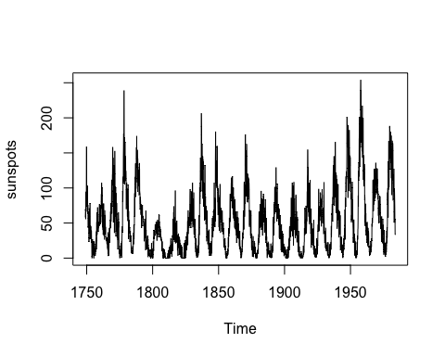

acf(sunspots)

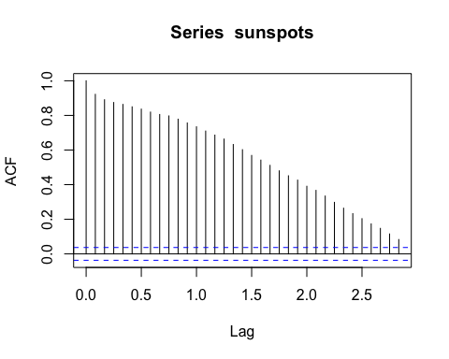 The Corellogram graph above is shown to have a gradual decay, indicating a time series model that contains a trend which is seasonal and has significant auto correlation at every lag point, as usual acf is one at lag 0.0.

# Question 2

got <- read.csv("/Users/Kalabe/got.csv")  
str(got)

## 'data.frame': 60 obs. of 4 variables:  
## $ X : int 1 2 3 4 5 6 7 8 9 10 ...  
## $ x : num 9 8.8 8.6 8.7 9.1 9.1 9.2 9 9.6 9.4 ...  
## $ season : int 1 1 1 1 1 1 1 1 1 1 ...  
## $ episode: int 1 2 3 4 5 6 7 8 9 10 ...

head(got)

## X x season episode  
## 1 1 9.0 1 1  
## 2 2 8.8 1 2  
## 3 3 8.6 1 3  
## 4 4 8.7 1 4  
## 5 5 9.1 1 5  
## 6 6 9.1 1 6

got_ts <- ts(data=got$x, start=c(1,1), frequency=10)  
plot(got_ts)

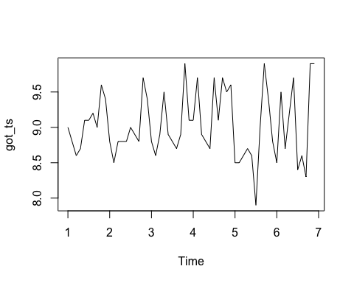

acf(got_ts)

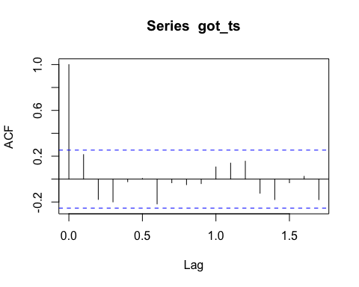 The Corellogram above is shown to not have any signficant auto correlation and is sinusidioial in nature, which may make it an autoregressive model.

# Question 3

got <- read.csv("/Users/Kalabe/got.csv")  
str(got)

## 'data.frame': 60 obs. of 4 variables:  
## $ X : int 1 2 3 4 5 6 7 8 9 10 ...  
## $ x : num 9 8.8 8.6 8.7 9.1 9.1 9.2 9 9.6 9.4 ...  
## $ season : int 1 1 1 1 1 1 1 1 1 1 ...  
## $ episode: int 1 2 3 4 5 6 7 8 9 10 ...

head(got)

## X x season episode  
## 1 1 9.0 1 1  
## 2 2 8.8 1 2  
## 3 3 8.6 1 3  
## 4 4 8.7 1 4  
## 5 5 9.1 1 5  
## 6 6 9.1 1 6

got_ts <- ts(data=got$x, start=c(1,1), frequency=10)  
plot(got_ts)



acf(got_ts)



lm_got <- lm(x~factor(season)+episode-1,data=got)  
res <- residuals(lm_got)  
plot(res)

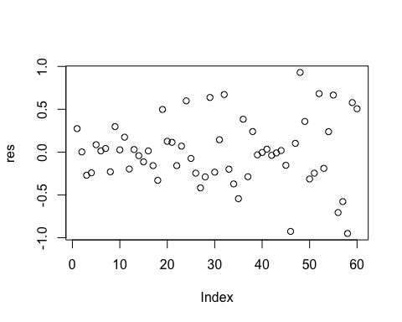

acf(res)

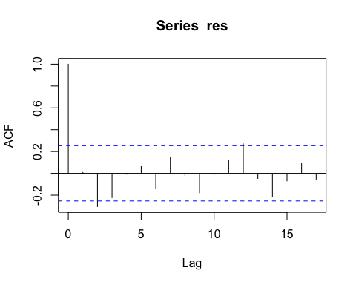

The Correlogram above shows two instances of significant autocorrelation at 1 LAG and 12 LAG and sinusiodal in nature.