**Laptop Request Catlog Item**

Team Id: NM2025TMID15369

Team Size : 4

Team Leader: Kalaiarasi S

Team Member : Nisha S

Team Member : Sabitha D

Team Member : Sudhalakshmi P

Problem Statement:

Right now, employees request laptops through a manual process, which is slow and often causes mistakes. There’s no smart form to guide users or collect correct details. We need a Service Catalog item that makes laptop requests easy, with dynamic fields, clear instructions, a reset option, and proper tracking for governance.

TASK INITIATION

**Milestone 1** : Update Set

**Activity 1**: Create Local update set

1. First open **ServiceNow**.

2. On the left side, click **All** and just type 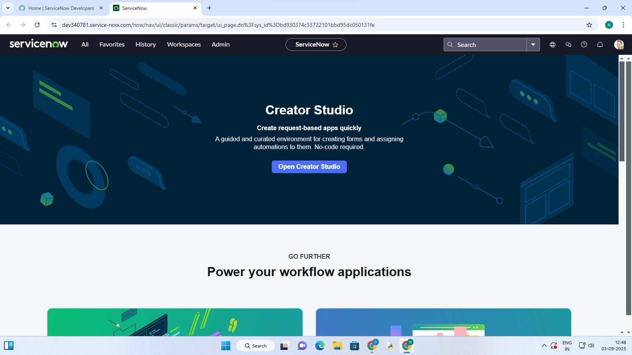**update sets** in the search.

. 3. Then click **Local update sets** under the system update sets section

4. Hit the **New** button.

5. Fill the details and give the name like **Laptop Request**.

6. After that, click **Submit** and then choose **Make Current**.

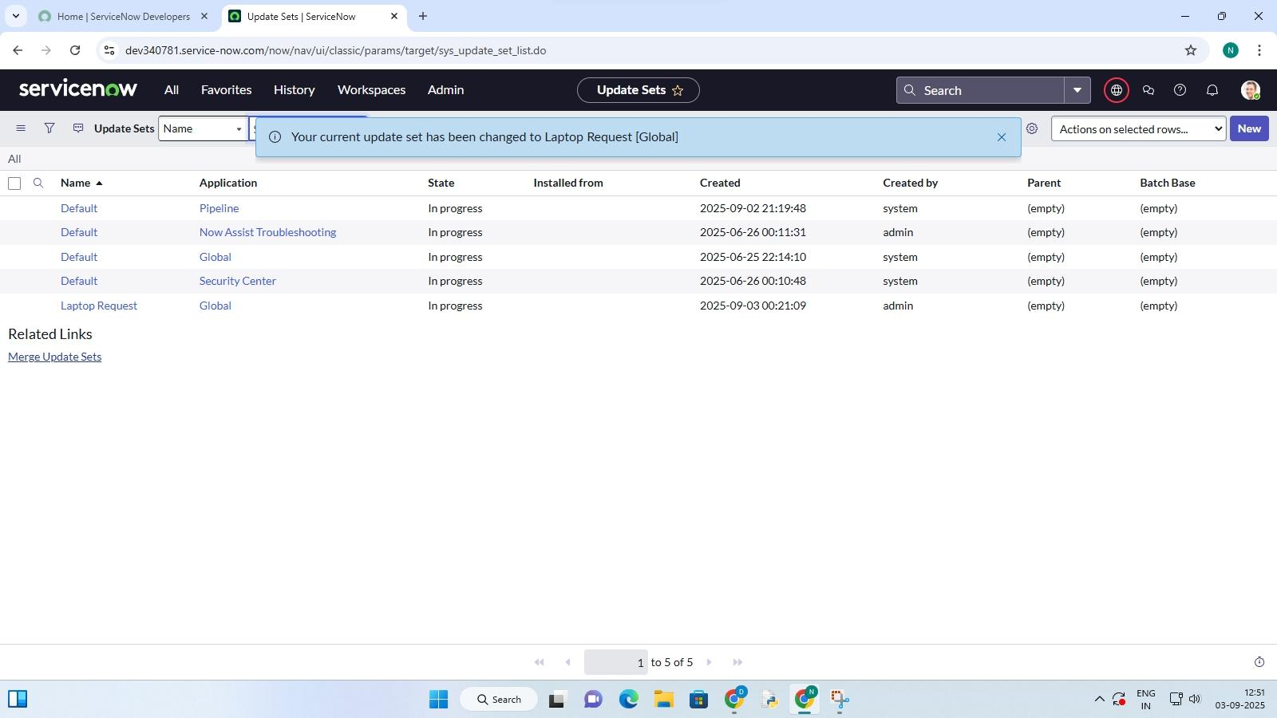 7. Done! Now the update set is active after clicking the button.

**Milestone 2** : Service Catalog item

**Activity 1**: Create service catalog item

1. Open **ServiceNow** .

2. Go to **All** and then click **Service Catalog**.

3. Under Catalog Definitions , pick **Maintain Items** .

4. Hit **New** to create something new.

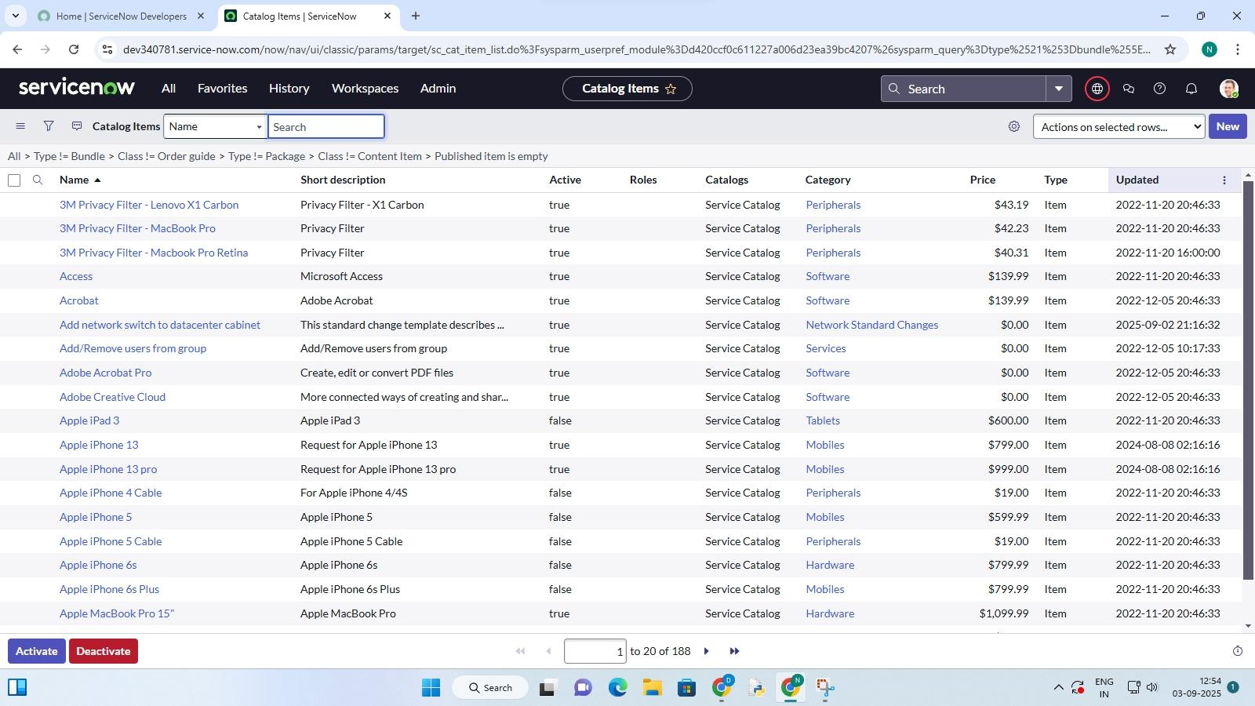

5. Fill in the info like this:

Name: Laptop Request

Catalog: Service Catalog

Category: Hardware

Short Description: Use this item to request a new laptop

6. Click **SAVE** and you’re done .

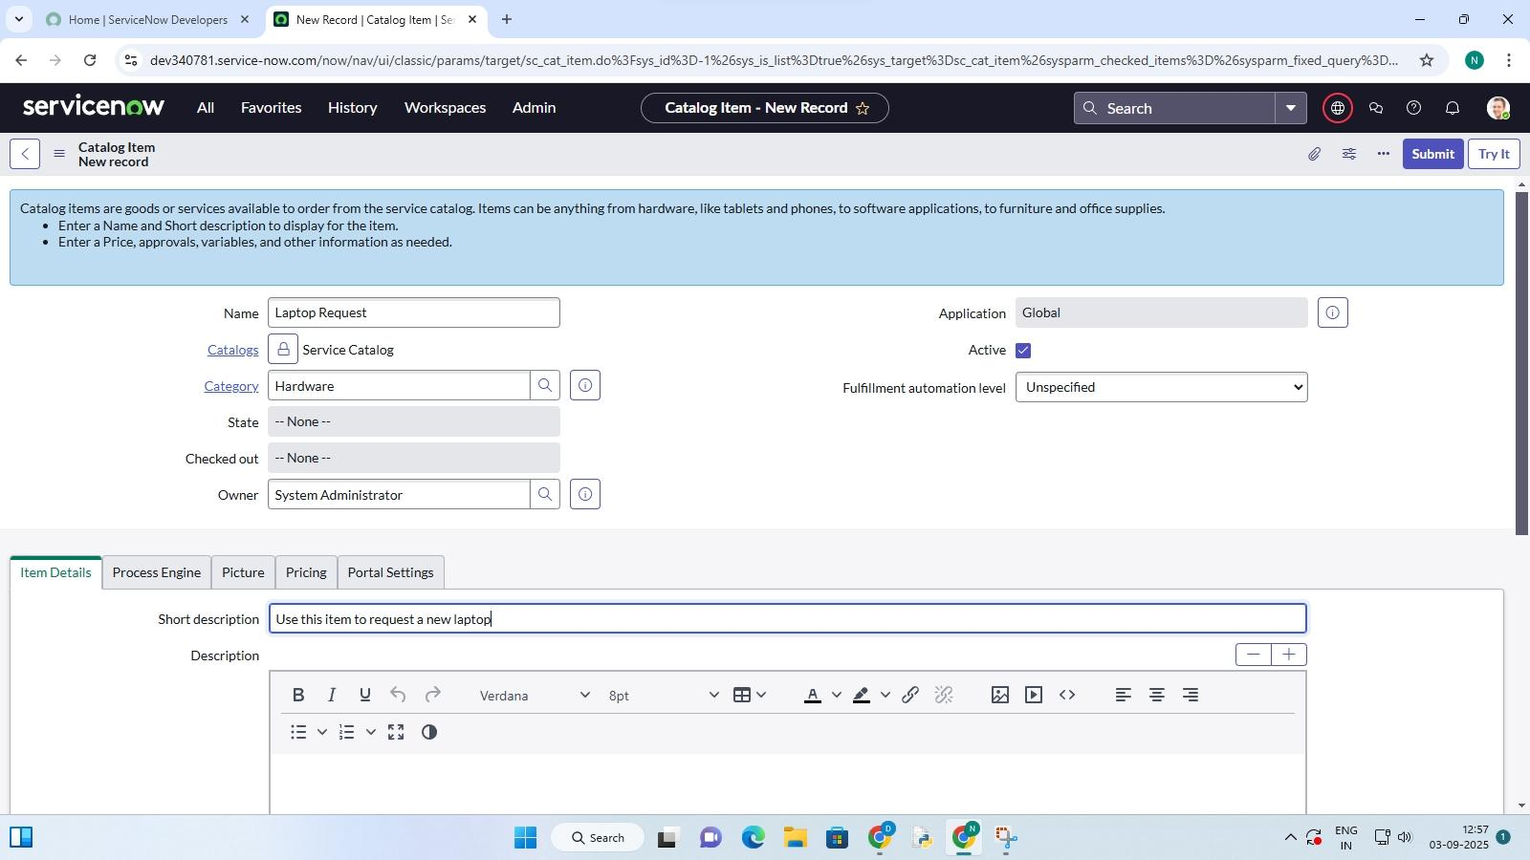

**Activity 2**: Add Variables

Step 1:

1. After you **save the catalog item** , scroll down a bit and click on **Variables** (the related list).

2. Click **New** and fill in the first variable:

**Variable 1:** Laptop Model

*Type*: Single line text

Name:laptop mode

Order:100

Click Submit

3. Click **New** again and add the next variables using the same way:

**Variable 2:** Justification

Type: Multi line text

Name: justification

Order: 200

**Variable 3:** Additional Accessories

Type: Checkbox

Name: additional accessories

Order: 300

**Variable 4:** Accessories Details

Type: Multi line text

Name: accessories details

Order: 400

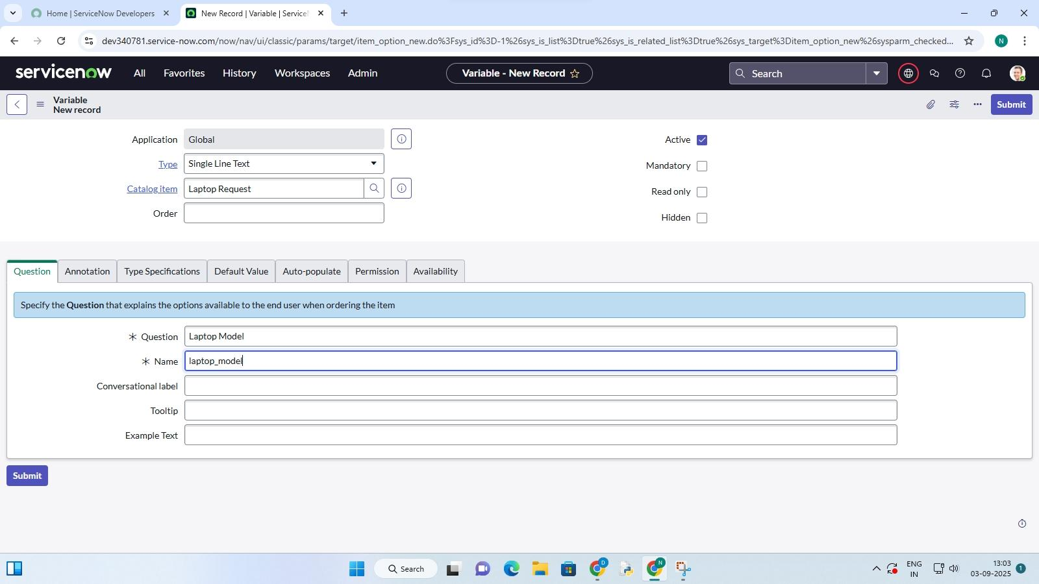

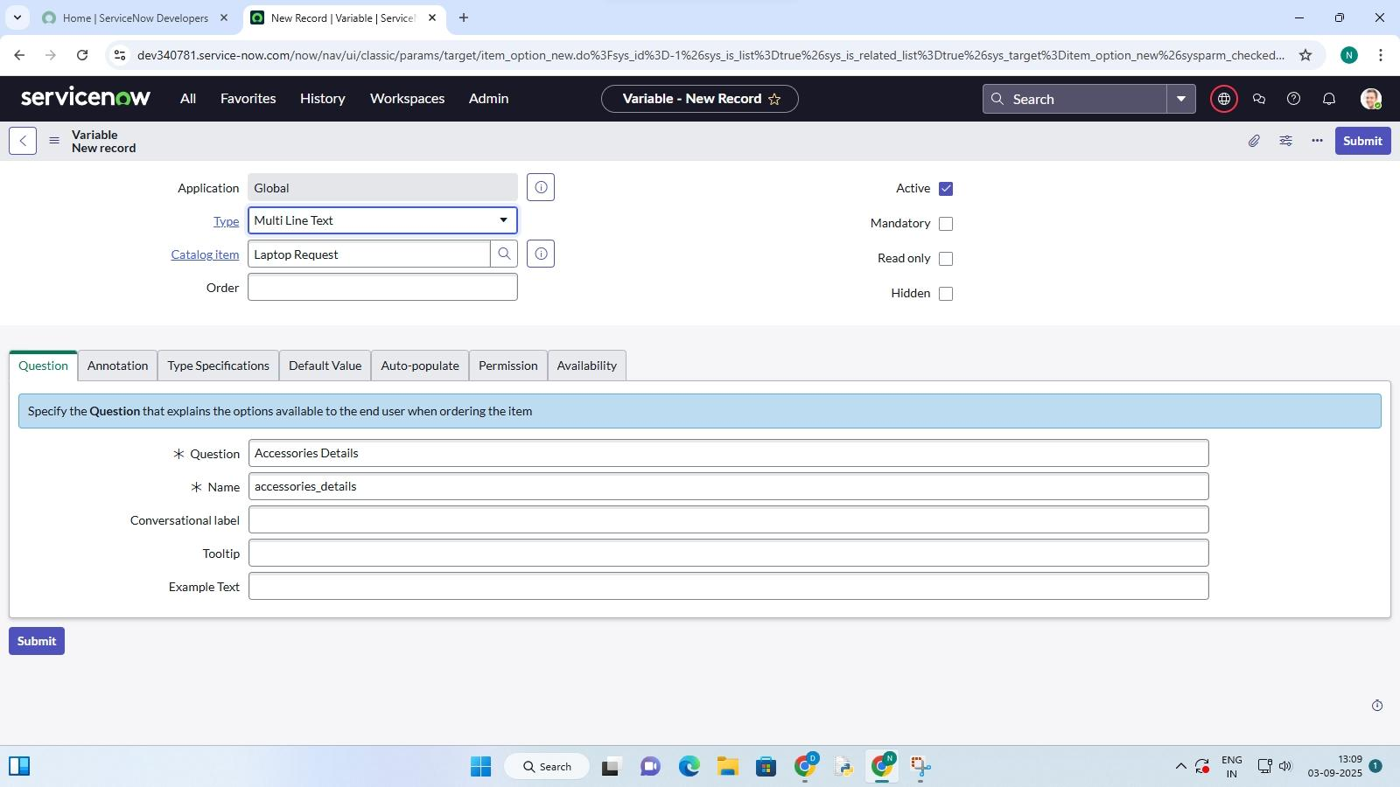

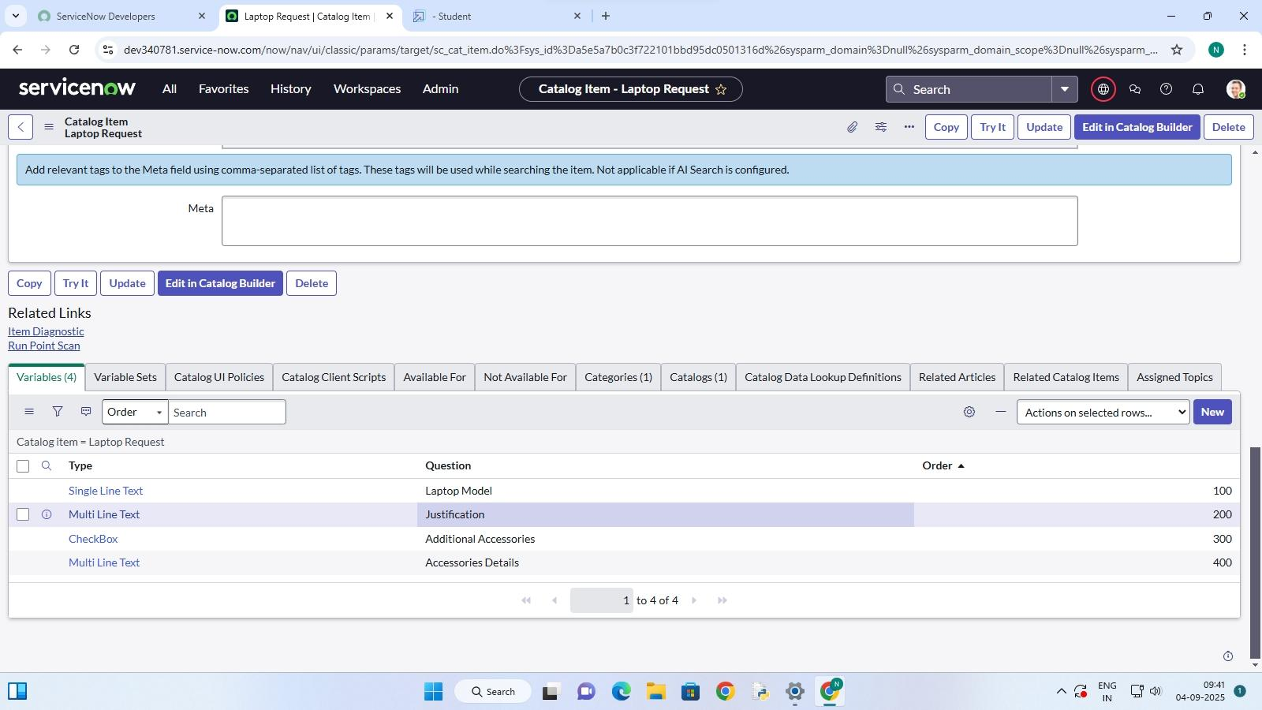

Step 2:

Save Everything

Once all these variables are added to your catalog item, just save the catalog item form again.



**Milestone 3 :** UI policy

**Activity 1:** Create Catalog UI Policies

1. Open **ServiceNow** click **All** search **Service Catalog**.

2. Under **Catalog Definitions**, pick **Maintain Items**.

3. Search for the **Laptop Request** item you made before and open it.

4. Scroll down and click **Catalog UI Policies**.

5. In the related list, click **New**.

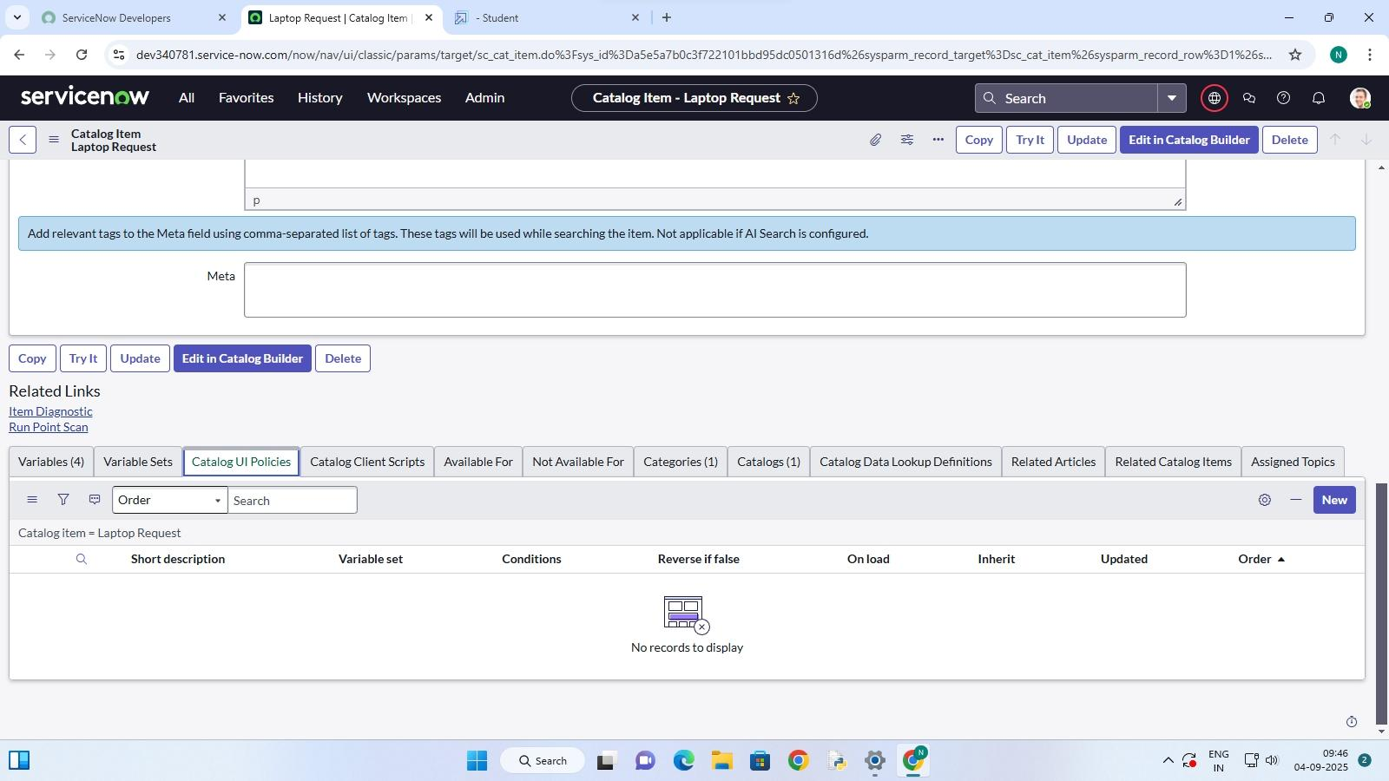

6. Add a short description like: **Show accessories details** .

. 7. Set the condition under **When to apply**:

**Field**: additional accessories

**Operator**: is

**Value**: true

8. Click **Save** (don’t hit Submit).

9. Scroll down and click **Catalog UI Actions**.

10. Click **New**.

11. Fill in the details:

**Variable Name**: accessories details

**Order**: 100

**Mandatory**: True

**Visible**: True

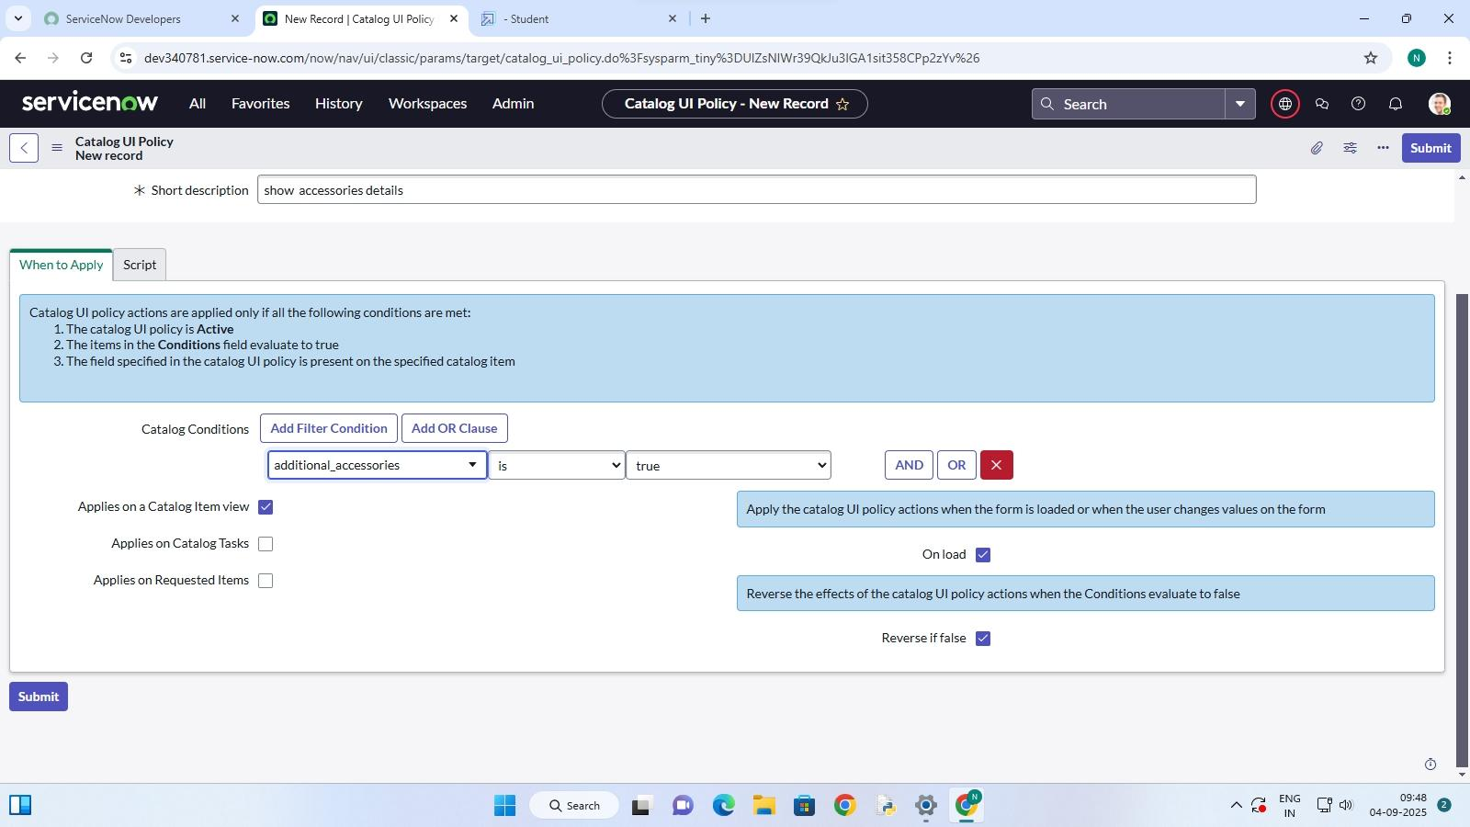

12. Click **Save** , then again click **Save**  on the **Catalog UI Policy** form.

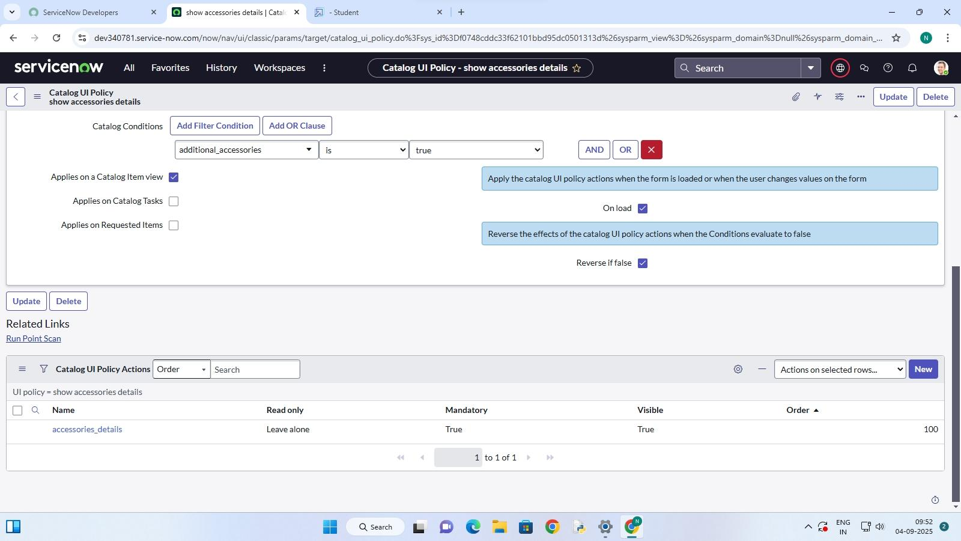

**Milestone 4** : UI Action

**Activity 1**: Create UI action

1. Open **ServiceNow** .

2. Click **All** and search for  **UI Action**.

3. Under **System Definition** , select **UI Actions** .

4. Click **New .**

5. Fill in the details like this:

**Table**: shopping cart sc_cart

**Order**: 100

**Action Name:** Reset Form

. **Client:** Check the box

**Script:**

java script

function resetForm() {

g_form.clearForm(); // Clears all fields

alert("The form has been reset.");

}

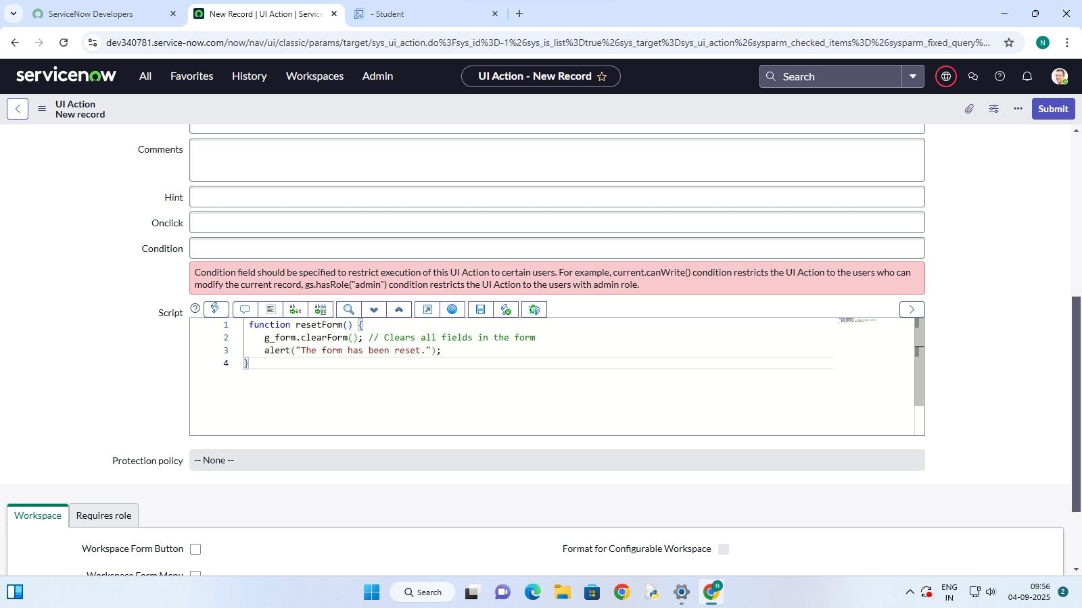

6. Click **Save**.

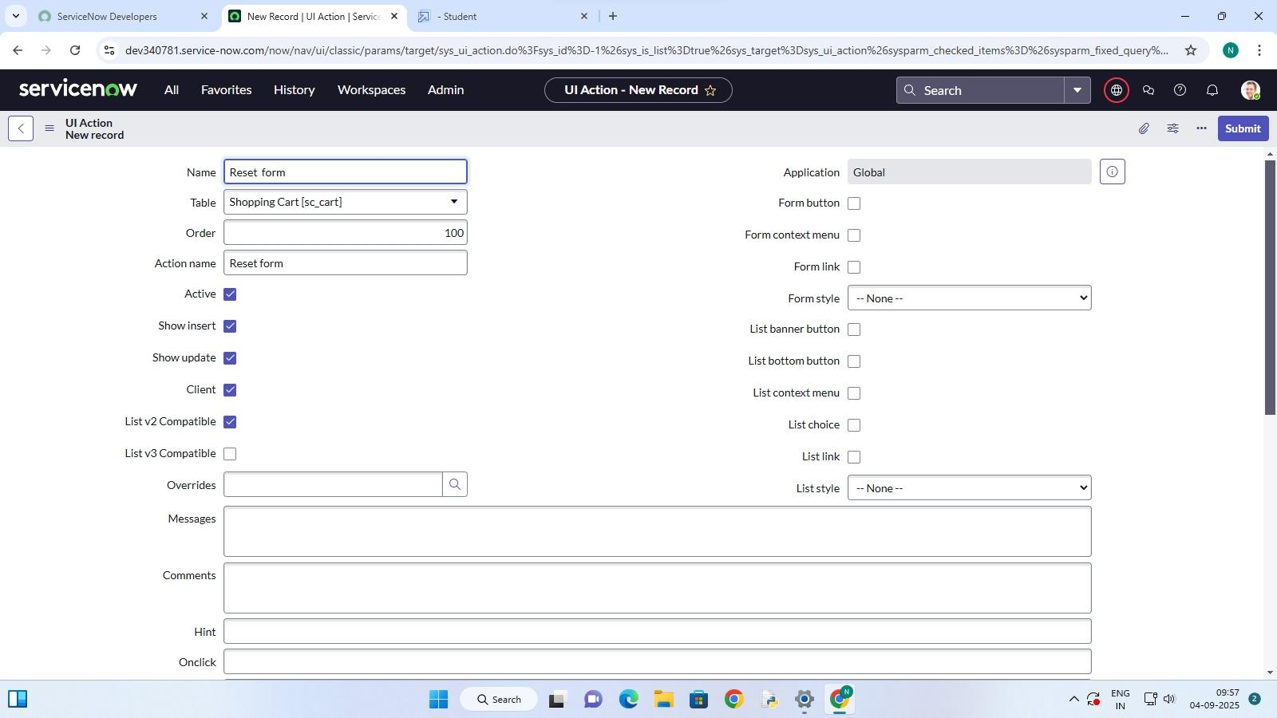

**Milestone 5 :** Export Update set

**Activity 1:** Exporting changes to another instances

1. Open **ServiceNow** , click **All** , and search for. **Update Sets** .

2. Go to **Local Update Sets** .

3. Find and open the update set you made earlier ( **Laptop Request Project** )

4. Change its **State** to **Complete** .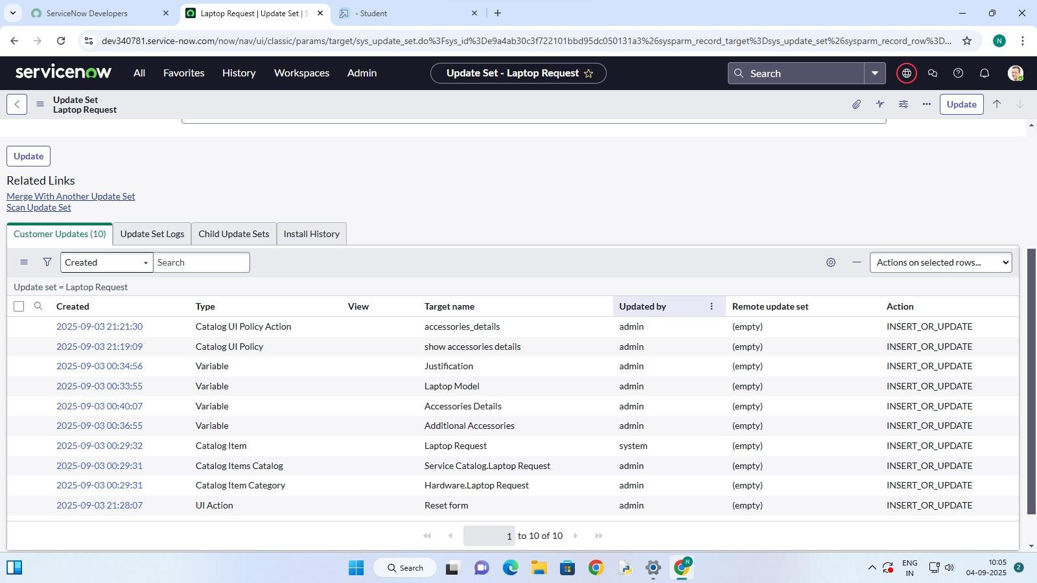

5. Scroll to the **Updates**. related list — you’ll see all the changes done under this . update set.

6. Click **Export to XML** it will download a file to your computer.

**Milestone 6 :** Login to another instance

**Activity 1:** Retrieving the Update set

1. Open **another ServiceNow instance** in an **incognito window** .

2. Log in with your **credentials.**

3. Click **All** and search for **Update Sets**..

4. Under **System Update Sets** , pick **Retrieved Update Sets** .

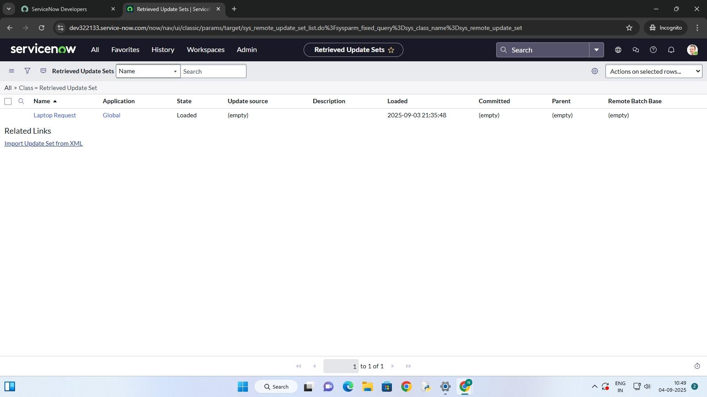

5. You’ll see the list of retrieved update sets — scroll down a bit.

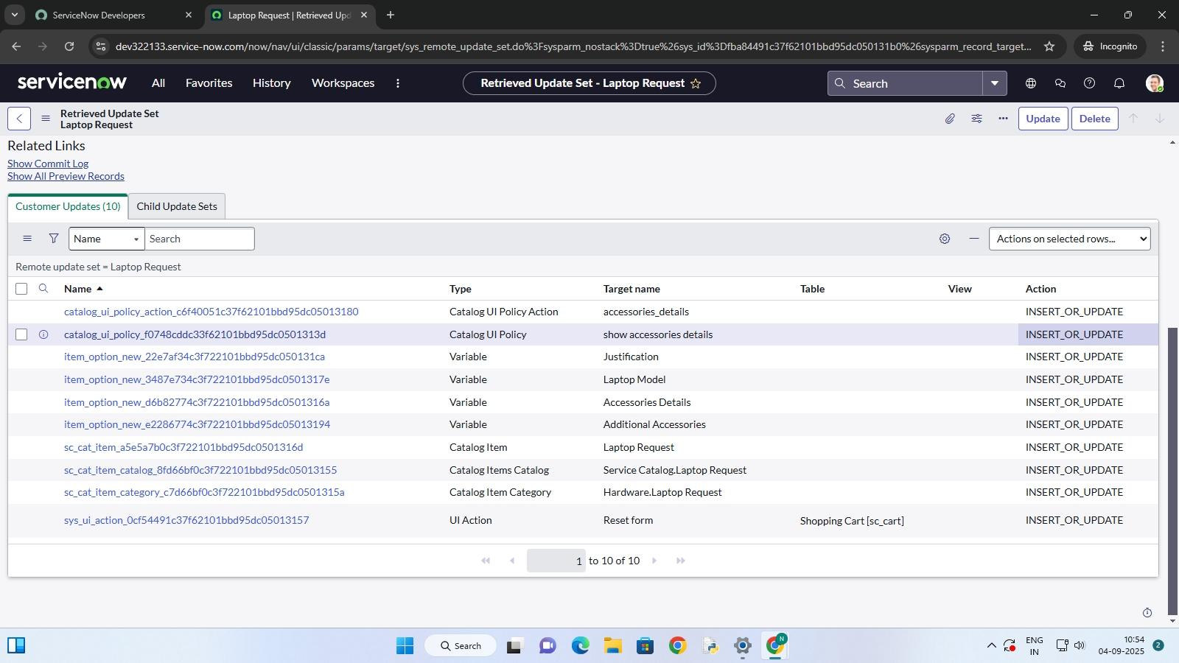

6. Click **Import Update Set from XML** .

7. Upload the XML file you downloaded earlier.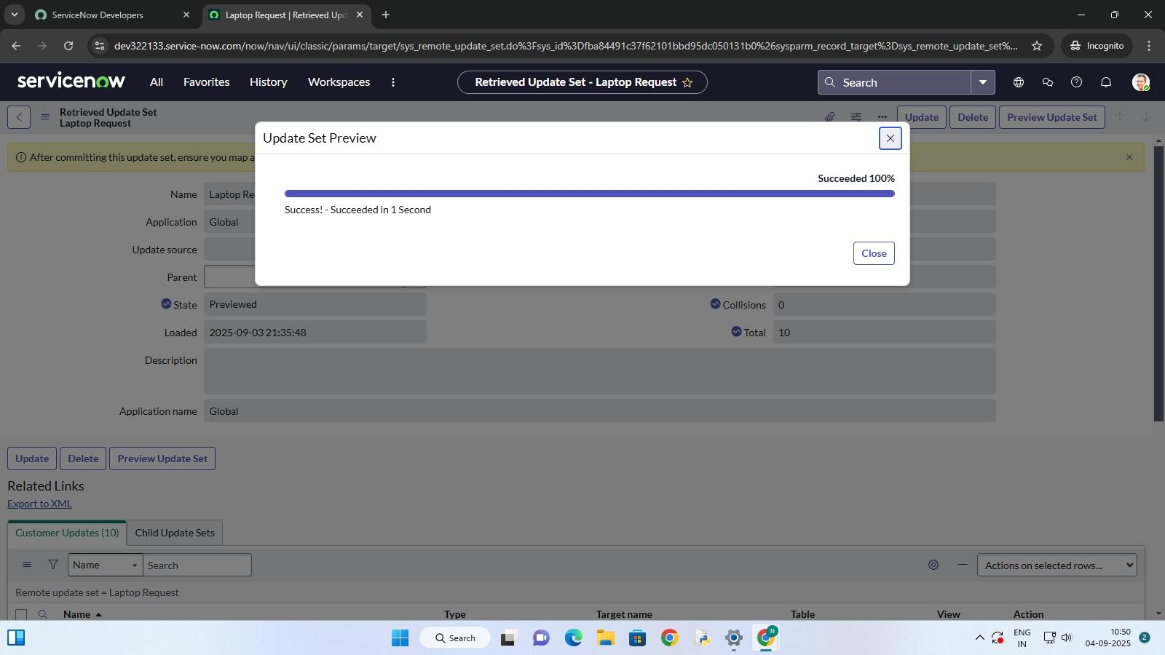

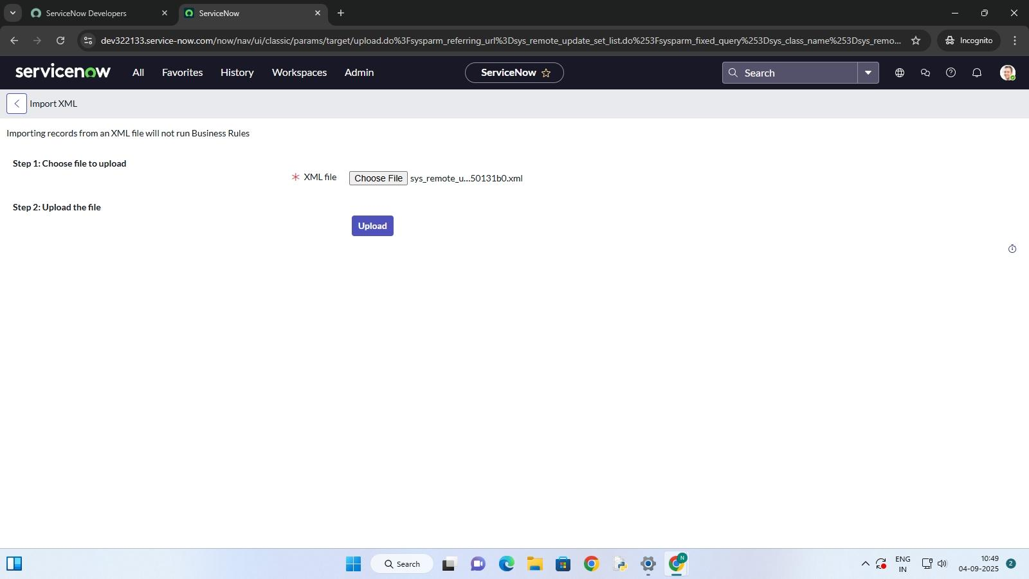

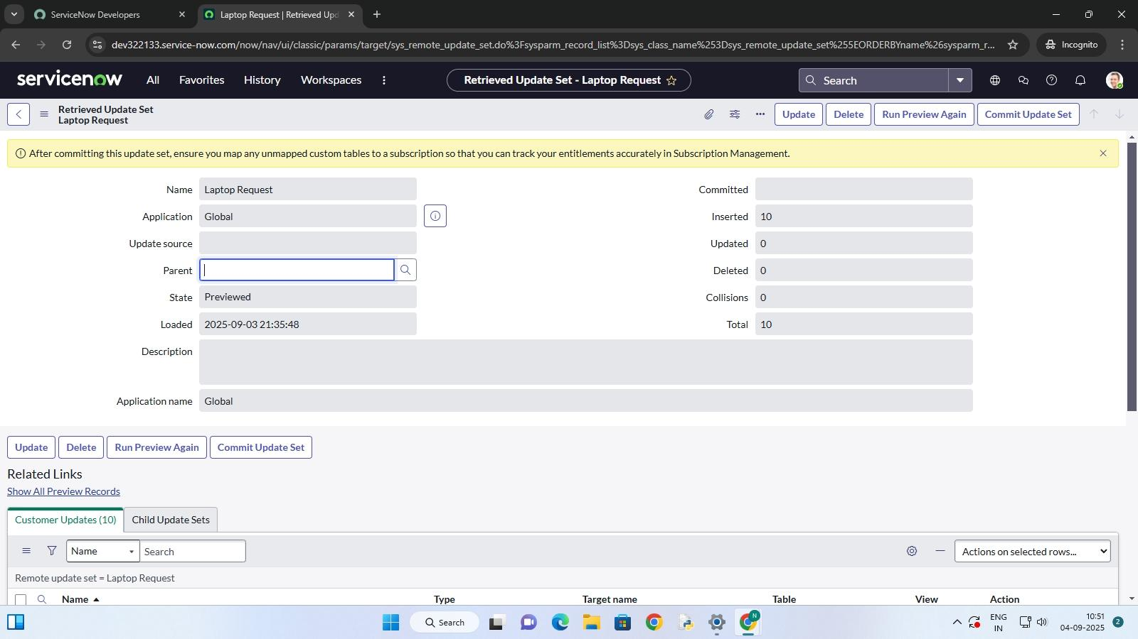



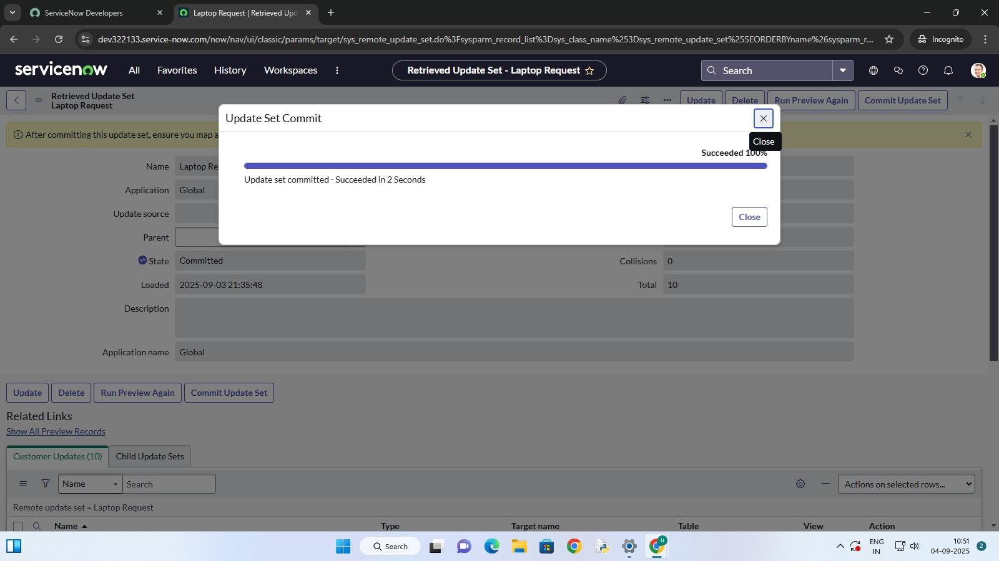



8. Click **Upload** now the update set is added to this instance.

**Milestone 7 :** Testing

**Activity 1 :** Test catalog item

1. In the **target instance** , search for **Service Catalog**  in the app navigator.

2. Click on **Catalog** under Service Catalog.

3. Go to the **Hardware** category and look for the **Laptop Request**  item.

4. Open the **Laptop Request** item.

5. You’ll see the first three variables only.

6. Test it: click the **Additional Accessories** checkbox → the **Accessories Details** . field should appear and be mandatory.

7. Check the result if everything works like this, it matches what we wanted .

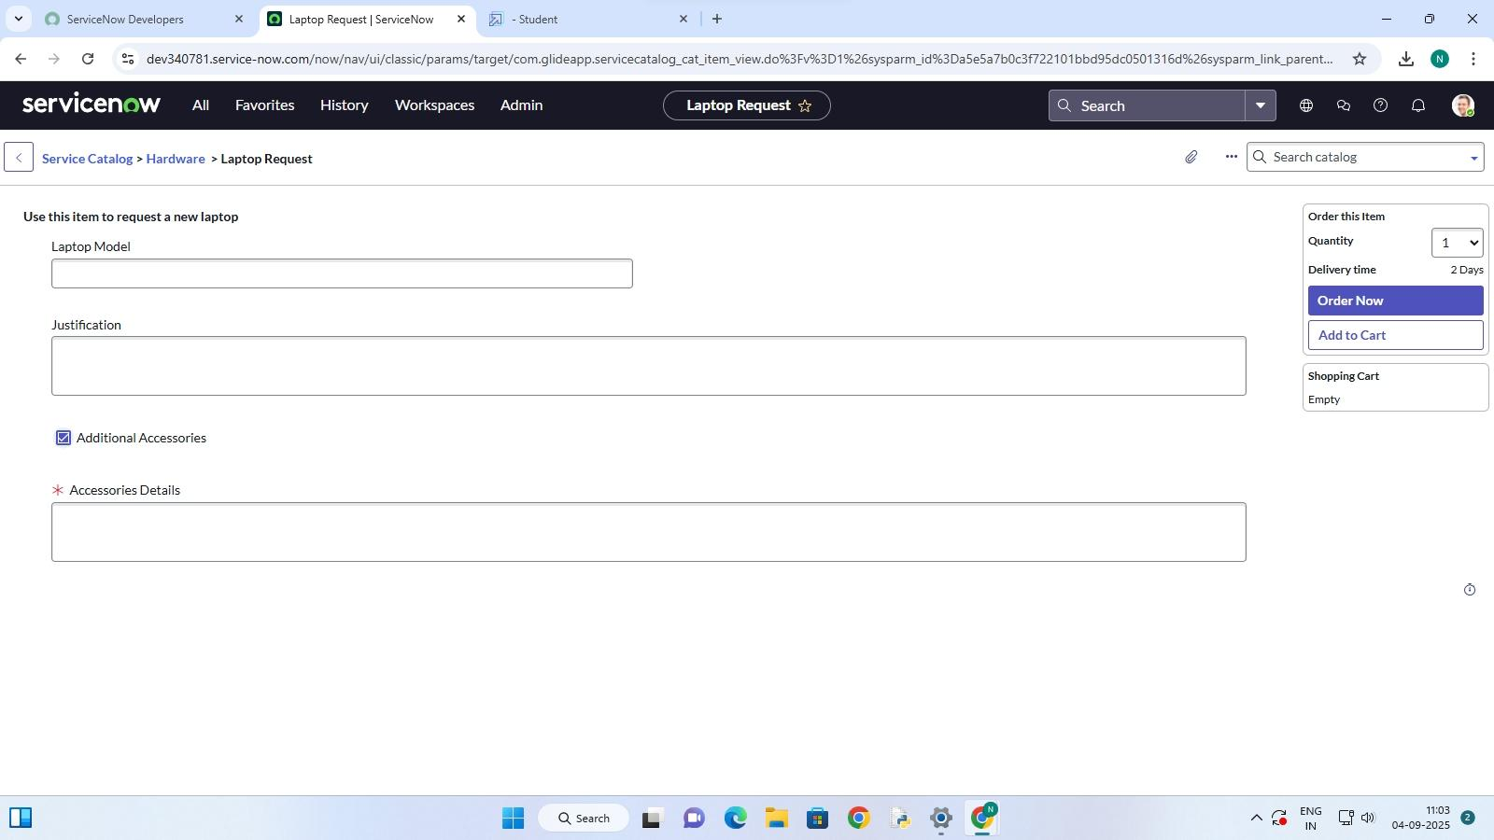

**Conclusion** :

The Laptop Requesrt Catalog Item makes it easier and faster for employees to request laptops. By using ServiceNow, the process becomes simple, automatic, and less error-prone, which improves efficiency and employee satisfaction.