COLLEGE NAME : Shri Nehru Maha Vidhyalaya College of Arts & Science.
TEAM ID: SWTID-2026-1943
Team Leader : PRIYADHARSHINI M
Email : 23snmvbcapriya@gmail.com
Team Member: KALAIYARASAN S
Email : 23snmvbcakalai@gmail.com
Team Member: DEVIKA V
Email : 23snmvbcadevika@gmail.com
Team Member: VIGNESH K
Email : rraguvaran743@gmail.com

Project Title

Replace and modernize legacy vpn architectures with a cloud native Zscaler zero trust solution

Overview of the project

- Replaces traditional VPN-based architectures with a modern Zero Trust approach using Zscaler.
- Eliminates the risks of broad network access by ensuring users and devices are never trusted by default.
- Utilizes the Zscaler Zero Trust Exchange to securely connect users, applications, and devices.
- Provides application-level access instead of full network access, reducing the attack surface.
- Enhances security through identity-based access control, continuous verification, and policy enforcement.
- Improves scalability, performance, and user experience with a cloud-native architecture.
- Reduces dependency on traditional network infrastructure, lowering operational complexity and maintenance costs.
- Provides real-time monitoring and visibility into user activity and network traffic for better threat detection.
- Supports secure remote access and hybrid work environments, enabling users to connect safely from anywhere.
- Ensures better compliance with security standards and regulatory requirements through centralized policy control.
- Minimizes the risk of data breaches by enforcing least-privilege access and preventing lateral movement within the network.

Abstract
- This project focuses on modernizing traditional network security by replacing legacy VPN architectures with a cloud-native Zero Trust solution using Zscaler. Traditional VPNs provide broad network access, increasing the risk of unauthorized access and lateral movement within enterprise environments. To address these challenges, the project adopts a Zero Trust approach, where no user or device is trusted by default, and access is granted based on strict identity verification and contextual policies.
- The implementation leverages the Zscaler Zero Trust Exchange platform to securely connect users, devices, and applications over the internet without exposing the internal network. This approach enables application-level access, reduces the attack surface, and enhances overall security posture.
- By eliminating the limitations of traditional VPNs, the proposed solution improves scalability, performance, and user experience while ensuring secure remote access for modern hybrid work environments. The project highlights how organizations can adopt a cloud-first, Zero Trust architecture to protect sensitive data, ensure compliance, and strengthen cybersecurity resilience.
- This project aims to enhance enterprise security by replacing traditional VPN-based access with a Zero Trust architecture using Zscaler. Legacy VPN solutions expose internal networks and increase the risk of cyber threats due to excessive trust and broad access. The proposed solution uses the Zscaler Zero Trust Exchange to provide secure, identity-based access to applications without connecting users to the entire network.
- By implementing a cloud-native approach, the project improves security, visibility, and scalability while supporting remote and hybrid work environments. This transformation helps organizations reduce risks, protect sensitive data, and achieve a more efficient and resilient security framework.
.

Use case Scenarios

- Use Case: Secure Remote Workforce Access
For example, an employee working remotely logs into a business application. The system authenticates the user, checks device compliance, and grants access only to the required application—not the entire network. All traffic is securely routed and continuously monitored.
Output:
- Access is granted based on user identity, device compliance, and security policies.
- Reduced risk of unauthorized access and lateral movement within the network.
- Improved visibility and monitoring of user activities in real time.
- Enhanced user experience with faster and more reliable cloud-based connections.
- Stronger overall security posture by implementing Zero Trust principles using Zscaler.

- Use Case: Secure Access to Private Applications (Zero Trust Access)
Secure Access to Private Applications using Zero Trust ensures that users can access internal applications without exposing the corporate network. Instead of relying on traditional VPNs, the solution uses a cloud-based approach provided by Zscaler. Through the Zscaler Zero Trust Exchange, users are connected directly to specific applications based on their identity, device status, and security policies.
Output:
- Provides secure, direct access to private applications without exposing the internal network.
- Grants application-level access instead of full network access.
- Ensures strong authentication and continuous verification of users and devices.
- Reduces attack surface and prevents lateral movement within the network.
- Improves user experience with faster and seamless connectivity.

- Use Case: Centralized Identity and Access Management
Using Zscaler, integrated with identity providers like Azure Active Directory or Okta, the Zero Trust model verifies users based on identity, role, and device posture. Every access request is authenticated and authorized before granting permission to applications via the Zscaler Zero Trust Exchange.
Output:
- Centralized control over user identities and access permissions across the organization.
- Strong authentication using identity providers like Azure Active Directory and Okta.
- Consistent enforcement of security policies for all users and devices.
- Reduced risk of unauthorized access and identity-based attacks.
- Simplified user management and improved operational efficiency.
Use Case: Secure SaaS and Internet Access Control
By implementing a Zero Trust approach with Zscaler, all internet and SaaS traffic is routed through the Zscaler Zero Trust Exchange. The platform inspects traffic in real time, enforces security policies, and blocks malicious or unauthorized content. It also provides data protection by controlling how sensitive information is accessed and shared across SaaS applications.
Output:
- Secure access to SaaS applications and internet resources with real-time threat protection.
- Prevention of malware, phishing attacks, and malicious websites.
- Data protection through controlled access and monitoring of sensitive information.
- Consistent security policy enforcement across all users and devices.
- Improved visibility into user activity and internet traffic.
Use Case: Enhanced Security with Multi-Factor Authentication (MFA)
Multi-Factor Authentication (MFA) adds an extra layer of security by requiring users to verify their identity using multiple factors such as password, OTP, biometric, or authentication apps. This reduces the risk of unauthorized access even if user credentials are compromised.
Output:
- Stronger user authentication through multiple verification factors.
- Reduced risk of account compromise and unauthorized access.
- Protection against phishing, credential theft, and brute-force attacks.
- Seamless integration with identity providers like Azure Active Directory and Okta.
- Improved security for remote access and cloud applications.

TITLE:
OWASP TOP 10
OVERVIEW:
The OWASP Top 10 is a standard awareness document published by the Open Web Application Security Project (OWASP) that identifies the most critical security risks to web applications. It is designed to help developers, security professionals, and organizations understand common vulnerabilities that attackers often exploit. The OWASP Top 10 highlights major risks such as Broken Access Control, Cryptographic Failures, Injection, Insecure Design, Security Misconfiguration, Vulnerable and Outdated Components, Identification and Authentication Failures, Software and Data Integrity Failures, Security Logging and Monitoring Failures, and Server-Side Request Forgery (SSRF). These vulnerabilities can allow attackers to gain unauthorized access, steal sensitive data, modify information, or even take full control of a system. For example, Injection attacks occur when malicious code is inserted into a program, while Broken Access Control allows users to access resources they are not authorized to use. Similarly, Cryptographic Failures happen when sensitive data such as passwords or credit card information is not properly encrypted. The OWASP Top 10 serves as a guideline for improving application security by encouraging organizations to adopt secure coding practices, proper configuration, regular updates, and continuous monitoring. By understanding and addressing these risks, developers can build more secure and reliable web applications and reduce the chances of cyberattacks.
Rank | Vulnerability
1 | Broken Access Control
2 | Cryptographic Failures
3 | Injection
4 | Insecure Design
5 | Security Misconfiguration
6 | Vulnerable and Outdated Components
7 | Identification and Authentication Failures
8 | Software and Data Integrity Failures
9 | Security Logging and Monitoring Failures
10 | Server-Side Request Forgery

S.NO |  | Vulnerability | CWE/CVE NO
1. |  | Absolute Path Traversal | CWE-36
2. | Sensitive Cookie in HTTPS Session Without 'Secure' Attribute |  | CWE-614
3. | Use of Unmaintained Third Party Components |  | CWE-1104
4. | Insufficient Entropy in PRNG |  | CWE-332
5. | Public Static Field Not Marked Final |  | CWE-500
6. | Client-Side Enforcement of Server-Side Security |  | CWE-602
7. | Incorrectly Specified Destination in a Communication Channel |  | CWE-941
8. | Reliance on Cookies without Validation and Integrity Checking |  | CWE-565
9. | Insertion of Sensitive Information into Log File |  | CWE-532
10. | Improper Check for Unusual or Exceptional Conditions |  | CWE-754

REPORT:
1.Vulnerability Name : Absolute Path Traversal
CWE NO : CWE-36
OWASP Category : Broken Access Control
Description: Absolute Path Traversal is a security vulnerability that occurs when an application allows users to access files and directories outside the intended directory by manipulating file paths. Attackers can exploit this flaw by providing absolute file paths (e.g., /etc/passwd or C:\Windows\system32) to gain unauthorized access to sensitive system files. This vulnerability arises due to improper validation or sanitization of user-supplied input used in file operations.
Business Impact: Absolute Path Traversal can lead to unauthorized access to sensitive files such as system configurations, user data, and application source code. This may result in data breaches, exposure of confidential information, and compromise of system integrity. Attackers could leverage this access to further exploit the system, potentially leading to financial loss, reputational damage, legal consequences, and loss of customer trust.
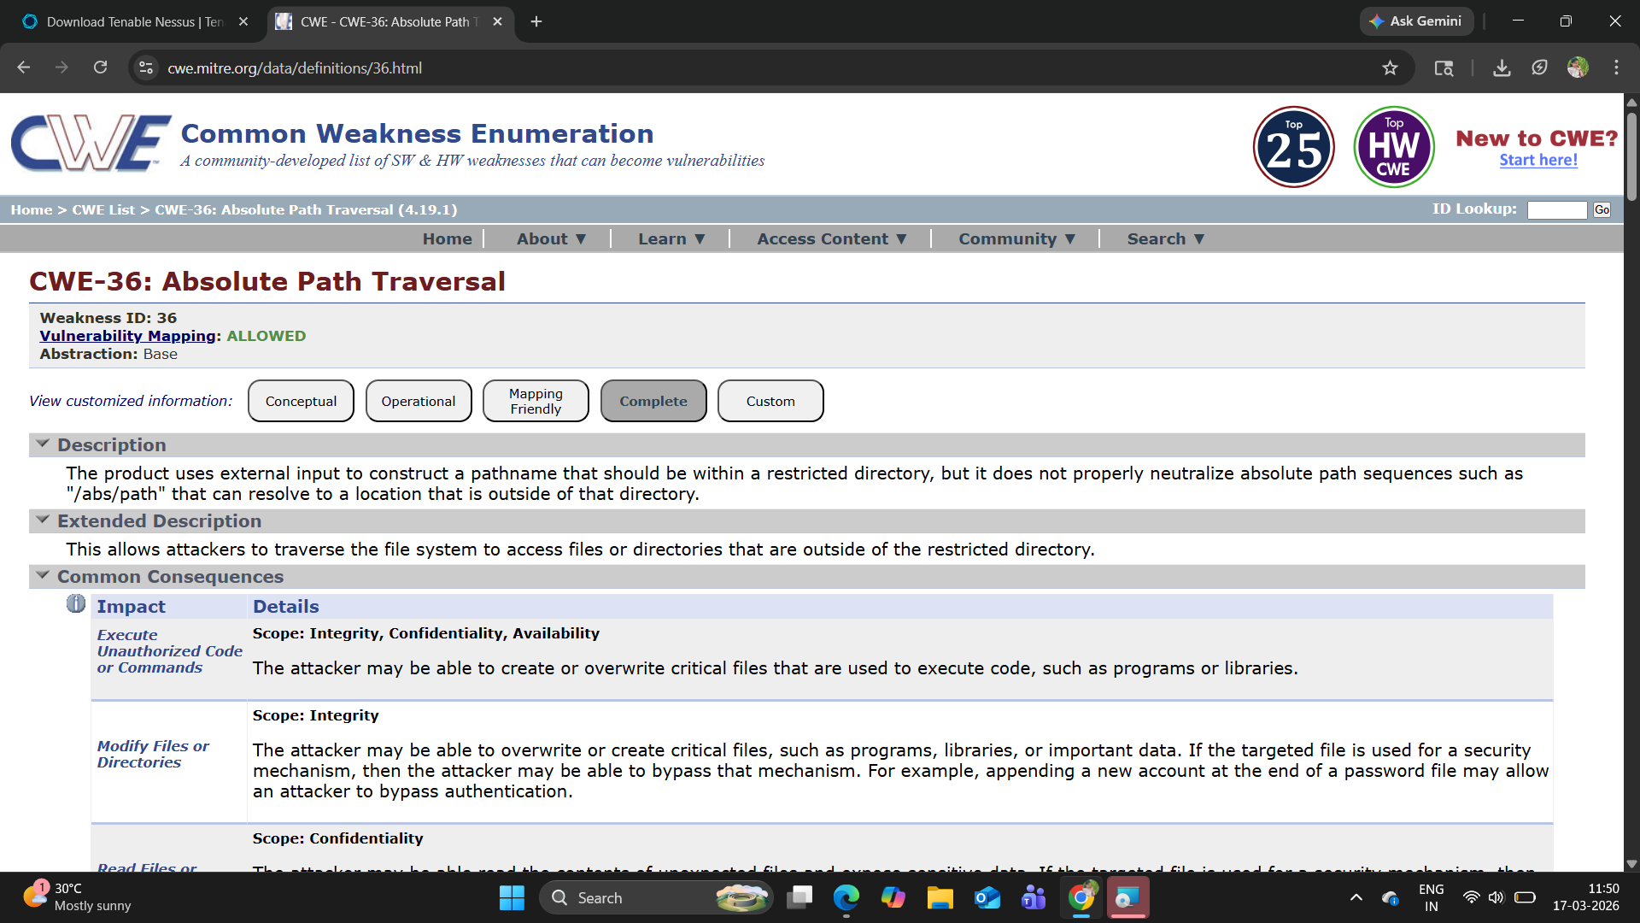

2) Vulnerability Name : Sensitive Cookie in HTTPS Session Without 'Secure' Attribute
CWE NO :CWE-614
OWASP Category: Security Misconfiguration
Description: This vulnerability occurs when a sensitive cookie (such as session ID or authentication token) is transmitted over an HTTPS connection but does not have the Secure attribute set. Without this attribute, the browser may send the cookie over unencrypted HTTP connections as well, exposing it to interception. Attackers can exploit this by performing man-in-the-middle (MITM) attacks or forcing users to access the application over HTTP, thereby capturing sensitive session information.
Business Impact : The absence of the Secure attribute can lead to session hijacking, where attackers gain unauthorized access to user accounts by stealing session cookies. This may result in unauthorized transactions, data breaches, and compromise of user privacy. For businesses, it can cause financial loss, damage to brand reputation, legal liabilities, and erosion of customer trust.
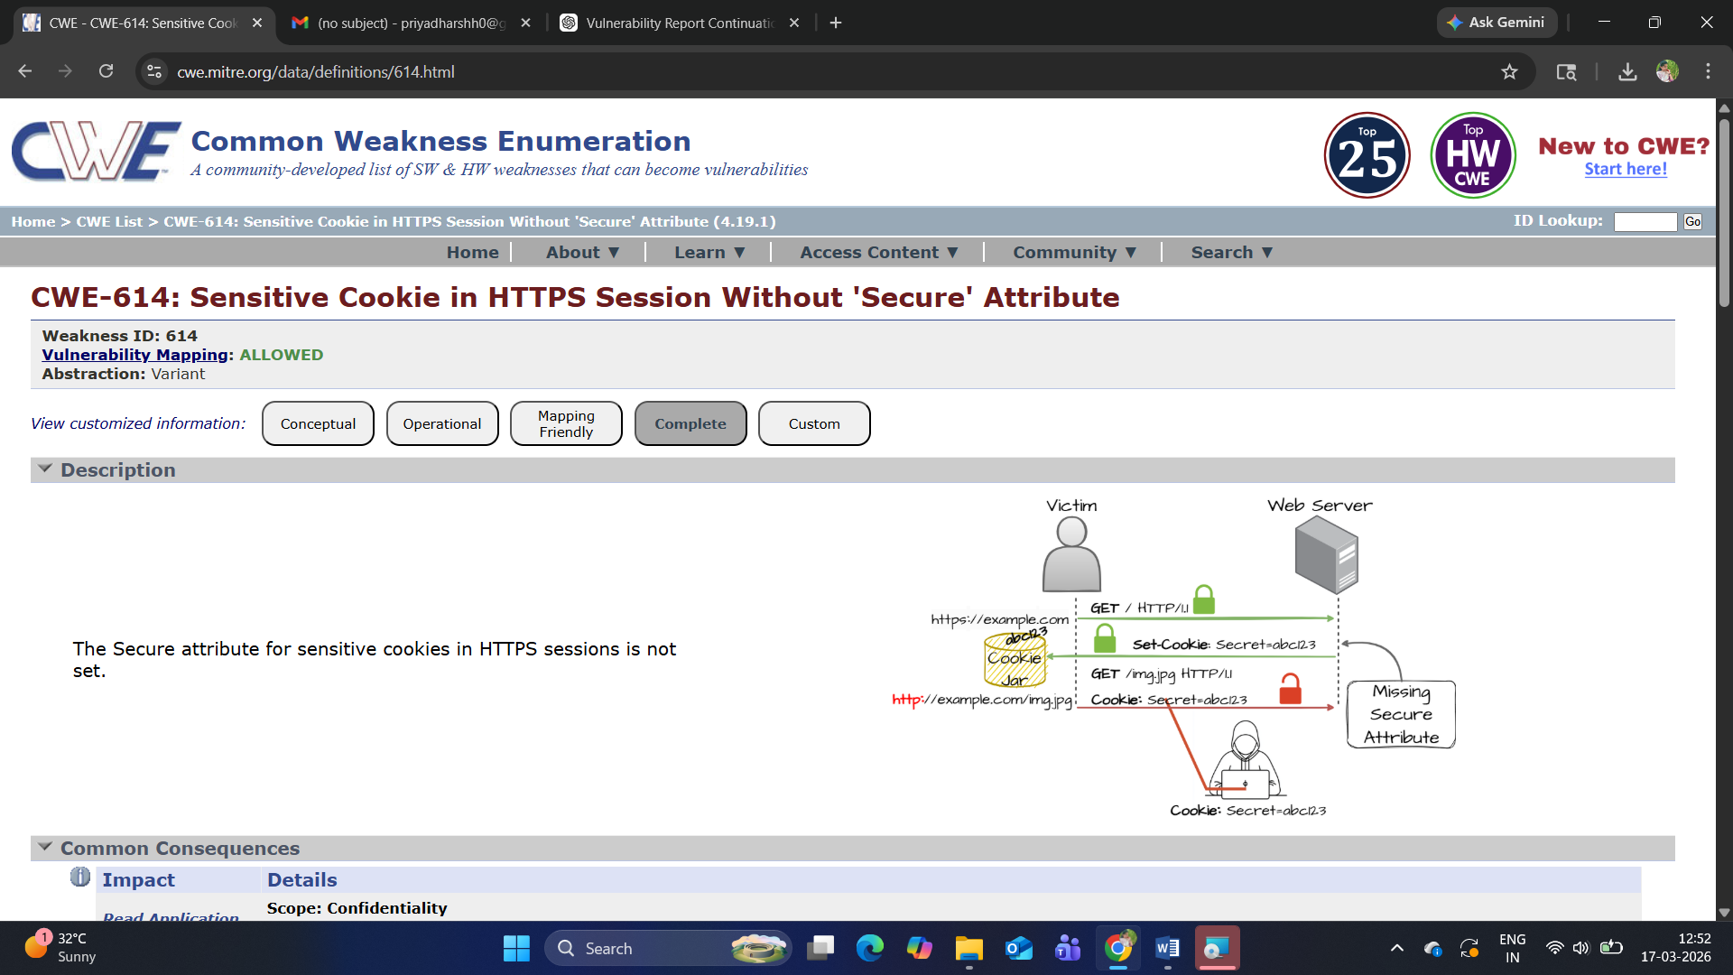

3) Vulnerability Name : Use of Unmaintained Third Party Components
CWE NO: CWE-1104
OWASP Category: Software supply chain Failures
Description: This vulnerability occurs when an application relies on third-party libraries, frameworks, or components that are no longer maintained or updated by their developers. These outdated components may contain known security vulnerabilities, bugs, or compatibility issues that remain unpatched. Attackers can exploit these known weaknesses to compromise the application, as no security fixes or updates are provided for such components.

Business Impact : Using unmaintained components increases the risk of exploitation through known vulnerabilities, potentially leading to data breaches, system compromise, and service disruption. It can also result in compliance violations if outdated software does not meet security standards. For businesses, this may cause financial losses, operational downtime, reputational damage, and increased costs for emergency fixes or system upgrades.

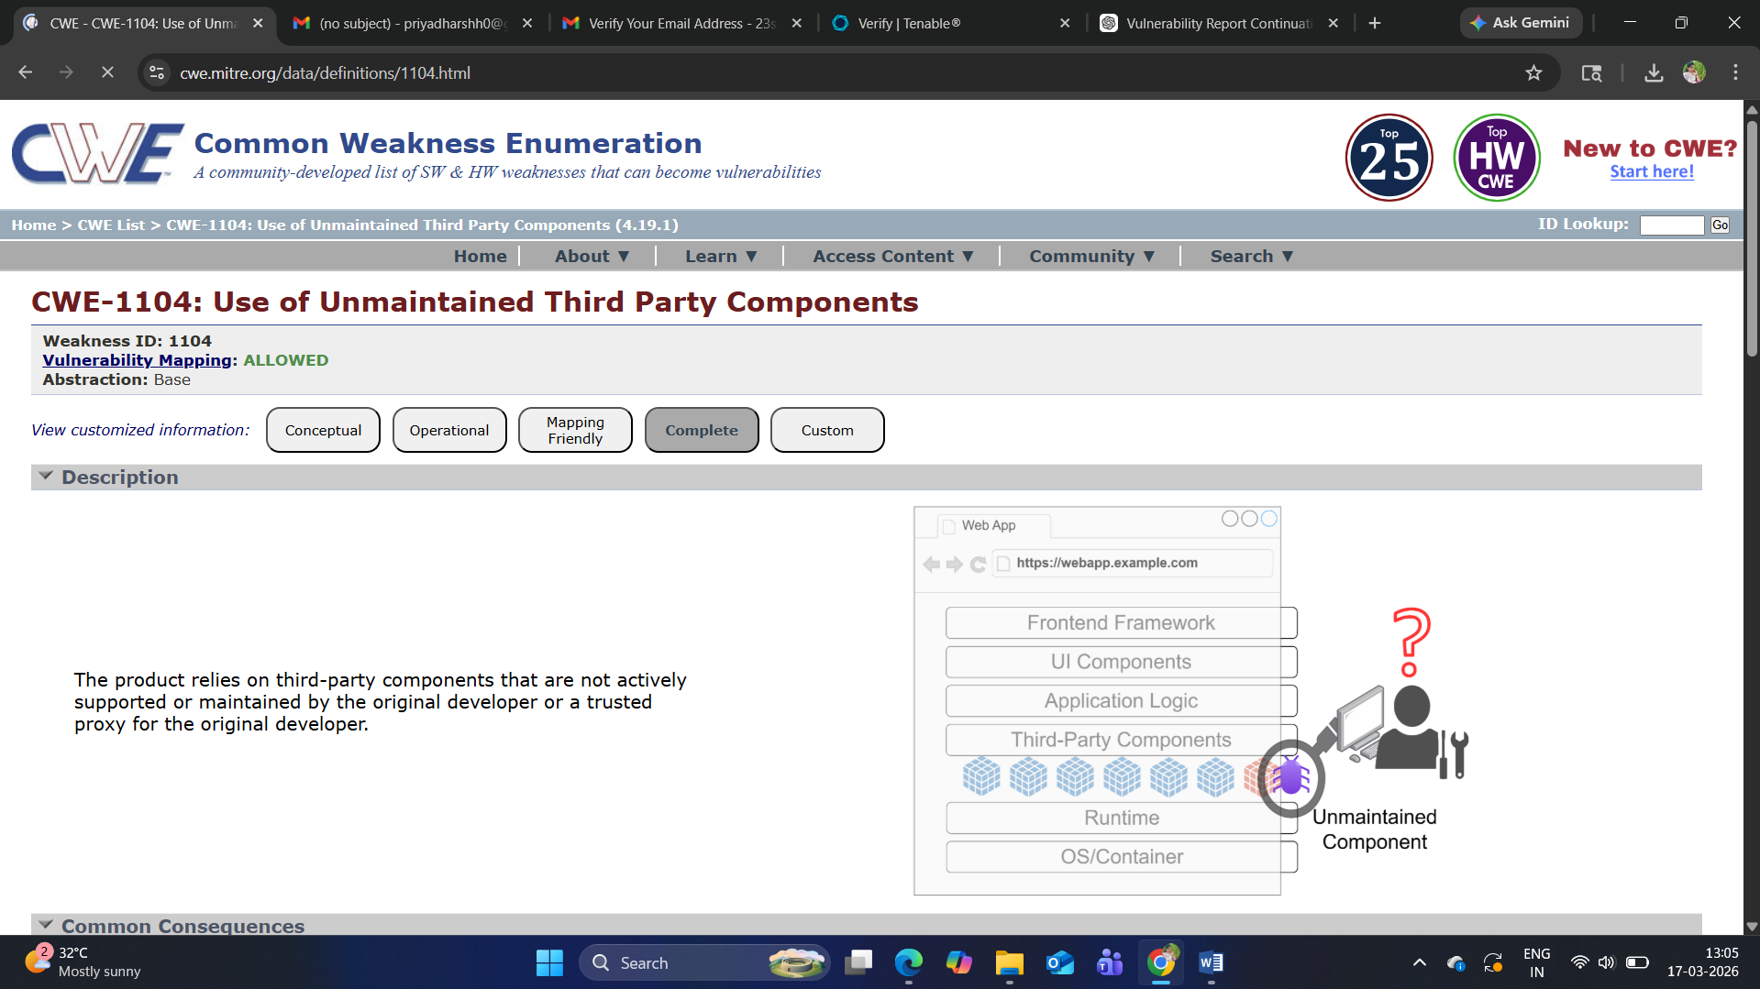

4) Vulnerability Name : Insufficient Entropy in PRNG
CWE NO : CWE-332
OWASP Category: Cryptography failures
Description: This vulnerability occurs when a Pseudo-Random Number Generator (PRNG) does not use enough entropy (randomness) while generating values. As a result, the generated numbers become predictable. Applications that rely on such weak randomness for security functions—like session IDs, encryption keys, tokens, or passwords—can be compromised. Attackers may analyze patterns or guess the generated values, leading to unauthorized access or cryptographic attacks..
Business Impact : Insufficient entropy can lead to predictable security tokens or cryptographic keys, making it easier for attackers to break authentication mechanisms, hijack sessions, or decrypt sensitive data. This can result in data breaches, unauthorized system access, and loss of confidentiality. For businesses, it may cause financial losses, regulatory penalties, reputational damage, and reduced customer trust.
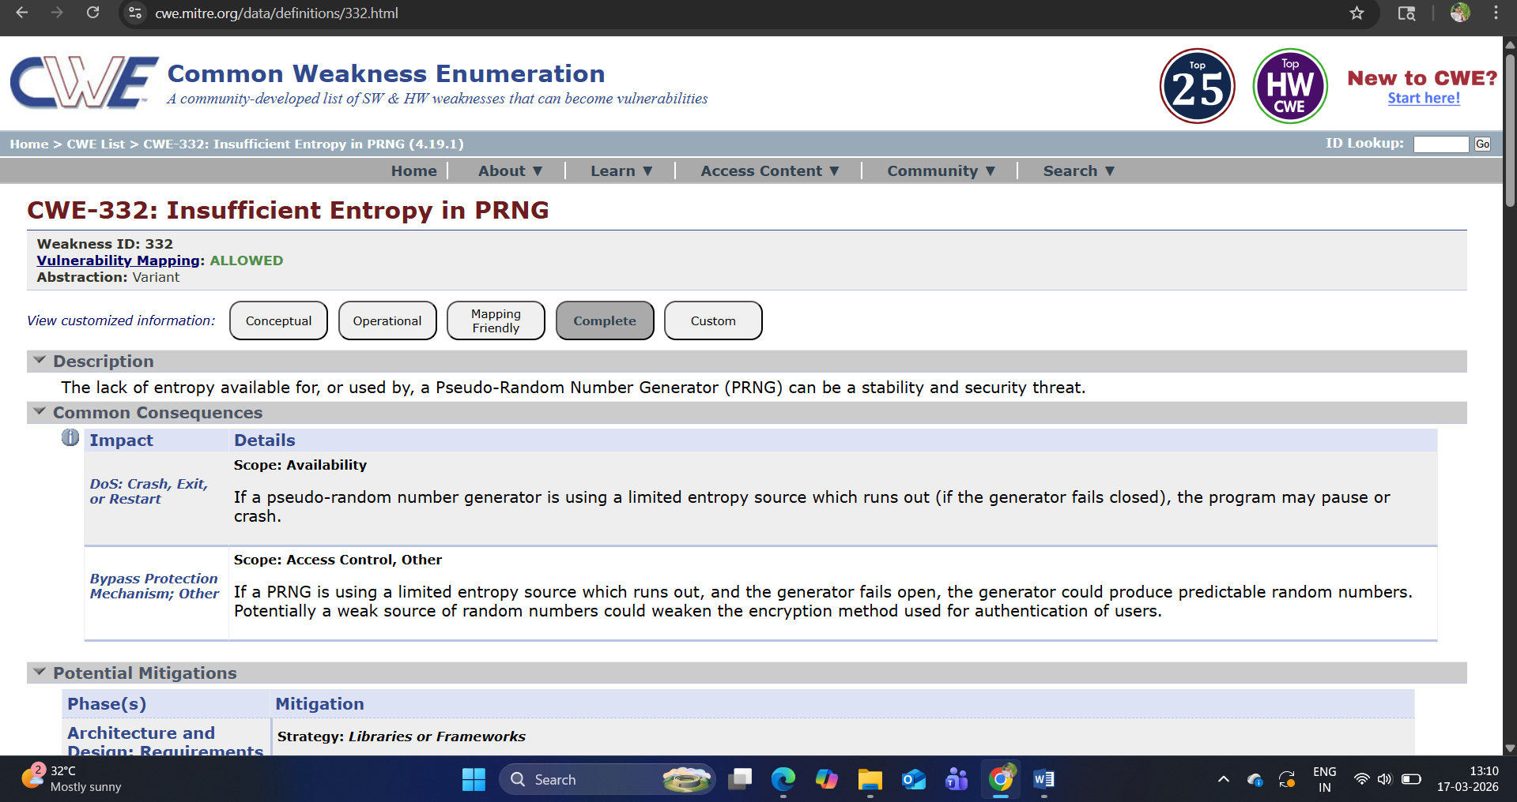

5) Vulnerability Name : Public Static Field Not Marked Final
CWE NO : CWE-500
OWASP Category: Injection
Description: This vulnerability occurs when a class declares a public static field without marking it as final, allowing its value to be modified at runtime. Since the field is publicly accessible, any part of the application or even external code (in some cases) can alter its value. If the field is used to store sensitive data, configuration settings, or security-related values, this can lead to unintended behavior or security risks. Improper control over such fields may also open the door to code manipulation or injection-like attacks..
Business Impact : Modifiable public static fields can compromise application integrity and lead to unpredictable behavior. Attackers or malicious code may alter critical values, bypass security controls, or manipulate application logic. This can result in unauthorized access, data corruption, system instability, and potential security breaches. For businesses, it may cause operational disruptions, financial losses, and reputational damage.

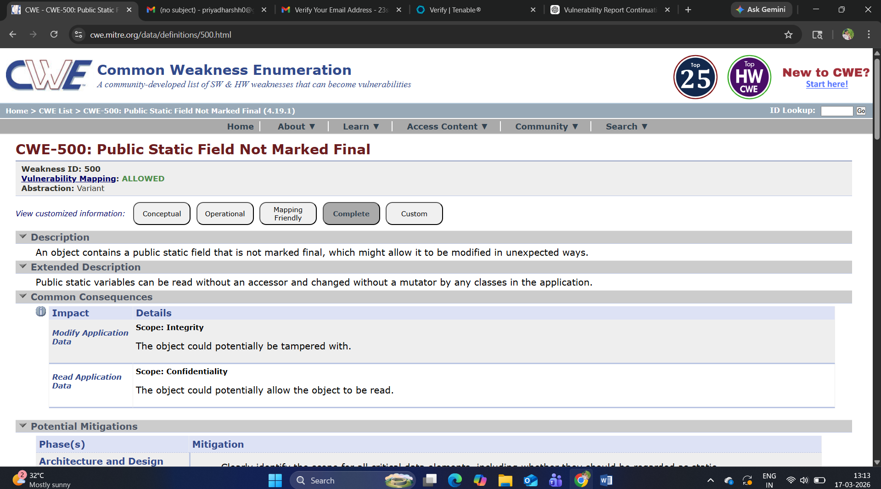

6) Vulnerability Name : Client-Side Enforcement of Server-Side Security

CWE NO : CWE-602
OWASP Category: Insecure Design
Description : This vulnerability occurs when security controls are implemented only on the client side (such as in browser scripts or UI logic) instead of being enforced on the server. Since client-side code can be easily modified, bypassed, or tampered with by attackers, relying on it for critical validations (like authentication, authorization, or input validation) is insecure. Attackers can manipulate requests, disable scripts, or use tools to directly interact with the server and bypass these protections.
Business Impact : Relying on client-side enforcement can lead to unauthorized access, privilege escalation, and data manipulation. Attackers may bypass validation checks, perform unauthorized actions, or access restricted resources. This can result in data breaches, financial fraud, and compromise of sensitive information. For businesses, it may cause revenue loss, legal consequences, reputational damage, and loss of customer trust.
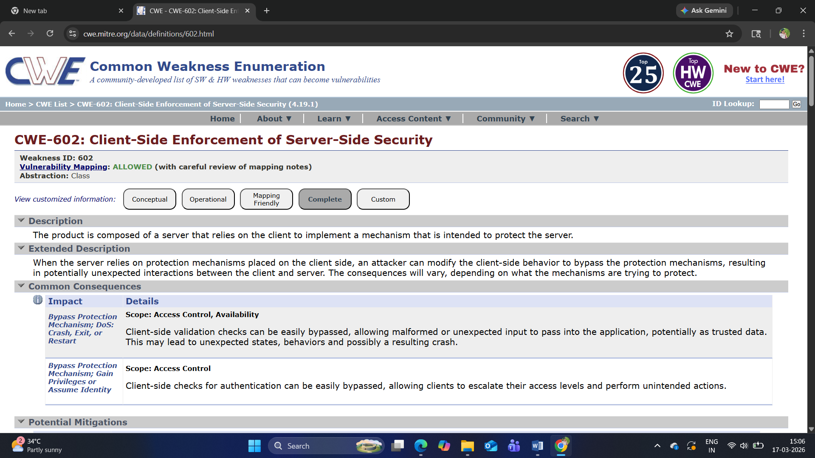

7) Vulnerability Name : Incorrectly Specified Destination in a Communication Channel

CWE NO : 941
OWASP Category: Authentication Failures
Description: This vulnerability occurs when a communication channel (such as a network request, API call, or data transmission) is directed to an incorrect or unintended destination due to improper configuration or validation. This can happen when endpoints, URLs, or addresses are not correctly specified or verified. As a result, sensitive data may be sent to unauthorized systems, or attackers may redirect communication to malicious destinations. This often arises from weak validation of destination parameters or misconfigured network settings.
Business Impact : Incorrectly specified communication destinations can lead to leakage of sensitive information, including credentials and personal data, to unauthorized parties. It may also enable attackers to intercept or manipulate communications, potentially resulting in account compromise or data tampering. For businesses, this can cause data breaches, regulatory non-compliance, financial losses, and significant reputational damage.
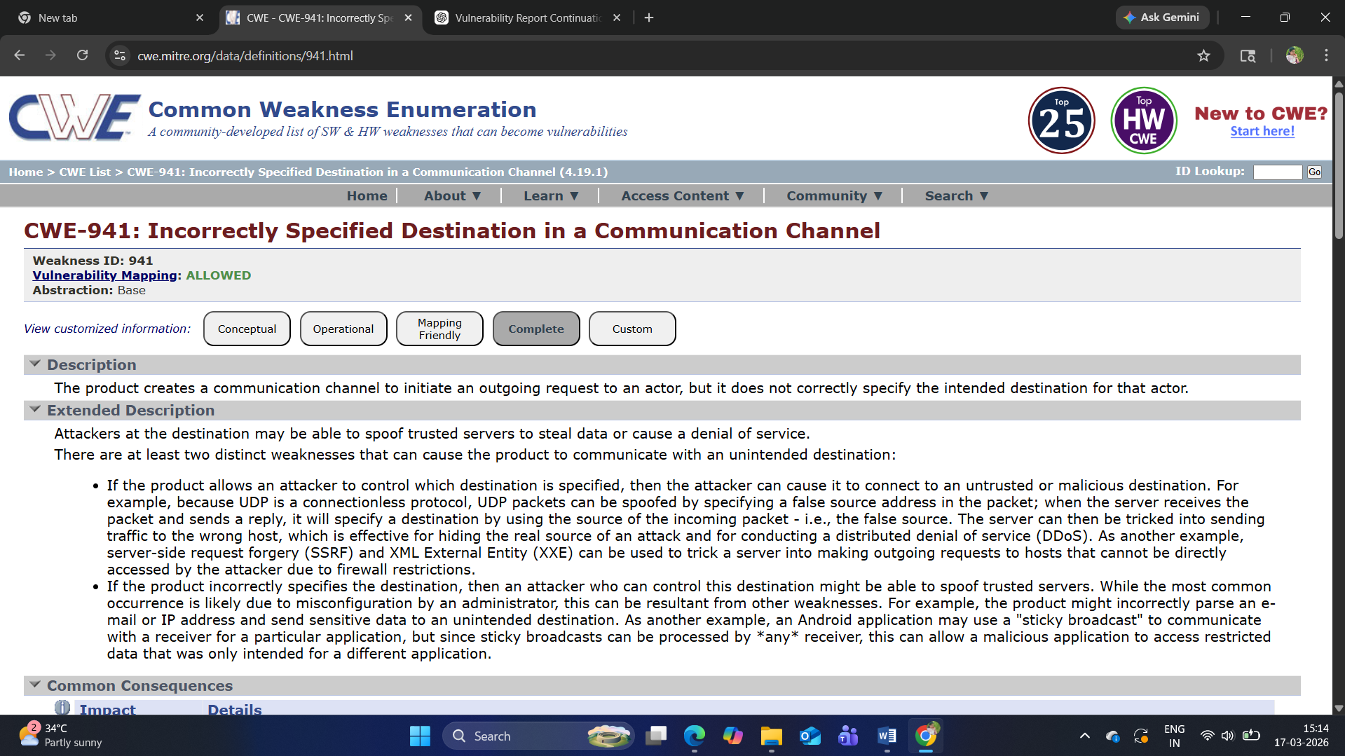

8) Vulnerability Name : Reliance on Cookies without Validation and Integrity Checking
CWE NO: CWE-565
OWASP Category: Software or data integrity failures
Description: This vulnerability occurs when an application relies on cookies for storing sensitive data (such as user roles, session details, or preferences) without properly validating their integrity. Since cookies are stored on the client side, attackers can modify their values. If the application does not verify the authenticity (e.g., using hashing, encryption, or signing), manipulated cookies may be accepted as valid. This can allow attackers to alter application behavior, escalate privileges, or bypass security controls.
Business Impact : Lack of cookie validation can lead to session hijacking, privilege escalation, and unauthorized access to sensitive data or functionality. Attackers may tamper with cookie values to gain higher privileges or impersonate other users. For businesses, this can result in data breaches, financial fraud, regulatory penalties, and damage to brand reputation and customer trust. 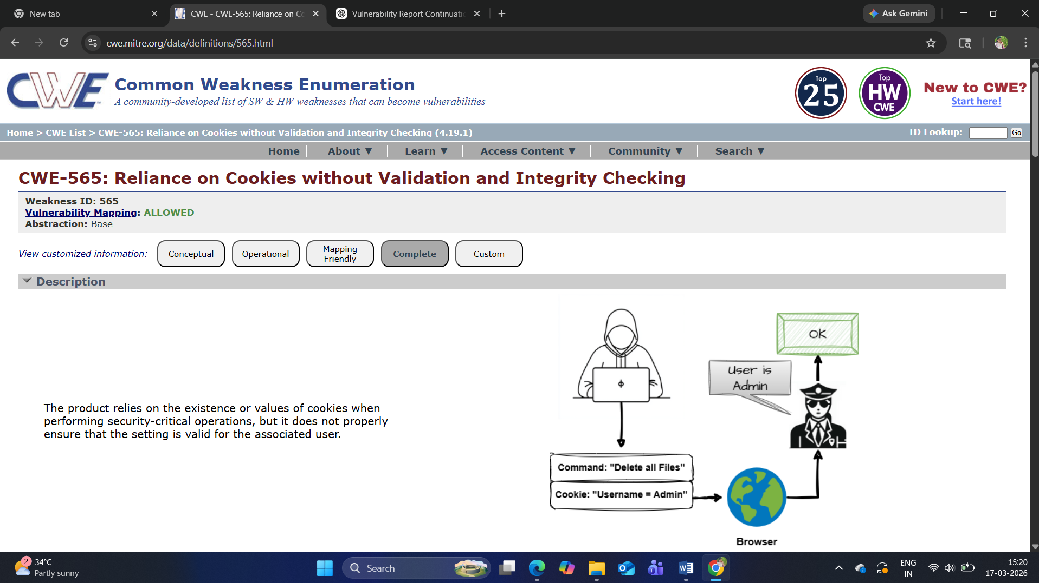

9) Vulnerability Name : Insertion of Sensitive Information into Log File
CWE NO: 532
OWASP Category: Security logging and alerting failures
Description: This vulnerability occurs when an application writes sensitive information—such as passwords, authentication tokens, personal data, or financial details—into log files. Logs are often stored in accessible locations and may not be adequately protected. If sensitive data is recorded without proper masking, encryption, or access control, it can be exposed to unauthorized users, administrators, or attackers who gain access to the logging system..
Business Impact : Storing sensitive information in logs can lead to data leakage and unauthorized access if logs are compromised. Attackers may retrieve credentials or confidential data from log files, enabling further attacks such as account takeover or identity theft. For businesses, this can result in regulatory non-compliance, financial penalties, reputational damage, and loss of customer trust.
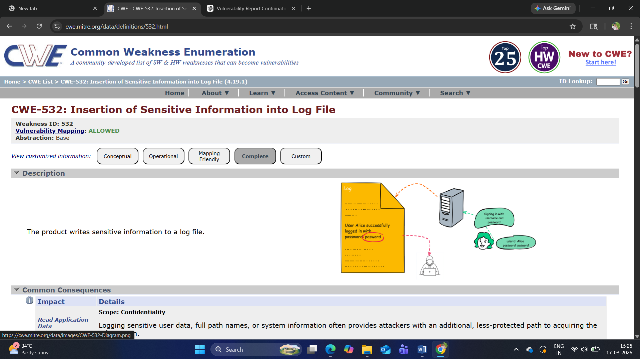

10) Vulnerability Name : Improper Check for Unusual or Exceptional Conditions
CWE NO : CWE-754
OWASP Category: Mishandling and Exceptional handling
Description: This vulnerability occurs when an application fails to properly handle unexpected or exceptional conditions such as errors, invalid inputs, resource failures, or edge cases. Without adequate checks and error handling mechanisms, the application may behave unpredictably, crash, or expose sensitive information through error messages. Attackers can exploit these weaknesses to trigger abnormal behavior, bypass security controls, or gain insights into the system’s internal workings..
Business Impact : Improper handling of exceptional conditions can lead to application instability, denial of service, and potential security breaches. Attackers may exploit these flaws to disrupt services, access sensitive information, or manipulate system behavior. For businesses, this can result in operational downtime, financial losses, degraded user experience, and reputational damage.

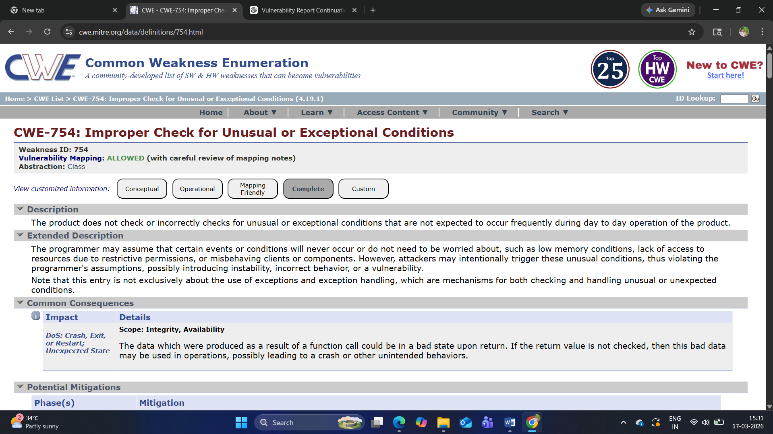

TITLE: NESSUS SCAN
OVERVIEW:
This project focuses on identifying and analyzing security vulnerabilities in systems and applications using Nessus, a widely used vulnerability assessment tool developed by Tenable. The main objective is to perform automated security scanning to detect potential weaknesses, misconfigurations, and known vulnerabilities in the target environment.
The Nessus scan evaluates systems against a vast database of known vulnerabilities (CVE), security standards, and best practices. It generates detailed reports that include vulnerability descriptions, severity levels, risk scores, and remediation recommendations.
Through this project, various vulnerabilities such as outdated software, weak configurations, and security flaws are identified and categorized based on their impact. The results help organizations understand their security posture and take corrective actions to mitigate risks, enhance system security, and ensure compliance with industry standards.

Importance of Nessus Scan:
- Detects misconfigurations, outdated software, and missing security patches.
- Provides detailed risk assessment with severity levels (Low, Medium, High, Critical).
- Assists organizations in prioritizing and fixing vulnerabilities effectively.
- Enhances overall security posture and reduces the risk of cyberattacks.
- Supports compliance with security standards and regulations.
- Saves time through automated scanning and comprehensive reporting.
S.NO | Vulnerability Name | Severity | Plugins
1. | Microsoft Windows SMB Service Detection | INFO | 11011
2. | HTTP Server Type and Version | INFO | 10107
3. | SSL/TLS Versions Supported | INFO | 56984
4. | Netstat Portscanner (SSH) | INFO | 14272
5. | DCE Services Enumeration | INFO | 10736
6. | Service Detection | INFO | 22964
7. | Common Platform Enumeration(CPE) | INFO | 45590
8. | Device Type | INFO | 54615
9. | Host Fully Qualified Domin Name (FQDN) Resolution | INFO | 12053
10. | SMB Signing not required | MEDIUM | 57608

REPORT:
1)Vulnerability: Microsoft Windows SMB Service Detection
Severity: INFO
Plugin: 11011
Description: This finding indicates that the Server Message Block (SMB) service is running and accessible on the target Microsoft Windows system. SMB is a network file-sharing protocol used for sharing files, printers, and other resources. While detection of SMB itself is not always a vulnerability, exposed or improperly configured SMB services can be exploited by attackers.
Solution: Disable SMBv1 and use secure versions like SMBv2 or SMBv3.
• Restrict SMB access using firewalls and allow only trusted IP addresses.
• Apply the latest security patches and updates to Microsoft Windows systems.
• Disable SMB service if it is not required.

Bussiness Impact: Unauthorized access to shared files and sensitive data.
• Increased risk of malware or ransomware attacks exploiting SMB vulnerabilities.
• Potential system compromise leading to data breaches and service disruption.
• Financial loss, operational downtime, and reputational damage.

2)Vulnerability: HTTP Server Type and Version
Severity: INFO
Plugin: 10107
Description: This vulnerability occurs when a web server reveals its type and version information in HTTP response headers (such as the Server header). For example, the server may disclose details like Apache, Nginx, or IIS along with specific version numbers. This information leakage helps attackers identify the exact software and version running on the server.
Solution:
• Disable or hide server version details in HTTP response headers.
• Configure the web server to remove or modify the Server and X-Powered-By headers.
• Regularly update and patch the web server software.
• Use web application firewalls (WAF) to filter and protect against attacks.

Bussiness Impact:
• ncreased risk of targeted attacks based on disclosed server information.
• Easier exploitation of known vulnerabilities in specific server versions.
• Potential unauthorized access, data breaches, or system compromise.

3)Vulnerability: SSL/TLS Versions Supported
Severity: INFO
Plugin: 56984
Description: This finding identifies the versions of SSL (Secure Sockets Layer) and TLS (Transport Layer Security) protocols supported by the server. If outdated and insecure versions such as SSLv2, SSLv3, or older TLS versions (e.g., TLS 1.0, TLS 1.1) are enabled, they may contain known vulnerabilities and weak encryption mechanisms.
Solution:
• Disable insecure protocols such as SSLv2, SSLv3, TLS 1.0, and TLS 1.1.
• Enable only secure versions like TLS 1.2 and TLS 1.3.
• Configure strong cipher suites and disable weak encryption algorithms.
Bussiness Impact:
• Exposure of sensitive data due to weak encryption mechanisms.
• Increased risk of man-in-the-middle and downgrade attacks.
• Potential data breaches affecting customer and business information.

4)Vulnerability: Netstat Portscanner (SSH)
Severity: INFO
Plugin: 14272
Description: This finding indicates that the Secure Shell (SSH) service is running and accessible on the target system, typically on port 22. SSH is used for secure remote login and administration. While SSH itself is a secure protocol, its exposure to the network can be identified through port scanning tools like Netstat.
Solution:
• Restrict SSH access to trusted IP addresses using firewall rules.
• Disable root login and use least-privilege user accounts.
• Enforce strong passwords and enable key-based authentication.
Bussiness Impact:
• Risk of unauthorized remote access to critical systems.
• Potential system compromise due to brute-force or credential attacks.
• Data breaches or manipulation of sensitive information.
• Operational disruption and possible service downtime.

5)Vulnerability: DCE Services Enumeration
Severity: INFO
Plugin: 10736
Description: This finding indicates that Distributed Computing Environment (DCE) / Remote Procedure Call (RPC) services are accessible on the target system, typically on Microsoft Windows. Enumeration of DCE/RPC services allows attackers to gather detailed information about available services, endpoints, and system configurations.
Solution:
• Restrict access to DCE/RPC services using firewalls and network segmentation.
• Disable unnecessary RPC services if not required.
• Apply the latest security patches and updates to Microsoft Windows systems.
• Limit exposure of services to trusted networks only.
Bussiness Impact:
• Exposure of internal system and service information to attackers.
• Increased risk of targeted attacks, including exploitation of known vulnerabilities.
• Potential privilege escalation and unauthorized access.

6)Vulnerability: Service Detection
Severity: INFO
Plugin:22964
Description: This finding indicates that various services running on the target system have been identified through scanning. Service detection reveals details such as open ports, running services, and sometimes their versions. While this is primarily an informational finding, exposed services can provide attackers with valuable insights into the system’s architecture.
Solution:
• Disable or remove unnecessary services that are not required.
• Restrict access to services using firewalls and network segmentation.
• Regularly update and patch all running services.
• Configure services securely by following best practices.

Bussiness Impact:
• Exposure of system and service information to potential attackers.
• Increased attack surface due to unnecessary or vulnerable services.
• Risk of exploitation leading to unauthorized access or system compromise
.

7)Vulnerability: Common Platform Enumeration(CPE)

Severity: INFO
Plugin: 45590
Description: This finding identifies the standardized naming of software, hardware, and operating systems on the target system using Common Platform Enumeration (CPE). CPE provides a structured way to describe platforms such as operating systems, applications, and versions.
Solution:
• Regularly update and patch all identified software and systems.
• Remove or replace outdated and unsupported platforms.
• Limit exposure of system details to unauthorized users.
• Use vulnerability management tools to monitor CPE-mapped risks.

Bussiness Impact:
• Exposure of detailed platform information that can aid attackers.
• Increased risk of targeted attacks based on known vulnerabilities.
• Potential exploitation of outdated or unpatched systems.

8)Vulnerability: Device Type

Severity: INFO

Plugin: 54615
Description: This finding identifies the type of device present on the network, such as a server, workstation, router, firewall, or IoT device. It is typically detected through network scanning and fingerprinting techniques. While this is an informational finding, it reveals details about the network infrastructure and the roles of different devices.
Solution:
• Limit exposure of network information to unauthorized users.
• Implement network segmentation to isolate critical devices.
• Use firewalls and access control lists (ACLs) to restrict access.

Bussiness Impact:
• Exposure of network structure and critical devices to attackers.
• Increased risk of targeted attacks on high-value systems.
• Potential unauthorized access or compromise of critical infrastructure.

9)Vulnerability: Host Fully Qualified Domin Name (FQDN) Resolution

Severity: INFO
Plugin: 12053
Description: This finding indicates that the Fully Qualified Domain Name (FQDN) of a host has been successfully resolved through DNS queries. An FQDN uniquely identifies a device within a network (e.g., server.company.com). While this is generally an informational finding, it reveals details about the internal or external domain structure of the organization.
Solution:
• Restrict DNS information exposure to authorized users only.
• Configure DNS servers securely and disable unnecessary zone transfers.
• Use internal DNS for sensitive systems and avoid public exposure.
• Implement network segmentation to limit access to critical hosts.

Bussiness Impact:
• Exposure of internal network structure and host information.
• Increased risk of reconnaissance and targeted cyberattacks.
• Potential phishing or DNS-based attacks using discovered domain names.

10)Vulnerability: SMB Signing not required
Severity: MEDIUM
Plugin: 57608
Description: This vulnerability occurs when SMB (Server Message Block) signing is not enforced on the target system. SMB signing ensures that communication between client and server is digitally signed to prevent tampering. When signing is not required, attackers on the network can intercept and modify SMB traffic.
Solution:
• Enable and enforce SMB signing on both client and server systems.
• Configure Group Policy to require SMB signing in Microsoft Windows.
• Restrict SMB access to trusted networks only.
• Disable SMBv1 and use secure versions like SMBv2 or SMBv3.
Bussiness Impact:
• Increased risk of man-in-the-middle (MITM) attacks.
• Potential interception and modification of sensitive data.
• Exposure of user credentials leading to unauthorized access

TITLE:
Replace and modernize legacy vpn architectures with a cloud native Zscaler zero trust solution To Reduce Attack Surface And Lateral Movement.
Overview:
This project focuses on replacing and modernizing traditional VPN architectures with a cloud-native Zero Trust solution using Zscaler. Legacy VPNs provide broad network access, which increases the attack surface and allows attackers to move laterally within the network once access is gained.
  - Zscaler Private Access (ZPA)

Zscaler Private Access (ZPA) is a cloud-based Zero Trust Network Access (ZTNA) solution provided by Zscaler that enables secure access to private applications without exposing the internal network to the internet.

Unlike traditional VPNs, ZPA does not connect users to the entire corporate network. Instead, it provides application-level access based on user identity, device posture, and defined security policies. This ensures that users can only access the specific applications they are authorized to use.

  - Need for Replacing Legacy VPNs

Legacy VPNs also expand the attack surface, as internal applications and services become exposed to the internet. If credentials are compromised, attackers can gain entry and move laterally across the network, leading to data breaches or system compromise.

In addition, VPNs often suffer from performance issues, especially with increasing remote work. All traffic is backhauled through centralized data centers, causing latency and poor user experience. Managing VPN infrastructure is also complex and costly due to hardware maintenance and scaling challenges

  - Zscaler Internet Access (ZIA)
ZIA acts as a secure web gateway (SWG), routing all user internet traffic through the Zscaler cloud where it is inspected in real time. It protects users from cyber threats such as malware, ransomware, phishing attacks, and malicious websites.
Unlike traditional on-premise security solutions, ZIA eliminates the need for hardware like firewalls and proxies by delivering security through the cloud. It enforces security policies consistently across all users and devices, whether they are on-campus or working remotely.

- Role as Secure Web Gateway (SWG)
Zscaler Internet Access (ZIA) functions as a cloud-based Secure Web Gateway (SWG) that protects users while accessing the internet. It acts as an intermediary between users and web applications, ensuring that all internet traffic is securely filtered and monitored.
ZIA inspects incoming and outgoing web traffic in real time to block malicious websites, malware, phishing attempts, and other cyber threats. It enforces organizational security policies, allowing only safe and authorized content to pass through.

- Real-Time Traffic Inspection
Zscaler Internet Access (ZIA) performs real-time inspection of all internet traffic passing through the platform. Every request and response is analyzed instantly to detect and block threats before they reach the user or the organization’s network.
The system scans for malware, ransomware, phishing attempts, and suspicious behavior using advanced security techniques. It also inspects encrypted traffic (SSL/TLS) to ensure that hidden threats are identified and stopped.
- Data Protection Features (DLP, CASB, Sandbox)

Zscaler Internet Access (ZIA) functions as a cloud-based Secure Web Gateway (SWG) that protects users while accessing the internet. It acts as an intermediary between users and web applications, ensuring that all internet traffic is securely filtered and monitored.

ZIA inspects incoming and outgoing web traffic in real time to block malicious websites, malware, phishing attempts, and other cyber threats. It enforces organizational security policies, allowing only safe and authorized content to pass through.

- Protection Against Cyber Threats

Protection against cyber threats is multi-layered: strong authentication, secure networks, data encryption, endpoint protection, user training, and continuous monitoring. Combining these measures significantly reduces risks and enhances organizational security.

Conclusion
Stage 1: Web Application Testing:
During web application testing, I gained a deeper understanding of how vulnerabilities can compromise application security. Issues such as improper input validation, broken access controls, and security misconfigurations can create entry points for attackers, potentially exposing sensitive data or allowing unauthorized actions. This stage highlighted the importance of secure coding practices and rigorous application testing.
Stage 2: Vulnerability Assessment with Nessus:
From analyzing the Nessus vulnerability report, I learned how automated scanning tools systematically identify system weaknesses, assess risk levels, and recommend remediation steps. This process illustrated how organizations can proactively detect security gaps in their infrastructure and prioritize fixes to reduce potential attack vectors. It emphasized the significance of continuous vulnerability management in maintaining a secure environment.
Stage 3: SOC, SIEM, and IBM QRadar Monitoring:
Through exposure to SOC operations, SIEM tools, and the IBM QRadar dashboard, I understood how organizations monitor, detect, and respond to cyber threats in real time. Centralized security systems allow security teams to correlate events, identify suspicious activities, and take timely action to mitigate attacks. This stage reinforced the importance of real-time threat intelligence and incident response in maintaining an organization’s cybersecurity posture.
Future Scope:
Stage1: To strengthen web application security in the future, the following steps can be considered:
- Secure Development Practices – Integrate secure coding standards and perform code reviews to minimize vulnerabilities during development.
- Automated Application Security Testing – Use automated tools for static and dynamic analysis to continuously detect security flaws.
- Runtime Application Protection (RASP) – Implement solutions that monitor applications in real time to block attacks as they happen.
- Integration with CI/CD Pipelines – Embed security testing within the development lifecycle to catch vulnerabilities before deployment.
Stage2: To further enhance system security and vulnerability management, the following steps can be considered:
- Regular Vulnerability Scanning – Conduct periodic Nessus scans to identify new vulnerabilities and ensure resolved issues remain fixed.
- Automated Patch Management – Implement automated patching to quickly apply updates to operating systems, applications, and servers.
- Upgrade and Modernization – Replace outdated software, frameworks, and libraries with modern, supported technologies.
- Security Monitoring and Logging – Deploy SIEM tools and real-time monitoring systems to detect suspicious activity.
- Penetration Testing – Perform regular penetration tests to simulate real-world attacks and uncover vulnerabilities that automated tools may miss.
Stage3: Project Context Mentioned: It clearly states the integration of Zscaler with IdPs (Azure AD, Okta, Active Directory) and lists the operational components (SSO, MFA, RBAC, user provisioning, monitoring). This is similar to how your previous Stage 3 paragraph introduced SOC/SIEM context.
• Focus on Enhancements: It points out opportunities for future improvement—advanced Zero Trust policies, context-aware access, adaptive authentication—which is exactly what a “future scope” paragraph should do.
• Forward-Looking Approach: It emphasizes real-time threat adaptation, AI-driven detection, and dynamic access control, just like your earlier Stage 3 paragraph emphasized evolving threat monitoring.
Furthermore, as cyber threats continue to evolve, organizations will need to adopt a proactive and adaptive security strategy. This includes continuous security awareness training for employees, frequent system audits, and integration of emerging technologies such as behavioral biometrics, zero trust frameworks, and AI-driven threat prediction. By combining these approaches with real-time monitoring and automated response, organizations can not only detect and respond to threats faster but also anticipate potential attacks, minimizing risks and ensuring long-term resilience in an increasingly complex cyber landscape.
In addition, future enhancements can focus on scalable and centralized security orchestration that unifies multiple tools, platforms, and threat intelligence sources. By implementing automated workflows, real-time analytics, and cross-system correlation, organizations can respond to incidents more efficiently and reduce human error. The adoption of predictive threat modeling and AI-powered decision support can further help security teams anticipate vulnerabilities and prioritize critical actions. These strategies collectively enable a resilient, adaptive, and intelligent cybersecurity posture, capable of defending against both current and emerging cyber threats.

Topics Explored:
• Nessus Scanner
• Nessus Professional
• Nessus Home (for personal use)
• Nessus Plugins Library
• Nessus Dashboard and Reporting Tools
• Credentialed Scan Tools
• Compliance Audit Templates
• Patch Management Integration Tools
• Scheduling and Automation Tools
• Real-Time Monitoring Features

Tools Explored:
Zscaler, Nessus, OWASP 10.

