**Public Transportation Efficiency Analysis**

|  |  |
| --- | --- |
| **Date** | **10-10-2023** |
| **Project Name** | Public Transportation Efficiency Analysis |

**Table of Contents**

|  |  |
| --- | --- |
| 1 | Introduction |
| 2 | Problem Statement |
| 3 | Design and Innovation Strategies |
| 3.1 | Data Collection and Feature Engineering |
| 3.2 | Data Pre-processing |
| 3.3 | Model Selection and Training |
| 3.4 | Predicting Service Disruptions |
| 3.5 | Monitoring and Feedback Loop |
| 3.6 | Visualization and Reporting |
| 3.7 | Explainable AI (XAI) |
| 3.8 | Continuous Learning |
| 4 | Conclusion |

**1. Introduction**

The purpose of this document is to provide a detailed analysis of the design and innovation strategies for developing Public Transportation Efficiency Analysis. Public transportation plays a vital role in modern urban infrastructure, facilitating the movement of millions of passengers daily. Ensuring the efficiency, reliability, and passenger satisfaction. This project aims to utilize innovative approaches to enhance the accuracy and effectiveness of Transportation Efficiency Analysis.

**2. Problem Statement**

To conduct a comprehensive analysis of public transportation systems to assess and enhance operational efficiency, reduce delays, optimize resource allocation, and improve overall service quality for the benefit of passengers and urban mobility.

**3. Design and Innovation Strategies**

**3.1. Data Collection and Feature Engineering**

Innovation: Comprehensive Data Gathering

Gather historical data related to service disruptions, including information on dates, times, locations, and reasons for disruptions. Also, collect passenger feedback data, which may include text reviews, ratings, and comments.

Create relevant features from the data that could be useful for prediction and sentiment analysis.

For service disruptions, features could include time of day, location, weather conditions, and historical disruption data.

For sentiment analysis, features could include text sentiment, passenger demographics, and historical service quality.

**3.2. Data Pre-processing**

Innovation: Natural Language Processing (NLP) for Feedback Analysis

Utilize natural language processing (NLP) techniques for sentiment analysis of passenger feedback.

Preprocess text data by tokenizing, removing stopwords, and stemming /lemmatizing.

Train an NLP model (e.g., LSTM, BERT) to classify passenger feedback into sentiment categories (positive, neutral, negative).

**3.3. Model Selection and Training**

Innovation: Advanced Machine Learning Models

Choose appropriate machine learning algorithms for your tasks. For service disruption prediction, time series forecasting methods like ARIMA or machine learning models like decision trees, random forests, or deep learning models can be used. For sentiment analysis, natural language processing (NLP) techniques like sentiment analysis using recurrent neural networks (RNNs) or transformer-based models like BERT can be effective.

**Split your data into training, validation, and test sets. Train your machine learning models on the training data and validate their performance on the validation set. Adjust hyperparameters and features as needed.**

**3.4. Predicting Service Disruptions**

Innovation: Deep learning

Use machine learning algorithms for predictive maintenance to anticipate potential service disruptions. Algorithms like Random Forest, Gradient Boosting, or deep learning models can be effective.

Features for the model can include historical disruption data, weather information, maintenance schedules, and other relevant data sources.

Implement classification models that can predict the likelihood and severity of disruptions.

**3.5. Monitoring and Feedback Loop**

Innovation: Interaction History Analysis

Continuously monitor the model's performance and retrain it periodically to adapt to changing data patterns.

Gather feedback from passengers and operational teams to improve model accuracy and usefulness.

**3.6. Visualization and Reporting:**

Develop dashboards and reporting tools to visualize key performance indicators related to service disruptions and passenger sentiment.

Provide actionable insights to decision-makers.

**3.7. Explainable AI (XAI)**

Innovation: Model Interpretability

Incorporating XAI techniques into your machine learning-driven public transportation system will help build trust among stakeholders, improve the acceptance of automated decision-making processes, and enhance the overall quality of your services.

It allows both technical and non-technical users to understand why certain predictions are made, which is essential for making data-driven decisions and addressing service disruptions effectively.

**3.8. Continuous Learning**

Innovation: Real-time Model Updates

Continuously monitor and update your models as more data becomes available or as the transportation system evolves.

Collect ongoing passenger feedback to adapt and refine your sentiment analysis models and service improvements.

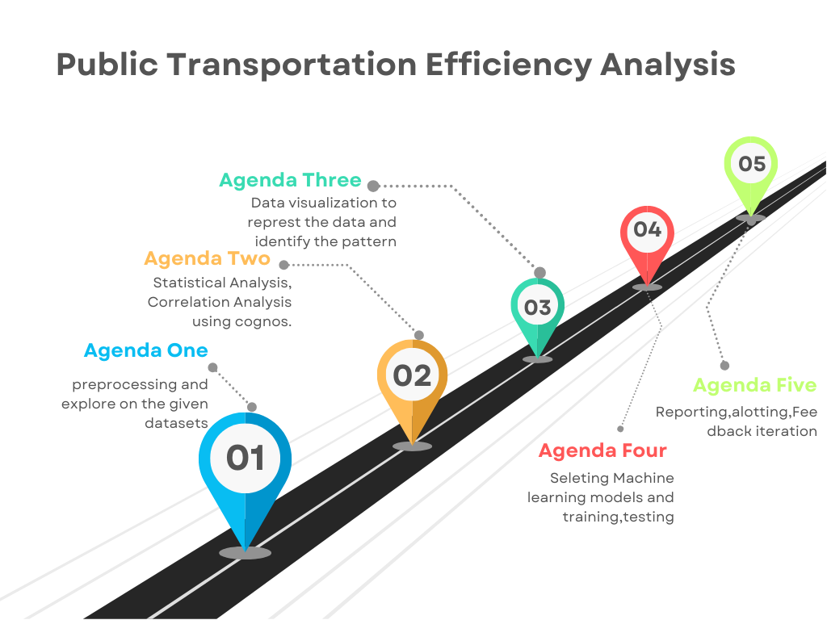Note: In the diagram below, we've depicted the key components and interactions described in sections 3.1 to 3.8, offering a clear and concise overview of our solution architecture. This visualization simplifies the complex concepts and relationships discussed in those sections,making it easier for the reader to grasp the overall design and innovation strategies at a glance.

**4. Conclusion**

In conclusion, the integration of machine learning algorithms into data analytics for transportation services has the potential to revolutionize the industry by improving service reliability, passenger satisfaction, and overall operational efficiency. Transportation providers should consider investing in this technology and establishing a data-driven culture to reap the benefits of predictive analytics and sentiment analysis. With the right approach, it can lead to a brighter and more connected future for the transportation industry.