Sum, Count, and Average

SUM : =SUM(D2:D35)

COUNT : =COUNT(D2:D35) (we have to calculate product as well)

AVERAGE : =AVERAGE(D2:D35)

Minimum and Maximum Values

Minimum : =MIN(D2:D35)

MAXIMUM : =MAX(D2:D35)

Logical Function – IF

IF FUNCTION FORMULA :

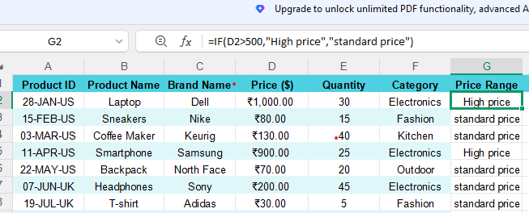

Electronics category : =SUMIF(F2:F35,"Electronics",D2:D35)

COUNTIF : =COUNTIF(D2:D35,"<100")

Text Formatting – LEFT, RIGHT, MID

LEFT : =LEFT(A2,2)
RIGHT : =RIGHT(A2,2)
MID : =MID(A2,4,3)

