CANTEEN

MANAGEMENT SYSTEM

CAT-3 PROJECT

PROJECT BY:

AJAY.M(1831003)

DHARANI PRASAD(1831013)

KALAI PRIYA.M(1831027)

RUTHSAN(1831045)

VIKASHINI.S(1831058)

CLASS DIAGRAM:

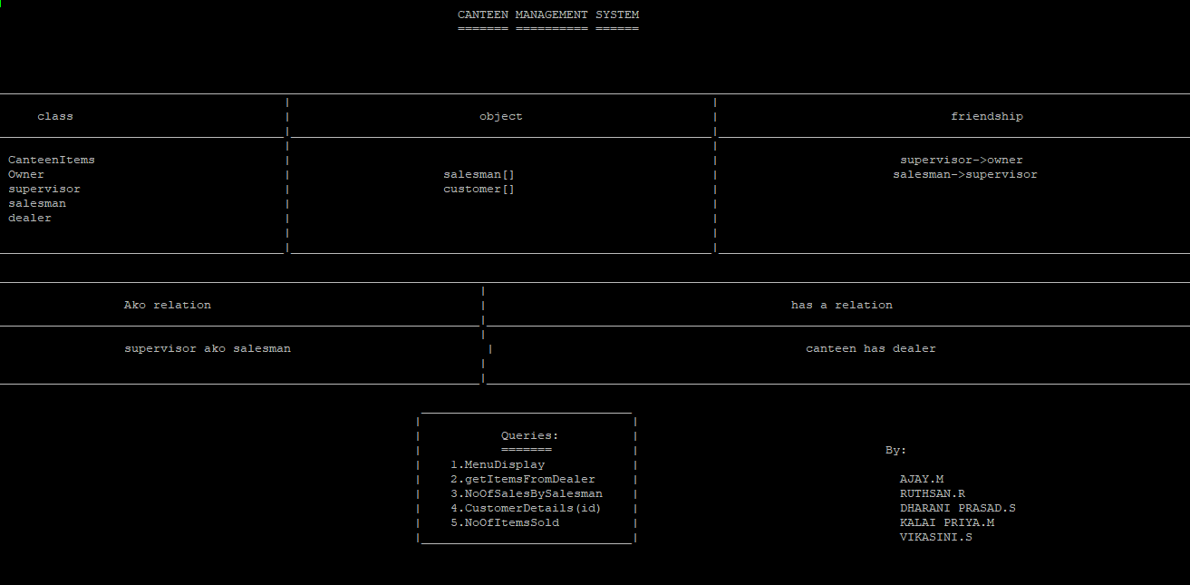

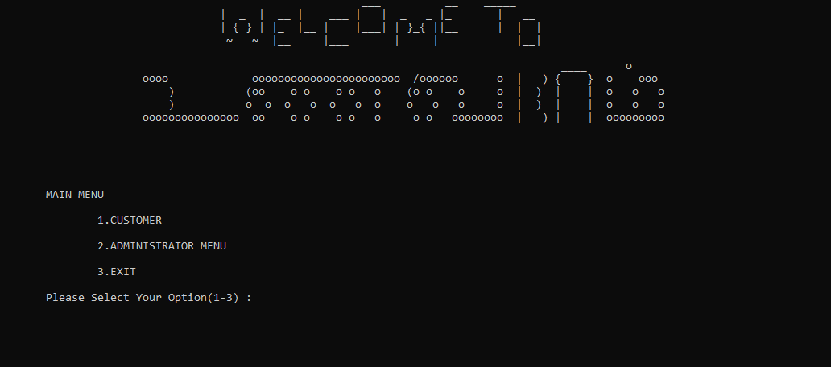

* FIRST PAGE IS THE HOME PAGE
* CUSTOMER HAS A SEPARATE CLASS AND ITS OWN FUNCTIONS
* ADMINSTRATOR CLASS ACCESS CANTEEN MANAGEMENT OPTIONS

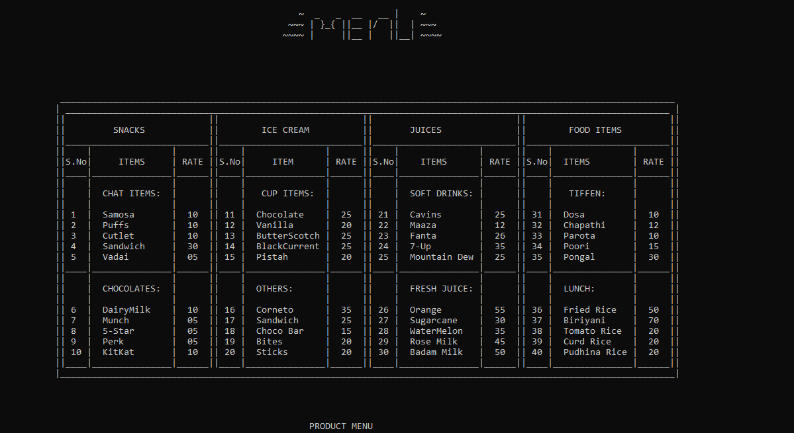

* MENU TABLE DISPLAYS ITEMS AVAILABLE IN CANTEEN